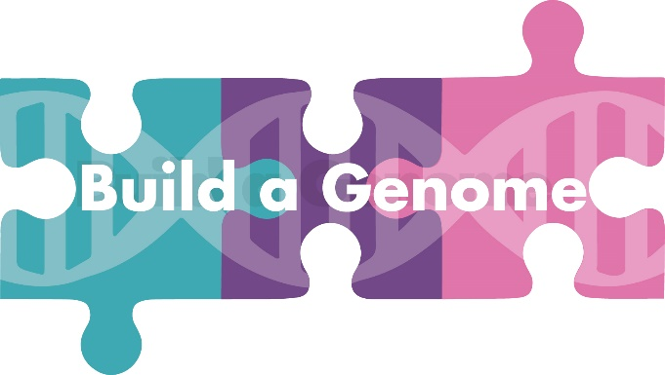

Build-a-Genome Membership Application

Build-a-Genome is a national network whose goal is to increase teaching and research in synthetic genomics, especially in undergraduate and community settings. Build-a-Genome supports research in three areas: (1) Design and synthesis of bacteriophage genomes, (2) Design and synthesis of neochromosomes in yeast, (3) Scramble of synthetic yeast chromosomes. You can learn more about Build-a-Genome at http://qubeshub

Thanks to funding from the National Science Foundation, BUGSS has been able to join the Build-a-Genome Network. This funding has supported our Build-a-Genome course and is also sponsoring 6 individuals to continue this research by providing them with 6-months BUGSS memberships. The goal is for the 6 participants to use the tools and techniques learned in Build-a-Genome to pursue their own research either as individuals or as a team. The individuals will have all the benefits of BUGSS membership, including mentoring from BUGSS staff and volunteers and the ability to work on additional projects in addition to Build-a-Genome. In return for the sponsorship, we hope that recipients will share the results of their research with the broader BUGSS community through presentations and outreach activities.

  - Name

  - Email address

  - Phone number

  - Mailing address

  - Are you currently a member of BUGSS?

No
Yes, I'm a full member Yes, I'm a student member
Yes, I'm a Friend of BUGSS/Associate Member

  - Did you attend the Build-a-Genome course at BUGSS?

  - Which of the following experiences have you participated in at BUGSS?

Attended courses other than Build-a-Genome
Worked on my own project
Worked on a community project
Attended talks and seminars
Volunteered at BUGSS
Other:

  - How do you identify?

White/Caucasian Black/African-American Hispanic/Latino
Asian
Native American or Paciﬁc Islander More than one of the above
Prefer not to say
Other:

  - Would you be willing and able to volunteer 5

