EDSIN Slack Quick Start Guide

Getting the most from the EDSIN Slack group

Table of Contents

Acknowledgements 3
About the Guide 4
1. Configuring your account 5
A. PROFILE 5
B. STATUS UPDATES 5
2. Adjusting the volume - notification settings 6
A. HOW TO FIND AND JOIN CHANNELS 6
B. CONFIGURING YOUR NOTIFICATIONS 6
i) For the overall group 6
ii) Channel by channel 6
iii) Following a specific thread 7
iv) Getting a reminder about a specific thread 7
C. MUTING OR LEAVING CHANNELS 7
3. Communicating with others 8
A. A FEW POINTS OF ETIQUETTE 8
B. SENDING PRIVATE MESSAGES 8

Acknowledgements
The content of this guide was based upon the Center for Scientific Collaboration and Community Engagement “Slack quick start guide” by Lou Woodley and Katie Pratt, licensed under a Creative Commons Attribution 4.0 (CC BY 4.0) license.

The original guide is cited as: Center for Scientific Collaboration and Community Engagement. (2020) Slack quick start guide. Woodley and Pratt doi: 10.5281/zenodo.3763730

About the Guide
Note: these instructions are created for the browser version of Slack. There are also desktop and mobile apps that may have minor differences.

Welcome to the Environmental Data Science Inclusion Network (EDSIN) Slack group – a place for EDSIN members and those interested in diversity, equity, and inclusion in environmental and data science fields to ask questions, share resources, opportunities and more.

If you’re new to Slack or simply overwhelmed by the prospect of yet another Slack group, here are some quick pointers to help you to configure and use the tool in a way that works best for you. They’re in 3 key areas:

- Configuring your account
- Notification settings
- Communicating with others.

For more detailed information on getting started with Slack, including accessibility features, please visit their website.

Any questions? Email: acrall@battelleecology.org

1. Configuring your account

A. PROFILE
When you set up your profile there are three things to bear in mind:

- Your username – please use a name by which others will be able to identify you. Your email address will not be visible to others.
- Your avatar – please add a profile picture or other identifier that you’re comfortable with so that others can associate your posts with you more easily.
- Your time zone – this determines when Slack will notify you and can also help others know whether it’s a reasonable time of day to get in touch.

B. STATUS UPDATES
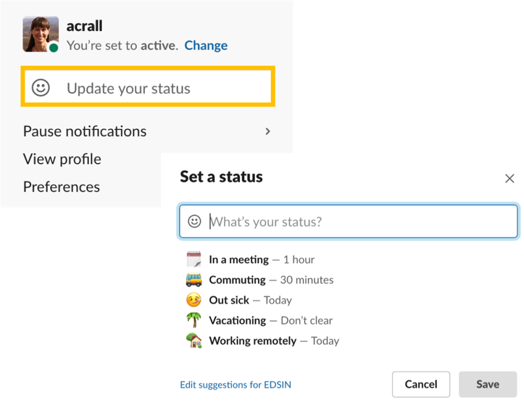
Status updates can be a useful way to let others know your availability. For example, if you’re away at a conference, you may want to let others know that you’ll be slower to respond or entirely absent from the group.

Remember that your status will be visible to everyone in the Slack group.

To update your status, click your name in the top left of the screen and select “update status”. You can select when you want your status update to be removed by stipulating a timeframe from the “clear after” dropdown.

You can clear a status update at any time by clicking on your name and selecting “clear status” from the dropdown.

2. Adjusting the volume - notification settings

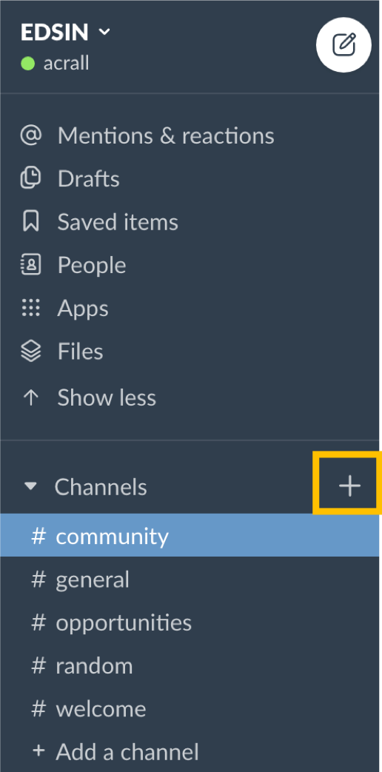
A. HOW TO FIND AND JOIN CHANNELS
By default, you’re automatically added to the #community channel which is the shared community of practice that everyone belongs to. You’re also added to #welcome – and encouraged to say hello there.

There are additional channels that you may be interested in. To find them:

- Click the “+” icon to the right of the word “channels” to reveal the “browse channels” page.
- Want to join in? Simply click “Join channel” at the bottom of the page. The channel will now be listed in your left hand side bar.
- Click a channel name in the sidebar to load the channel in the center pane.

B. CONFIGURING YOUR NOTIFICATIONS
Slack has lots of options for you to determine how and when you are informed about content – and at what level of granularity.

i) For the overall group
- Click on your name at the top left of the page and select “preferences” from the dropdown
- In the Notifications section you have options which include:
- Set times when you do not want to be disturbed by notifications
- Enable desktop notifications
- Choose to be alerted when certain keywords are mentioned

ii) Channel by channel
- When you’re in a channel, click the “i” icon at the top right. Choose “more” and then click “notifications.”
- Here you have the option to ignore any @channel messages, or mute the channel entirely.

iii) Following a specific thread
- If another group member posts something of particular interest you can choose to follow that thread.
- Click the ellipsis (three dots) to the right of the original post and select “follow message” from the dropdown.

iv) Getting a reminder about a specific thread
- You additionally have the option to be reminded about a thread at a more convenient time. From the ellipsis to the right of the original post select “remind me about this” from the dropdown and choose a timeframe.

C. MUTING OR LEAVING CHANNELS
- If a channel has become too noisy, you can additionally:
  - Mute it: When you’re in a channel, click the “i” icon at the top right. Choose “more” and then choose “mute” from the dropdown.
  - Leave it: When you’re in a channel, click the “i” icon at the top right. Choose “more” and then choose “leave” from the dropdown.

3. Communicating with others

A. A FEW POINTS OF ETIQUETTE
- Use threads to continue conversations
  - When someone posts a brand new item in a channel, anyone in the channel can reply directly to it, creating a thread. Threads allow separate conversations to take place in the group without confusion - and for members to choose which of those conversations to follow more closely.
  - To add a comment to a thread, click the speech bubble icon to the right of an existing post.
- Use @channel and @here sparingly
  - If you type @channel or @here in a post or comment that will send a notification to everyone in that channel. Please use this only for items that really do need everyone's attention.
- Respect the context of this shared space
  - While this group is open for anyone interested in scientific community engagement, we want it to be somewhere where learning can happen in a supportive, safe environment.
  - Please DO NOT take conversations out of context and copy/paste them elsewhere without the permission of all the individuals who posted.
- Not all communications will be synchronous
  - While IM-based conversations can feel very immediate, please don't feel that you have to respond to messages immediately, nor expect others to respond immediately. We're all busy!

B. SENDING PRIVATE MESSAGES
It can be helpful to others when you're sharing resources and brainstorming solutions to "work out loud" in a specific thread because then your learning becomes a future resource for others, too.

However, sometimes you want to start a private conversation. To do this, go to the direct messages section on the bottom left of the left-hand side bar. Click the + icon to start a new message. You can add more than one recipient to create a group message.

