Global Temperature Change in the 21st Century?
For today’s supplemental instruction we will set out to answer three questions.
- Will average temperatures change this century? If so, how much will these changes vary geographically (regions; major U.S. cities)? Seasonally?
- Are human activities impacting atmospheric temperatures resulting in a changing climate?
- What kind of impact could these temperature changes have on ecosystems and biodiversity in different regions of the country?
In order to investigate these questions, you will be working together in small groups. All of you must work as a group to organize and interpret your data. Divide up into groups of 4 or less and record each group member’s name.
Group Member 1 _______________________ Group Member 2 ________________________
Group Member 3 _______________________ Group Member 4 ________________________
Step 1. Understanding the parameters of the models. Below is a table providing three “scenarios/conditions” that have been considered from models already run by the Canadian Center for Climate Modeling and Analysis (http://www.cccma.ec.gc.ca/data/data.shtml)
- Decrease: Energy consumption via fossil fuels is decreased.
- Increase: Energy consumption via fossil fuels is increased.
- Current: Based on current government regulations, conditions remain the same.
The three scenarios of these future conditions have correlating factors, related to societal and technological changes, that are candidates for our future demands on environmental resources.
Scenario conditions | Decrease | Increase | Current
Population Growth | Medium | Medium | Low
Emphasis placed on environmental sustainability | Very High | Low | Low
Economic Growth | High | Medium | Very High
Greenhouse Gas Emissions  (CO₂, CH₄, NO_{x}’s) | Very Low | Very High | High
Investment and Implementation of Alternative Energy (Solar, Wind, Geothermal) | Very High | Very Low | Low
Question 1: Do you predict any disparity in forecasted temperatures between the three scenarios?
___________________________________________________________________________________
Step 2. Exploring and Understanding Microsoft Excel. On each computer, there is a Microsoft Excel file prepared for each group. The following information is located in this file:
- Four different sheets (tabs at the bottom of the Microsoft Excel file).
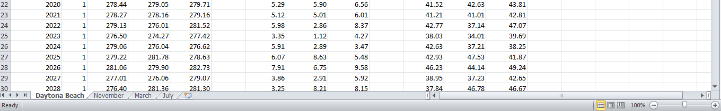
- The first sheet has forecasted temperatures (3 different scales: Kelvin, °Celsius, and °Fahrenheit) from 2001–2100 based on three scenarios from Step 1 across 12 months of the year in a region.
- The other three sheets are labeled by months, which you will modify in Steps 3 and 4.
The three major regions/U.S. cities we will collectively investigate/compare as a class are:
- Daytona Beach, Florida - 29°N Latitude
- Fairbanks, Alaska - 64°N Latitude
- New York City, New York/Chicago, Illinois – 40/41°N Latitudes

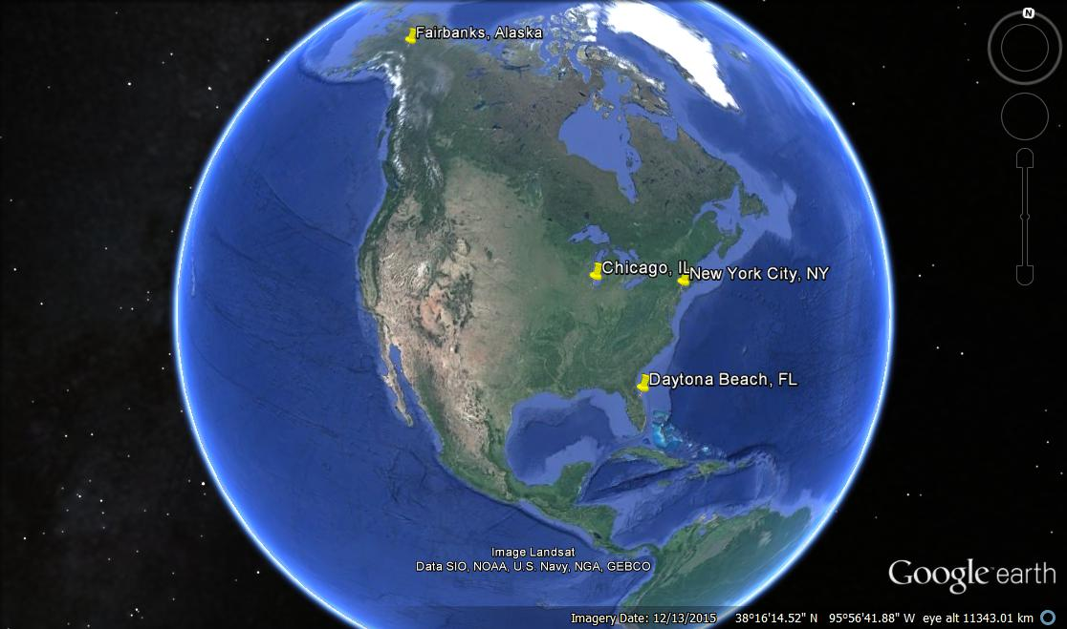
Question 2: What major U.S. city is your group assigned (look at the Microsoft Excel file)?
______________________________________________________________________________
Question 3: You have four sheets in the Excel file. What do you see appear at the top of the program
(f_{x} window) if you click on cell H3 in your first sheet? What if you click on cell K3?
______________________________________________________________________________
Step 3. Organizing data in Microsoft Excel. In this step, we will become familiarized with navigating through different sheets. To answer our three questions, we must be able to easily navigate through Microsoft Excel to modify each sheet. Click on the November tab at the bottom of the Excel file.
Question 4: What do you see when you click on the November tab at the bottom of the Excel file? ___________________________________________________________________________________
Question 5: What trends (projected pattern) do you notice on the three different scenarios (from the graphs) for the month of November?
___________________________________________________________________________________
Question 6: What do you see when you click on the March tab at the bottom of the Excel file?
___________________________________________________________________________________
Question 7: What is missing in the March sheet vs. the November sheet?
___________________________________________________________________________________
Your group needs to “organize” your data in the March sheet to resemble your November tab. Steps:
- Click on the first sheet (city name) and find temperatures for March (Month 3; °F) in 2015 for the three scenarios (should be cells K217, L217, and M217).
- Select these three cells with your touchpad/mouse by starting at cell K217 holding down your left button on the touchpad/mouse and move the touchpad/mouse to M217. Once these are selected, release the left click button.
- Now right click, and Select copy (or you can hit “Ctrl” and “c” at the same time).
- Navigate to the sheet titled March.
- Locate the appropriate place to insert what you copied (March temperatures for three scenarios; cells C17, D17, and E17).
- Select these three cells and right click on the touchpad/mouse.
- Under the “Paste” options, you will see a multitude of options, but you want to click
values ( ), which is an icon that looks like a clipboard with 123 on it.
- Your data should have copied and pasted, but you need to select data from 2016 to 2100 all at once. Repeat the steps above, but select cells from 2016 to 2100 for the month of March.
- When pasting data into your March sheet, place the cursor in cell C18 and right click to paste such that you can paste remaining data in the spreadsheet.
Question 8: What happened to your graphs when you added data from 2016 to 2100?
___________________________________________________________________________________
Question 9: Look at your figures in the November sheet vs. the March sheet. Is there anything missing on the March figures that the November figures have?
___________________________________________________________________________________

Step 4. Organizing data in Microsoft Excel continued. Your group has completed organizing data for spreadsheet March, but now we need to organize July.
Question 10: Which group member primarily organized data in the spreadsheet for the month of March?
____________________________________________________________________________________
Switch group members such that another person in your group can repeat the steps in Step 3, but make sure you are copying and pasting data from July into the appropriate sheet.
Question 11: Which group member primarily organized data in the spreadsheet for the month of July?
____________________________________________________________________________________
Congratulations, you have successfully navigated through a Microsoft Excel spreadsheet!!!!!!!!!!!!!!!!!!
Step 5. Completing the supplemental instruction session. Now we can revisit our three questions since our data are now easily visualized with the graphs constructed.
Question 12: In your city, do you see any differences in projected temperatures based on the three scenarios in the month of November? What about March? How about July?
____________________________________________________________________________________
Question 13: What scenario results in lower average temperatures in the month of November? How about March? How about July?
____________________________________________________________________________________
Now we can revisit our three questions and see if we can address each of them. Here are those three questions again:
- Will average temperatures change this century? If so, how much will these changes vary geographically (regions; major U.S. cities)? Seasonally?
- Are human activities impacting atmospheric temperatures resulting in a changing climate?
- What kind of impact could these temperature changes have on ecosystems and biodiversity in different regions of the country?
Question 14: Which of these questions can we answer with the information you have in your Excel spreadsheets? _____________________________________________________________________________________
Look at the projector screen for some basic climate factors associated with the three regions the class has investigated. Prior to finalizing your answers to each question below, make sure you visit with another group that has completed the first 4 steps of this exercise.
Question 15: How would you answer each of the three questions posed to you today?
____________________________________________________________________________________

