Investigating the footprint of climate change on phenology and ecological interactions in north-central North America

Adapted from an exercise written by Kellen M. Callinger

Department of Evolution, Ecology, and Organismal Biology, The Ohio State University, Columbus, OH 43210-1293; kcalinger@gmail.com

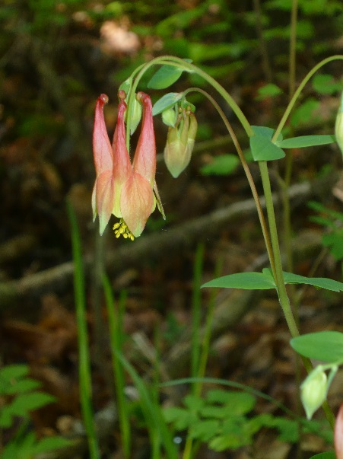
Used with permission

THE ECOLOGICAL QUESTION:
Have long-term temperatures changed throughout Ohio? How will these temperature changes impact plant and animal phenology, ecological interactions, and, as a result, species diversity?

Biological Indicators of Climate Change: Butterfly Emergence and Hummingbird Arrival Times

Along with shifts in the timing of plant phenological events (like flowering), scientists have observed significant shifts in the timing of animal phenological events such as migration, insect emergence, and mating associated with temperature increase (Cotton 2003). Like flowering time in plants, the timing of these phenological events has direct impacts on reproductive success in animals.

Further, changes in the timing of phenological events in plants and animals may disrupt important plant-animal interactions such as pollination. These disruptions of interactions as a result of shifting phenology are called trophic mismatches. For example, in pollination mutualisms, the pollinator benefits from pollen and nectar food resources and the plant benefits by being pollinated and increasing its reproductive success. Under average climate conditions, without climate change or warming, flowering time in the plant and arrival time of the pollinator (based on migration or insect emergence date) are cued to coincide. However, if the plant or pollinator responds more strongly to climate warming and shifts their phenology more than their mutualistic partner, this relationship will be disrupted. Perhaps the plant flowers earlier, but the pollinator does not adjust with changing climate and arrives too late – after the flowers die. Or perhaps the pollinators adapt to changing climate, but their plant partner does not, which would mean that the food or nectar that the pollinator organism is expecting will not be available. This trophic mismatch results in decreased pollination and reproduction for the plant and a loss of important floral food resources for the pollinator.

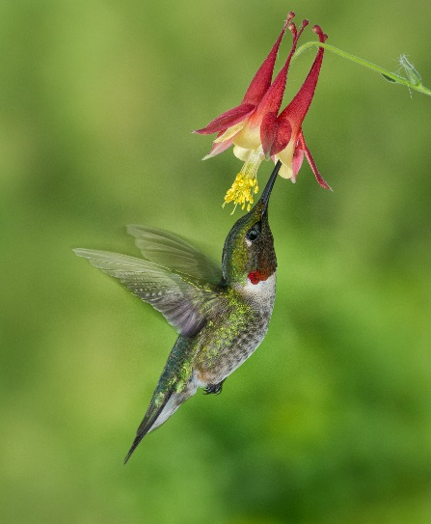
Using data provided below, you will be assessing the effects of warming on shifts in arrival time of the migratory ruby throated hummingbird, Archilochus colubris and emergence from overwintering of the Spring Azure butterfly, Celastrina ladon (data from Ledneva et al. 2004). Both of these species occur in Ohio although this data was collected in Massachusetts. For this study, we will assume that the responses of both the ruby throated hummingbird and the Spring Azure butterfly are uniform throughout their ranges. You will also discuss whether we have evidence for trophic mismatches based on your findings.
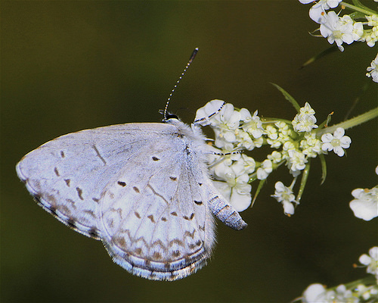

Species | Arrival Time Change (days/ºC)
Spring Azure Butterfly adults | 0.55
Ruby-throated Hummingbird | -1.40

- Based on the data given above for arrival time change, describe the pattern of shifting arrival/emergence time phenology for each pollinator species. In other words, is each pollinator species arriving earlier or later as temperature increases by one degree Celsius?
  - Describe the pattern for Spring Azure Butterflies.

  - Describe the pattern for Ruby-throated Hummingbirds.

2. Ruby-throated hummingbirds uses Aquilegia canadensis (columbine) flowers as a nectar food resource, and, in turn, is an important pollinator of this plant (Bertin 1982). Spring Azure butterfly caterpillars feed on Cornus florida (flowering dogwood) flowers (University of Florida IFAS Extension), although this interaction is not mutualistic as the dogwood receives no benefit. Given your knowledge of flowering shifts with temperature in Columbine and Flowering Dogwood (from last week’s assignment) as well as arrival time shifts with temperature in hummingbirds and butterflies, speculate on what effects climate warming might have on survival and reproduction in these species. You will need to refer back to the results of your assignment from last week to answer these questions. Specifically, answer the following questions by filling in the tables below.

- How would species interactions between hummingbirds and columbine change with a 1ºC temperature increase? With a 3ºC temperature increase?

Temperature Change | Shift for Flower | Shift for Pollinator | How do you think plant-pollinator interaction is affected?
1º increase
3º increase

- How would species interactions between butterflies and flowering dogwood change with a 1ºC temperature increase? With a 3ºC temperature increase?

Temperature Change | Shift for Flower | Shift for Pollinator | How do you think plant-pollinator interaction is affected?
1º increase
3º increase

Debunking a climate change skeptic tactic

Climate change skeptics often try to argue that temperatures have not been increasing and present misleading data to support their point. Frequently, they use a tactic called “cherry picking” data. Cherry-picking data involves including only the data that supports whatever point you are trying to make while disregarding the rest of the data that would discredit that point.

Look at the graphs of spring temperature change across Ohio. The data indicate a significant temperature increase of about 0.9ºC since 1895. In fact, 3 of the 5 warmest years in the temperature record are in the 1990’s and 2000’s.

Now, go back to the data your group worked with the FIRST WEEK, and plot statewide temperature including ONLY yearly spring temperatures from 1990-2009. Follow the same methods you used to create your temperature graphs in that part of the group research project, but use STATEWIDE data only (not your specific climate division).

- Does your plot indicate temperature increase or decrease from 1990-2009? What is the rate of temperature change?

- Based on the long-term, 115-year assessment of temperature change versus the shorter, 20-year assessment, can we accurately assess temperature change using a small subset of the data? Refer to the data in your answer.

- Why is it inappropriate to use only a subset of the total years to establish a climatic pattern?

Upon completion, please submit this completed Word document AND the Excel file with your temperature graph from 1990-2009 to the Dropbox before the deadline 11:59pm Sunday night.

Literature Cited
Bertin RI. 1982. The ruby-throated hummingbird and its major food plants: ranges, flowering phenology, and migration. Canadian Journal of Zoology 60: 210-219.
Calinger, K., S. Queenborough, and P. Curtis. 2013. Herbarium specimens reveal the footprint of climate change in north-central North America. Ecology Letters 16:1037–1044.
Cotton, P.A. 2003. Avian migration phenology and global climate change. PNAS 100:12219-12222.
IPCC, 2007: Climate Change 2007: The Physical Science Basis. Contribution of Working Group I to the Fourth Assessment Report of the Intergovernmental Panel on Climate Change [Solomon, S., D. Qin, M. Manning, Z. Chen, M. Marquis, K.B. Averyt, M.Tignor and H.L. Miller (eds.)]. Cambridge University Press, Cambridge, United Kingdom and New York, NY, USA.
Ledneva, A., Miller-Rushing, A.J., Primack, R.B., and Imbres, C. 2004. Climate change as reflected in a naturalist’s diary, Middleborough, Massachusetts. Wilson Bulletin 116: 224-231.
Menne, M. J., Williams Jr., C. N., and Vose, R. S. 2010. United States Historical Climatology Network (USHCN) Version 2 Serial Monthly Dataset. Carbon Dioxide Information Analysis Center, Oak Ridge National Laboratory, Oak Ridge, Tennessee.

Menzel, A., Sparks, T.H., Estrella, N., Koch, E., Aasa, A., Ahas, R., et al. 2006. European phenological response to climate change matches the warming pattern. Global Change Biology 12:1969–1976.
Parmesan, C. & Yohe, G. 2003. A globally coherent fingerprint of climate change impacts across natural systems. Nature 421:37–42.
Rosenzweig, C., Karoly, D., Vicarelli, M, Neofotis, P., Wu, Q., Casassa, G., et al. 2008. Attributing physical and biological impacts to anthropogenic climate change. Nature 453:353-357.
United States Environmental Protection Agency. Heat Island Effect. [http://www.epa.gov/hiri/] Last accessed April 5, 2013.
University of Florida IFAS Extesion. Butterfly Gardening in Florida. [http://edis.ifas.ufl.edu/uw057] Last accessed January 31, 2014.

