Investigating the footprint of climate change on phenology and ecological interactions in north-central North America

Adapted from an exercise written by Kellen M. Calinger

Department of Evolution, Ecology, and Organismal Biology, The Ohio State University, Columbus, OH 43210-1293; kcalinger@gmail.com

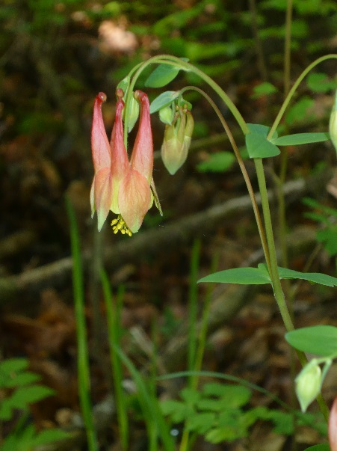
Used with permission

THE ECOLOGICAL QUESTION:
Have long-term temperatures changed throughout Ohio? How will these temperature changes impact plant and animal phenology, ecological interactions, and, as a result, species diversity?

ECOLOGICAL CONTENT:
Climate change, phenology, pollinators, trophic mismatch, species diversity, arrival time, mutualism

WHAT YOU WILL DO:
- Produce and analyze graphs of temperature change using large, long-term data sets (Synthesis, Analysis)
- Develop methods for calculating species-specific shifts in flowering time with temperature increase (Synthesis)
Aquilegia canadensis (red columbine) flowering with open and closed flowers
- Use these methods to calculate flowering shifts in six plant species (Application)
- Describe the ecological consequences of shifting plant and animal phenology (Comprehension)
- Understand how interactions between species as well as with their abiotic environment affect community structure and species diversity (Knowledge, Comprehension)
- Evaluate data “cherry-picking” as a climate change skeptic tactic (Evaluation)

INSTRUCTIONS

Introduction
Climate change as a result of anthropogenic greenhouse gas (GHG) emissions is clear in both climatological and biological data. Global temperatures have increased by 0.74°C ± 0.18°C over the past 100 years (1906-2005), although some regions experience locally greater warming (IPCC 2007). Along with this average increase in temperature, extreme weather events including extreme heat have become more common. The ten hottest years on record have all occurred since 1998.

Scientists use long-term climate (for example, see Figure 1) and biological datasets to assess past and current rates of warming and the impacts of this warming on key ecosystem functions. These analyses provide crucial information for the prediction of future impacts of warming as we continue to release massive quantities of GHGs into the atmosphere.
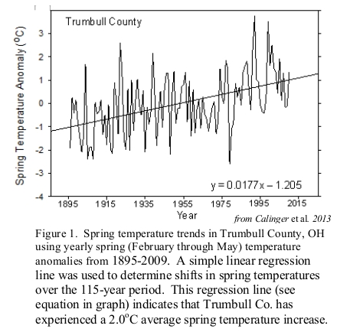
One clear biological indicator of climate change is phenology, or the timing of key life events in plants and animals. Phenological events are diverse and include time of flowering, mating, hibernation, and migration among many others. Generally, phenological events are strongly driven by temperature, with warmer temperatures typically resulting in earlier occurrence of springtime migration, insect emergence from dormancy, and reproductive events. Shifts in phenology in the direction predicted by climate change have been observed worldwide, suggesting that climate change is already having profound, geographically broad impacts on ecology (Parmesan & Yohe 2003, Menzel et al. 2006; Rosenzweig et al. 2008).

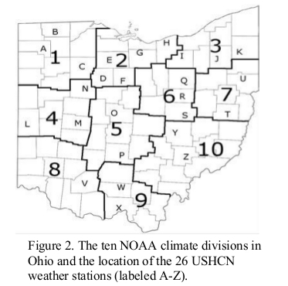
In this assignment, you will be (1) analyzing long-term temperature data collected in Ohio by the U.S. Historical Climatology Network http://cdiac.ornl.gov/epubs/ndp/ushcn/ushcn.html) to establish temperature trends in Ohio over the past 115 years. (2) You will then investigate temperature effects on the flowering of six plant species and the arrival and (3) emergence times of two pollinator species to determine biological signals of climate change in Ohio. We will look at the temperature data this week, the plant data next week, and the pollinator data the following week.

EXERCISE

i. Regional Long-term Temperature Trends

The data for these exercises are provided for you on D2L in your group’s Discussion Topic in the “Climate Change and Phenology Research Project” Discussion Forum. There are also additional links with resources and information on the Content page if you need more information or help with the data manipulations in Excel.

The first thing you must do is introduce yourself to your group members, and state your commitment to work together collaboratively on our Research Project over the next few weeks. Participation in the Group Discussion Topic for the Research Project will be part of the assessment (including earning points). We will be using this Group Discussion Topic this week, and the next two weeks as we continue to work on this project.

An important component of climate change studies is the analysis of temperature change over long timescales in the region of interest. For our analysis of Ohio, you will assess temperature change across the entire state as well as at smaller, regional scales. The U.S. Historical Climatology Network (USHCN) has collected temperature and precipitation data at 26 weather stations throughout Ohio since 1895 (Figure 2). The number of USHCN weather stations is limited as USHCN stations are required to have a consistent, non-urban location since 1895; this eliminates urban heat island effects (urbanized areas that are hotter than surrounding rural areas, U.S. EPA) and latitudinal/altitudinal effects. Changes in the location of weather stations can cause apparent increases or decreases in temperature as a result of moving to a generally warmer or cooler location. These possible altitudinal or latitudinal effects are eliminated in the USHCN climate record by requiring consistent station locations since the start of data collection. Using the mean of temperatures recorded at all 26 weather stations in Ohio, we can evaluate statewide trends in temperature since 1895.

To assess regional trends in temperature, we can use the ten climate divisions in Ohio established by the National Oceanic and Atmospheric Administration (NOAA, see Figure 1).

Look at the Excel file with data that has been provided. The temperature record for each climate division is given in separate worksheets. Each climate division worksheet includes two columns; “Year” provides the year in which the temperature data were collected, and “Temp (deg C)” provides the spring time temperature for that year in degrees Celsius. These division temperatures were calculated by averaging the temperature records for every USHCN weather station in that division for the year of interest from February to May (spring temperatures). For example, Division 1 temperatures are the mean Feb.-May temperatures of USHCN weather stations A, B, and C (Figure 2).

All groups will look at the statewide temperature data. Your group has also been assigned a climate division to analyze. That division matches the group number you see in the “Climate Change and Phenology Research Project” Discussion Forum. Please use that Discussion Topic to communicate with all members of your group and collaborate on the three parts of the research project that you’re conducting over the next three weeks.

Looking at the data for the climate divisions you were assigned to analyze, how would you determine temperature change from 1895-2009? In your answer, address the following questions. Please remember the skills you gained from the first part of the Research Project that you completed individually about graphing and using statistics (scatterplots and line graphs with trendlines) as you’re answering these questions.
- What is your independent variable?

- What is your dependent variable?

- What type of graph would be useful and why?

- What method, statistics, or type of analysis would you use to extract the rate of temperature change from that graph (Hint – think about what you did in the first part of our Research Project)?

- How would you calculate total temperature change over the 115 year period?

Based on your answers to the questions above, produce a plot of temperature change for the climate division you were assigned. You will be uploading your Excel file with the completed graphs to the Dropbox on D2L when you have completed this entire assignment (Research Project Part 2). Using the graph you produced, record the rate of change (ºC/year) and total temperature change (ºC) from 1895-2009 in the table below. Hint: for the rate of change, you’ll use the equation for the line, and for the total temperature change, you’ll need to figure out how many years that time period spans and then use the annual rate of change multiplied by the total number of years.

- Please complete the data table with the information from the graph you plotted with your temperature data from your assigned climate division.
Division | Rate of Temperature Change (ºC/year) | Total Temperature Change (ºC)

- Is temperature increasing, decreasing, or remaining stable in your climate division?

Another tool commonly used by climate change scientists is a temperature anomaly plot. Yearly temperature anomalies indicate how much warmer or colder a given year is compared with the long-term average temperature. These plots are useful because they clearly indicate anomalously warm and cold years while still providing information on long-term temperature trends (See Figure 1 for an example).

To calculate yearly temperature anomalies for your division, you first need to calculate the average spring-time temperature (ºC) for your division. Simply calculate the mean of all 115 temperatures in your division. Next, subtract the mean temperature from each of the yearly temperature values to produce yearly temperature anomaly values. This has been done for you on the Excel datasheets, but please look at the formulae and functions in the cells so you can understand how it was calculated. You can also review the “Spreadsheet Tutorial 1 -- Formulae, Functions, and Averages” that can be found under the “Climate Change and Phenology Research Project” heading on the Content page in D2L.

8. If the temperature anomaly for a given year is negative, what does this mean?

9. If the temperature anomaly for a given year is positive, what does this mean?

10. What type of graph should you use to analyze temperature anomaly data?

Based on your answer to question 10, produce a temperature anomaly graph for your assigned climate division. Using the graph, answer the following questions:

11. Please enter the information in the table below you got from interpreting the two graphs you made.
Division | Rate of Temperature Change (ºC/year) | Total Temperature Change (ºC)

12. Is the temperature change rate and total temperature change value the same as in your original graph (Question 6)? Why or why not?

ii. Statewide Long-term Temperature Trends

Click on the worksheet labeled “State T Trends.” We have provided both the temperature and temperature anomaly data for you. Plot these data to calculate the statewide rate of temperature change and total temperature change over the past 115 years. You will produce two graphs. Make sure to include the equation for the line on both graphs.

13. What is the statewide rate of temperature change (ºC/year)? _________________

14. How much has spring time temperature (ºC) in Ohio changed over the past 115 years?

________________________

This week’s graded discussion will actually be open for an extended period, as you and your group members will be contributing to it as you analyze temperature data, plant phenology, and animal phenology data. Please either copy your group’s climate divison graphs into a message and post it in this week’s Graded Discussion, or copy and paste them into a new Word document and upload that to a message in the Graded Discussion. This is so that all 10 groups will be able to see the differences and similarities among the 10 climate divisions in Ohio. We will begin next week’s assignment with comparisons among and between these climate divisions, and how they compare to the statewide averages.

Make sure to upload your group’s (1) Excel file and (2) this Word document with the answers filled in to the Dropbox for this part of the assignment before the deadline.

