Global Temperature Change in the 21st Century

This activity was taken with permission from: Daniel R. Taub and Gillian S. Graham. May 2011, posting date. Global Temperature Change in the 21st Century. Teaching Issues and Experiments in Ecology, Vol 7 [online]. TIEE is a project of the Education and Human Resources Committee of the Ecological Society of America (http://tiee.esa.org).

ECOLOGICAL BACKGROUND
Human industrial activity, use of fossil fuels, and land use changes have been leading to increasing emissions and atmospheric concentrations of carbon dioxide and other greenhouse gases (Figure 1). Greenhouse gases are ones that allow electromagnetic radiation (light) at the wavelengths emitted by the sun to pass through to the Earth’s surface, but absorb the radiation that is emitted by the Earth out toward space. In this fashion, they act to heat the atmosphere near the Earth’s surface. Recent increases in the concentrations of these gases, along with increases in temperature, have been the basis for concerns about “global warming.”

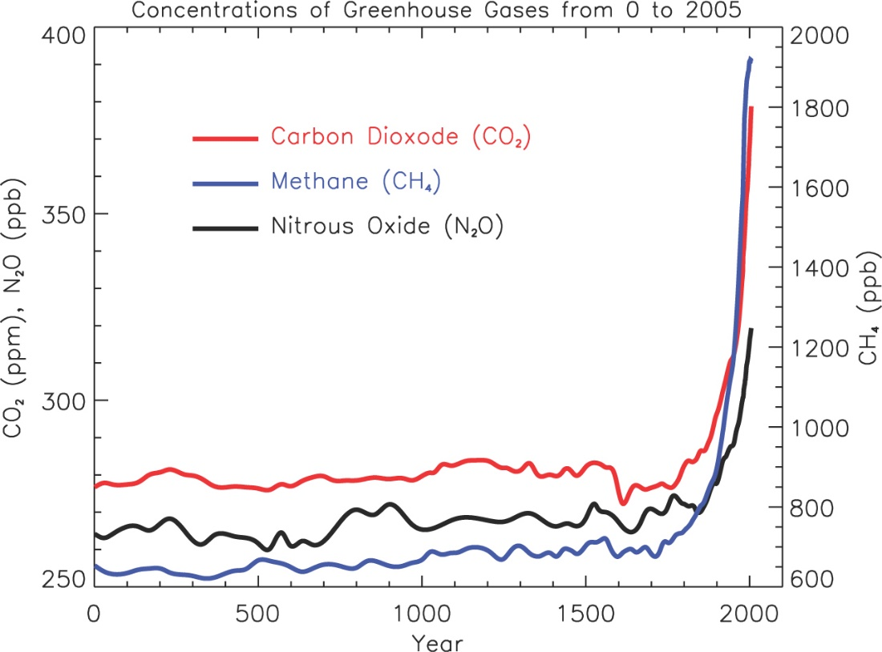
Figure 1. Atmospheric concentrations of greenhouse gases have been rising rapidly in recent years. Reprinted from Faq 2.1, Figure 1 of Solomon, S., D. Qin, M. Manning, Z. Chen, M. Marquis, K.B. Averyt, M. Tignor and H.L. Miller (eds.) Contribution of Working Group I to the Fourth Assessment Report of the Intergovernmental Panel on Climate Change, 2007.Cambridge University Press, Cambridge, United Kingdom and New York, NY, USA. Used with permission.
Major changes in climate that might result from such increased concentrations of greenhouse gases could of course have profound implications for agriculture, human health, natural resources, and a host of other areas of ecological and social importance. To anticipate these effects, we must first anticipate the details of projected changes in climate. For example, how much warming can be expected to occur over the next century? How would different social, economic, and technological developments affect greenhouse gas emissions and climate change? Would warming be truly global, or vary from location to location? Would warming occur mostly in summer (affecting the prevalence of heat wave, heat damage to crops, etc.), mostly in winter (potentially decreasing the severity of winters, affecting sea ice formation, etc.) or equally in both?

Since these questions concern the future, they cannot be answered directly by empirical observation- unless we are willing to wait decades for the answers. We have only one Earth, so we cannot directly perform experiments with the climate system (other than the one we are inadvertently performing). To make detailed predictions about the future, researchers therefore must rely on perturbing simulated Earths rather than the actual Earth. It would be impossible in a physical simulation (such as a giant globe) to capture the processes in the Earth’s complex systems in a realistic and meaningful way. Researchers therefore rely on computer simulations that mathematically represent the chemical, physical and biological complexities of global climate systems and how they inter-react and respond to changes in external conditions (such as increasing emissions of CO₂ from the burning of fossil fuels).

In practice, there are two major steps to predictions of the effects of future human activities on climate. The first is to predict the quantities of greenhouse gases, particulate matter, and other substances that will be emitted into the atmosphere. The second is to use these estimates of emissions as inputs into models that simulate global climate.

Future anthropogenic emissions of gases such as CO₂ will vary greatly depending on the rates of human population growth and industrialization and the development and spread of new technologies, such as alternatives to fossil fuels for energy generation. The climate change community has therefore developed a variety of different emissions “storylines” and scenarios that describe alternative versions of future social, economic, and technological changes (Table 1). Each scenario, with its different projections of social, economic and technological changes generates different predicted quantities of emissions and atmospheric concentrations of carbon dioxide (Figure 2) and other greenhouse gases.
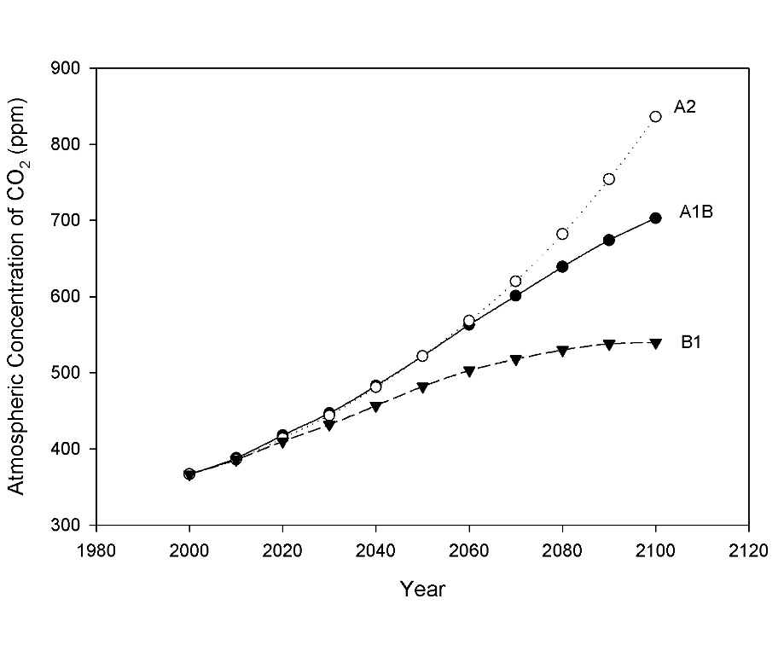

Figure 2. Projected atmospheric concentrations of CO₂ for the 21st century. Data is from the Bern-CC (reference model from Appendix II In: Climate Change 2001: The Scientific Basis. Contribution of Working Group I to the Third Assessment Report of the Intergovernmental Panel on Climate Change. Houghton, J.T.,Y. Ding, D.J. Griggs, M. Noguer, P.J. van der Linden, X. Dai, K. Maskell, and C.A. Johnson, eds. Cambridge University Press, Cambridge, United Kingdom and New York, NY, USA).

Table 1: Characteristics of Selected Emissions Scenarios. These scenarios represent alternative possibilities for future social and technological change as envisioned by a range of governmental and non-governmental analysts. Adapted from Nakicenovic, N. and R. Swart, eds. (2000). Special Report on Emissions Scenarios (Cambridge, U.K., Cambridge University Press).

Scenario characteristics | A1B | A2 | B1
Human Population growth | Low | high | low
Globalization, economic convergence among regions of the world | High | low | high
Increases in social and political emphasis on environmental sustainability | Low | Low | High
Economic growth | very high | medium | high
Land- use changes | Low | medium/high | high
Pace of technological changes in energy use | Rapid | slow | medium
Changes in energy use and production | rapid: changes in both energy production and use | slow: vary by region | medium: emphasis on efficiency of use and shift to lowered use of materials
Energy use | very high | high | low

Climate simulation models then are used to predict future climates under these different emissions scenarios. Typically, these models divide the surface of the Earth, the ocean and the atmosphere into large spatial cells (Figure 3). Each cell has specified physical properties; for example, a cell in the atmosphere will have a specified temperature, pressure, humidity, etc. In the model, time is simulated in steps; for each step the chemical and physical properties of each cell are updated as the cell receives radiation from the sun and Earth, exchanges energy and materials with adjacent cells, etc. One can use such models to predict changes in any of these physical and chemical parameters, in any location within the Earth-atmosphere system.

In these exercises, you will work with output from simulations of future climates performed using models developed by the Canadian Centre for Climate Modeling and Analysis (CCCma), focusing on near-surface air temperature, a concept familiar through daily weather reports. In doing so, you will develop increased understanding of how predictions of future climate are derived, as well as practicing skills in analysis and interpretation of large data sets.

INSTRUCTIONS
In these exercises, you will work with output from one set of climate models, created by the Canadian Centre for Climate Modeling and Analysis (CCCma), who have kindly made the results of a number of runs of their models available online. Information on the models can be found on the Models section of the CCCma website (http://www.cccma.ec.gc.ca). We will be using data from their third-generation (CGCM3) model. This is the latest model for which they have made available extensive climate predictions over nearly the entirety of the Earth’s surface. We will focus on one parameter, temperature above surface, defined as the air temperature 2 m above the Earth’s surface. This corresponds to the familiar air temperature reported in the daily weather report in newspapers and on TV.
The data you will examine is the mean temperature (°K) for each month over the 100 years (2001-2100), giving a total of 1200 values for the 1200 consecutive months. You are provided these data for the three scenarios described in Table 1 (A1B, A2, and B1) and for a fourth set of conditions representing “Committed” climate change. The “Committed” set of conditions assumes that the composition of the atmosphere remains unchanged at year 2001 values. Therefore, the only climate changes that will occur are those to which the climate system is already committed due to past changes in atmospheric concentrations. The Committed scenario is not intended as a realistic scenario. Instead, it serves as a control for comparison with the other scenarios. By comparing the results of a given scenario with the results under the Committed scenario, one can see how much additional climate change a scenario produces compared to what would be produced if alterations in climate forcing agents were to immediately stop.

For each scenario, we provide data for 19 grid cells in a continuous North-South transect through North America (Figure 3). I will assign you latitudes to work with.
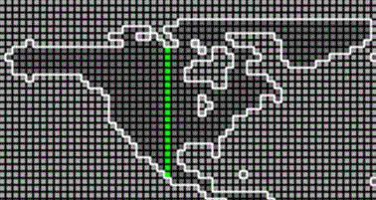
Figure 3. Location of the data transect through North America. Screenshot from Canadian Center for Modelling and Analysis website, http://www.cccma.ec.gc.ca/cgibin/data/cgcm3/cgcm3_a1#id1, November 11, 2010.

Pre-exercise: Detecting and interpreting trends

First, as a group, discuss the following questions to help you consider how you will organize and analyze your data.

- What would be the best graphical format for presenting the data to illustrate changes (if any) in temperature across the century?

- How should you organize and analyze the data to determine: 1) whether or not a meaningful trend exists, and 2) how much the temperature has changed (if at all) over the course of the century?

Exercise 1: Comparison of temperature trends among emissions scenarios

1. Examine the data spreadsheet. Notice the variables that are included, how the data is organized, and the time period it spans.

2. Make a graph showing how summer (July) temperature varies across the 100 years of this study. Begin with the Committed scenario. Only graph the data for your assigned latitude. You will want Year to be the x axis of the graph and Temp to be the y axis. Select these columns (but only for those rows in which the month is July). Use the graphing tools of Excel to create a scatterplot with these values; choose the plot that includes only data points and no connecting lines.

3. Label the axes appropriately, including units. Give the figure an appropriate, detailed title. Since the class will be creating a number of different figures, it will be important to have a title that distinguishes among them, including the range of years depicted, the dependent variable, the latitude, and which scenario was used.

4. Insert a trend line (linear regression), including the equation and the R² value. You can do this by clicking on one of the data points in the figure. This should select the entire series of data points. You can then choose add trend line from the Chart menu (the location of this command may vary with the version of Excel).

5. Note the slope from the trend line equation. Based on this analysis, explain in words how much July temperature changed per year over the time period analyzed.

____________________________________________________________________________________________________________________________________________________________________________________________________________________________________

6. Now, graph the remaining three scenarios for your specific latitude, and add the trend lines to each graph (you will have four total). Note the slope for each equation.

7. Change the scale for the x and y axes for each of your figures. You can do this by clicking on the axis in the finished figure, and then changing the scale values. Set the range of X and Y values for all figures so that they are the same for each figure. This allows for visual comparison of the regression lines.

8. Come together as a class so everyone can briefly share their findings.
- Are there any patterns as to which scenarios show changes in temperature across the century, or show the greatest change?

____________________________________________________________________________________________________________________________________________
- What might differences in projected climate change under these scenarios be due to?

____________________________________________________________________________________________________________________________________________

- What might differences among scenarios indicate about future climate change?

____________________________________________________________________________________________________________________________________________

Exercise 2: Comparison of temperature change across seasons
1. Repeat Exercise 1, using data from winter (January).

2. Come together as a class to share your findings.
- Does temperature change seem to be more pronounced in one season than in the other?

____________________________________________________________________________________________________________________________________________
- What implications might the seasonality of future climate change have for potential impacts (social, ecological, medical, etc.) of climate change?

____________________________________________________________________________________________________________________________________________

Exercise 3: Latitudinal Comparisons
1. As a class, devise an approach to share the details of your findings (i.e., the magnitude of temperature change over the century for each analysis you have performed).

2. Once everyone has access to all of the results, answer the following questions.
- What is the geographic pattern of temperature change? Was it greater at some latitudes than at others? Did it differ between arctic and tropical regions?

____________________________________________________________________________________________________________________________________________
- What implications might latitudinal patterns of climate change have for the impacts (social, ecological, medical, etc.) of future climate change?

____________________________________________________________________________________________________________________________________________

