**Global Climate Change and Phenology Part 0: EXCEL**

*Modified from an exercise written by Kellen Callinger and Kristen Genet. Used with permission.*

We will be working on a research project that will use publicly available data from Ohio to explore global climate change and its effects on local ecology. Much of the research project will rely on the ability to efficiently construct and interpret graphs. This will be done using computers rather than by hand. Specifically, you will be using Microsoft Excel, an extremely useful graphing tool. The following activity may be totally new to you, or it may just help dust off and refine some of your existing graphing skills.

*This portion is optional and will not be graded. You are free to ask questions about it!*

**Your task: MAKE GRAPHS!** The following information will walk you through the construction of two graphs using the provided set of data. We will use Excel – if you do not have Excel on your computer (or access to a computer that does), you have FREE access to Microsoft Office 365 here. Use the Excel file provided on this page in Blackboard called "practice data.xls"**.**

Most graphs can be easily created in Excel by going to the **Charts** option on the “Insert” tab toolbar.

**Graph A:** First, we’ll make scatterplots. Please watch the following video that demonstrates how to make a scatterplot in Excel: <https://www.youtube.com/watch?v=bYf6qO-iBW0>

Scatterplots are a commonly used Excel graphing format when neither variable is categorical, that is, both variables are sets of continuous numbers. For example, consider the data below comparing island size to the number of bird species present. **Enter the data as shown below in Excel and follow the instructions to create a scatterplot.** Highlight both columns of data without including the column headings and choose the “Insert” tab on the menu bar. Then select “Scatter” from **Charts** on the toolbar. Choose “Scatter with only markers.” Excel will automatically make the first column highlighted the **independent** variables (X-values) and the second column highlighted the **dependent** variables (Y-values). Keep this in mind when entering data into a worksheet. Your graph should look similar to the one below.

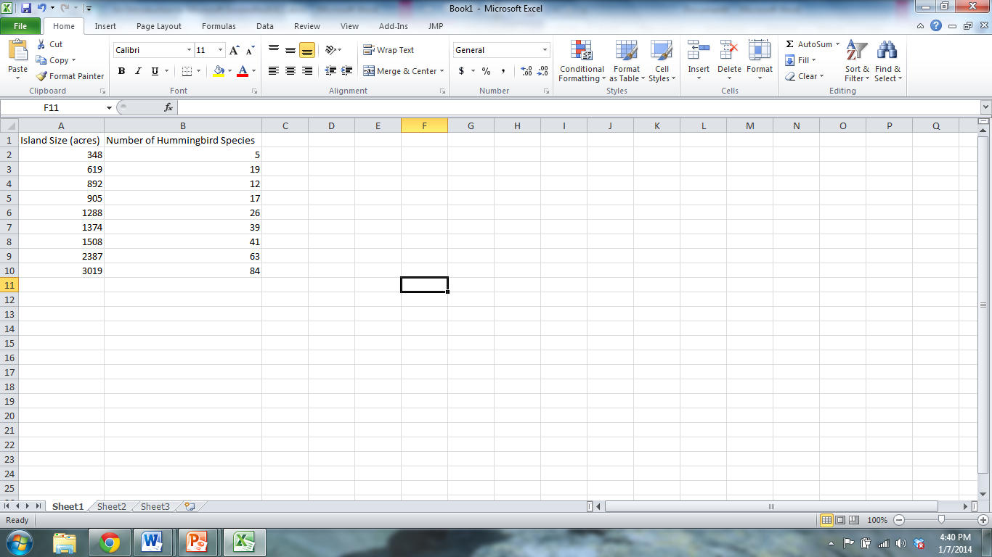

You can and should delete the legend on the graph (**Series1**) by just highlighting the box, right-clicking, and going to “Delete.”

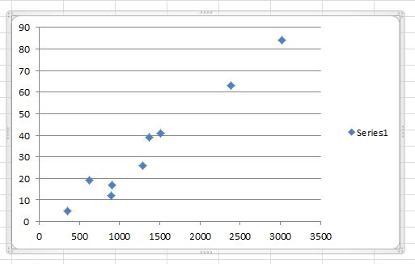

Chart and axes titles can be added by clicking on the “Layout” tab in the “Chart Tools” section of your upper tool bar. Click on the “Chart title” button and select where you’d like to place your title on the graph. Once you’ve selected your title placement, a new dialog box that says “Chart Title” will appear on your graph. Click on this dialog box and type in your chart title-titles should be descriptive of the data contained in the graph.

Now click on “Axis Titles” in the Layout tab of Chart Tools. You’ll be able to choose your “Primary Horizontal Axis Title” (your x-axis title) and your “Primary Vertical Axis Title” (your y-axis title) separately. As with the Chart Title, dialog boxes will appear on your graph and you can click them to add text for your axis labels. Axis labels should describe the data on each axis and the units in which it was measured.

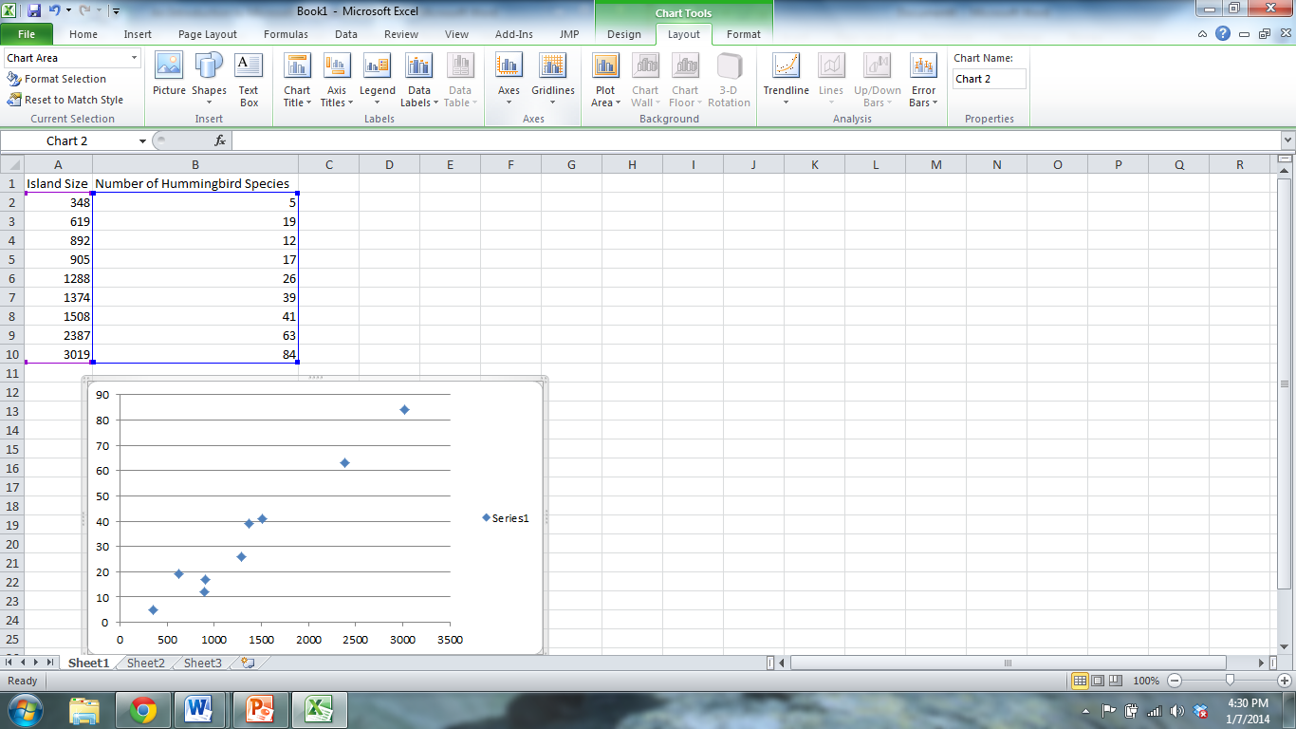

You can also change the style of the markers on the scatter plot by highlighting them, right-clicking, and going to “Format Data Series” and **Marker Options**.

Finally, scientists often use lines of best fit to determine the relationship between two variables. In our example, we want to understand how island size affects the number of hummingbird species that will be present on that island. You can add a line of best fit to the scatter plot by right-clicking on the points, going to “Add trendline,” and making sure that the linear option is selected (see below). Remember to check the “Display equation on chart box” to show the equation of the best fit line you’ve added. This is a step that was not included in the video tutorial, but please make sure to check the box to display the equation on your chart.

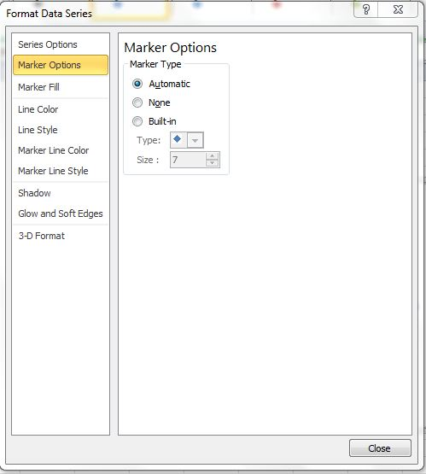

Once you’ve added your line of best fit and added the chart and axis titles, your scatterplot should look something like this. **Using the equation of our best fit line, we can see that an island will have roughly 0.03 more bird species per acre increase in size of the island (derived from the slope of the line).**

Remember (from a math class you have had, even if it was long ago) that the equation for a line is y = mx + b, where m = slope of the line, and b = y intercept (where line crosses the Y axis). We can use the slope to interpret the relationship between our independent and dependent variables. In this case, the slope is a positive number (and the line goes up from the lower left to upper right), so we can interpret the relationship between island size (our independent variable) and number of hummingbird species (our dependent variable) to be a positive relationship. In other words, as island size increases, the number of hummingbird species also increases. More specifically, as an island increases in size by 1 acre, it will increase number of hummingbird species by 0.03 (0.0296 rounds to 0.03).

*Hint for later: you will be asked in this lab to calculate how much temperature increased over a time period. The slope in this regression equation will be very useful for this calculation, as well as the amount of time that has gone by.*

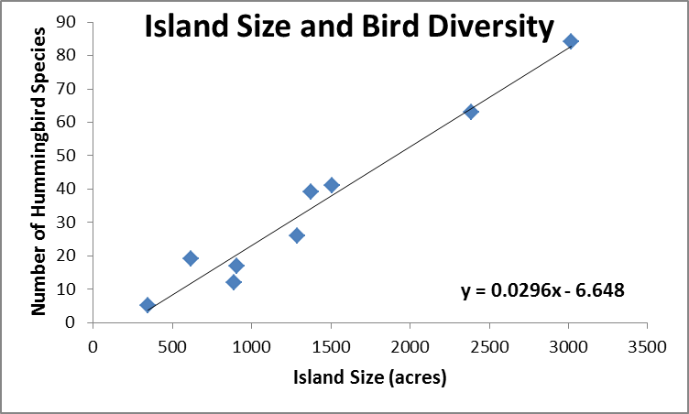

**Graph B:** The second type of graph we’ll explore is the **line graph.** Please watch the following video that demonstrates how to make a line graph in Excel: <https://www.youtube.com/watch?v=1mJoPI67ZuY>

Line graphs are useful for plotting changes in variables over time such as changes in CO2 concentrations, temperature, or ocean levels to name a few. We’ll be practicing making line graphs using the following data of yearly precipitation levels from 1990-2005**. Use the precipitation data in the Excel file to create a line graph found on the “precipitation data” tab.**

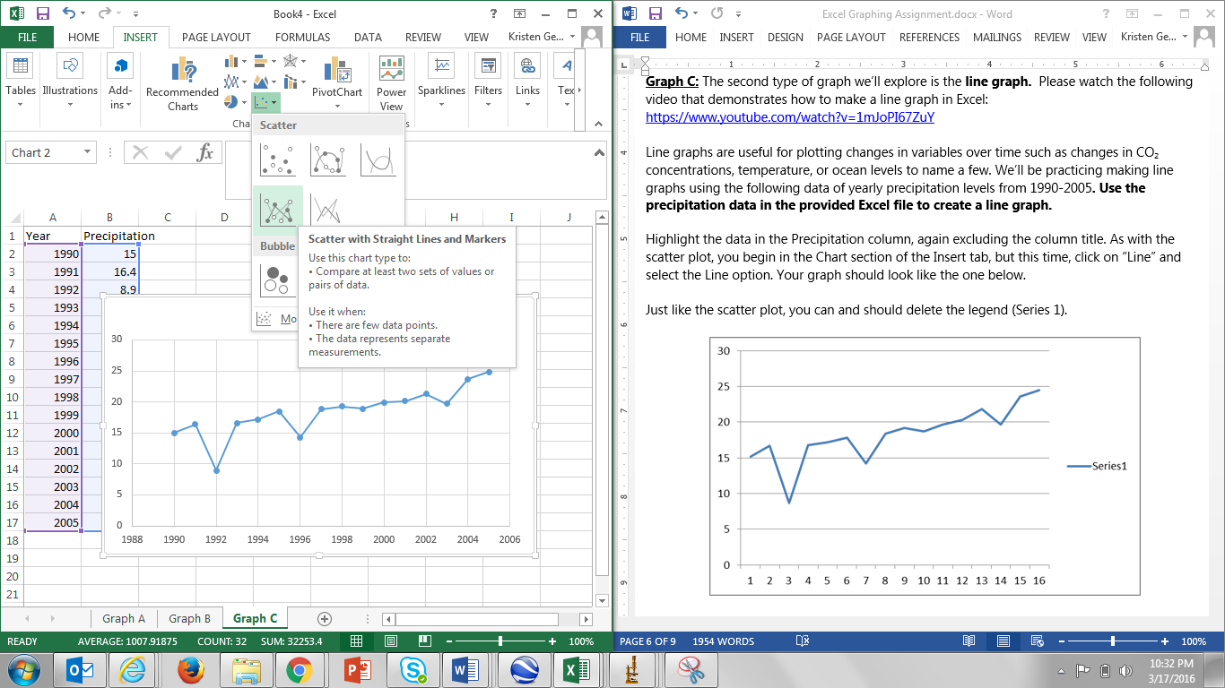Highlight the data in the Precipitation column, again excluding the column title. As with the scatter plot, you begin in the Chart section of the Insert tab, but this time, click on “Scatter” and select the “Scatter with Straight Lines and Markers” option. It may seem unusual to select the “Scatter with Lines” option instead of “Line Graph” option, but you can experiment and see what happens if you use the “Line Graph” option. For some reason, Excel does not graph the data correctly – but it DOES if you choose “Scatter with Lines.” ☺

Your graph should look like the one below.

Just like the scatter plot, you can and should delete the legend (Series 1).

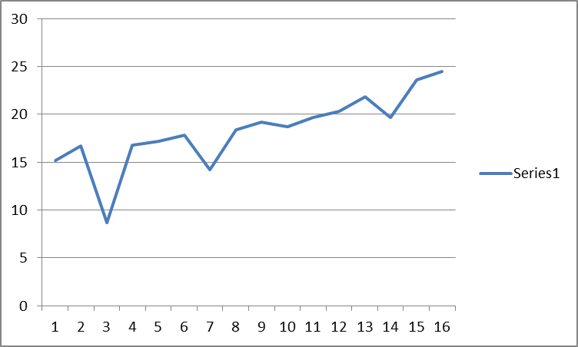

You’ll notice that the x-axis labels are incorrect in the graph above. Excel automatically labels each point starting with 1 and continuing on for each data point. However, we want the x-axis to be labeled in years, so we need to change the x-axis labels.

To change the x-axis labels, right click on your graph. A pop-up box will appear. Click the “Select Data…” option.

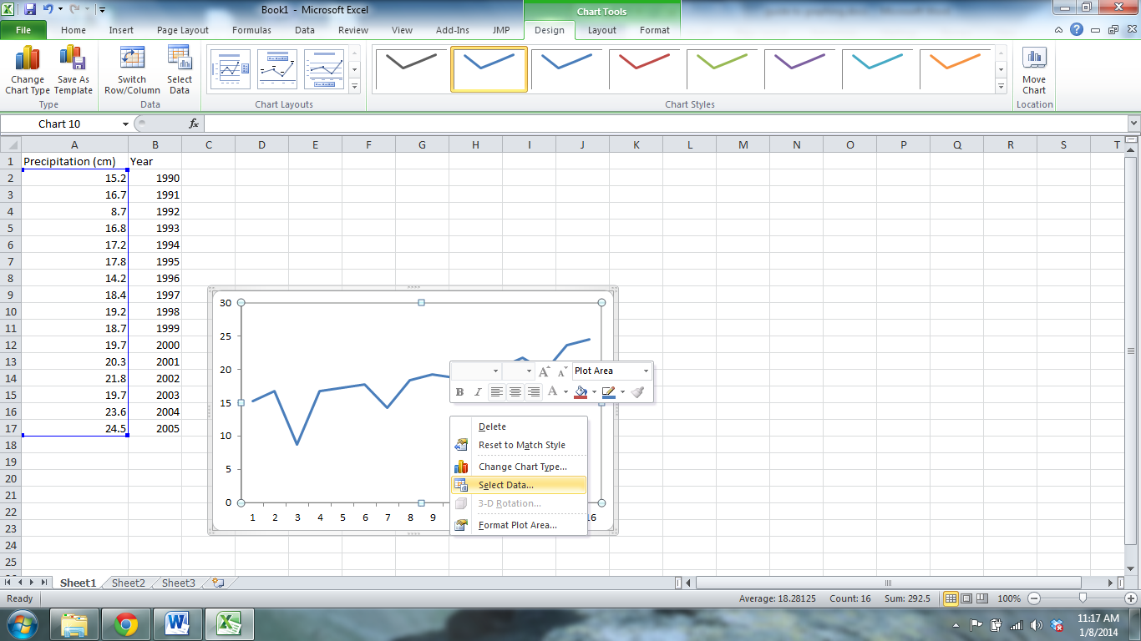

This will bring up the “Select Data Source” window. In this window, click the Edit button under “Horizontal (Category) Axis Labels.”

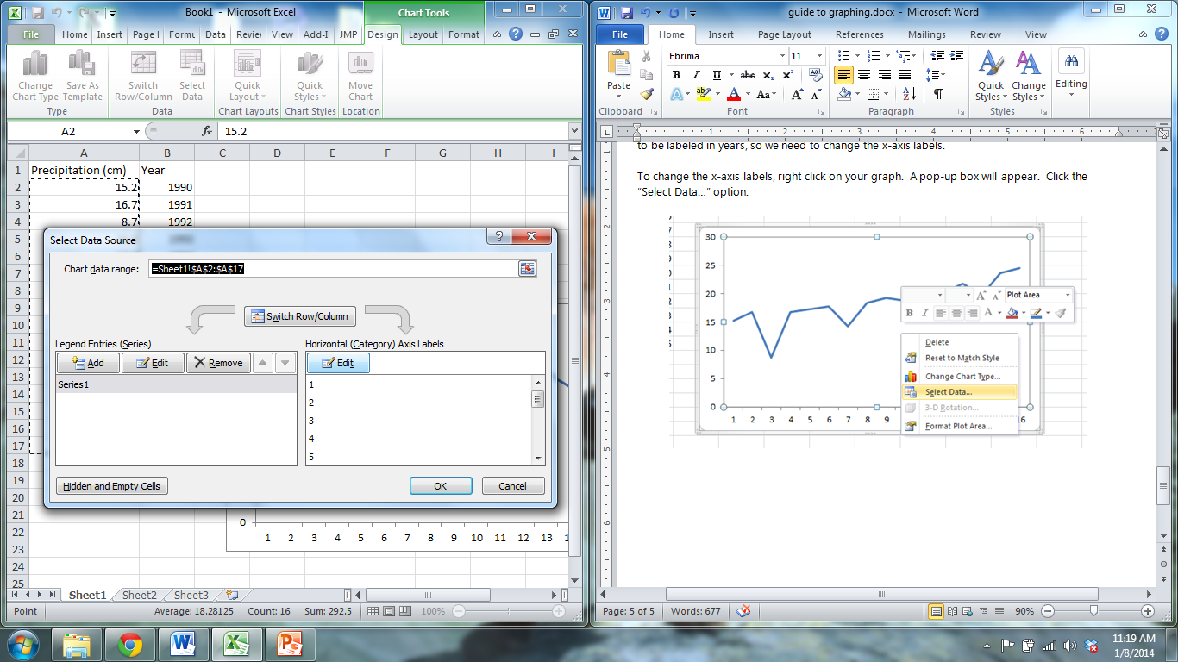

A pop-up window called “Axis Labels” will appear. Use your cursor to select the data under the Year column (surrounded by the dashed black line in the picture below). The cell identifications for this range of data will appear in the box called the Axis label range. Click OK and then click OK again in the Select Data Source window.

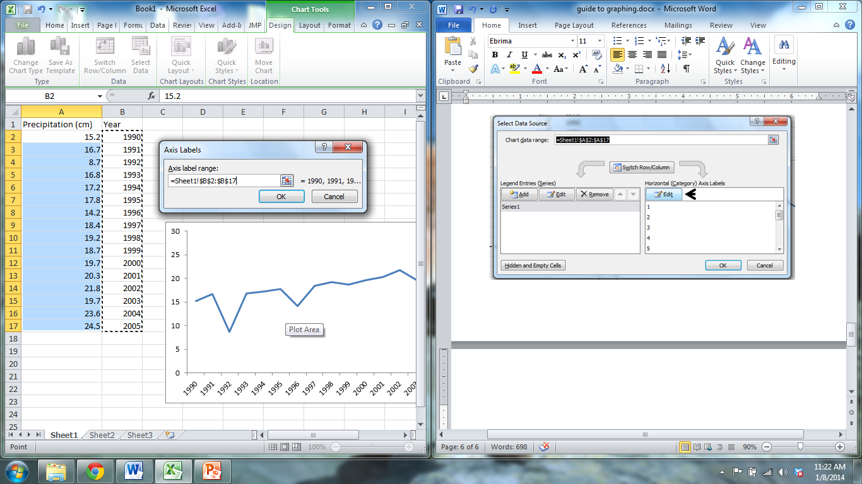

Your graph should now have the appropriate years on the x-axis.

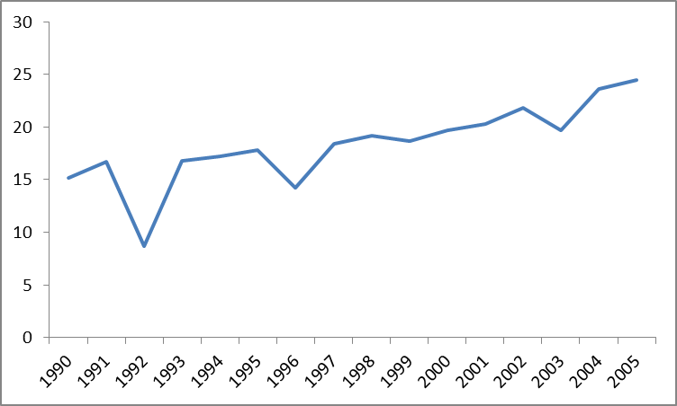

Add a chart title and axis titles in the same manner as the scatterplot.

As with the scatter plot, we can add a line of best fit to examine how precipitation levels have changed over time. The procedure for adding a trend line is the same as for the scatter plot. Once you’ve added axis labels and the line of best fit (don’t forget to include the equation for the line!), your graph will look like this:

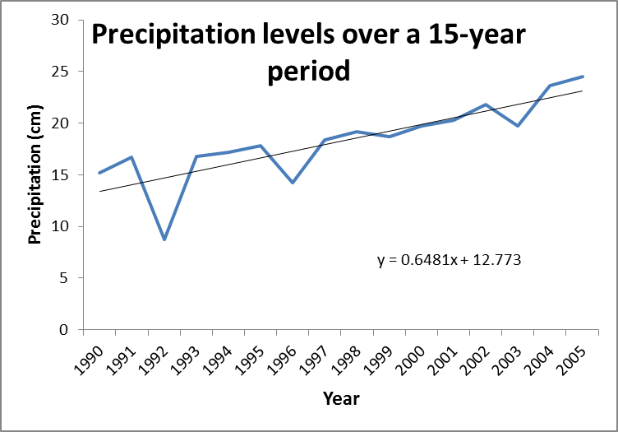

Key points to remember when you submit graphs for credit

* Have an informative title
* Make sure both the x and y axis are labeled, with units if appropriate
* Make sure the graph is clear and makes sense
* You must interpret the graph - what does the graph show? What does this mean? *One of the biggest mistakes students make is to make a graph and never think about what it shows. That is the point of making the graph - so that you can see if there is a trend.*