John M Moore: Lactase Persistence Module

BIO 201: Foundations of Cell Biology and Genetics

Materials Used

Lactase Persistence materials developed by the group

Materials already on the BioInteractive site

Also Used

DNA

DNA Replication

DNA Transcription

Translation

Quantitative Skill Focus

Data Collection

Graphing

Probability Analysis

Data Analysis

Hardy-Weinberg

Χ2 Analysis

Propositional Logic

Combinatorial Logic

Hypothetical Deductive Reasoning

**Implementation Dates**

In Class Sequencing of classroom & Lab:

Classroom: Black Txt.

Flipped or Homework: Green txt.

Lab: Red txt.

This is the flow of the Class where the lactase lab will be used. Notice that it begins at the end of DNA replication and before Central Dogma. After watching the Video of Lactase persistence, the first lab will determine their lactase persistence.

UNIT 3

24 Central Dogma: DNA The Chemical Structure

26 Central Dogma: DNA Replication Basic Structure & Advanced

Watch first five minutes of Got Lactase? The Co-evolution of Genes and Culture, www.hhmi.org/biointeractive/making-fittest-got-lactase-co-evolution-genes-and-culture

27 LAB PROJECT DAY ONE

28 Central Dogma Transcription

www.hhmi.org/biointeractive/dna-transcription-basic-detail

www.hhmi.org/biointeractive/dna-transcription-advanced-detail

31 Central Dogma Translation

www.hhmi.org/biointeractive/translation-advanced-detail

Nov. 02 Chapter 10 Gene

www.bozemanscience.com/031-gene-regulation

03 LAB PROJECT DAY TWO

www.hhmi.org/biointeractive/regulation-lactase-gene.

04 Gene Regulation

07 Mutation

www.hhmi.org/biointeractive/lactase-film-quiz

09 Personal Genetic Testing

10 LAB PROJECT DAY THREE

UNIT 4

11 Exam3

14 Cell Division/Cell Cycle

www.bozemanscience.com/028-cell-cycle-mitosis-and-meiosis

16 Mitosis and Apoptosis

17 LAB PROJECT DAY FOUR

18 Meiosis

21 Abnormal Cell Development

Read and Annotate Original Research Paper on Analysis of a SNP Linked to Lactase Persistence by Patrick J. Schultheis and Bethany V. Bowling

23 -27 Thanks giving Holiday

28 Genetics Mendel

www.bozemanscience.com/029-mendelian-genetics

30 Mendelian Inheritance

www.bozemanscience.com/hardy-weinberg-punnett-square

Got Lactase? The Co-evolution of Genes and Culture, http://www.hhmi.org/biointeractive/making-fittest-got-lactase-co-evolution-genes-and-culture

DEC 02 Class Project on Geographic Distribution of Lactase Persistence

05 Non-Mendelian & Human Genetics

www.bozemanscience.com/030-advanced-genetic

07 Pedigree Analysis

www.hhmi.org/biointeractive/classroom-activities-pedigree-analysis-activity

19 Review

12 - FINAL EXAM WEEK Comprehensive Exam

**SCIENCE OBJECTIVES**

Pre Lab Project Day One:

http://www.hhmi.org/biointeractive/lactase-film-quiz

Questions Arise in science for natural causes

Hypotheses are derived from existing knowledge to propose relationships within phenomenon

LAB PROJECT DAY ONE:

Development of General Hypotheses

Data Collection

Graphing

Literature Search

LAB PROJECT DAY TWO:

Learning lab protocols

Development of Explanatory Hypotheses

Development of Predictions

LAB PROJECT DAY THREE

Protocol testing of Predictions

Data Collections

Data Analysis

LAB PROJECT DAY FOUR

Protocol testing of Predictions

Data Collections

Data Analysis

Poster Development

POST PROJECT PRESENTATION

Poster Presentation

**LEARNING OBJECTIVES & OUTCOMES**

Pre Lab Project Day One:

www.hhmi.org/biointeractive/lactase-film-quiz

The student will identify areas of science and knowledge that relate to Lactase Persistence

The student will develop several questions that arose the background information.

The student can develop several hypotheses that come from this information that may explain the lactase persistence phenomenon

LAB PROJECT DAY ONE:

The student will conduct a Literature Search on Lactose Persistence

The student will collect data on lactase persistence

The student will conduct a graph of blood glucose level

The student will develop a General Hypothesis

LAB PROJECT DAY TWO:

The student will record the protocols on restriction enzymes and gel electrophoresis

The student will develop an explanatory hypotheses related to the restriction enzymes

The student will development as set of predictions based on the explanatory hypothesis

LAB PROJECT DAY THREE

The student will develop and record the protocol testing of predictions

The student will collect the data from the above protocols

The student will analyze the above data

LAB PROJECT DAY FOUR

The student will develop and record the protocol testing of predictions

The student will collect the data from the above protocols

The student will analyze the above data

The student will work with their lab partners to develop a Poster Presentation of the project

POST PROJECT PRESENTATION

Poster Presentation

2. Pedagogical techniques you used to facilitate the BioInteractive activities and reinforce the quantitative reasoning skill.

Films were used to help explain big pictures or provide understanding of scientific thought. Interactive modules were used to provide practice with data analysis and data collection

3. Did you make adaptations to the BioInteractive materials? If yes, please describe them here. If no, please indicate why.

Modules were adapted for each day depending on the flow of the unit and where the students questions directed the flow of understanding and application. Often they were used by student to gain understanding during the laboratory on what they were attempting to address in the lactase persistence study.

4. Did you use supplemental materials with this module, please describe them (e.g. where did you find them?).

I used some Bozemena Science materials to help provide a flipped aspect as well as a place for students to do online review. I also have a large file of exercises and learning modules from teaching that I can bring in to supplement ideas in teaching, such as problem sets and other short annimations.

5. What assessments did you use to measure student progress? Please either describe, attach, or provide a link here.

The exam covered understanding of the Central Dogma

The lactase-persistence was covered by a poster presentation of the lab group. It is attached.

Student evaluation of the project were positive and reflected that the activities help to excite them about their major and the process of science.

6. What would you do differently if you were to implement this module again?

Because our lab design is to reflect more of a research aspect, a couple other activities that were provided in the lab (e.g., DNA extraction from pancreas) will not be used. Although the students enjoy extracting it, it took of too much time for analysis in lab.

7. Overall, how would you describe your experience with the BioInteractive modules? Please provide any additional teacher notes here.

It was a good experience as I worked with a colleague (2nd year professor) and she added great insight for the students from a research module basis so that they could see how the process models research.

Pedagogical techniques you used to facilitate the BioInteractive activities and reinforce the quantitative reasoning skill.

3. Did you make adaptations to the BioInteractive materials? If yes, please describe them here. If no, please indicate why.

4. Did you use supplemental materials with this module, please describe them (e.g. where did you find them?).

5. What assessments did you use to measure student progress? Please either describe, attach, or provide a link here.

6. What would you do differently if you were to implement this module again?

7. Overall, how would you describe your experience with the BioInteractive modules? Please provide any additional teacher notes here.

**Lab Day 1: Lactose Persistence Protocol**

**Prelab:**

**Refrain from eating any sugar-base foods 3 hours prior to the lab.**

**Caution! You are no doubt aware of the different kinds of infectious agents (e.g. hepatitis virus and HIV) that can be transmitted in the blood. And, although I’m sure that *your* blood is perfectly safe, I’m not so sure about that of your neighbors. Therefore, you must handle only your own blood and follow carefully the instructor’s directions for drawing your blood and disposing of all materials that come in contact with blood.**

**Prep:**

**Watch video on Lactose Persistence**

**View blood glucose testing from Mayo Clinic:**

<http://www.mayoclinic.org/diseases-conditions/diabetes/multimedia/blood-sugar/sls-20076114>

**Materials**

**Alcohol pads Blood Glucose Test Strip**

**Sterile lancets or autolet self pokers tap water**

**Glucose Monitor Milk/Lactose Sugar solution**

**Latex gloves Tray with 5% bleach solution**

**Protocol for glucose test:**

**Wash hands with soap and water. Dry**

**Use an alcohol pad to clean the area to be lanced**

**Place test strip and fully insert into monitor / code monitor if needed**

**Use lancing divice to lance area**

**Touch blood drop to test strip**

**Record glucose level**

**Dispose of lance and contaminated materials into plastic container**

**Determination of Lactose Persistence**

**Base Line Test:**

**Perform the glucose test above:**

**Record your baseline**

**Lactose ingestion:**

**Drink one liter of whole milk/lactose solution as quickly as possible.**

**Glucose Level:**

**Perform a glucose test at 20 minute intervals for 1 hour.**

**Record your data**

**Graph your glucose levels.**

**Record if Lactose Persistent or Intolerant**

**Compare LP results to Population Group Data**

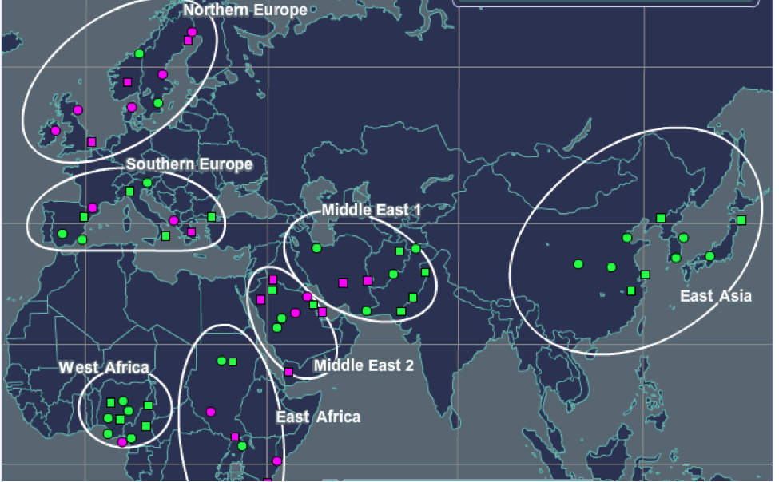

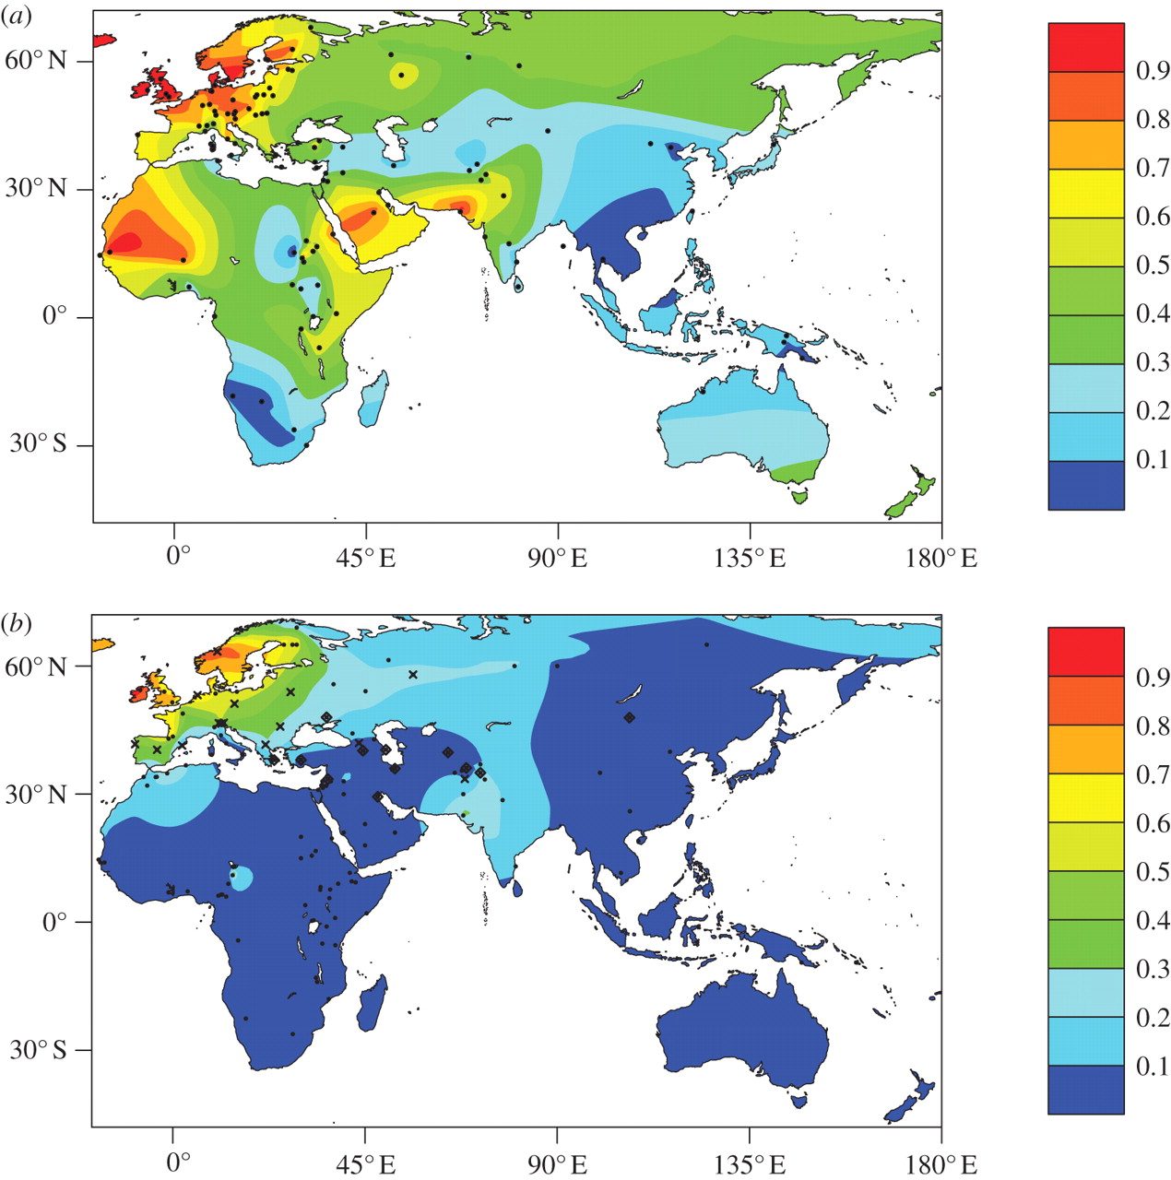

Fraction of adults with LP trait

**Using the cards determine the potential lactase persistence for each group and see if it corresponds with the above data.**

**DNA ISOLATION**

**DEOXYRIBOSE NUCLEIC ACID & INITIAL ISOLATION**

**In the eukaryotic cell the DNA is found in the nucleus complex, combined with a variety of proteins. As such, the DNA molecules are well protected and tightly packaged.**

**Initial Prep of Tissue:**

**Protocol: isolation of DNA**

#### **I. The Nuclear Suspension Examination and prep.**

1. **Obtain a vial and mark two lines, one 8 mm from the bottom and another 4 mm above that.**
2. **Add the nuclear suspension up to the first mark.**
3. **Make an wetmount of the suspension using a drop of aceto-orcein**
4. **Observe under low to Oil-immersion power.**

**II. Nuclear Lysis**

**EDTA weakens the nuclear envelope by removing calcium and magnesium ions from the solution and the envelope.**

**Membrane Prep**

1. **Add EDTA solution up to the second mark.**
2. **Mix GENTLY by rolling the vial between your hands.**
3. **Let stand for 5 minutes.**

**Nuclear Membrane Disassociation**

1. **Add twelve drops of 20% SDS solution slowly and mix gently again by rolling between your hands.**

**SDS (sodium dodecyl sulfate) is a detergent used a great deal in cell biology to dissolve membranes.**

1. **Let stand for one minute and watch for a change in appearance. There should be a clearing of the vial’s contents. If not, mix a little bit and/or add a few more drops of SDS. The DNA has now unraveled and is extremely fragile, so be GENTLE!**
2. **Place a drop of the suspension (not any of the material settled on the bottom) on a slide and stain with aceto-orcein. View under the microscope.**
3. **What you see is chromatin that is freed from the nuclei.**

**III. Purification of the DNA**

**Add twelve drops of salt solution, drop-by-drop. Chromatin is a mixture of DNA and protein. Salt will precipitate the protein out of solution leaving the DNA in solution. Should you see any white precipitate dropping in the solution it is salt and proteins.**

**IV. DNA Precipitation of DNA**

1. **While sitting down, tilt the vial at a 45° angle and slowly pipette 4 ml of cold Isopropyl down the side of the vial.**
2. **The isopropyl should be visible as a layer on top of the salt and DNA solution. Do not mix these two solutions.**

**Spooling of DNA for collection**

1. **Slowly twirl a glass-stirring rod across the interface between the two solutions. Think of lifting the DNA up from the lower aqueous phase up into the upper isopropyl phase, while simultaneously wrapping the DNA up on the stirring rod like very fragile spaghetti.**
2. **Be extremely careful not to fragment the DNA through over zealous action.**
3. **Slip the wound DNA off into a microfuge tube.**
4. **Continue to twirl out more of the DNA strands**
5. **Fill the microfuge tube with cold isopropyl and keep as a souvenir.**

**Learning Reflection**

**What are hypotheses?**

**What were areas of knowledge that pertained to this issue that were drawn upon to develop these hypotheses?**

**What is advantageous for mammal not to be lactase persistent?**

**Why is is advantageous for humans to be lactase persistent?**

**When is it thought that lactase persistence evolved?**

Lab Day 2: Restriction Digestion Protocol

Restriction Endonuclease Digestion of Lambda Phage DNA

Procedure: Restriction Digest

1. Label four 1.5 ml microcentrifuge tubes with the following letters to represent the restriction endonucleases used in each

B = *Bam*HI

E = *Eco*RI

H = *Hind*III

0 = no enzyme

1. Add the reagents to each tube in order according to the following table.
2. Use a fresh tip for each new reagent.
3. Keep your tubes and the reagents on ice.

|  |  |  |  |  |  |  |
| --- | --- | --- | --- | --- | --- | --- |
| Tube | λ DNA | Buffer | *Bam*HI | *Eco*RI | *Hind*III | H2O |
| B | 4 μl | 5 μl | 1 μl | ------ | ------ | ------ |
| E | 4 μl | 5 μl | ------ | 1 μl | ------ | ------ |
| H | 4 μl | 5 μl | ------ | ------ | 1 μl | ------ |
| 0 | 4 μl | 5 μl | ------ | ------ | ------ | 1 μl |

1. Close the tube tops, place them in the microcentrifuge in a balanced configuration with the hinge sides up, and briefly microcentrifuge to start the restriction of the DNA.
2. Place tubes in your floating tray and place in a 37°C water bath for at least 45 minutes. Remove when you are done with the first part of Lab #13 and freeze for next week.

II. Cast an 0.8% Agarose Gel to run the lambda digests.

Gel-Casting Tray Set-up

1. Seal the end of the gel-casting tray by raising the end baffles and tightening the screws. Insert the smaller well forming comb in the far end slot of the tray. Place the tray out of the way on the lab bench so it will not be disturbed once the gel is poured.

Agarose Gel Pre

1. Prepare the agarose solution by heating 50 ml TBE buffer and 0.4g agarose in a 200 ml flask with an inverted 50 ml flask as a lid. Heat in the microwave on high in 15-second increments, gently swirling the flask in between heating. BE CAREFUL! The hot agarose solution may boil over if heated for too long.
2. Let the agarose cool in the flask until you can hold the bottom if the flask in your palm with a minimum of discomfort. Have the instructor add 1 μl of 10 mg/ml gel red then mix carefully by swirling.

Pouring the Gel

1. Carefully pour the agarose solution into the corner of the casting tray away from the comb to a depth of about 5 mm. The agarose solution should cover only about one-third the height of the comb teeth. Use a pipette tip to move any large bubbles or solid debris to the edge of the agarose while it is still liquid.
2. After about 10 minutes, the agarose should gel, becoming cloudy as it sets up.

Setting the Gel into the Electrophoresis Box.

1. When the gel has set, carefully remove the comb using both hands, thus creating the wells but without ripping them. Lower the baffles at the ends of the casting tray and tighten them in the down position.
2. Place the tray on the platform of the gel running box so that the wells are closest to the negative (black) electrode.
3. Fill the box with enough TBE buffer so that the gel surface is covered by 3 – 4 mm of the TBE.
4. If dimples exist around the wells, add a little more buffer.

III. Sample Preparation, Gel Loading, and Running the Gels

A. Sample preparation

1. Obtain your group’s four λ-DNA digest tubes kept frozen from last week.
2. Add 1 μl of blue loading dye to each tube. Microfuge for a few seconds.
3. Obtain your individual PCR sample (~20 μl) to which the loading dye has already been added.

B. Gel Loading

* 1. Practice Loading in the Agar Plates.
  2. The group’s four λ-DNA digest samples will be loaded into the 0.8% agarose gel you just prepared. Align the the samples in a B, E, H, O order. Use a P10 micropipettor to load 10 μl of each of your group’s four λ-DNA digests to the gel according to the pattern you have established.

3. To load samples into the wells:

1. Use a fresh tip for each sample.
2. Steady the pipette by using two hands.
3. Follow the sample gel below
4. Insert the tip with your loaded sample into the solution, directly over the well. Do not stick the tip into the well, but hold it steady right above the well.
5. Slowly press the plunger to dispense your sample. The loading dye is denser than the buffer, so your sample will sink to the bottom of the well. Do not release the plunger until you pull the tip out of the buffer solution. Otherwise you will suck your sample back up. Also avoid blowing bubbles as you are loading, as they will displace your sample up into the buffer.

C. Running the Gels

* + - * 1. Close the top of the box, and connect the electrical leads to a power supply, anode to anode (red to red) and cathode to cathode (black to black). Make sure the cords are connected to the same channel of the power supply.
        2. Turn the power supply on and set to 170 V for the lambda digest gel. PRESS THE RUN BUTTON. Bubbles should rise from the electrodes as the current flows through the gels. If no current is detected, check the electrical connections.
        3. Run the lambda digest gel for 30 minutes, and the PCR gel for about 5-8 minutes. Good separation will have occurred when the bromophenol blue band has moved 4-6 cm from the wells. If time permits, electrophorese until the bromophenol blue band nears the end of the gel. Stop before this band runs off the end of the gel.
        4. Turn off the power supply and remove the top of the box.
        5. Carefully remove the casting tray from the electrophoresis box and dry off the bottom of the tray. DO NOT remove the gel from the tray. You’re your gel photographed.

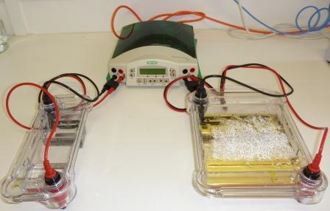



This is a picture of a successful digest of lambda phage DNA by restriction endonucleases. From the left the lanes are the lambda DNA fragment patterns from digestion with *Bam* H1, *Eco*R1, *Hind*III, and the single band of undigested lambda DNA. Compare this with your own group’s results.

**Experiments in Human Population Genetics**

**Using a Single Nucleotide Polymorphism (SNP) to examine Lactose Persistence of both the European and African adaptations**

**A. Introduction**

**DNA Extraction Protocol:**

**B. Materials**

**Sterile 0.9% NaCl solution (10 ml in sterile 15 ml culture tubes)**

**10% Chelex (~700 μl, in a microfuge tube)**

**PCR reaction mix 1.5 ml microfuge tubes**

**Micropipettors and tips 0.2 ml PCR tubes**

**C. Protocol—*Isolation of cheek cell DNA***

**1. Clearly label your 15 ml culture tube (which contains 10 ml of sterile saline) with your number assigned to you by your instructor.**

**2. Pour all of the saline solution into your mouth, and vigorously swish for 30 seconds. Be sure to save the empty 15 ml culture tube for the next step!**

**3. Expel the saline solution into a paper cup. Then carefully pour the contents of the cup back into the 15 ml culture tube. Recap the tube and then centrifuge for 20 minutes at 1000 x *g* in the tabletop centrifuge. This will pellet the cheek cells, food, etc. at the bottom of the tube.**

**4. Very carefully, so as not to disturb the cell pellet, pour off as much as the supernatant as possible (discard). Then place the tube containing the cheek cell pellet on ice.**

**5. Vortex or resuspend the microfuge tube containing the 10% Chelex, then quickly, transfer 700 μl the solution into the 15 ml culture tube.**

**6. Resuspend the cheek cells in the Chelex solution by vortexing. Make sure that no visible clumps of cells remain.**

**7. Transfer 500 μl of the resuspended cell/Chelex sample to a clean 1.5 ml microfuge tube. Be sure that your tube is clearly labeled with your number!**

**8. Place your 1.5 ml microfuge tube in a boiling water bath for 10 minutes.**

**9. After the 10 minutes are up, remove your tube from the boiling water. Cool the tube on ice for approximately 1 minute.**

**10. Spin your sample in the microcentrifuge for 30 seconds at maximum speed; this will pellet the Chelex beads.**

**11. Carefully transfer 200 μl of the supernatant to a clean, numbered 1.5 ml microfuge tube, and store the tube on ice. Be sure to avoid transferring any of the Chelex beads!**

**Learning Reflection**

**What is a general hypothesis, explanatory hypothesis and a prediction?**

**How do these three concepts relate?**

**How does the restriction ezmyes help you test your prediction?**

**Lab 3 & 4 Protocol—*PCR amplification, gel electrophoresis and DNA sequencing***

**1. Transfer 5 μl of your cheek DNA sample to a labeled 0.2 ml PCR tube. Add 45 μl of a PCR reaction mix (which contains a buffer, a mix of the four deoxynucleotides, the two PCR primers, and the DNA polymerase). The samples will then be subjected to PCR using the thermal cycler (see pp. 71-72 for cycling profile).**

**The following primer set was used in this experiment:**

**Forward primer sequence:**

**50-GAGTGTAGTTGTTAGACGGAGAC-30**

**PCR Reverse primer sequence:**

**50-GGAGGAGAGTTCCTTTGAGT*CCAG-30**

**qPCR primer sequence for T genotype:**

**50-AGGCCAGGGACTACATTATC-30**

**qPCR primer sequence for C genotype:**

**50-AGGCCAGGGGCTACATTATC-30**

**Protocol—*Restriction digest and gel electrophoresis***

**After the PCR has been done, a portion of each PCR reaction will be digested with the restriction enzyme *Hae*III. The sizes of undigested and digested PCR products will then be determined by agarose gel electrophoresis (think back to BIO 101 lab when you did the DNA gels).**

**1. Label a 1.5 ml microfuge tube with your assigned number and the letter “U”. Transfer 10 μl of your PCR reaction to this tube (this represents the uncut DNA).**

**2. Carefully transfer 1 μl of 10 U/μl *Hae*III to the PCR product remaining in the PCR tube. Place the tube in the thermal cycler, and use it to incubate the sample at 37°C for 30-60 minutes.**

**3. During the restriction digestion, prepare a 2% agarose TBE gel. Add 40 ml of 1X TBE electrophoresis buffer to a 150 ml beaker. Place a magnetic stir bar in the beaker, get it spinning, and then add 0.8 g of agarose powder. Disburse the agarose powder then remove the stir bar and cover the beaker with plastic wrap (in which you’ve poked several holes). Weigh the beaker, and the microwave it until the agarose is completely dissolved (follow the instructions from your instructor). Then reweigh the beaker, adding back hot water until the original weight is achieved. After the agarose solution has cooled to a “holdable” temperature, pour it into the casting tray.**

**4. After the gel is set, place it in the gel box and cover it with ~250 ml of 1X TBE. Load 10 μl of uncut sample and 16 μl of digested sample into consecutive wells. A separate well should contain 10 μl of DNA size markers (e.g. 1 Kb Plus markers from Invitrogen). Run the gel at 130 V for ~30-40 min. After the electrophoresis is completed, visualize the DNA fragments by staining with ethidium bromide (10 min., followed by a 10 min. destain) and photographing on a UV transilluminator (302 nm). (Note: the 44 bp restriction fragment will probably appear much fainter than the larger fragments.) Tape a copy of the gel image into your lab notebook.**

**D. Questions (to be answered in the Conclusions section of this experiment)**

**1. How many bands are visible in your sample? How many bands would you expect? What does it tell you if you only see one band?**

**2. Look carefully at the class PCR data. Do you feel that by using this PCR protocol you could *definitively* establish guilt in a crime or a paternity relationship? Explain.**

**Protocol—*PCR amplification and gel electrophoresis* Learning Reflection**

**If you were going to test for a known gene mutation.**

**In general, please explain the overall protocols of what you would have to do to accomplish the test.**

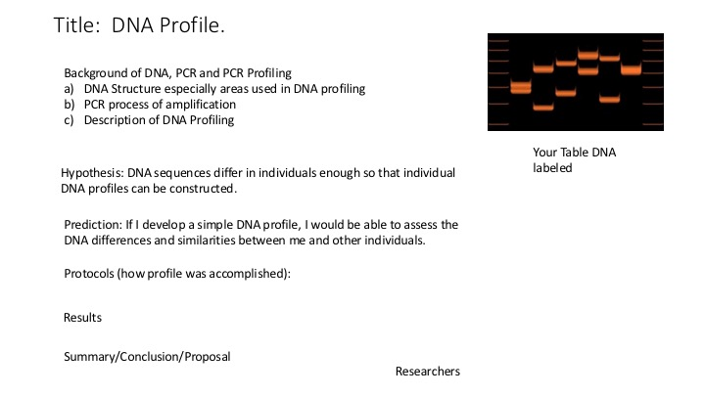**Lab Poster:**

