Got Lactase? Blood Glucose Data Analysis

Introduction

“Mother’s milk” is packed with the proteins, fats, and carbohydrates that support the growth, development, and survival of baby mammals. The sugar lactose is the main carbohydrate in milk. Lactose can be cleaved into two simpler sugars, glucose and galactose, by lactase, an enzyme produced in the small intestine. The two smaller sugars are readily absorbed though the intestinal wall into the bloodstream for delivery to the cells of the body, where they are used for energy.

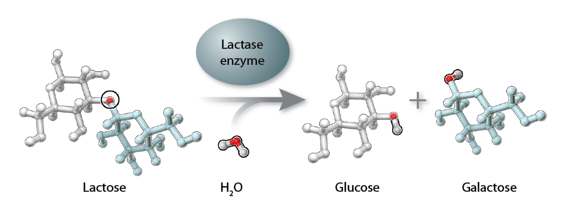

After infant mammals are weaned from their mother’s milk, lactase production shuts down, presumably because it is no longer needed. This condition is called lactase nonpersistence—meaning that production of the lactase enzyme does not *persist* into adulthood. The general condition for mammals is not to consume milk after weaning and to be lactase nonpersistent. Some populations of humans are unusual in that adults continue to consume milk from other mammals, such as cows.

If a person who is lactase nonpersistent drinks milk, undigested lactose passes from the small intestine to the large intestine, where it is fermented by bacteria. Fermentation produces various gases in the large intestine, which can cause abdominal pain, bloating, flatulence, and diarrhea—all symptoms of lactose intolerance. Worldwide, most adults are lactose intolerant, although some people may not know it because their symptoms are mild. Only a minority of human adults (about 35% of the global human population) continues to produce lactase into adulthood and can drink milk without any problems. These individuals are said to be lactase persistent or lactose tolerant.

There are several ways to test whether someone is lactase persistent. In the short film*, Got Lactase? The Co-evolution of Genes and Culture*, the narrator, Dr. Spencer Wells, takes a blood glucose test to deduce his lactase status. In this activity you will examine the results of blood glucose tests conducted on six different adults to determine who is lactase persistent (lactose tolerant) or lactase nonpersistent (lactose intolerant).

Procedure

1. Examine the data in the table below. It shows the blood glucose levels of six individuals tested in Dr. Sarah Tishkoff’s laboratory. After baseline (i.e., time 0 minutes) blood glucose levels were measured and recorded, each person drank a liter of milk. Blood glucose levels were again measured at 15, 30, 45, and 60 minutes after drinking the milk. Glucose levels were measured using glucose strips and a glucose reader similar to the one Dr. Wells used in the film.

|  |  |  |  |  |  |
| --- | --- | --- | --- | --- | --- |
|  | Blood Glucose (mg/dL) | | | | |
| Individual | 0 minutes | 15 minutes | 30 minutes | 45 minutes | 60 minutes |
| Spencer Wells | 117 | 128 | 146 | 160 | 152 |
| Peter | 97 | 111 | 135 | 154 | 143 |
| Rachel | 96 | 99 | 105 | 101 | 98 |
| Katherine | 95 | 97 | 99 | 101 | 102 |
| Sarah | 108 | 116 | 129 | 141 | 139 |
| Michael | 94 | 109 | 128 | 143 | 140 |
| Arthur | 97 | 96 | 94 | 83 | 88 |

2. Plot the results from the six individuals in the graph below. The graph already includes Dr. Wells’ blood glucose test results. Make sure to include a legend for your graph.

3. After graphing the data, answer the questions below.

QUESTIONS

1. Why is measuring blood glucose levels an indicator of someone’s lactase activity?

____________________________________________________________________________________________________________________________________________________________________________________________________________________________________________________________________________________________________________

2. Divide these individuals into two groups (A and B), based on their blood glucose test results. Write the names of the individuals in each group, including Dr. Spencer Wells.

Group A:

Group B:

3. Explain your rationale for dividing the individuals into these two groups using data to support your answer.

____________________________________________________________________________________________________________________________________________________________________________________________________________________________________________________________________________________________________________

4. Based on these data, do you predict that individuals in Group A are lactase persistent or nonpersistent? Describe the evidence that supports this claim.

____________________________________________________________________________________________________________________________________________________________________________________________________________________________________________________________________________________________________________

5. Based on these data, do you predict that individuals in Group B are lactase persistent or nonpersistent? Describe the evidence that supports this claim.

____________________________________________________________________________________________________________________________________________________________________________________________________________________________________________________________________________________________________________

6. If you performed the same blood glucose test on a group of people who are from the Maasai population in Kenya, predict whether their results would be more like those of Group A or Group B. Explain your prediction.

(Hint: Remember from the film that the Maasai people are pastoralists.)

____________________________________________________________________________________________________________________________________________________________________________________________________________________________________________________________________________________________________________

7. A person taking a blood glucose test is usually told to fast prior to the test. Why do you think that might be necessary?

____________________________________________________________________________________________________________________________________________________________________________________________________________________________________________________________________________________________________________

Extension Activity

Another common test used to determine whether a person is lactase persistent is the hydrogen breath test. This test measures the amount of hydrogen in a person’s breath. As you read in the introduction, undigested lactose is fermented by bacteria in the large intestine, producing several gases, including hydrogen. These gases exit the body through the anus; they can also be absorbed into the blood, circulated to the lungs, and eliminated through the breath.

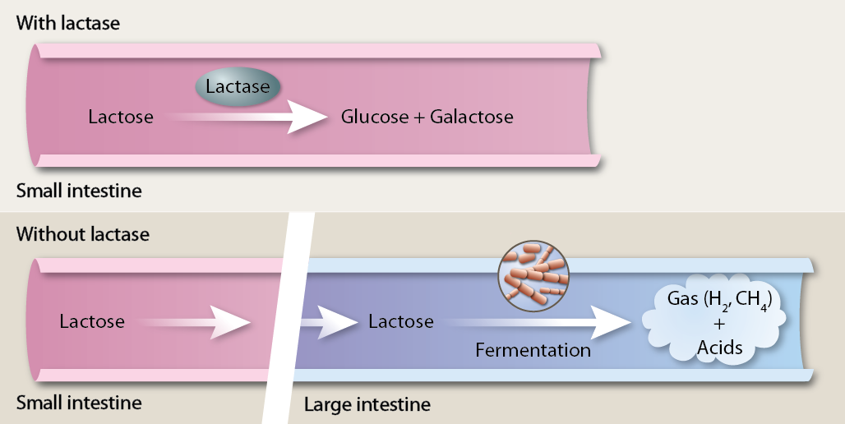

Making connections

1. Review the illustrations above, which describe the fermentation of lactose in the large intestine of a patient who is not lactase persistent. Then answer the following questions:
2. Why does fermentation occur in the large intestine and not the small intestine?
3. Explain the role of the brush border (microvilli) of the small intestine in digesting lactose in a person who is not lactose intolerant.
4. Explain how the creation of hydrogen gas leads to bloating.
5. In the space below, explain in a short paragraph, or diagram, how the hydrogen gas will move from the large intestine to the lungs so that it can be exhaled. Be sure to include the role of the blood
6. If a large amounts of lactose are consumed, undigested lactose also builds up in the large intestine leading to other recognizable side effects of lactase-deficient patients, such as diarrhea. In the space below, explain how the unabsorbed lactose pull fluid into the large intestine. Be sure to include the following terms in your answer: osmosis and osmolality (note: use your textbook to look up the definition of these terms).

PROCEDURE

1. Review the data in the following table. It shows the hydrogen breath levels of four individuals tested for lactase persistence. Time 0 represents the time before drinking milk and the other times are times after drinking milk.

|  |  |  |  |  |  |
| --- | --- | --- | --- | --- | --- |
|  | Hydrogen Breath Levels (ppm) | | | | |
| Individuals | 0 minutes | 30 minutes | 60 minutes | 90 minutes | 120 minutes |
| Lisa | 5 | 6 | 9 | 8 | 5 |
| Dan | 4 | 9 | 8 | 29 | 35 |
| Cindy | 6 | 8 | 10 | 31 | 32 |
| Brian | 4 | 7 | 6 | 9 | 6 |

QUESTIONS

1. Which individuals appear to be lactase persistent? Use data to support your answer.

____________________________________________________________________________________________________________________________________________________________________________________________________________________________________________________________________________________________________________

2. Which individuals appear to be lactase nonpersistent? Use data to support your answer.

____________________________________________________________________________________________________________________________________________________________________________________________________________________________________________________________________________________________________________

3. Can you think of another type of test you might do to determine a person’s lactase status? Describe in one to two sentences.

___________________________________________________________________________________________________________________________________________________________________________________________________________________________________________________________________________________________________________