Avery Boys and Girls STEM Club Project Competition
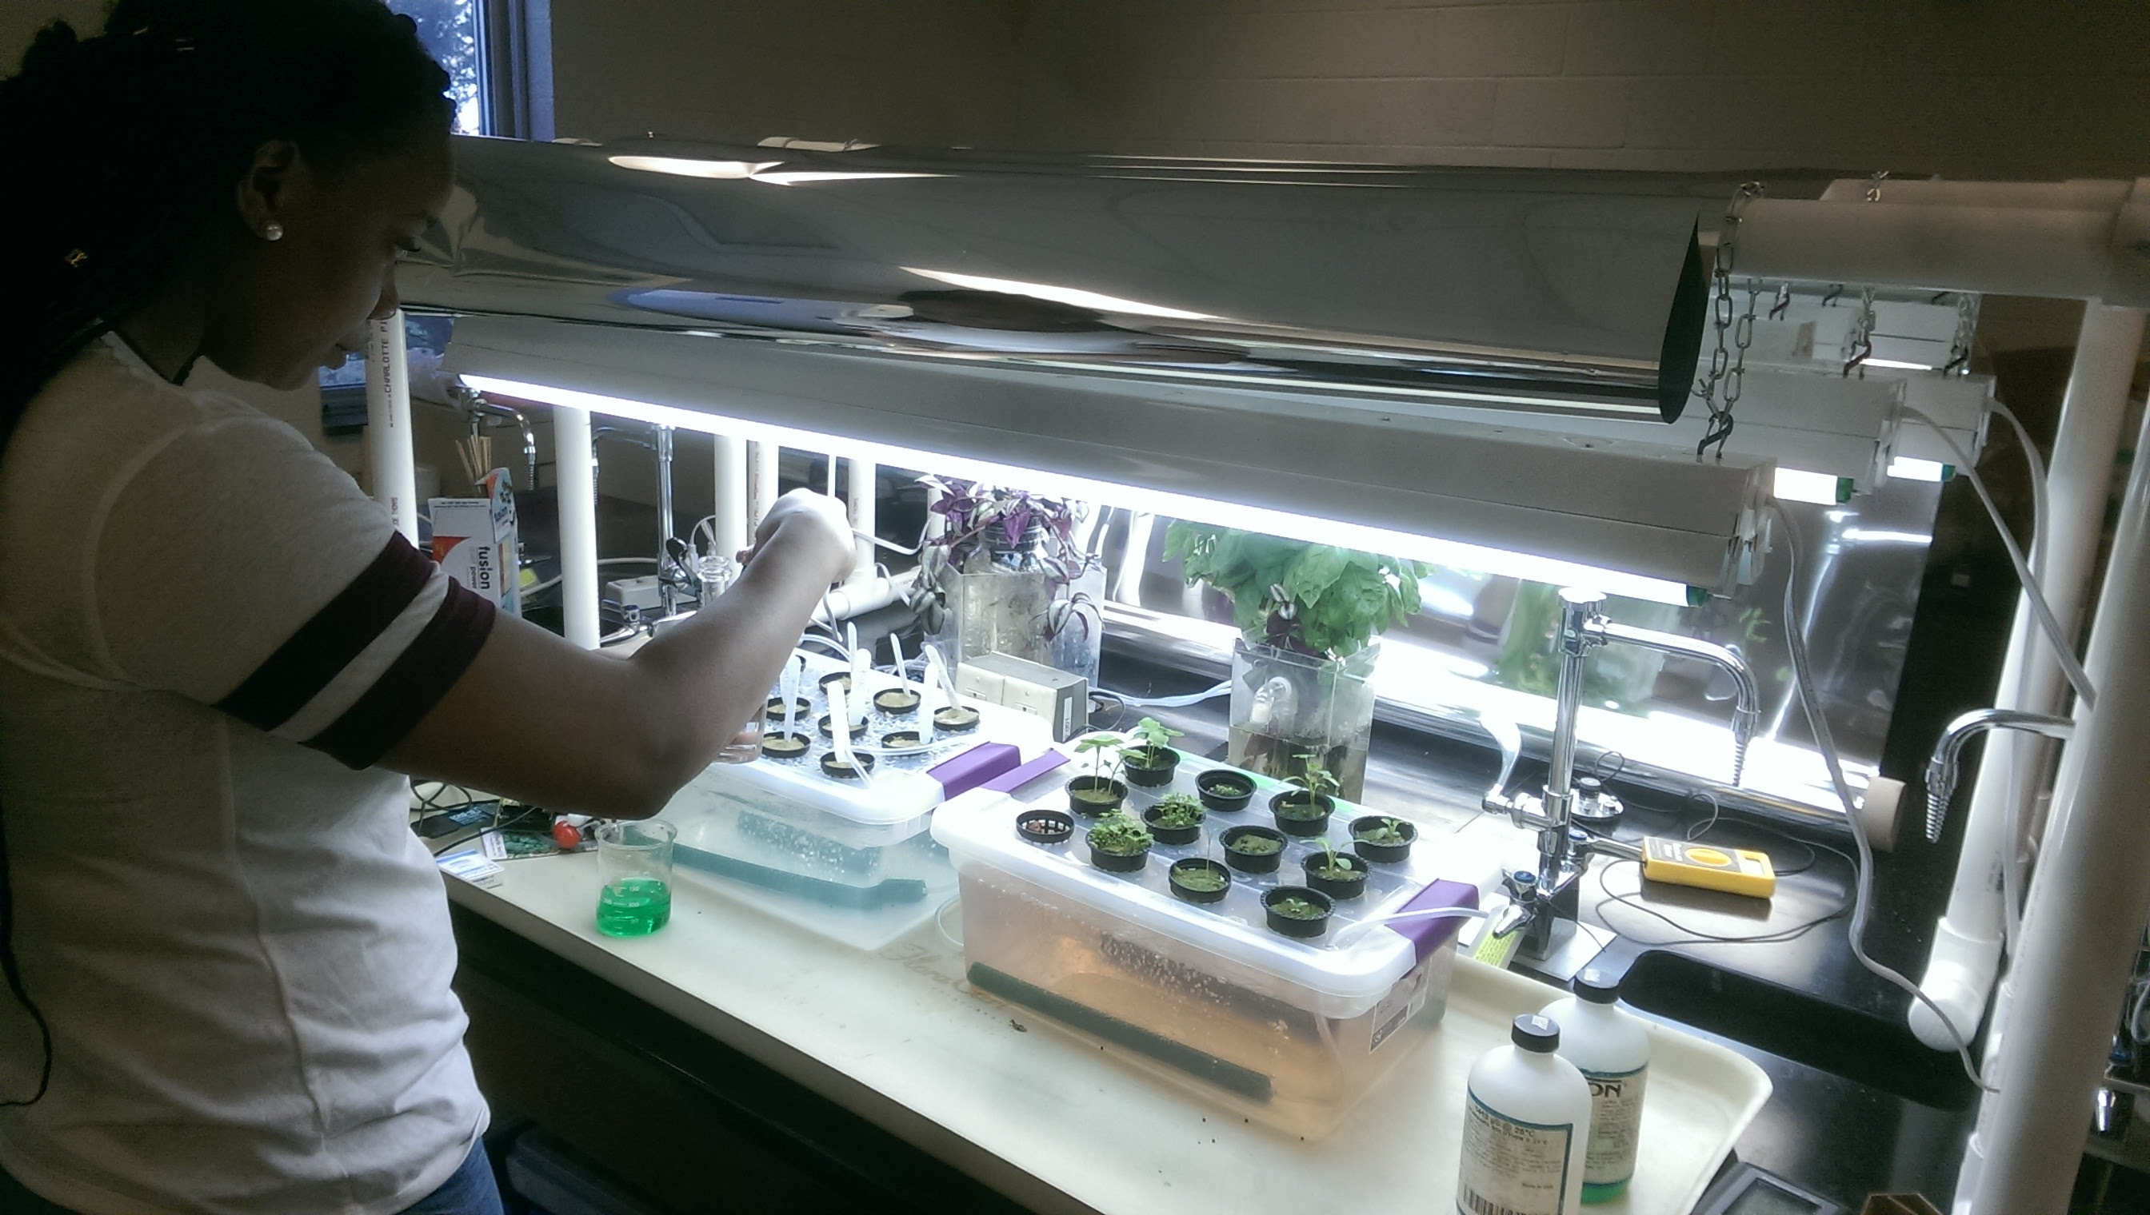
GROW THE BEST PLANT AND PRESENT YOUR RESULTS.
Teams of 2-3 students will conduct an experiment to study the life cycle of plants. Participants will
- Build a light bank
- Collect and analyze data
- Maintain a lab notebook
- Give interim presentations
- Make a final poster presentation on May 16th
Top 3 teams win PRIZES: $150, $100, $75
See Kelly for more information.

