NSF INCLUDES DISCUSSION Network
NCAT/NCCU STEM Camp
Overview:
Here is a classic experiment with eggs. If you soak a raw egg (Panel A below) in vinegar, over the course of time, the vinegar will dissolve the eggshell. What you’re left with is the egg’s translucent semipermeable membrane (Panel B below) to protect the egg white and yolk. Since the shell is made up mostly of calcium carbonate (CaCO_{3 (s)}; 94%), magnesium carbonate (MgCO_{3 (s)}; 1%), calcium phosphate (Ca₃(PO₄)_{2 (s)}; 1%), and 4% organic matter _{(s)}) -- vinegar which contains 5% acetic acid (CH₃COOH _{(aq)}) will dissolve the shell.
Panel A: Panel B:
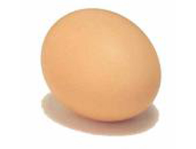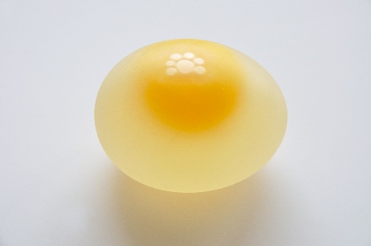
Chemical Reaction:
The first thing that happens is that the carbonate (CO₃⁻⁻) ion of calcium carbonate (CaCO_{3 (s)}) is protonated by acetic acid (CH₃COOH _{aq)}) to make carbonic acid (H₂CO_{3 (aq)}). Along with this, the calcium ion (Ca²⁺) and acetate ion (CH₃COO⁻) form calcium acetate (Ca(CH₃COO)_{2 (aq)}:
Chemical Equation 1: 2 CH₃COOH _{(aq)} + CaCO_{3(s)} H₂CO₃ _{(aq)} + Ca(CH₃COO)_{2(aq)}
In step 2, the carbonic acid (H₂CO_{3 (aq)}) breaks down to form carbon dioxide (CO_{2 (g)}) and water (H₂O_{(l)}):
Chemical Equation 2: H₂CO₃ _{(aq)} H₂O_{(l)} + CO_{2(g)}
The overall reaction is just the sum of the two reactions:
Sum of Chemical Reactions: CaCO_{3(s)} + 2 CH₃COOH_{(aq)} Ca(CH₃COO)_{2(aq)} + H₂O_{(l)} + CO_{2(g)}

Procedure:
- Place the egg in your bowl and cover the egg with vinegar.
- Wait a few minutes and look in the bowl. You should see bubbles forming on the egg.
- Leave the egg in the vinegar for a full 24 hours at room temperature (i.e., on your kitchen countertop).
- After 24 hours, carefully remove the egg from the vinegar and run cold tap water over the egg.
Possible outcomes:
- IF all of the shell comes off the egg while water is running over it, then pour the remaining vinegar out of the bowl, add tap water to the bowl and place the egg in the water in the bowl. Store the egg in your refrigerator until you need to bring it to camp.

- IF all of the shell has NOT dissolved and does NOT come off the egg while water is running over it, then place the egg back in the vinegar and let it remain in the vinegar for another 24 hours. Then check if the shell can be removed under running water over the egg again. Once all of the shell has been removed, pour all the vinegar out of the bowl and replace with tap water. Place the egg in the tap water. Store the egg in your refrigerator until you need to bring it to camp.
Naked Egg Created:
The naked egg looks translucent because the outside shell is gone. Notice that some of the vinegar has permeated through the egg's membrane and caused the egg to get a little bigger (osmosis). When you bring your egg to camp, you will determine the mass of your naked egg.

