Background & Procedures
SEED GERMINATION and SALINIZATION LAB
Adapted from: Dr. Biology’s Pocket Seed Experiment and the Environmental Literacy Council Salinization Experiment

OBJECTIVES
- Discuss the characteristics of plants
- Become familiar with the process of seed germination in angiosperms
- Explain how germination differs between monocots and eudicots.
- Discuss how different sea salt concentrations affect the germination of corn and bean seeds
- Measure the shoot and root length
- View the shoot of the germinating seeds using a compound microscope
- Analyze these data using statistical analysis.
- Write a group (research team) lab report

BACKGROUND
Seeds
A seed is the part of the plant containing the embryo from which a new plant can grow. Usually the seed contains one embryo and a food supply. Larger seeds have more stored food than small seeds. Food stored in larger seeds is called the endosperm. In smaller seeds, there are seed leaves called cotyledons, which must be in the light soon after emerging so they can provide food from photosynthesis for the developing seedling. Larger seeds can develop in the dark for much longer than small seeds, but eventually even seedlings that come from large seeds must reach a light source if they are to survive.

Germination is when a seed begins to sprout and grow. In order for a seed to germinate, conditions must be right. There must be enough moisture, and the right temperature. For different plants, the ideal conditions are different. This is true not only for different species, but also for the different offspring from one plant. This variation is necessary for the survival of the species. If all the offspring germinate at once, they can easily all be wiped out, either eaten or destroyed by unfavorable conditions.

Some seeds germinate in the cooler temperatures of Spring, others in warmer temperatures of Summer. Some seeds are more likely to germinate in the light while others prefer the dark. The first thing to happen is the seed re-hydrates by soaking up water. Then the seed coat cracks. Next, either the radicle (the root) or the cotyledon (the seed leaves) emerge out of the seed coat.
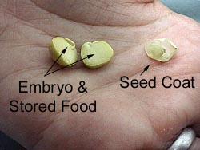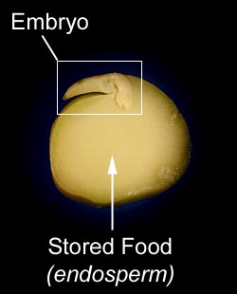

The developing seedling responds to light and gravity. Developing shoots grow against gravity, while developing roots grow towards gravity. This will happen even in the dark. It is called gravitropism, meaning movement in response to gravity. Developing shoots also grow towards the light. This is called phototropism.

Seed Anatomy
When you take a close look at a seed you can see why they are great time capsules. Bundled inside the protective seed coat is the embryo and plenty of food to begin growing when the time is right.

If you take a look at the photo in the upper right corner you can see the seed coat and the seed split in half. One half has the embryo and some of the stored food, and the other half holds the rest of the stored food.

When we magnify the image of the seed you can see the part of the embryo called the radicle, which will grow and develop into the roots. You can also see the part called the plumule, which will grow and develop into the stems and leaves.
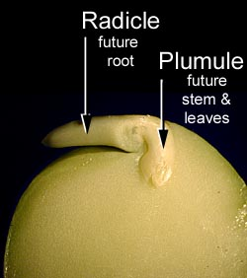

Question: How does the concentration of sea salt in water applied affect corn and bean seed germination?

Materials

Pre-soaked corn and bean seeds
Re-sealable plastic bags quart size bags
Colored napkins
50 ml tubes
Tape
Cardboard (optional)
Paper clips (optional)
Binder clips (optional)
Scissors
Compound microscope
Microscope Slide
Cover slip
Salt solutions (0%, 1% and 3.5% of sea salt)
String

Procedure
- Prior to beginning the lab, the corn and bean seed will be soaked overnight in tap water.
- Fold a 2 colored paper towels into 1/4 section. It should now fit inside sandwich size re-sealable plastic bag. If not, trim the excess edges with a pair of scissors.
- Slide the folded paper towel into the plastic bag. Thicker, more absorbent napkins will hold more water, which reduces the need to add water during the experiment.
- Once the paper towels are placed in the plastic bags, add water 30 ml of the designated solution to each bag. This should soak the paper towel well, but not leave too much extra water in the bag.
- Place three pre-soaked seeds into each re-sealable bag. It is best to place them about an inch apart and in the middle of the bag. It is important to place more than one seed in each bag. Some seeds fail to germinate, some germinate, but fail shortly afterwards. Having more than one seed will help to insure there will be some results. Having more than one seed in each bag also permits extended analysis of the results, such as averaging the shoot and root length of each seed in the each bag.
- Reseal and label the bag to track the different experimental treatments. Be sure to have at least one control bag to compare your results of the other treatment bags. The Pocket Seed Viewer is now ready!

Measurements
The roots and shoots - Roots and Shoots do not grow in a straight line. In order to measure them requires a flexible ruler. One way to measure the seed sprouts is to use a string. Cut a length of string about 30 cm or about 12 inches long and make a knot at one end. Next, use a ruler measure the length of the string to determine the length of the roots and shoots. Using the pocket seed data card, record your seed germination data just as the example provided below. Remember to tape each pocket seed data card into your lab journal. Measurements will be taken on Tuesday, April 11, Wednesday, April 12, Monday April 17, and Tuesday April 18.

Example of Data Collection using the Pocket Seed Data Card
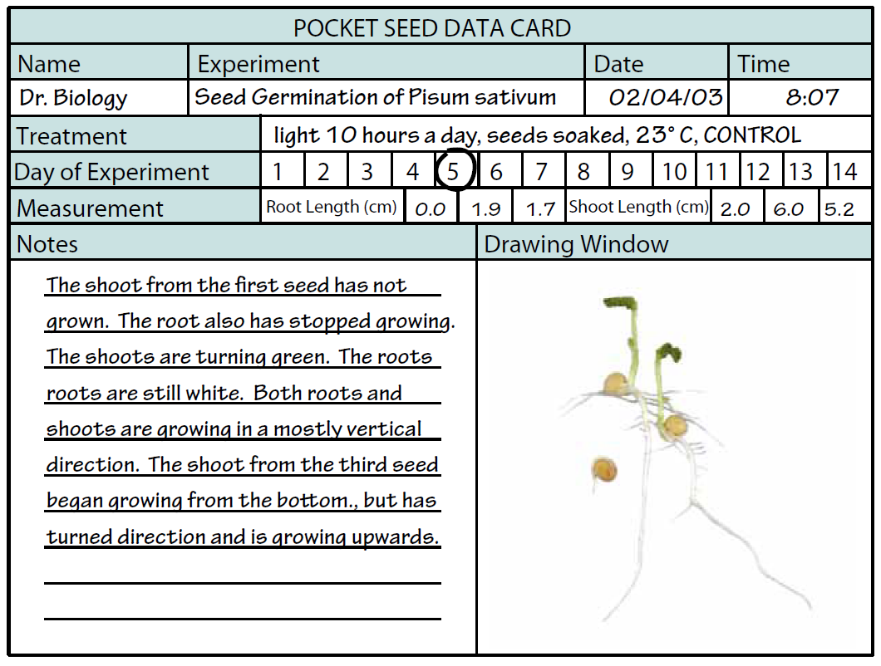

Microscope – On April 18, observations of the shoots will take place by making a wet mound of the corn and bean seeds and using a compound microscope at 400x total magnification. It will be required to draw or take a picture of the shoots observed under the microscope and write a detailed description.

Data Analysis
Students will use Microsoft excel to calculate the descriptive statistics and create graphs. Students will also use graphpad.com to conduct a t-test to determine if there is a significant difference in the corn and bean germination receiving the different salt concentrations. Differences in the sea salt concentrations will be considered significant at a p-value <0.05.
Post Lab Questions
- At which sea salt concentration did the highest number corn and bean seeds germinate? Explain your answer.
- At which sea salt concentration did the lowest corn and bean seeds germinate? Explain your answer.
- Was there a significant difference in the shoot and root lengths of the monocot and eudicot seeds receiving various sea salt concentrations? Explain your answer.
- Which seed type was more sensitive to increasing sea salt concentrations? Explain your answer.
- How are your results applicable to the real world? Explain your answer.

References
Dr. Biology. "Dr. Biology's Virtual Pocket Seed Experiment." ASU - Ask A Biologist. 15 Dec 2009. ASU - Ask A Biologist, Web. 1 Apr 2017. http://askabiologist.asu.edu/experiments/vpocketseeds

Salinization. (2015) The Environmental Literacy Council. Washington DC. https://enviroliteracy.org/teaching-resources/ap-environmental-science-course-material/salinization-student-2/

Salinization. Irrigation Water Management: Introduction to Irrigation. FAO Natural Resources Management and Environment Department http://www.fao.org/docrep/r4082e/r4082e08.htm

The pocket seed data card will be used to collect detailed information about each individual data for seed type receiving the different treatments. There should be at least 2 pocket seed data cards per data collection day.

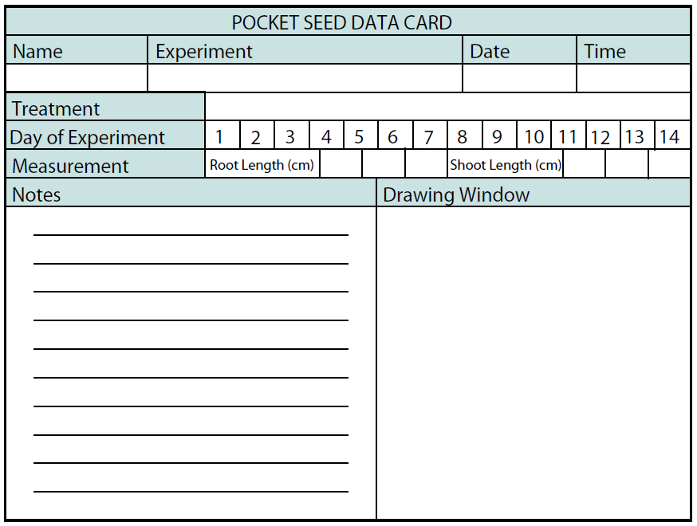
This data table can be used to collect your measurement data along with some basic comments. Use one table for each experimental treatment. Once the experiment is finished, the tables can be used to analyze and graph the results. There should be one table for each seed and treatment. Therefore a total of 6 data tables should be taped into your lab journal.

