Visualization (for Analysis and Comparison)
Tasks:
Visualize/explore the structures of EcoRV substrate and product DNA complexes. Compare the structures in the region of the enzyme active sites.

Steps:
Type the PDB code (1rvc) in the top search box on the page www.rcsb.org
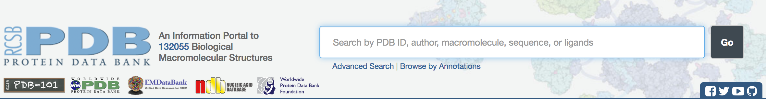

This should open the Structure Summary page for the PDB entry. Explore the page to learn about the following:
- How many protein chains are there in this structure?

- How many Nucleic acid chains are there in this structure?

- What is the source organism for this/these protein(s)?

- List 1 ligands bound to this structure? What are they?

- How was the structure determined? What is the quality of this structure?

Open the abstract for the primary citation. Read the abstract/article for the primary citation – name the two specific amino acid residues at the enzyme catalytic site mentioned here.

Click on the 3D view tab to open the structure in any one of the online visualization programs e.g. JSmol (you may also choose NGL or PV). Comment on the positions of the N- and C-termini in the protein(s) and the 5’ and 3’ ends of the DNA strands in the structure.

Prepare to visualize this structure using a software installed on your computer.
The molecular visualization software, UCSF Chimera, and instructions for downloading/installing the software are available at no cost from http://www.cgl.ucsf.edu/chimera/. This worksheet guides you through some of the key functions and features of the software. In the following exercises, you will learn to do the following:
- Fetch/load a PDB coordinate file
- Display the atomic coordinates in various formats
- Select specific regions of the coordinates
- Simple analysis of the visualized structure– draw hydrogen bonds, measure distances, etc.
- Compare structures – superpose 2 (or more structures)
- Make a simple movie/animation

Note: To save images that you make, select File… Save Image … and provide a file name. Import the image in any image manipulation software of your choice (e.g., Photoshop), or a document/powerpoint, etc. to add labels and additional text describing the images. Some key commands and functions of UCSF Chimera are included in the Appendix at the end of this document.

Visualize the structure of the protein in PDB entry 1rvc.
Launch the UCSF Chimera program. Assuming your machine is connected to the internet, from the “File” menu choose File… Fetch by ID and type 1rvc in the box, make sure that the radio button next to “PDB” is selected, then click “Fetch.”
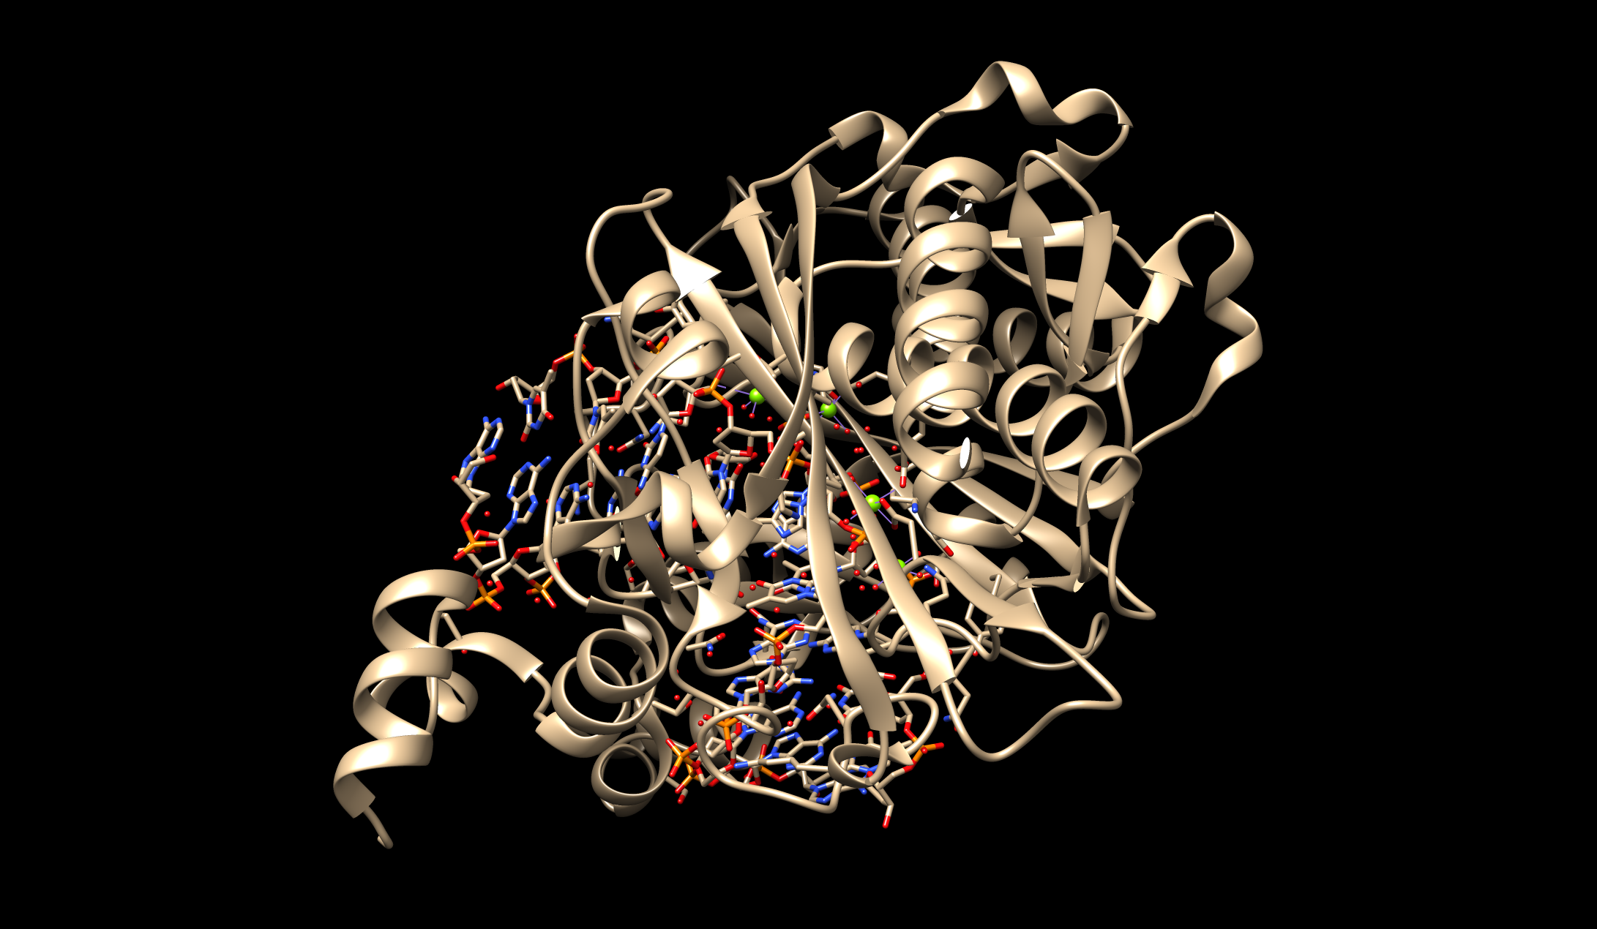

This is a view with the protein chains displayed as ribbons and the ligands and some selected amino acid residues are displayed in a stick representation. Using your mouse, you can rotate the structure and move/zoom using the following commands:
- Left-click and drag or mouse click and drag: Rotate molecule in X/Y directions
- Middle-click and drag or alt/option, click and drag: Move molecule in X/Y direction
- Right-click and drag or Command, click and drag: Zoom in and out of the view

In the navigation bar at the top of the screen, the Preset menu provides options to view the uploaded structure. A preset is a predefined combination of display settings.
Interactive manipulation of the structure may change 1 of 3 characteristics:
- Ribbons – offers a ribbon representation of the molecule and colors polymer chains
- All atoms – depicts all atoms and bonds in the wireframe representation
- Hydrophobicity surface – shows amino acid hydrophobicity using the Kyte-Doolittle scale where blue indicates the most hydrophilic and orange red for the most hydrophobic
Select Menu Presets … Interactive 1 (ribbons). This should color the polymer chains of the molecule as shown in the image below.
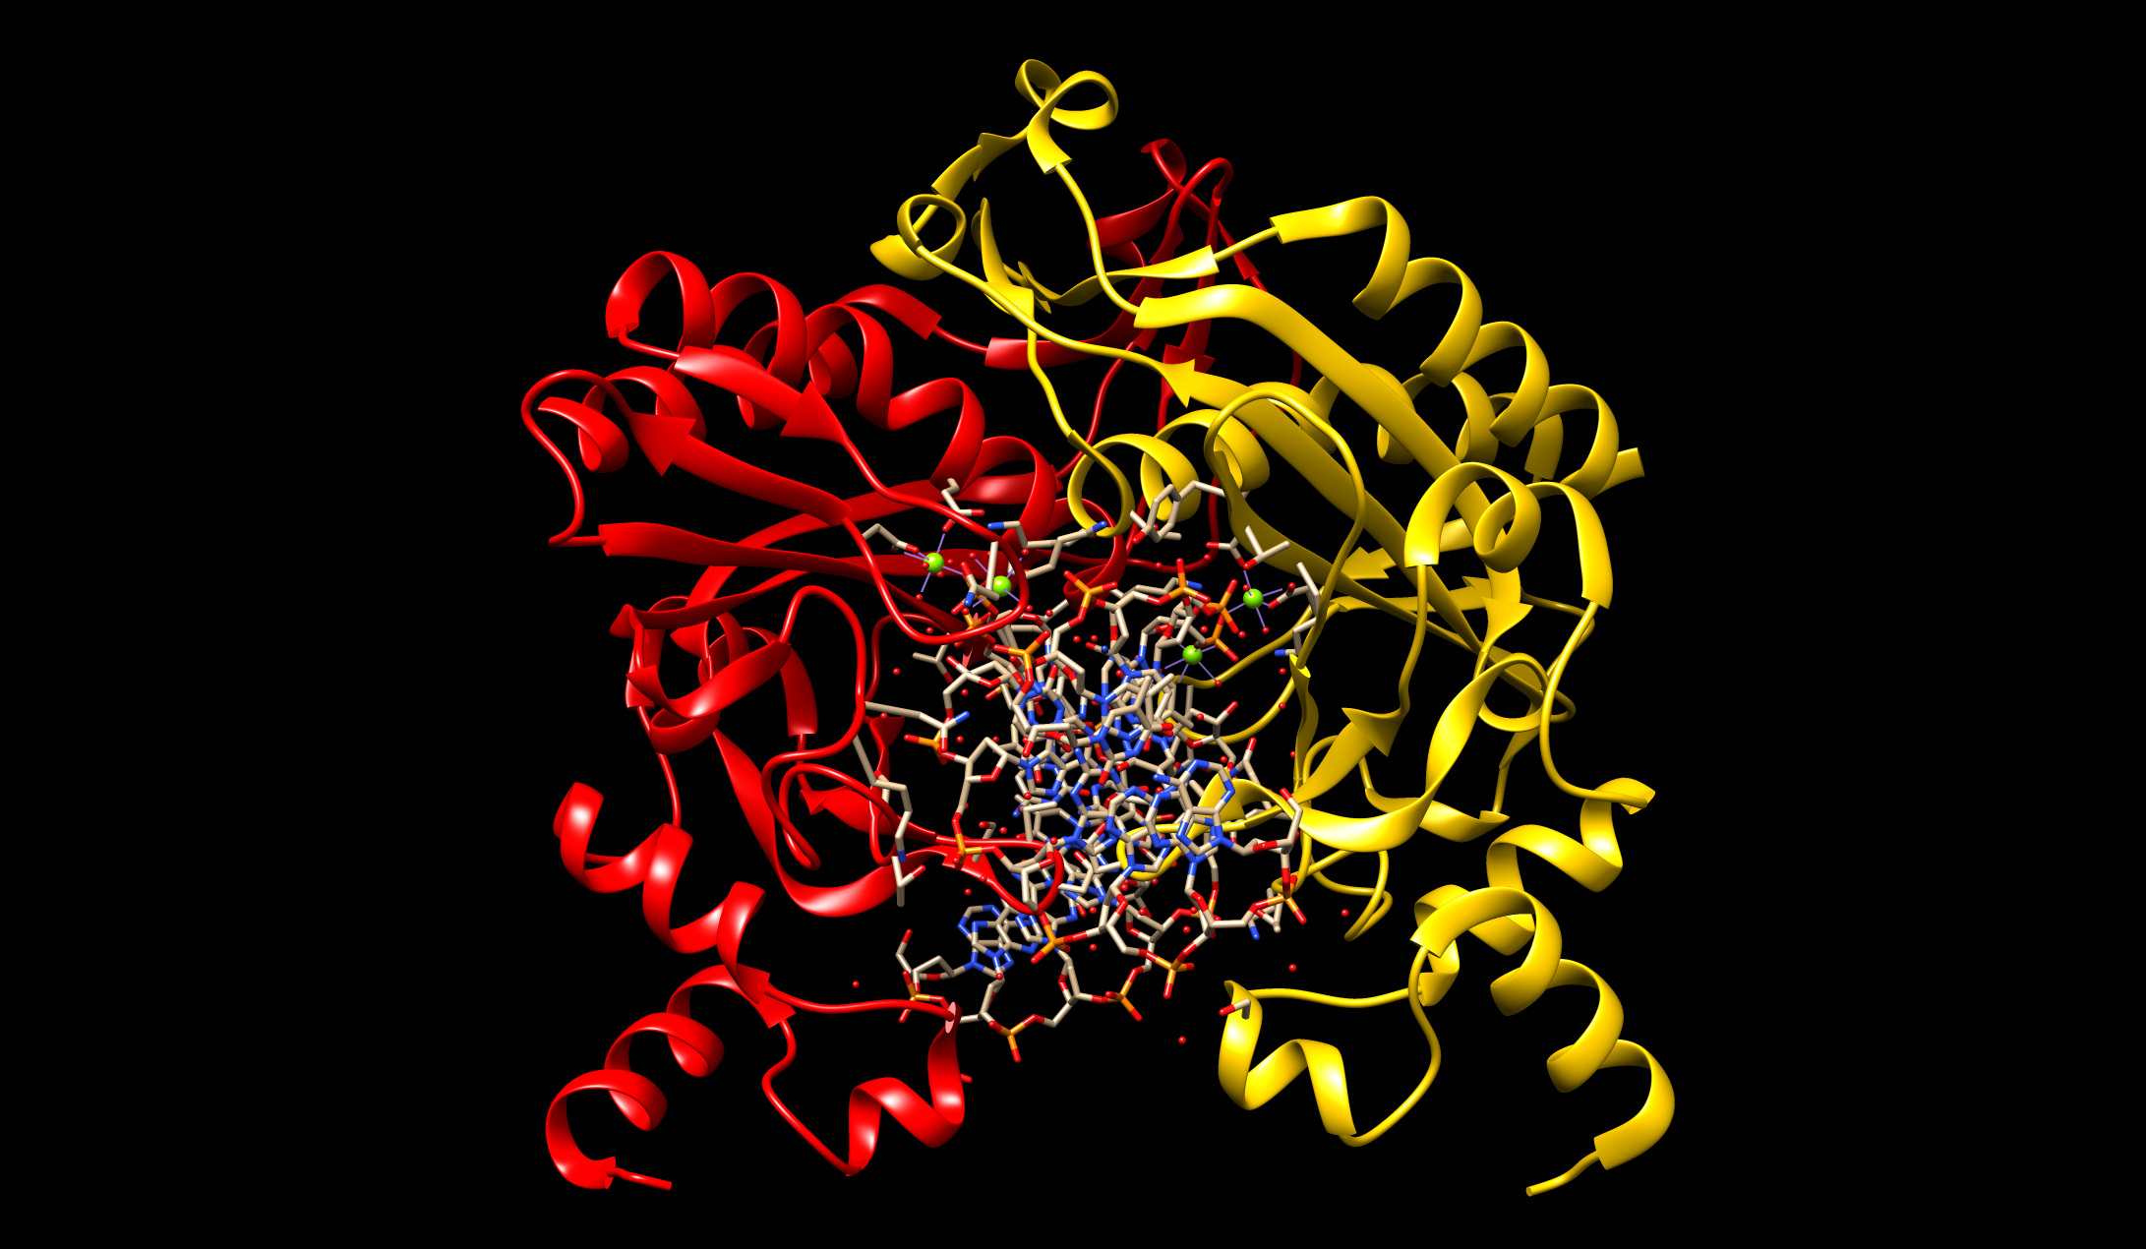
The same view could also be rendered using the following commands. Choose Tools… Depiction… Rainbow from the menu. This should launch a new window with various rainbow-coloring options. Select the Rainbow color scheme by Residue (default selection). Click on the Apply button.
Try out the other two Presets options. The molecule should look as follows:
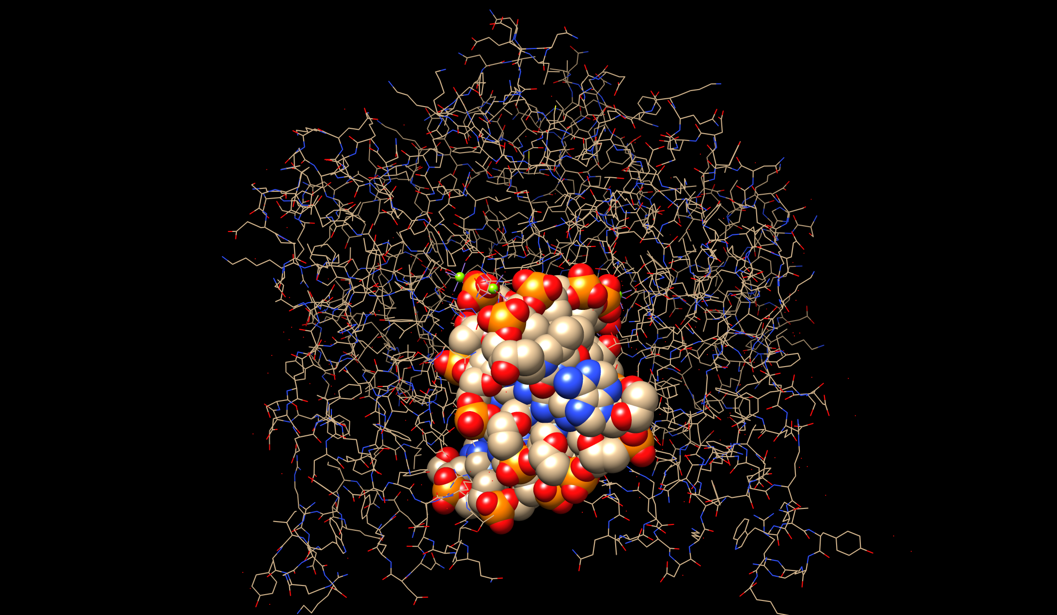
All atom view with DNA bases highlighted as space fill atoms. Note also the green spheres representing the Mg atoms bound to the active site of the enzyme.

Hydrophobicity surface with ligands in stick representation.
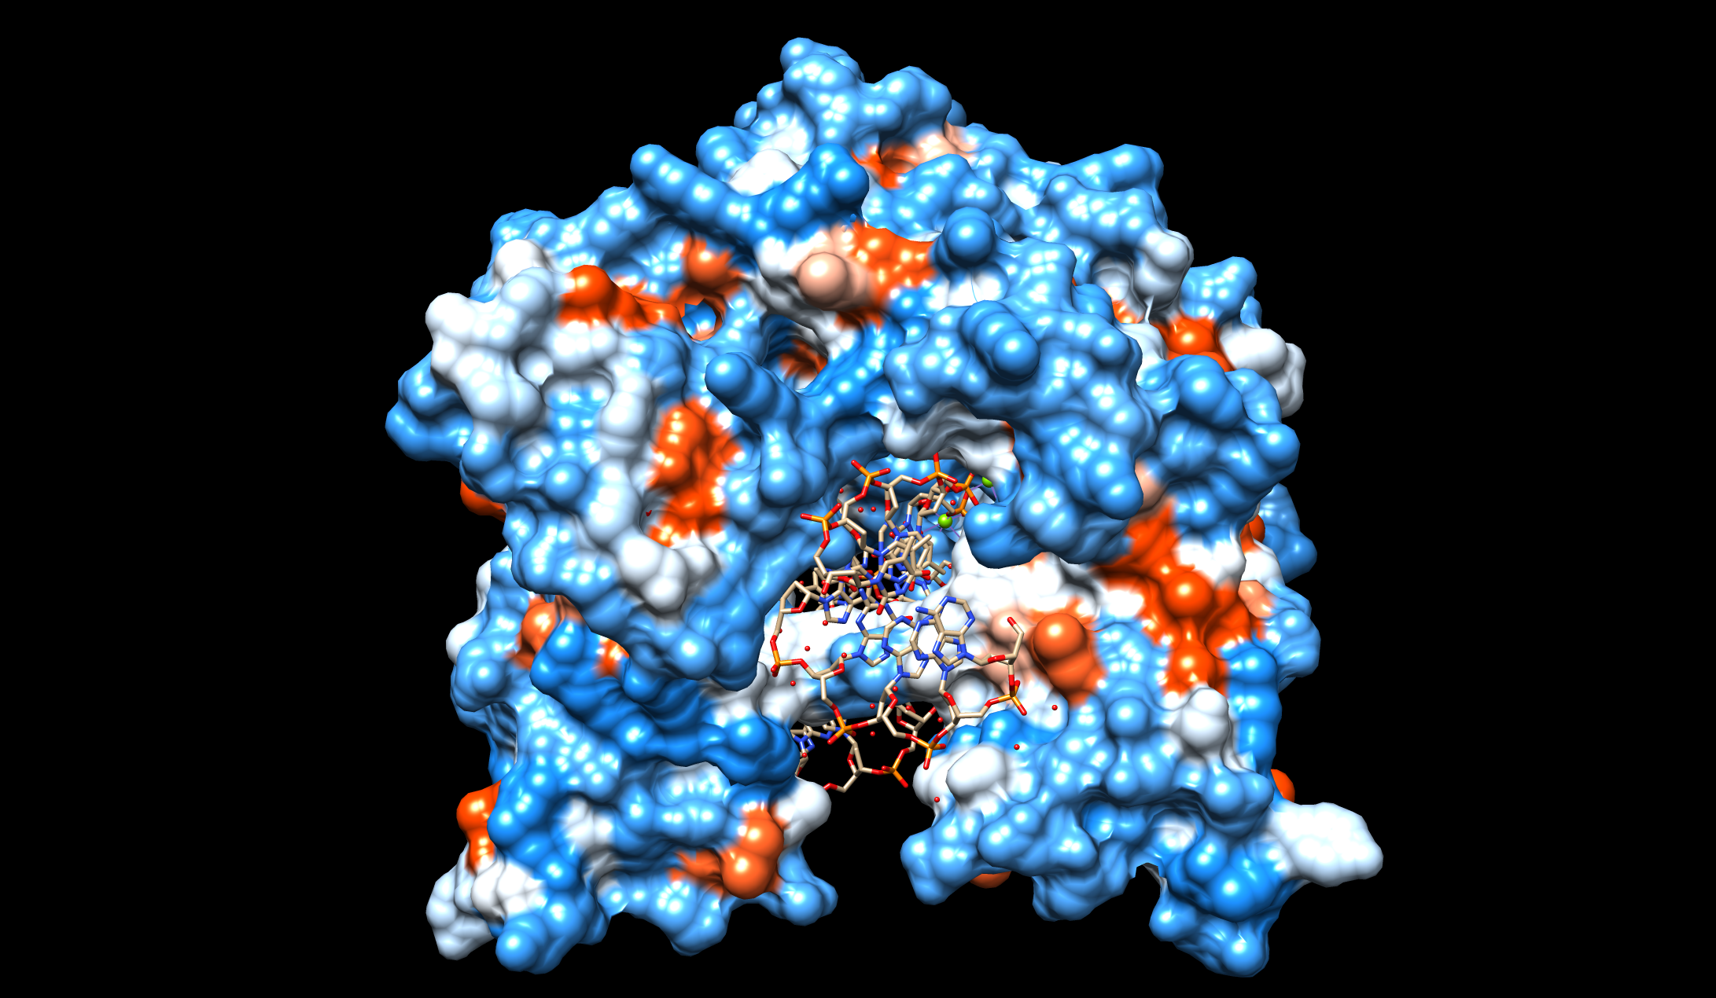
Note how the DNA: protein complex is stabilized.

List 3 things that you learn from these representations?

Revert back to the Preset Interactive 1 ribbons option.

In order to distinguish the α helices and the β strands in the molecule, color these secondary structural elements using the steps: Tools … Depiction … Color Secondary Structure …
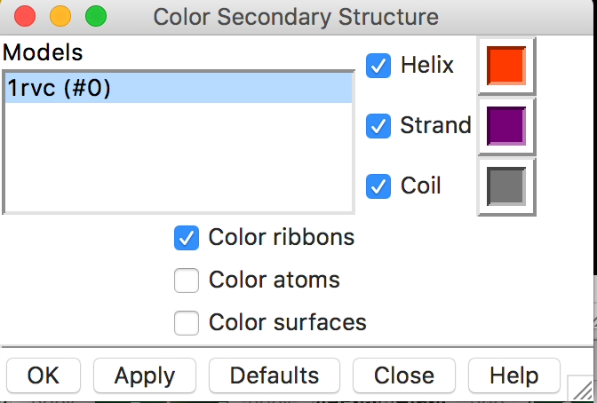

A new window should appear. Click on Apply or OK to color the ribbons based on secondary structure as shown below.
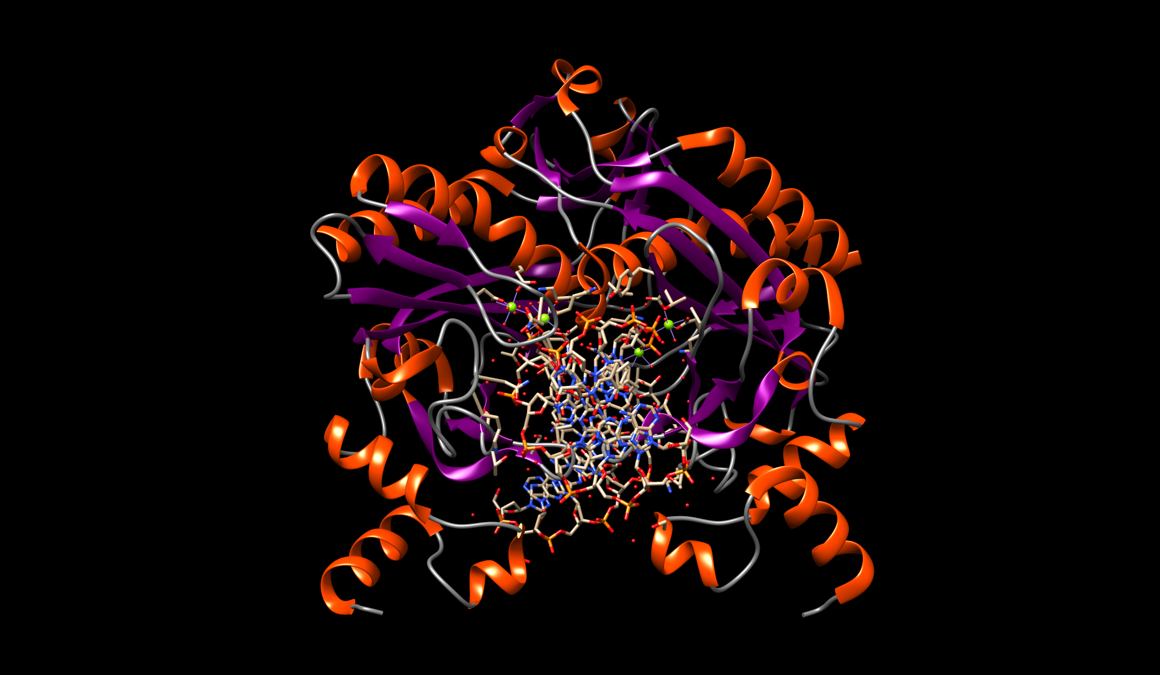

Now select the DNA strands and display a ribbon for the phosphodiester backbone. Choose: Select … Chain … C. This should highlight one DNA strand with a green halo. Now click on Actions … Ribbons … Show. Repeat this for DNA strands labeled chain D, E, and F. You should see the following figure:
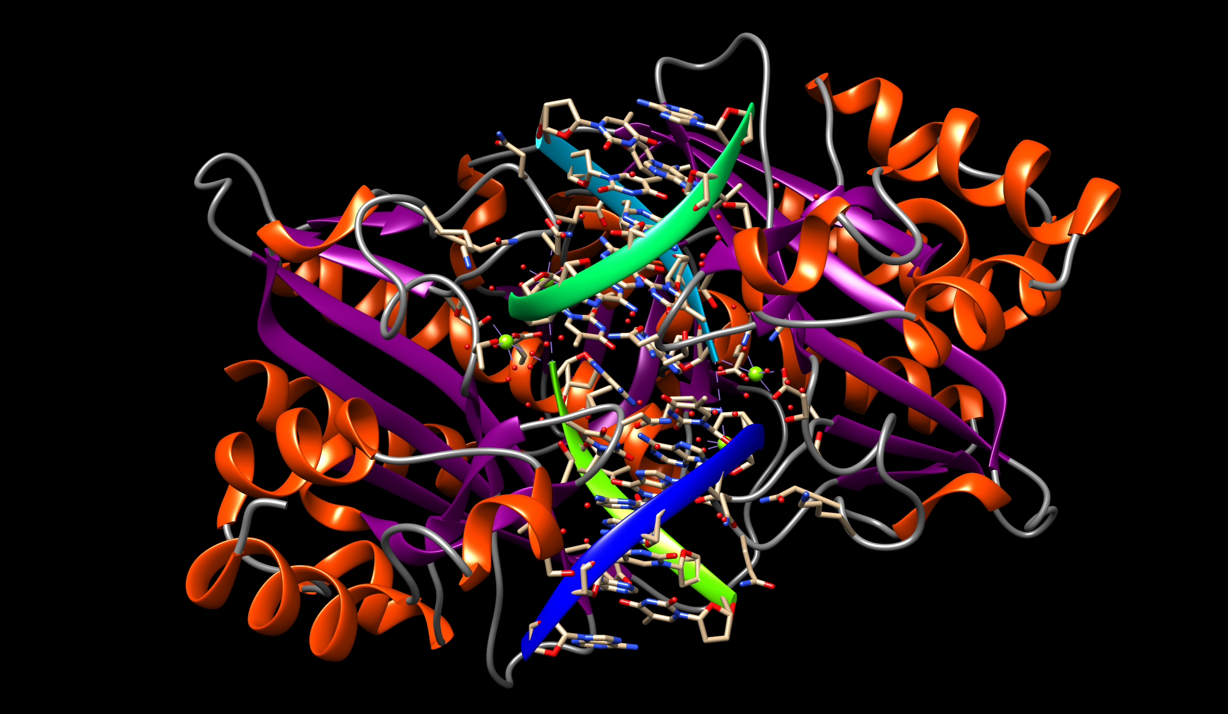
To further simplify the representation of the DNA strands, choose Actions … Atoms/Bonds … nucleotide objects … Settings …
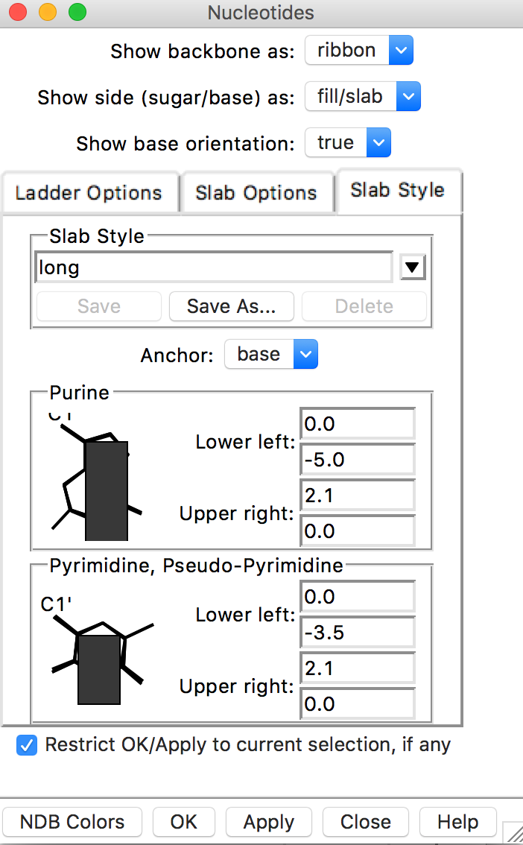
With the Show side (sugar/base) as: option to be fill/slab, click on Apply or OK
You should see the following:
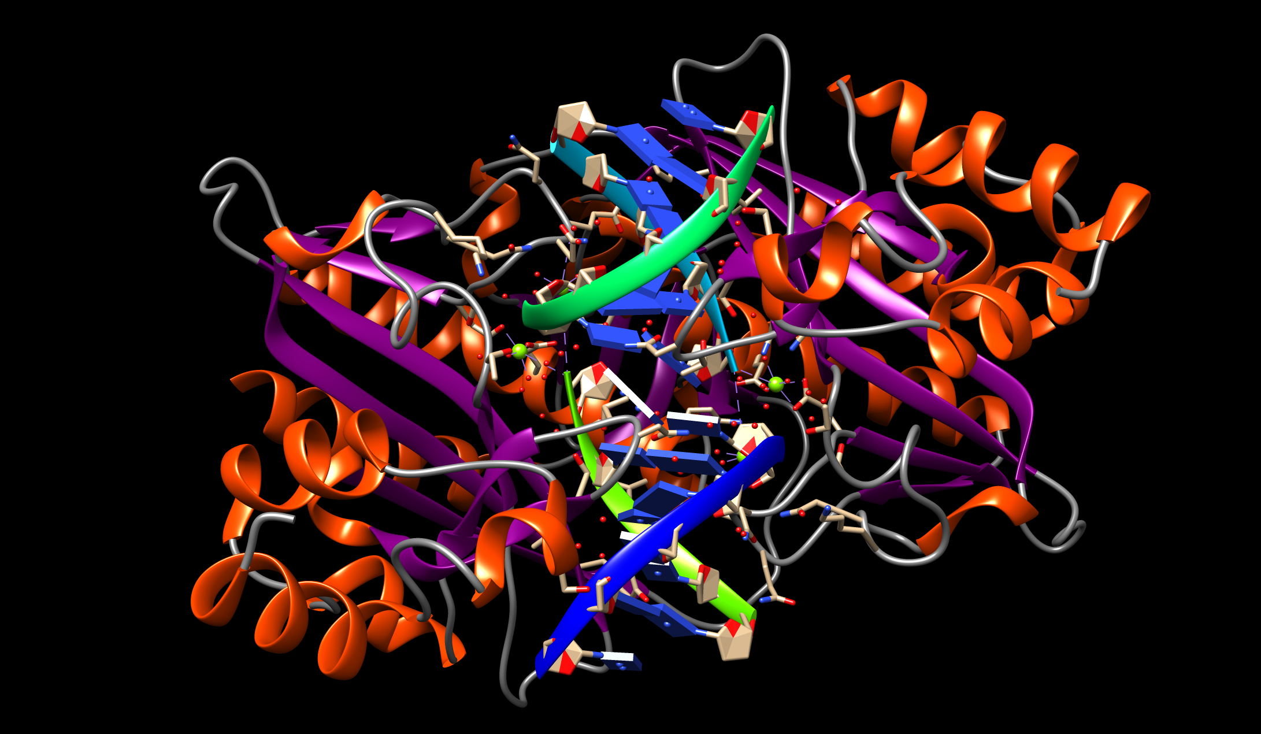
Describe the distribution of the secondary structural elements – α helices and β sheets with respect to the DNA strands. Rotate the molecule as necessary to examine the structure.

To turn off the slab representation click on Actions … Atoms/Bonds … nucleotide objects … Off

Questions: Examine the protein: DNA interactions and answer the following questions:
- How does the enzyme recognize the cognate DNA sequence?
- How do the active site residues and Mg cleave the Cognate DNA?

Explorations:
Recognition of the cognate DNA sequence - note that the β-turn (Gly184 – Thr187) binds to the DNA, close to the site of cleavage. Can you tell where do these amino acids bind – in the DNA Major groove or Minor groove?

Select the residues 184-187 and examine their interactions. Choose Favorites … Sequence … This opens a new window
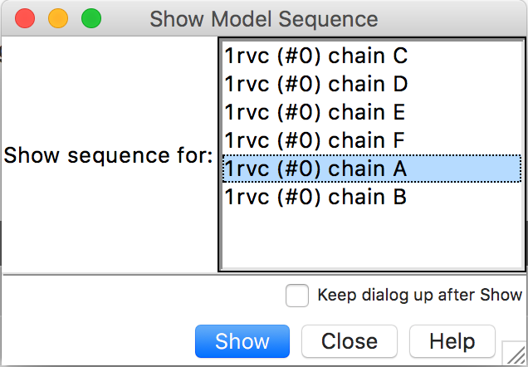
Click on the following Show sequence for … 1rvc (#0) chain A … Show. You should see a new window showing the sequence of one of the chains of the EcoRV protein:
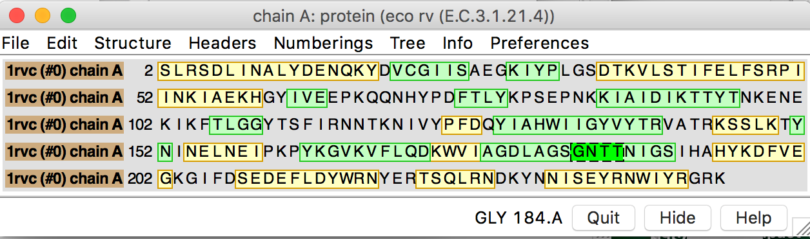
Click and drag on the sequence highlighted in bright green (GNTT), corresponding to the residues 184-187. You should see these amino acids highlighted with a green halo. Click on Actions… Atom/Bonds… Show to shows the amino acid side chains of all the selected residues.

Examine the interactions of these amino acid residues, starting with how they form hydrogen bonds. Display hydrogen bonds within the selected amino acids, click on the following steps:
Tools … Structure Analysis … FindHbond; a new box opens with options for displaying the H-bonds.
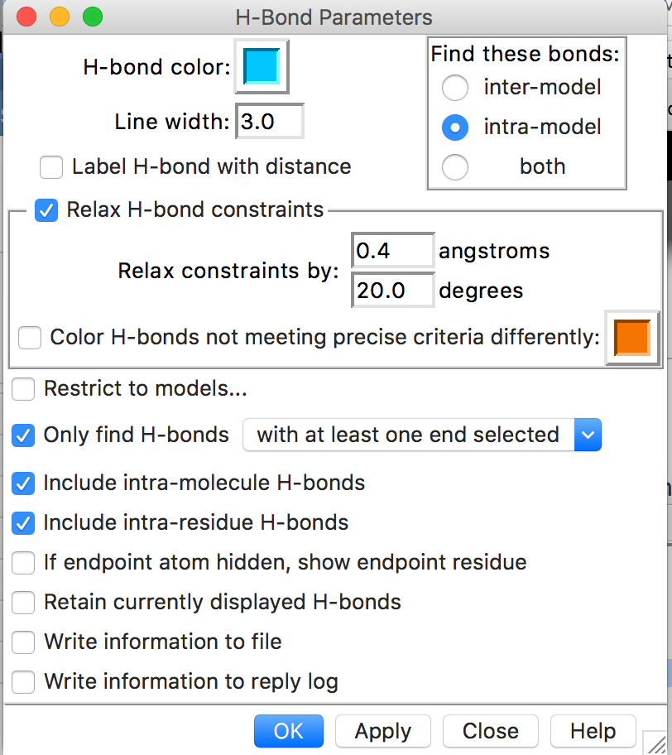
Check next to the option “Only find H-Bonds – with at least one end selected” and press on Apply at the bottom of the window. You should see hydrogen bonds (such as shown in blue in the figure below):
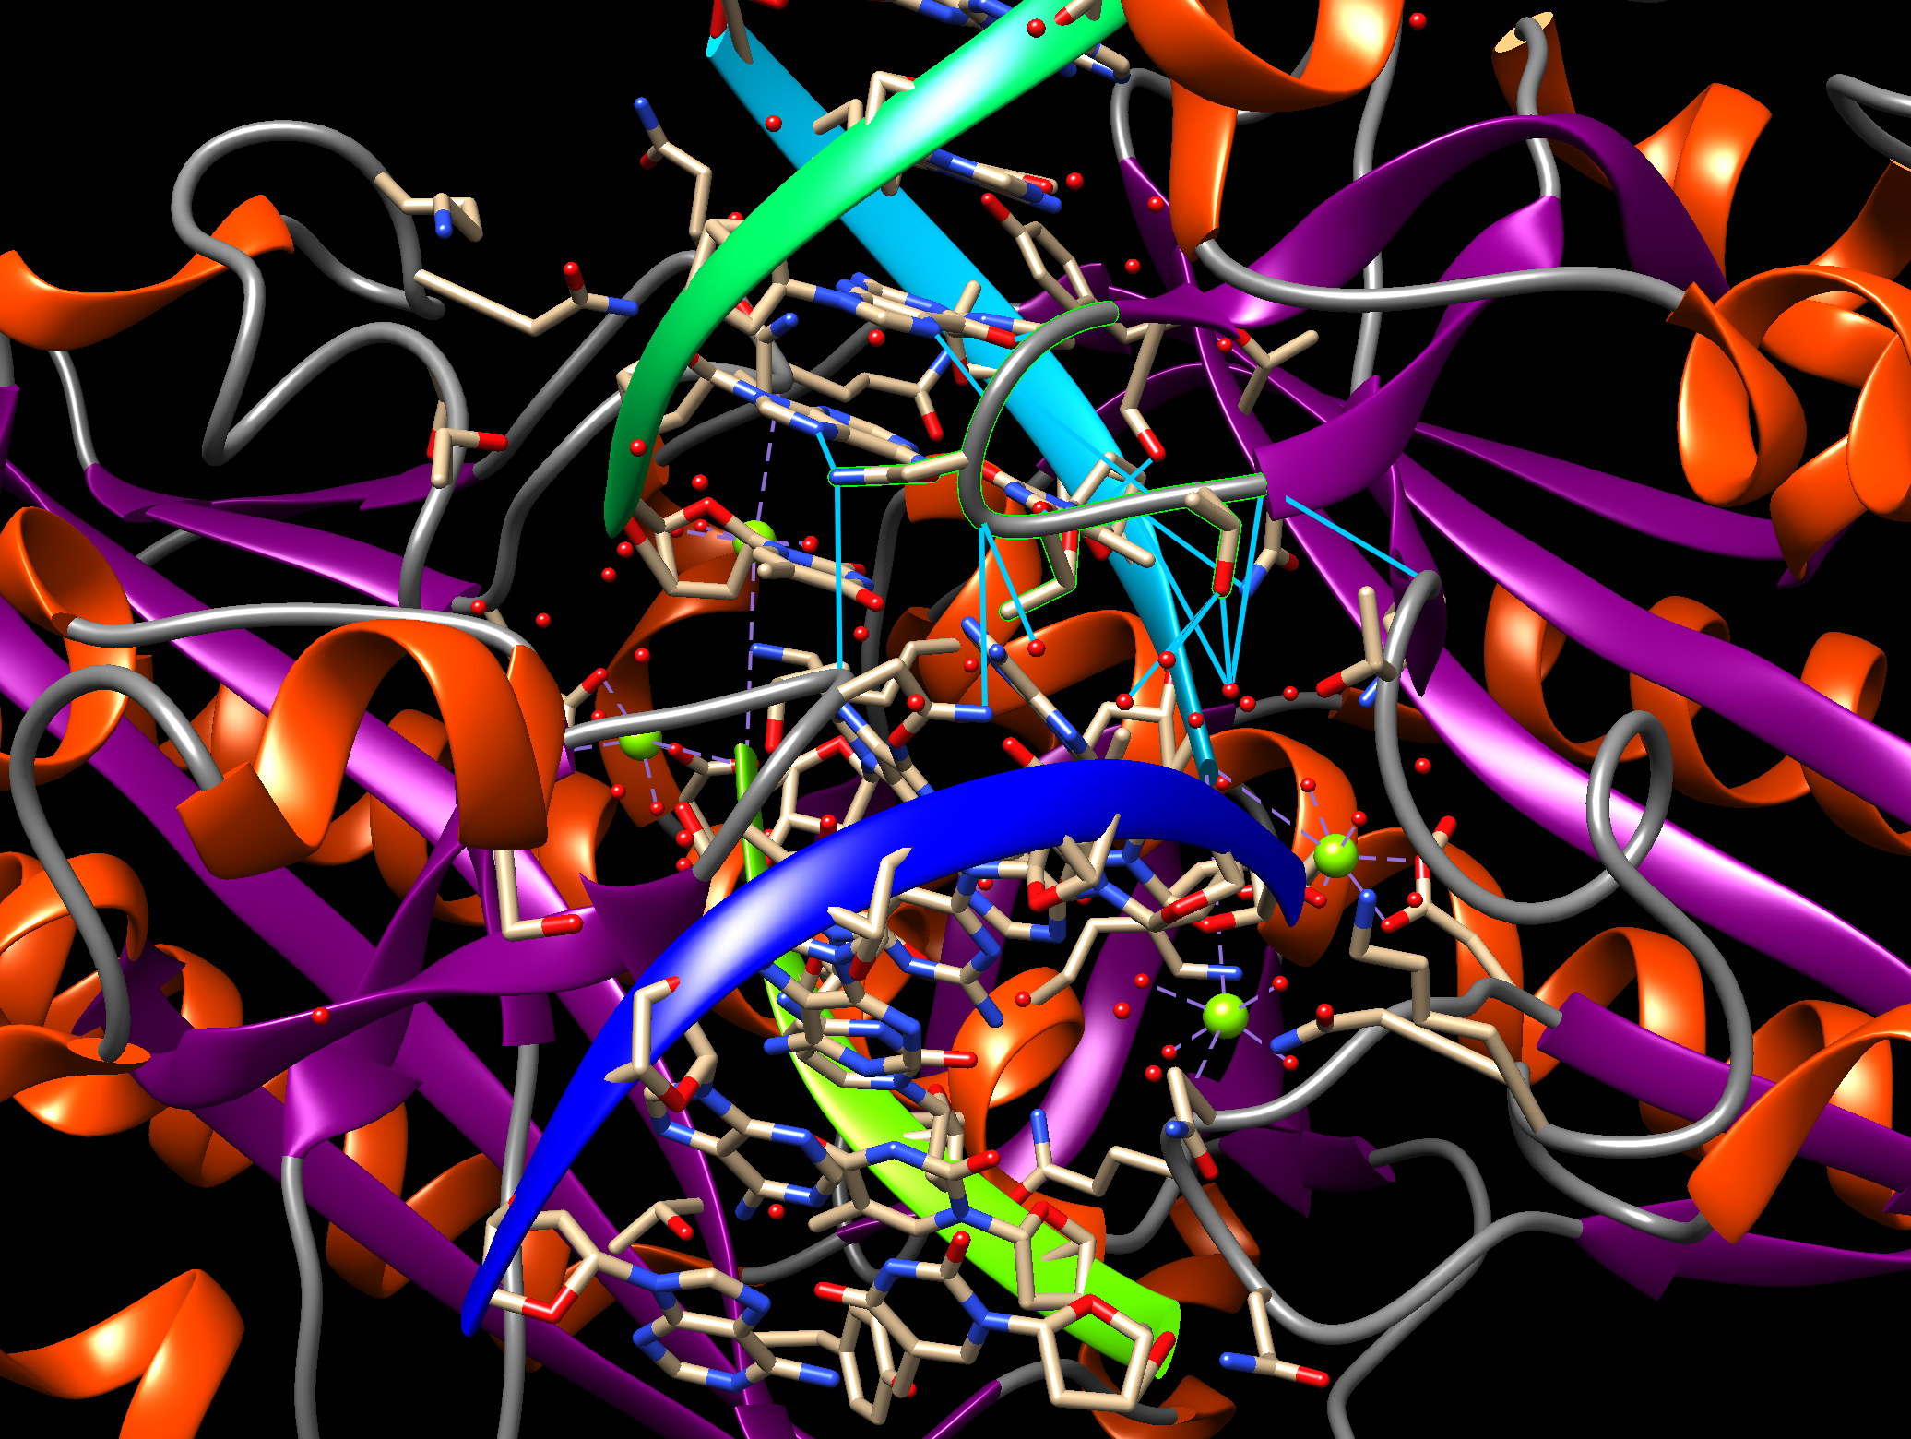
Examine the hydrogen bonds closely – especially ones formed between cognate DNA and the amino acid residues selected above. Discuss the nature of these interactions – and comment on how they contribute to the enzyme’s ability to recognize the cognate DNA.

Predict what you think would happen if the enzyme bound to a non-cognate DNA sequence? Verify your prediction by examining the structure of PDB entry 2rve.

Close the session - go to File … Close session. This closes the above graphics display session but keeps the Chimera program open. Alternatively, you can close this Chimera window and launch a new one for the next question.

Cleavage of cognate DNA at the enzyme active site:
In a fresh Chimera session load the PDB entry 1rvc. Now also upload the coordinates of the PDB entry with EcoRV in complex with the substrate DNA (PDB entry 1rvb) as File … Fetch by ID and type 1rvb in the box. Compare the structures of the 2 structures using the following commands:
Menu Tools… Structure Comparison… Matchmaker, this brings up the structure alignment window.
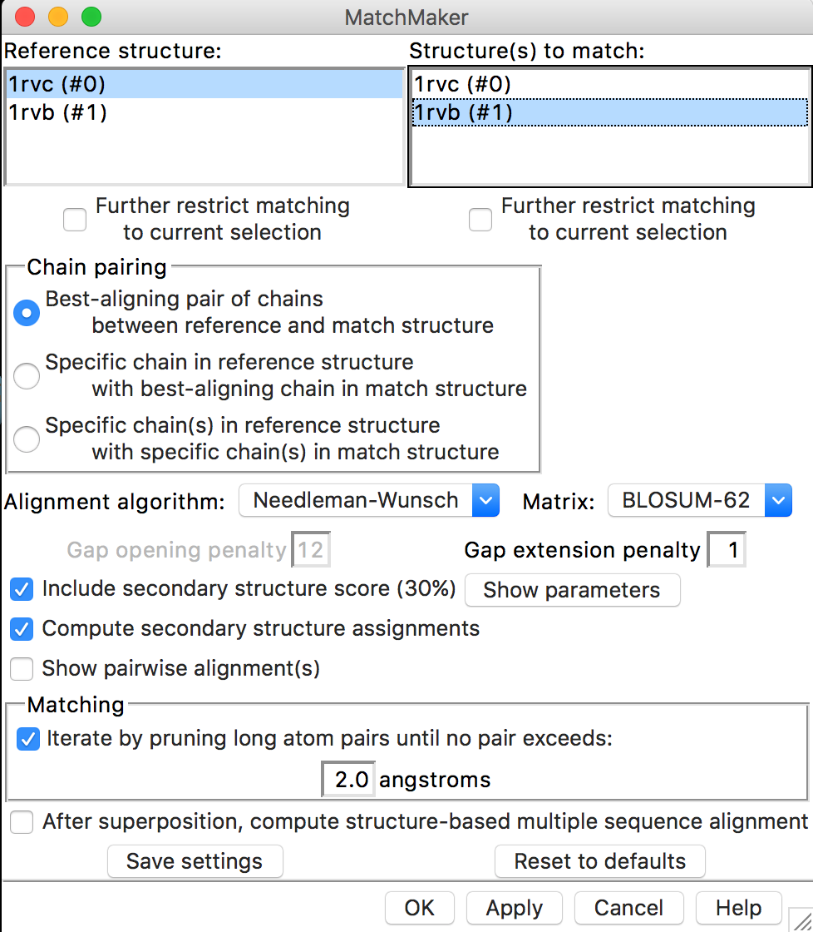
On the left side of the new window, under Reference Structure, highlight 1rvc by clicking it once, then select structure 1rvb in the right-hand section (structure to match). Now press Apply.
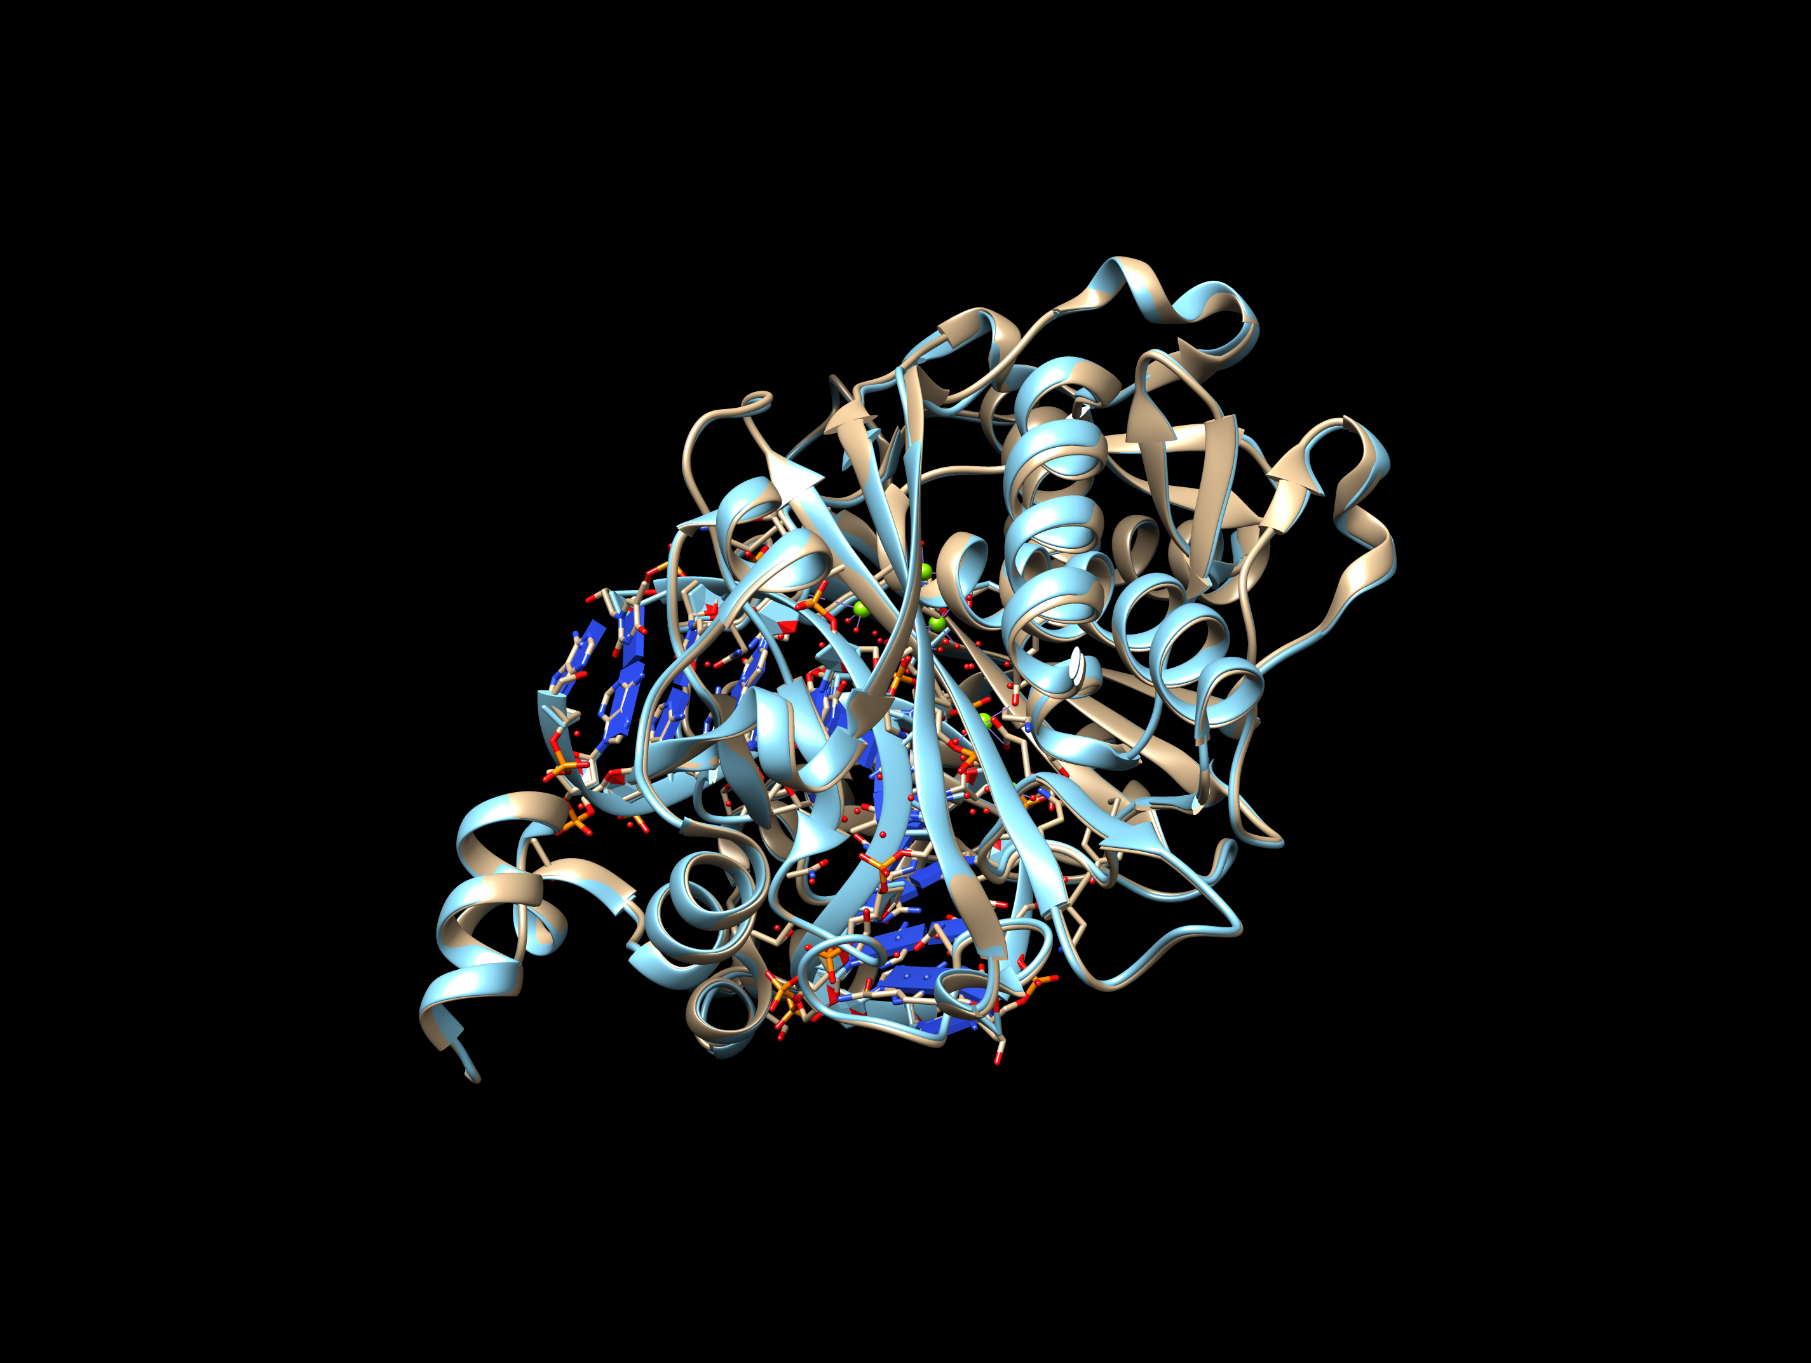

Locate the active site residues – Asp74, Asp90, Lys92 in Chain B. Open the sequence window showing the sequence of Chain B for both structures (as described above). In Each sequence window, identify and click on each of these amino acids with the shift button pressed down so that you can select the residues simultaneously.
Alternatively, you can activate the command line as Tools … General Controls … Command Line. Use the following command for the selection:
select: 74.b, 90.b, 92.b

Identify all residues within 5 angstrom of the ligand CEM as follows:
Select … Residue … CEM; Select … Zone … this should open a dialog box. Click on the buttons as shown below and press OK:
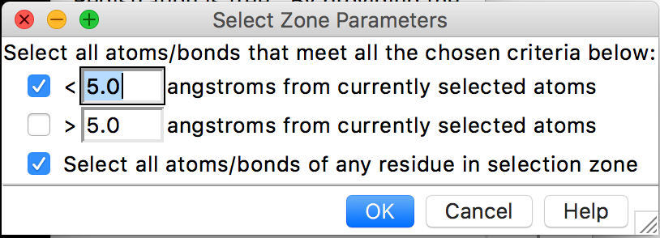
This will select all residues within 5 angstroms of CEM and high light them with a green halo. Show the side chains of these residues/ligands by the following:
Actions … Atoms/Bonds … Show

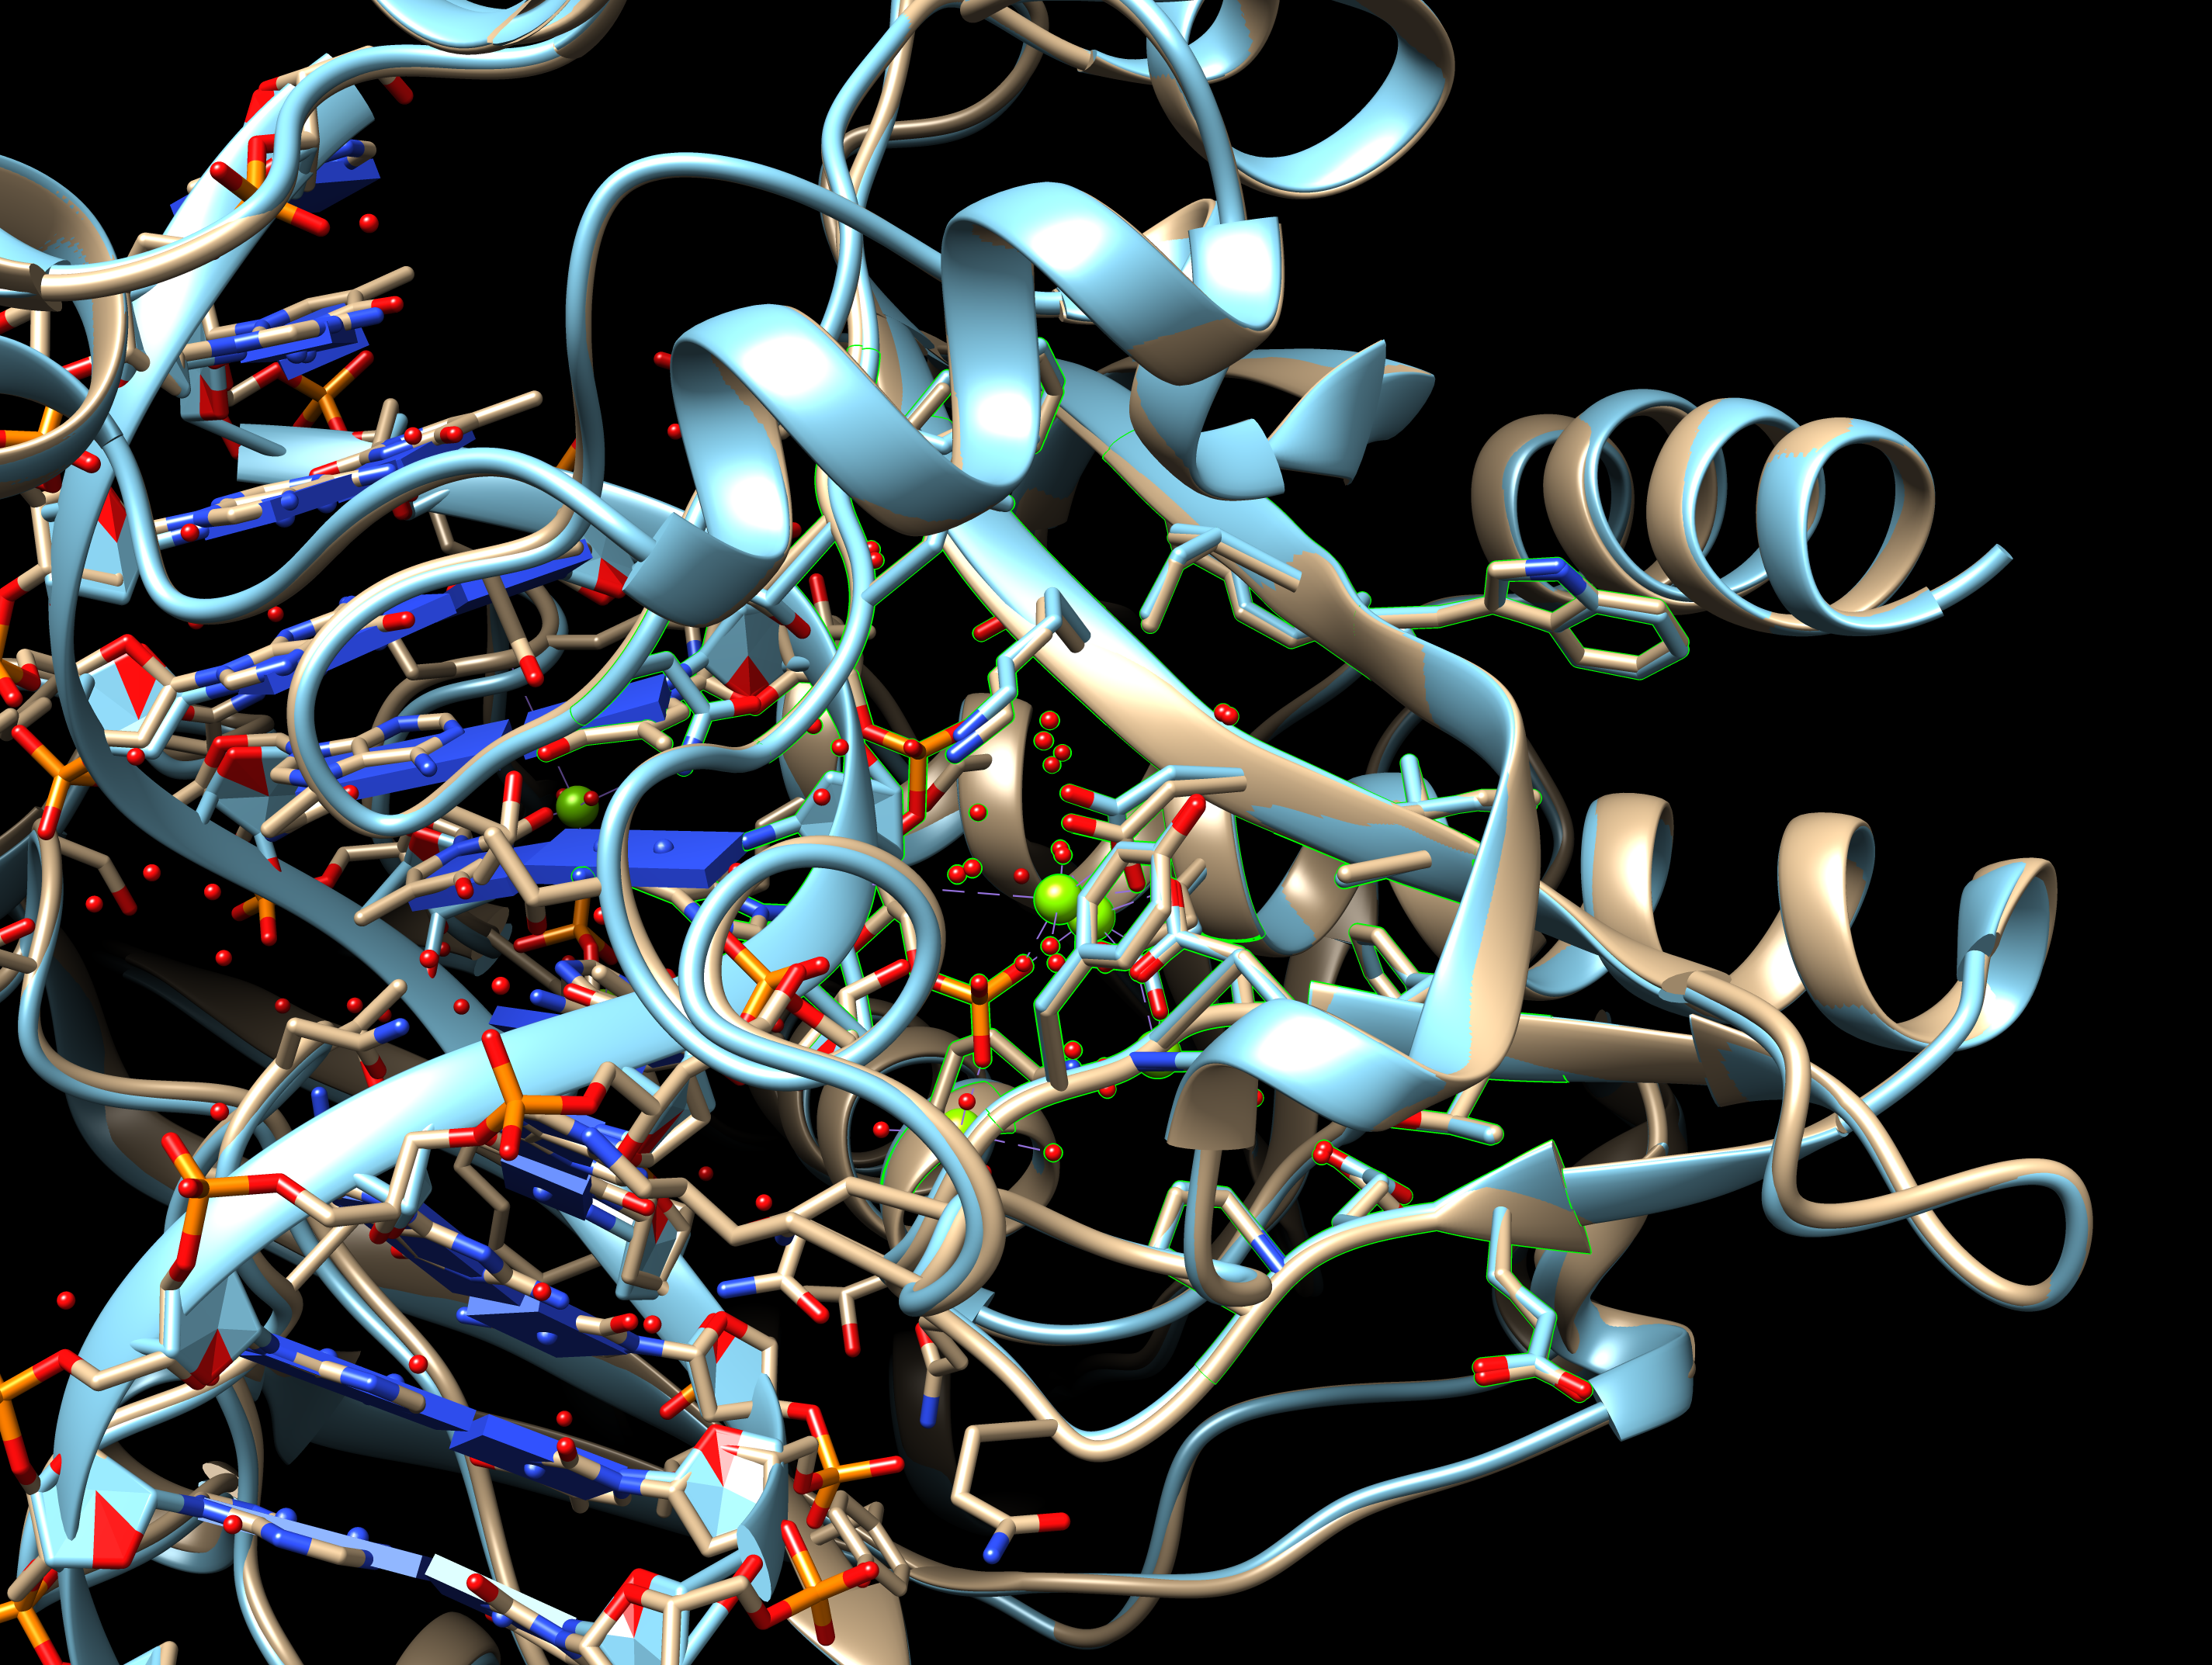

Examine these residues, highlighted with a green halo. What can you say about the nature of residues surrounding the active site residues – are they hydrophilic, hydrophobic, acidic, basic, mixed? You can selectively toggle on and off the structures from the model panel. Favorites … Model Panel … now show or hide the model by clicking on the box in the S column:
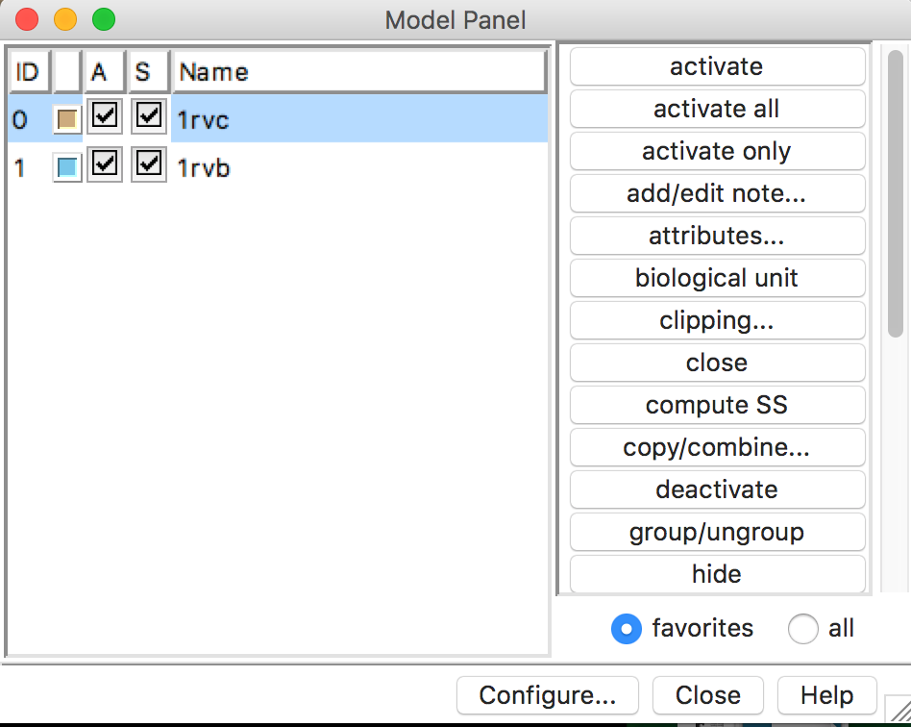

List any 2 amino acid residues that coordinate the Mg atoms in the PDB entries 1rvb and 1rvc.

Do any of the residues selected above form hydrogen bonds? Name it/them.

Display hydrogen bonds within the selected amino acids, click on the following steps:
Tools … Structure Analysis … FindHbond; a new box opens with options for displaying the H-bonds. Check next to the option “Only find H-Bonds – with both ends selected” and press on Apply at the bottom of the window.
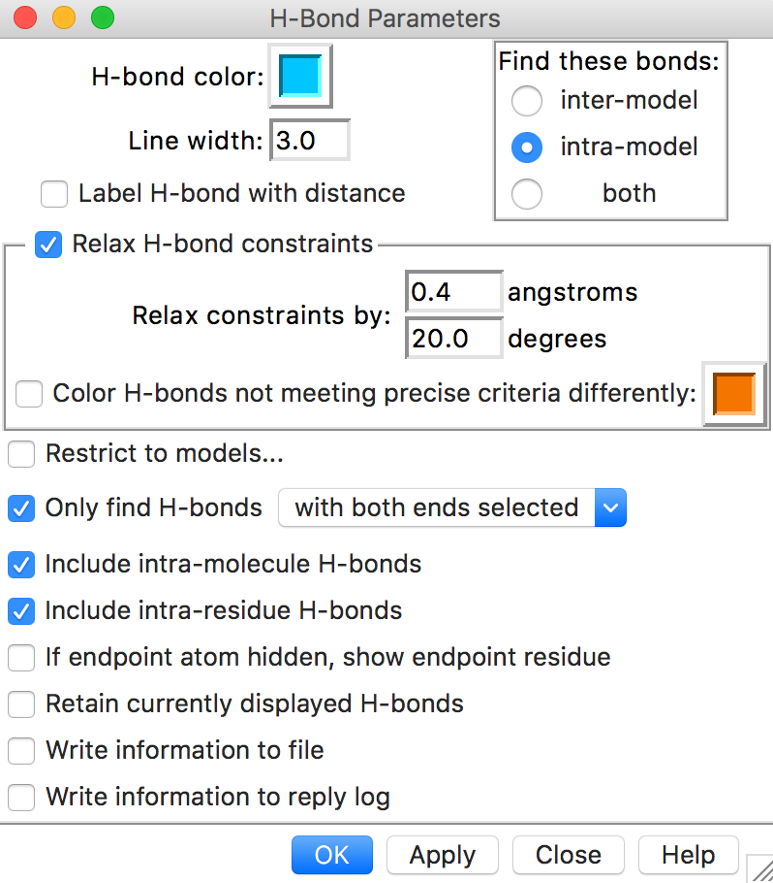
After pressing on OK in the above window, the hydrogen bonds are drawn as follows:
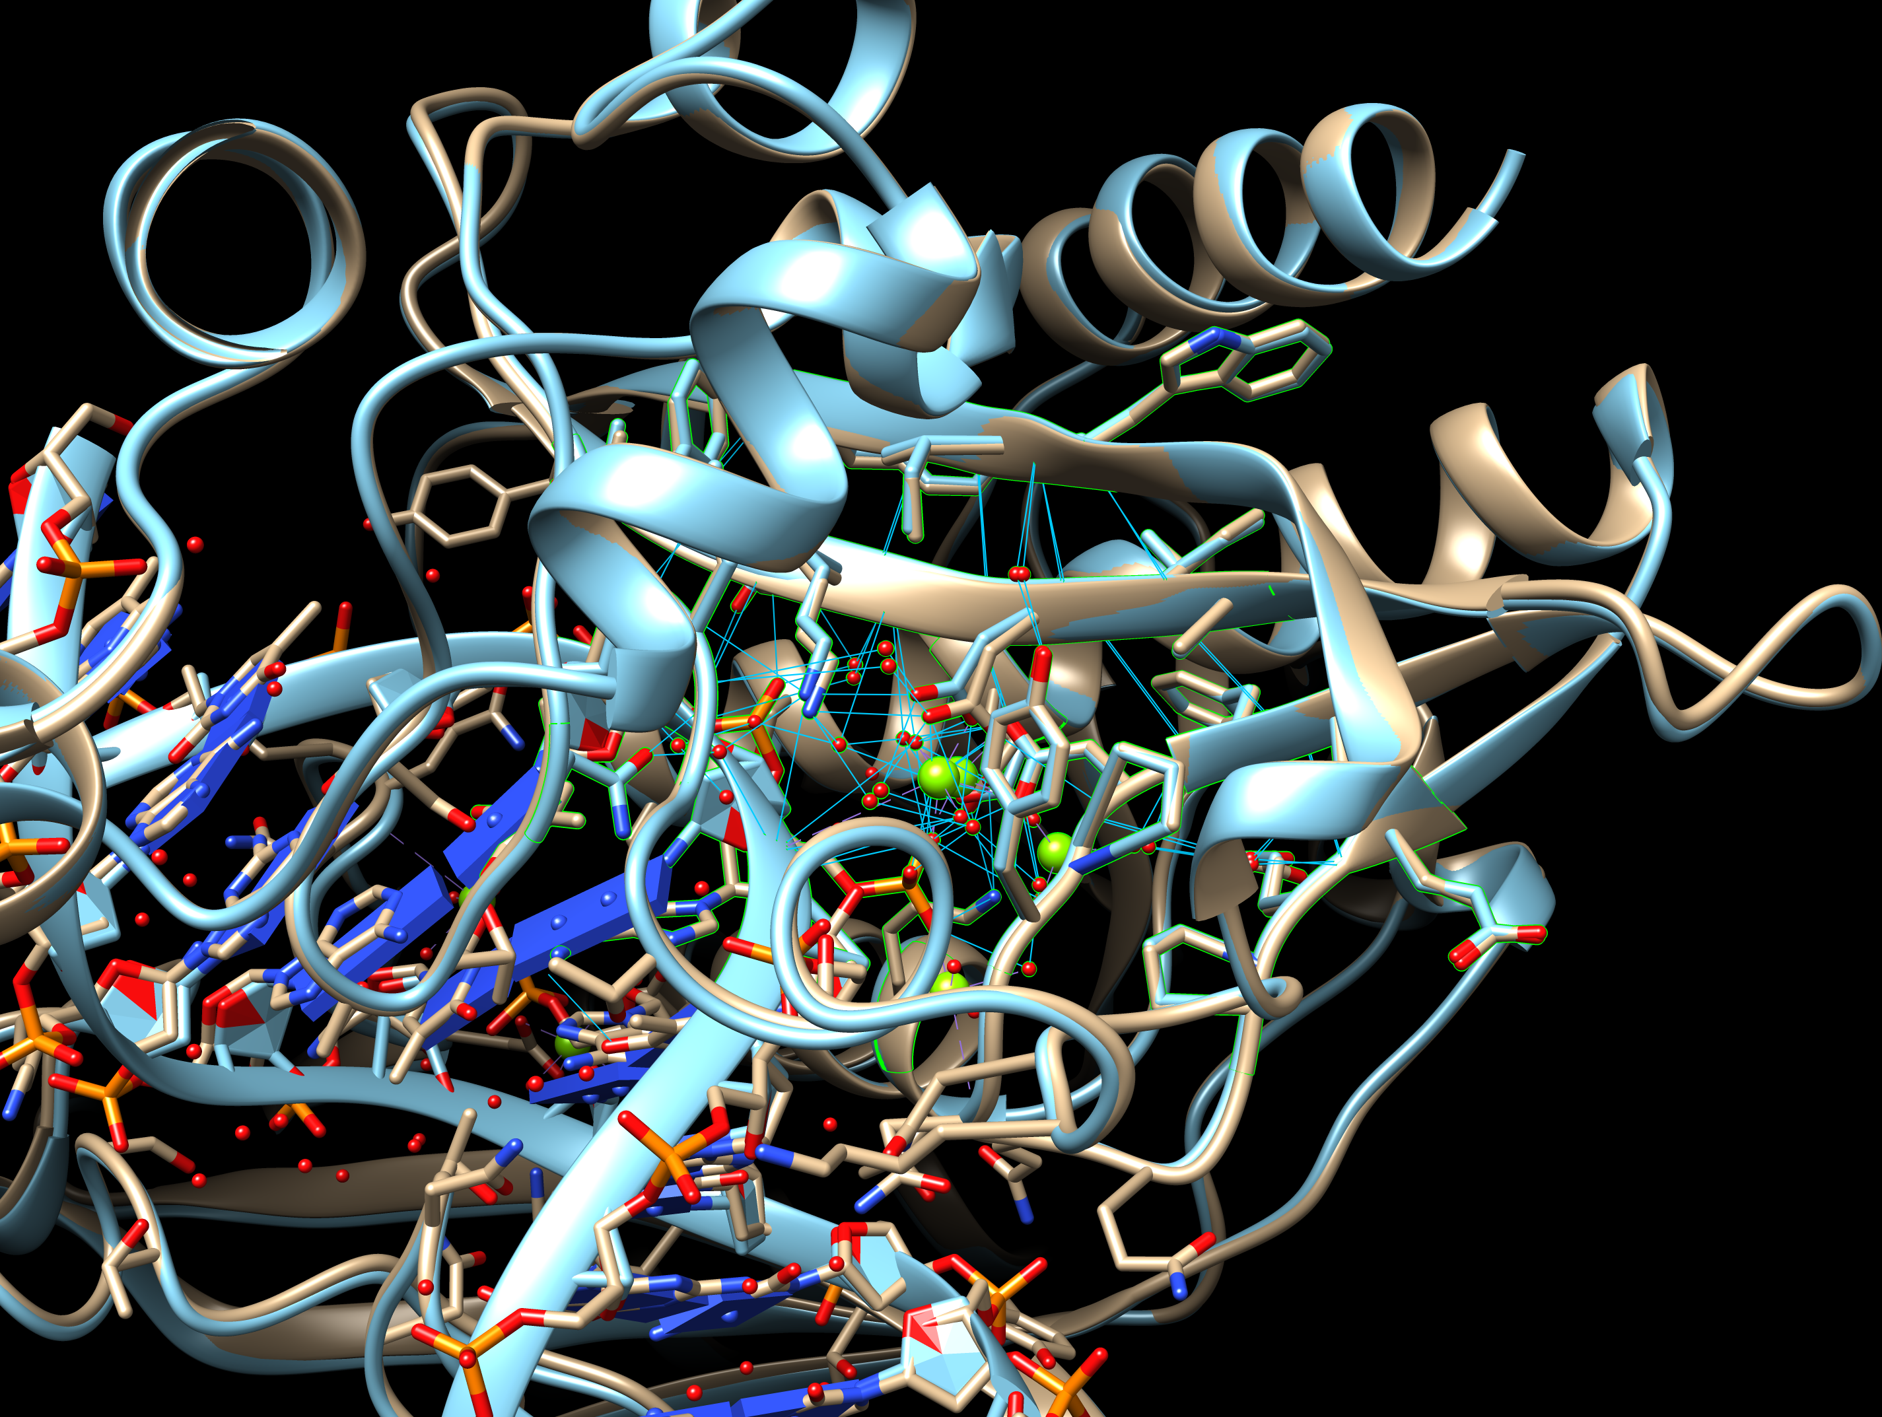

You can examine these interactions for each of the models separately (by selectively turning the models on and off using the Model panel. Mouse over the residues of interest to identify the name, chain identifier and residue number.

Note that the position of the two Mg atoms change in the substrate-bound and product-bound structures. Do the distances between these Mg atoms change too?

To find out, choose Tools … Structure analysis … Distances to open a window with distance measuring options. In the structure display window clear any selection using the menus (Select… Clear Selection) or by Control + Click in any part of the background.
Select the 2 atoms between which you want to measure the distance by using Click on each of the atoms while you simultaneously press on Shift + Control.
Go to the Structure measurements window and click on Create. Note down the distance measured between the 2 selected atoms.
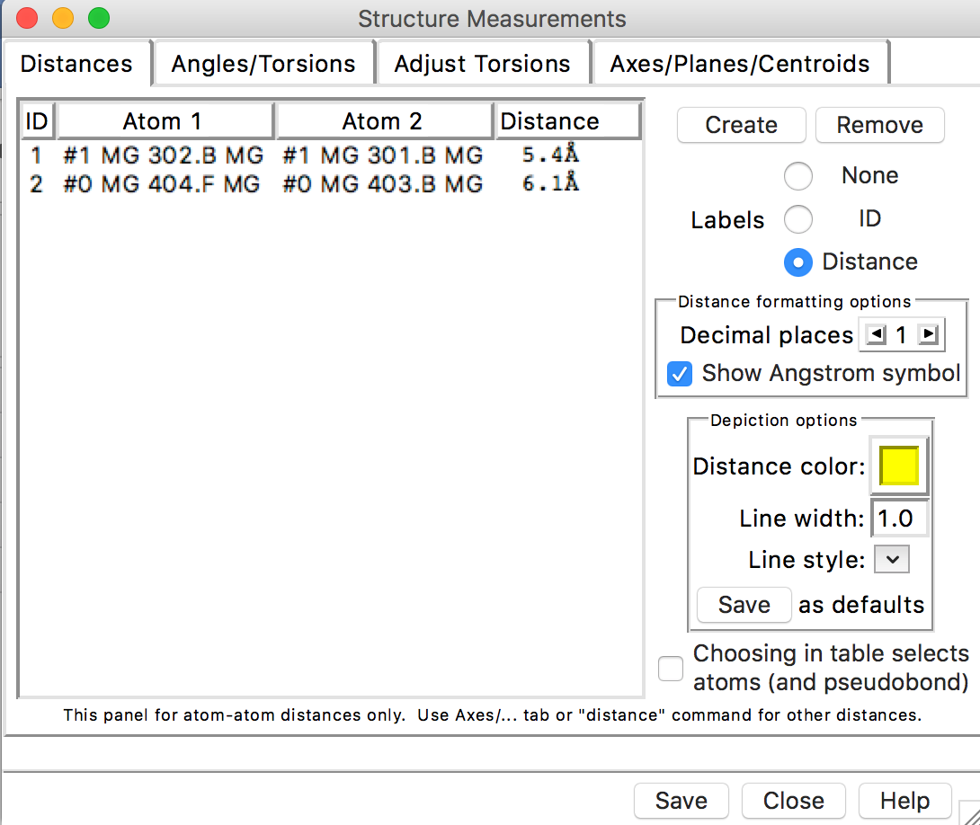

Can you propose how the enzyme catalyzes the cleavage of the DNA strand. Hint: to explore the interactions with the DNA atom you may want to select the DNA (chain D) and hide the ribbon (Action … Ribbon … Hide.

Appendix: Key commands and functions of UCSF Chimera

- What is in the PDB file that I am looking at?
- Upload/fetch file >> Presets >> Interactive 1 >>
- Figure out number and kind of chain (protein/DNA/RNA/saccharide) >>
  - Type PDB ID in top search box at www.rcsb.org >> Open structure summary page >>
  - Read about contents by chain ID AND
  - Mouse over chains to identify chain ID >>

- To Select: See selection (atom, residue, chain etc.) highlighted with a green halo
  - An atom(*)
- Left click on atom in graphics display with Control button pressed
  - A specific residue
- Left click on any atom of residue (see above*) >> press up arrow OR
- Favorites >> Sequence >> see new window with sequence >>
- Mouse over amino acid sequence to see chain ID and residue number >>
- Click-drag on one or more specific amino acid residues in sequence window
  - All residues of a type(#)
    - Select >> Residue >> Standard (or Non-standard) >> select a specific one (or all) OR
    - Select >> Residue >> Amino acid category
  - A chain
    - Left click on any atom of residue (see above*) >> press up arrow twice OR
    - Select >> Chain >> select Chain ID (A or B or C etc.)
  - A specific type of residues within a selected group or chain($)
- Select group/chain (see above) >> Select >> Selection Mode >> Intersect >>
- Select specific type of residue (see above #) >>
- Reset selection mode >> (Select >> Selection Mode >> Replace)
  - A zone (%)
- Select a residue or chain (as above) around which to explore >> Select >> Zone >>
- New window opens >> input the distance within which all residue should be selected >>
- Input/select options to select zone (atoms/residues within specified distance)

- To See or Hide:
- Select residue(s)/chain(s) >> Actions >> Atoms/Bonds or Ribbons or Surface >> Show or Hide

- To explore interactions within or between polymer chains:
  - Find H-bonds
- To find all H-Bonds in structure: Tools >> Structure Analysis >> FindHBond >> OK
- To find ones in a selected set of residues: Tools >> Structure Analysis >> FindHbond >>
- Check on “Only find H-bonds” options (with at least one end or both ends selected) >> OK
  - Find hydrophobic interactions
- Select >> Residues either in entire structure or within a selected set (see above $ or %) >>
- Amino acid category >> hydrophobic >> Action >> Atoms/Bonds >> Show >>
- Examine residues >> Mouse over atoms or Left click on them to identify them
  - Find charge-based interactions
- Select >> Residue >> Amino Acid category >> Negative >> Actions >> Atoms/Bonds >> Show >>
- Actions >> Color >> select color 1
- Select >> Residue >> Amino Acid category >> Positive >> Actions >> Atoms/Bonds >> Show >>
- Actions >> Color >> select color 2
- Locate pairs of amino acid side chains with color 1 and color 2 within proximity of each other
  - Find pi-pi interactions
- Select >> Residue >> Amino Acid category >> Aromatic >> Actions >> Atoms/Bonds >> Show >>
- Examine location and orientation of aromatic rings >> Identify sandwiched, edge-to-face, displaced interactions

- To compare structures:
- Upload/Fetch PDB entry of interest >> Orient/understand all components (polymer chains, ligands) >>
- For complex structure, click on Presets >> Interactive 1 >> this step colors the chains in the polymer >>
- Upload/Fetch one or more PDB entries to be compared >> Tools >> Structure comparison >>
- Matchmaker >> New window opens >> Click to select pairs of PDB IDs - Reference structure (in one column) and Structure(s) to match (in the other) >> OK >> Review the graphics window to see match

- To measure distances:
- Select two atoms – press Shift + Control + Left click on the atoms in the graphics window >>
- Tools >> Structure Analysis >> Distances >> Create - Distance reported in graphics and new window

- To label structures:
- Tools >> Utilities >> 2D Labels >> New Window opens >> Write text and select font, color etc. options >>
- Show or hide label and move to suitable location OR
- Actions >> Label >> select general or Residue options >>
- Edit label color options from Actions >> Color >> All Options >> select Label options in new window

Extra: Make a small movie - you can choose any structure to make a movie.
- Load a structure of your choice and render it in any way that is interesting for you.
Click on Tools … Utilities … Movie Recorder This will open a new window with options for recording a movie. Once you have oriented the molecule, click on the Record button. Now move the molecule manually using the mouse as appropriate. Once you have displayed the details of the structure click on the Stop button. Select the appropriate output format (or use the default) and click on the Make Movie button to encode the movie. The movie will be saved in Output file name (and path) that you provide.

- Another way to make the movie is using a command line mode
Activate the Command line by clicking on Tools … General Controls … Command Line. In the command line, you can use the following command to record a short movie:
movie record; roll y 1 360; wait; turn x 1 360; wait; movie stop; movie encode output ~/Desktop/name.mov
An alternative format is *.mp4

The movies can be played using a movie player, such as Quicktime.

