**Example 1**

Number of lab report in semester: first

This is a submission.

Date submitted: 2018-11-05 14:19:09

Author of this lab report is: Vinnie Wigglesworth

ID: R_235TsCz57LL20qOU8

Course number: 114

TA: Dan Johnson

**AzaGuard Hormone Blocker and Development of the Manduca sexta**

Abstract:

Hormones are important for the growth and development for all organisms. In this experiment, AzaGuard hormone blocker was used in the Manduca sexta. It was predicted that if AzaGuard was used to alter natural hormones, then the growth and development of Manduca sexta would be affected. The data showed that AzaGuard increased the height and weight of the experimental group and prevented the caterpillars from pupating. These results show how the balance and regulation of Juvenile Hormone and ecdysone is crucial for proper maturation and survival of the Manduca sexta and other developing organisms.

Introduction:

The Manduca sexta has a holometabolous life cycle and goes through egg, larvae, pupa, and adult stages. It weighs approximately 1g at the fifth larval instar and can grow to 8-10g in 4-5 days of feeding (Nijhout: 1974). The main hormones responsible for development in the Manduca sexta are PTTH, Ecdysterone, and Juvenile Hormone. A decline of JH in the caterpillar results in development and pupation. This allows the caterpillar to molt and mature into an adult. If natural hormone blockers are altered by using AzaGuard, then the growth and development of Manduca sexta will be affected.

Materials and Methods:

8 Manduca sexta caterpillars were selected and divided into 2 groups of 4. Each caterpillar was placed in its own section of a plastic container and fed 1 of 2 diets. The control group received 10g of normal diet mixed with 10 drops of water. The experimental group received 10g of normal diet mixed with 10 drops of AzaGuard hormone. The 2 groups were kept in identical conditions of temperature, light hours, and were fed at the same time. The caterpillars were measured and weighed daily and these results were recorded. A T-Test was used to determine the significance of the difference seen between the control and experimental groups.

Results:

Generally, the experimental and the control weights and heights increased over the first 3 days and then declined. The experimental group was consistently longer than the control group (Figure 1). The experimental group was heavier than the control group for the majority of the experiment (Figure 2). The average weight of the control group was 5.67575g and the average weight of the experimental group was 5.93475g. A two-sample T test revealed that one tailed p-value for weight was 0.320391 and the two-tailed p-value was 0.640782. The average length of the control group was 5.79625 and the average for the experimental group was 6.0725. A two-sample T test revealed that one tailed p-value for length was 0.228202 and the two-tailed p-value was 0.456403.

Discussion:

The results support the hypothesis that if natural hormone blockers are altered by using AzaGuard, then the growth and development of Manduca sexta will be affected. The Azaguard initially increased the height and weight of the experimental group compared to the control group. It prevented the JH levels from dropping, which did not allow the experimental group to pupate and develop. Eventually the experimental group lost weight and died while the control group pupated. This shows that the caterpillars cannot sustain a life in the juvenile stage.

Literature Cited:

NIJHOUT*, H. 1974. CONTROL OF MOULTING AND METAMORPHOSIS IN THE TOBACCO HORNWORM, MANDUCA SEXTA (L.): CESSATION OF JUVENILE HORMONE SECRETION AS A TRIGGER FOR PUPATION. http://jeb.biologists.org/content/jexbio/61/2/493.full.pdf, accessed September 24, 2018.

Figure Legends:

Figure 1

Figure 2

Figures and Tables:

Figure 1

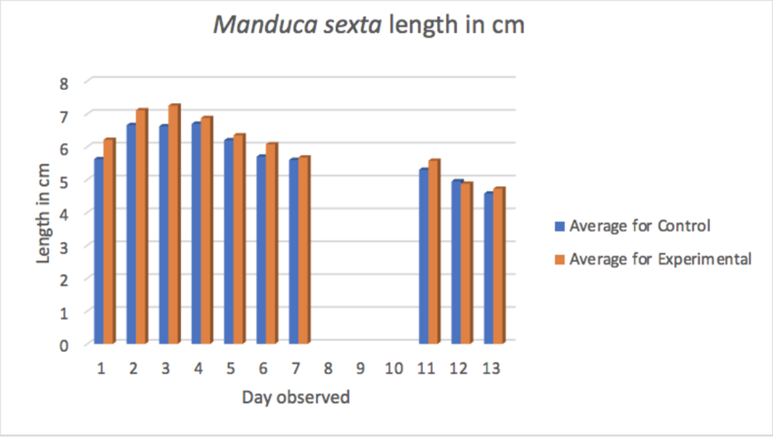

Figure 2

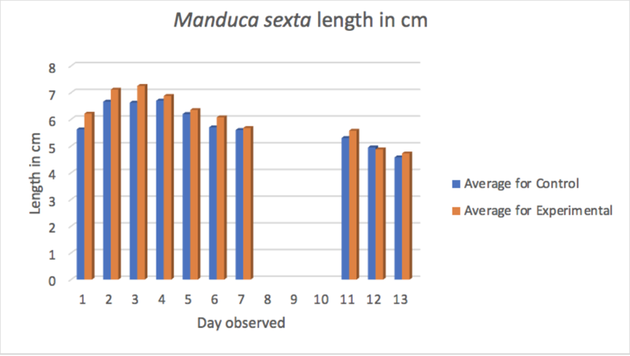

**Example 2**

Number of lab report in semester: first

This is a submission.

Date submitted: 2018-11-05 14:19:09

Author of this lab report is: Rosie Yalow

ID: R_235TsCz57LL20qOU8

Course number: 114

TA: Dan Johnson

**The Effect of AzaGuard Botanical Insecticide on Manduca sexta Development**

Introduction

The purpose of this experiment is to assess the influence of hormones on the growth and development of Manduca sexta. Hormones are chemicals in insects and mammals that promote specific gene expression. This alteration in expression can be shown through things such as the process of puberty, in which growth can either be inhibited or accelerated.

One example of an organism that may experience these effects due to hormones is the Manduca sexta. The Manduca sexta, also known as the Carolina Sphinx, is a large green caterpillar commonly found in the Eastern United States and Central & South America (Kanost, M. et. al : 2016). The life cycle of the M. sexta can be longer or shorter depending on the quality or diet available, average daily temperature, and hormone regulation. The M. sexta goes through a Holometabolous life cycle, which means using hormone – based and neuron based signaling to control growth, development, and behaviors.

Hormones such as Juvenile Hormones (JH) and Ecdysterone (20E) are known to have an effect on the life cycle and commitment pulses of insects. In this study, we are looking specifically at the effect of AzaGuard on these hormones. AzaGuard is an insect growth regulator known to have an effect on insect development by interfering with the metabolism of ecdysone (Echegaray, E. R., & Cloyd, R. A. : 2012). And because Ecdysterone is a steroid hormone which helps to regulate the timing of molts during insect development, it is believed that if AzaGuard is added to the diet of Manduca sexta, then they will reach adult moth stage faster than those larvae who do not have the growth regulator added to their diet.

Materials and Methods

*Cultivation of Manduca sexta*. Before the instar larva were placed into their respective observation chambers, two holes were punctured (with a metal bar and hole puncher tool) into each of the chamber compartments. There were four compartments in one chamber. Next, 8 Manduca caterpillars all in varying larva instar stages were then collected and placed into one of two observation chambers. Each caterpillar was placed in its own compartment in both the control and experimental chambers. One observation chamber was designated to hold the control group, consisting of 4 caterpillars, and the other observation chamber was designated as the experimental group, holding the other 4 non-control instar larvae.

In the experimental group, each caterpillar was fed 10g of previously prepared food with 5 drops of AzaGuard hormone (hand-mixed) mixed in. In the control group, each was fed 10g of previously prepared food with 5 drops of water (hand-mixed) mixed in to match the consistency of food presented to the experimental group. Manduca were kept in an incubator at a set 32 degrees Celsius when not being measured.

*Manduca Measurement*. The resulting length and weight of the caterpillars was observed and recorded over a period of two weeks. Each instar larva was weighed using a standard lab balance and measured in length (from head to end in cm) using a standard 12-inch ruler. During experimentation, if caterpillars were thought to need more food, they were given another 10g of food mixed in with either water or hormone depending on which group they belonged to.

*The statistical analyses.* A two-tailed two-sample T-test was used to determine differences in the average weight and length of Manduca sexta developing over time with exposure to AzaGuard (which interferes with the effects of Ecdysterone) compared to caterpillars not exposed to any additional hormone.

Results

The Mean mass of the control group of M. sexta was 5.786 with a standard deviation of 0.970, and the mean mass of the experimental (AzaGuard) group of M. sexta was 4.454 with a standard deviation of .780 (Table 1). The Mean length of the control group of M. sexta was 6.013 with a standard deviation of .737, and the mean length of the experimental group of M. sexta was 6.208 with a standard deviation of .530 (Table 1). All data mentioned is rounded to the nearest 1000th place.

We used a two-sample t-test to analyze our results. The mean weight of the control group was statistically significantly different than that of the weight experimental group (t-stat = 3.210, df= 16, P = 0.005). However, the mean length of the control group was not statistically significant compared to the mean length of the experimental group (t-stat = 0.642, df= 16, P = .530). Those in the experimental groups rapidly decreased in weight while those in the control group maintained a fairly steady decline and leveled-off weight (Figure 1). There were no noticeable differences in length for the experimental and control groups (Figure 2).

Discussion

Our hypothesis, that if AzaGuard is added to the diet of Manduca sext, then they will reach adult moth stage faster than those larvae who do not have the growth regulator added to their diet, was not supported. When observing the caterpillars during the final stages of the experiment there was a noticeable visible difference in the development between the two groups. Those in the control group had either begun the pupa stage or reached the final instar larva phase. Meanwhile, those in the experimental group had either died or not developed past their initially observed instar phase.

Overall, those in the experimental groups rapidly decreased in weight while those in the control group maintained a fairly steady decline and leveled-off weight. This would make sense, as in past investigations it has been found that these insects in this experimental group (consuming AzaGuard) tend to eat less as the experiment goes on (Echegaray, E. R., & Cloyd, R. A. : 2012). This could suggest that the AzaGuard interferes with ecdysterone negatively and essentially inhibits development of the insect, shown through symptoms of things like weight loss and lost appetite.

The next logical step for this experiment would be to see to what concentration or levels of AzaGuard it would be considered a "safe" amount to expose insects or specifically the Manduca sexta to. And another extension of this experiment would be to compare this data to data that looks at the amount of the insecticide or insecticides like AzaGuard in the field, and how that affects populations of M. sexta.

Literature Cited

Echegaray, E. R., & Cloyd, R. A. (2012). Effects of reduced-risk pesticides and plant growth regulators on rove beetle (coleoptera: Staphylinidae) adults. Journal of Economic Entomology, 105(6), 2097-2106. doi:10.1603/EC12244 .

Kanost, M. R., Arrese, E. L., Cao, X., Chen, Y., Chellapilla, S., Park, Y. (2016). Multifaceted biological insights from a draft genome sequence of the tobacco hornworm moth, manduca sexta. Insect Biochemistry and Molecular Biology, 76, 118-147. doi:10.1016/j.ibmb.2016.07.005

Legends:

Figure 1: This graph shows the average change in weight of the M. sexta over time for the experimental and control groups.

Figure 2: This graph shows the average change in length of the M. sexta over time for the experimental and control groups

Table 1: This table shows the overall averages, p-values, and standard deviations of weight after the experimentation period for control (Section A) and experimental groups (Section B)

Table 2: This table shows the overall averages, p-values, and standard deviations of length after the experimentation period for control (Section A) and experimental groups (Section B)

Figure 1

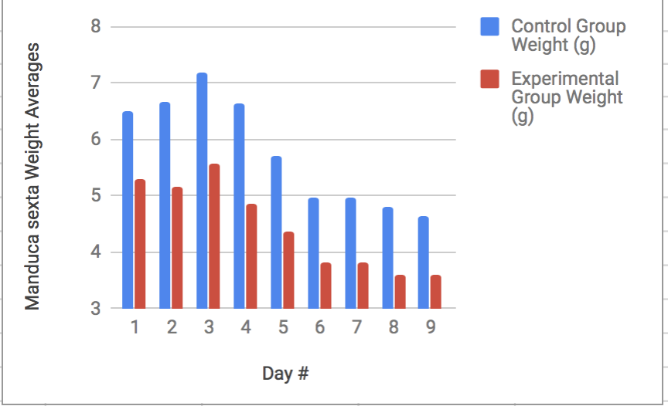

Figure 2

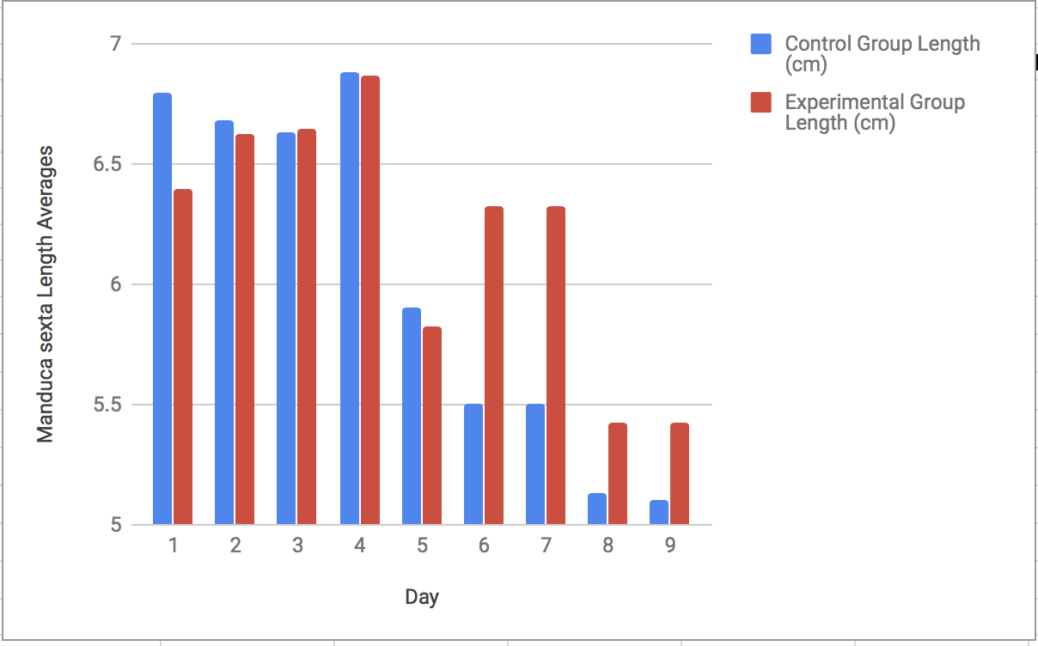

Figure 3

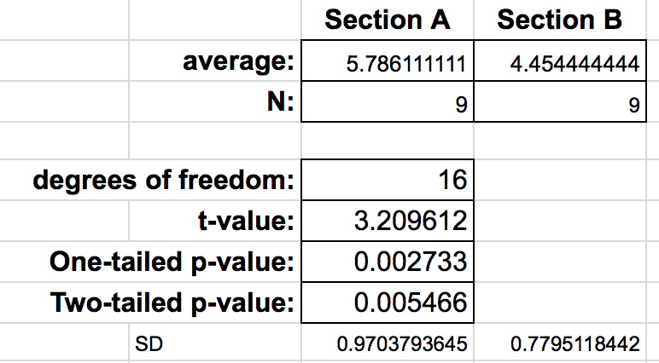

Figure 4

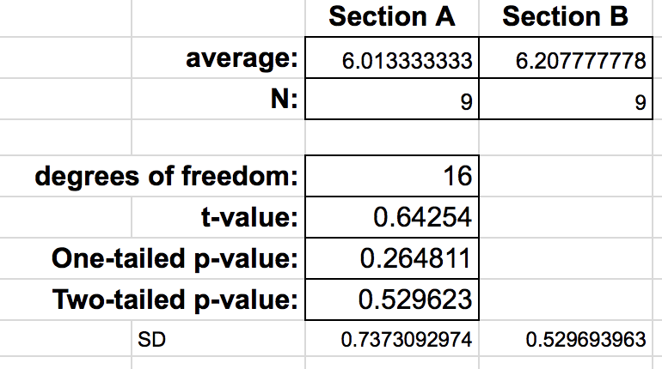

**Example 3**

Number of lab report in semester: first

This is a submission.

Date submitted: 2018-11-05 14:19:09

Author of this lab report is: Gerti Cori

ID: R_235TsCz57LL20qOU8

Course number: 114

TA: Dan Johnson

**Effect of Azaguard on Manduca sexta pupation**

Abstract

I forgot to add this

Introduction

The tobacco hornworm, Manduca sexta depends on two essential hormones, juvenile hormone (JH) and ecdysterone (20E), for the organization and maintenance of its life cycle. Because of its large size, the fact that it can be precisely staged and that it is reared on an artificial diet (see Gilbert et al., 1980), it has been possible to accumulate a considerable amount of data on the three principal hormones controlling its growth and development [Bollenbacher:1981]. JH is present in higher levels during the larval stage of the Manduca sexta and regulates the type of molt development, while 20E spikes during metamorphosis and pupation and regulates the timing of molting during insect development.

To signal that the Manduca sexta has grown large enough, a commitment pulse (small increase in ecdysteroids prior to 5th larval stage) is carried out. In general, it appears that there are three components of the ecdysteroid titer that influence the development of an insect: temporal, quantitative and qualitative [Bollenbacher: 1981]. The temporal component includes the time at which a change in titer occurs and the duration of that change; the quantitative component is the change(s) in the absolute amount(s) of ecdysteroids present; and the qualitative component represents the types of ecdysteroids that comprise the titer [Bollenbacher: 1981].

The present study will be examining what will happen if 20E is inhibited in the Manduca sexta leading up to pupation. The study will address the importance of the commitment pulse and subsequent 20E levels for successful pupation to occur. It is predicted that a decrease of 20E, due to the administration of the 20E inhibitor Azaguard, will result in unsuccessful pupation for the Manduca sexta. The effects of the 20E inhibitor will be measured by observing weight (g) and length (mm) as well as taking general observations over two weeks.

Materials and Methods

Manduca sexta were separated into equally sized experimental and control groups. The experimental group received 3 drops of Azaguard for every 10g of artificial diet, while the control group received 3 drops of distilled water for every 10g of artificial diet. All caterpillars were stored in an identical incubator. More food was added as seen necessary. Weight (g) and length (mm) were recorded once a day for two weeks. We used a two sample t-test to compare the weight and length respectively of the two groups.

Results

After two weeks it was found that the four Manduca sexta in the control group were all still alive, while the treatment group had zero subjects still alive. The treatment group had all deaths occur at some point between day 10 and day 15. The control group average weights experienced a larger percentage of growth than the treatment group (111% compared to 44% from day one to max weight). The control length compared with the treatment length has a similar pattern, although to a lesser extent, with the control group experiencing a 31% growth with day one being compared to max average length, while the treatment group experienced a 21% increase.

Both groups saw a similar pattern of weight and length increase for the first four days and then a decrease in both weight and length for the remainder of the study. The standard deviations for the control group were 1.236 for the weight and 7.011 for the length. The standard deviations for the treatment group were 0.816 for the weight and 6.200 for the length.

The caterpillars from the control group all underwent pupation by the end of the study, while only one subject from the treatment group started pupation before dying. We used a two tailed t-test to examine statistical significance. The t-value in comparing the weights of the two groups was 6.054 and the p-value was 4.30 x 10^(-6). The t-value in comparing the lengths of the two groups was 2.842 and the p-value was 0.00948.

Discussion

The hypothesis that introduction of a 20E inhibitor to the Manduca sexta diet would have a negative effect on pupation was proven to be correct. Due to the fact that 20E is necessary for a successful commitment pulse and during the experiment the commitment pulse would have been inhibited, the test subjects in the treatment group did not successfully pupate and instead died. For a successful molt to occur the pupation stage must observe a 20E rise much higher than JH levels. However, when we inhibited the secretion of 20E, the rise in 20E was not able to occur. Our caterpillars that received the 20E inhibitor all died without successfully entering the pupal stage, which is due to the inability to undergo a successful commitment pulse.

The 20E inhibitor also limited the growth of the treatment group, which further explains why the commitment pulse was unsuccessful. The treatment caterpillars did not reach a large enough size to where they had enough nutrients stored up for a successful pupation. Although we were not able to collect data from day 11-13, our data still showed significant correlation.

Our study was found to be statistically significant in that our p-value was well under .05 in comparing both weight and length of the different groups. This means that we can say to a greater than 95% (in our case greater than 99%) certainty that our data was not due to chance. For future experimentation we would first add more caterpillars to the study so that each group had a larger data set. We would also check in on the caterpillars every day to gain a more precise picture of 20E inhibitor effects. If the results from that experiment match what we have learned already, we would move into testing what amount of 20E inhibitor causes the unsuccessful pupation of the Manduca sexta.

Literature Cited

Bollenbacher WE, Smith SL, Goodman W, Gilbert LI. 1981. Ecdysteroid Titer during Larval- Pupal- Adult Development of the Tobacco Hornworm, Manduca sexta. General and Comparative Endocrinology. 44: 302-306.

Figure: 1

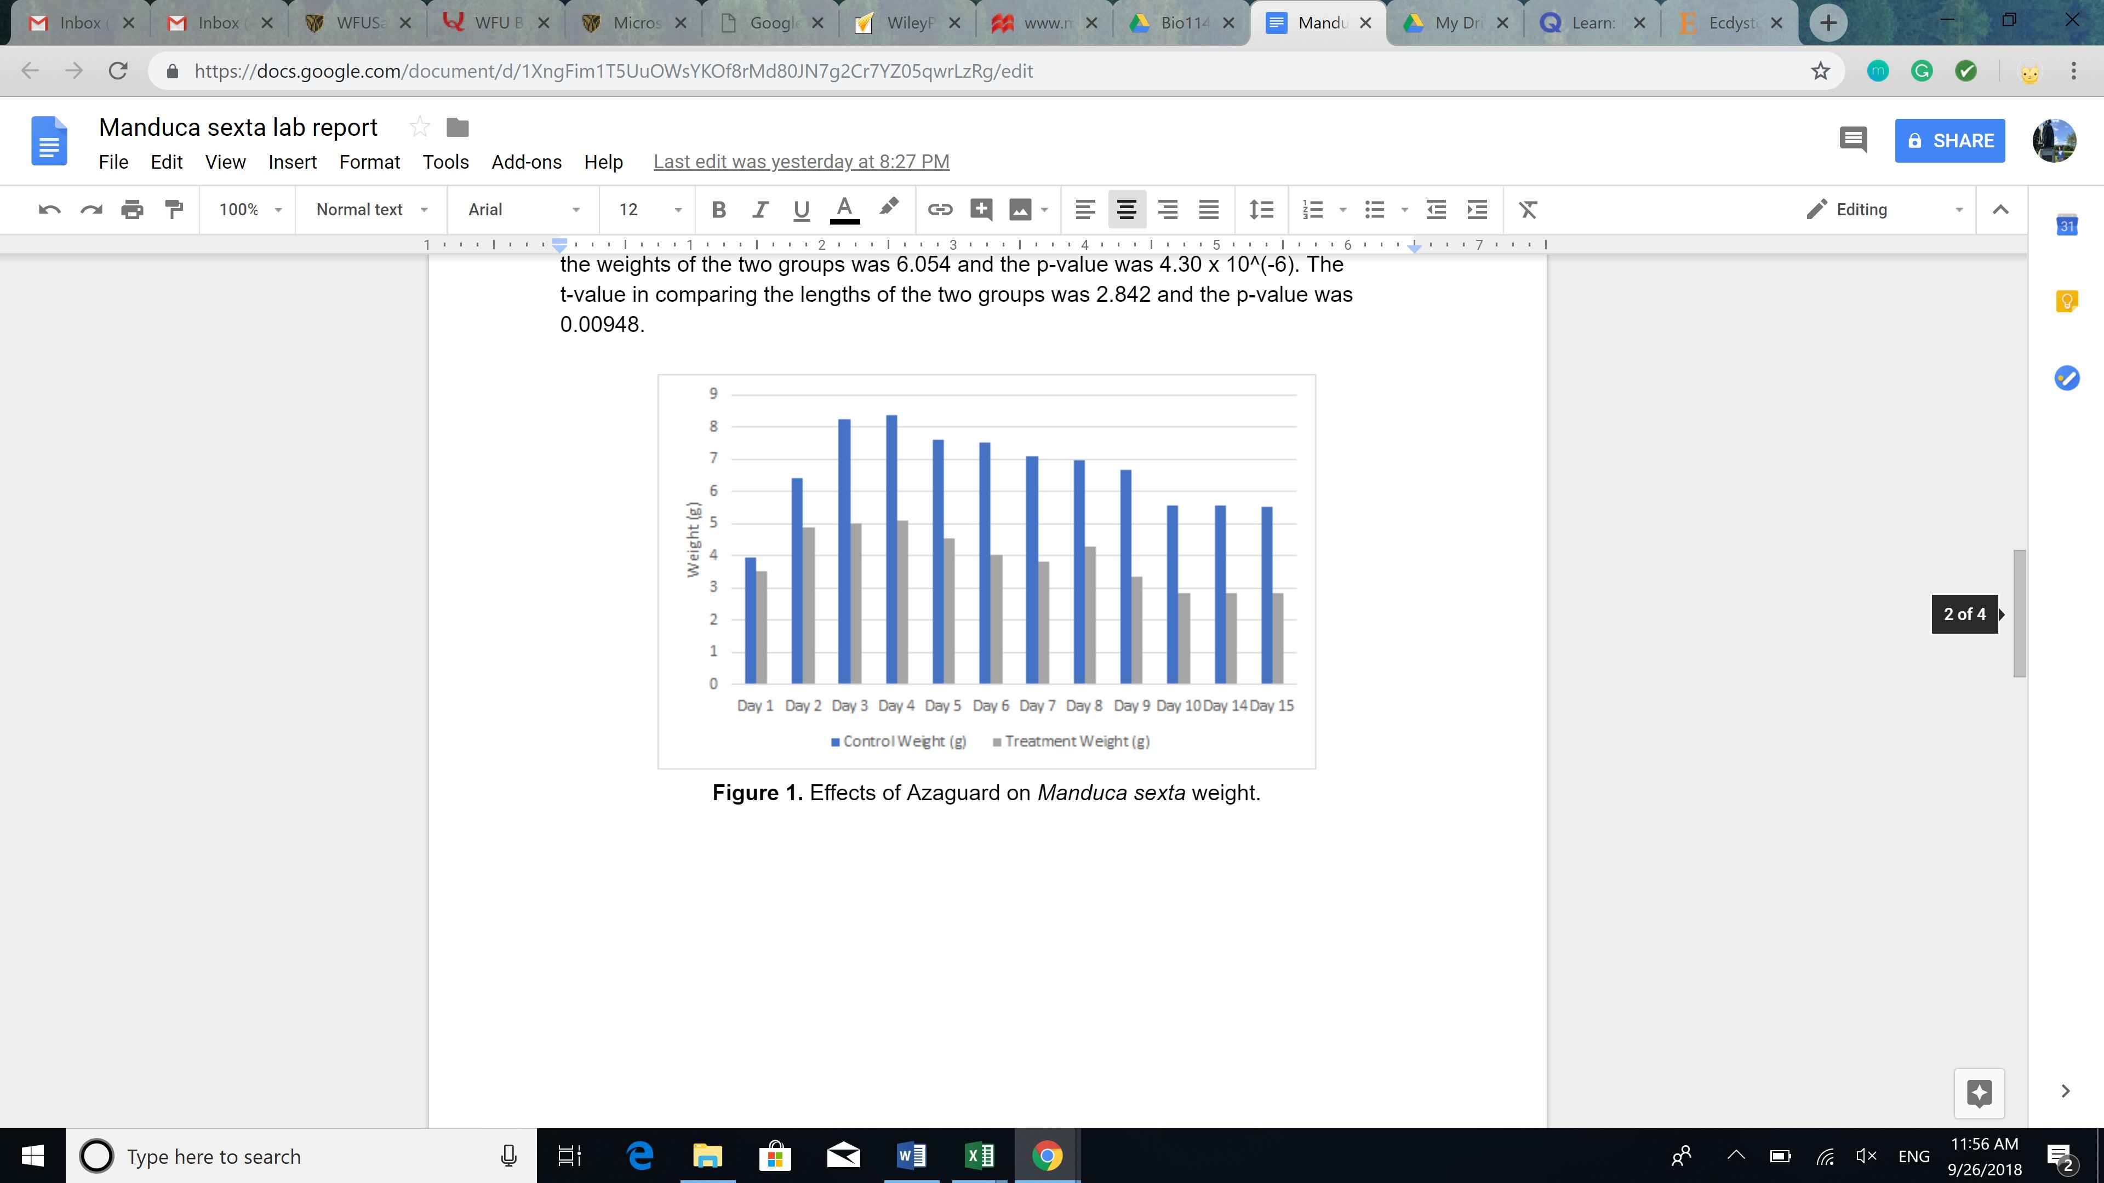

Figure: 2

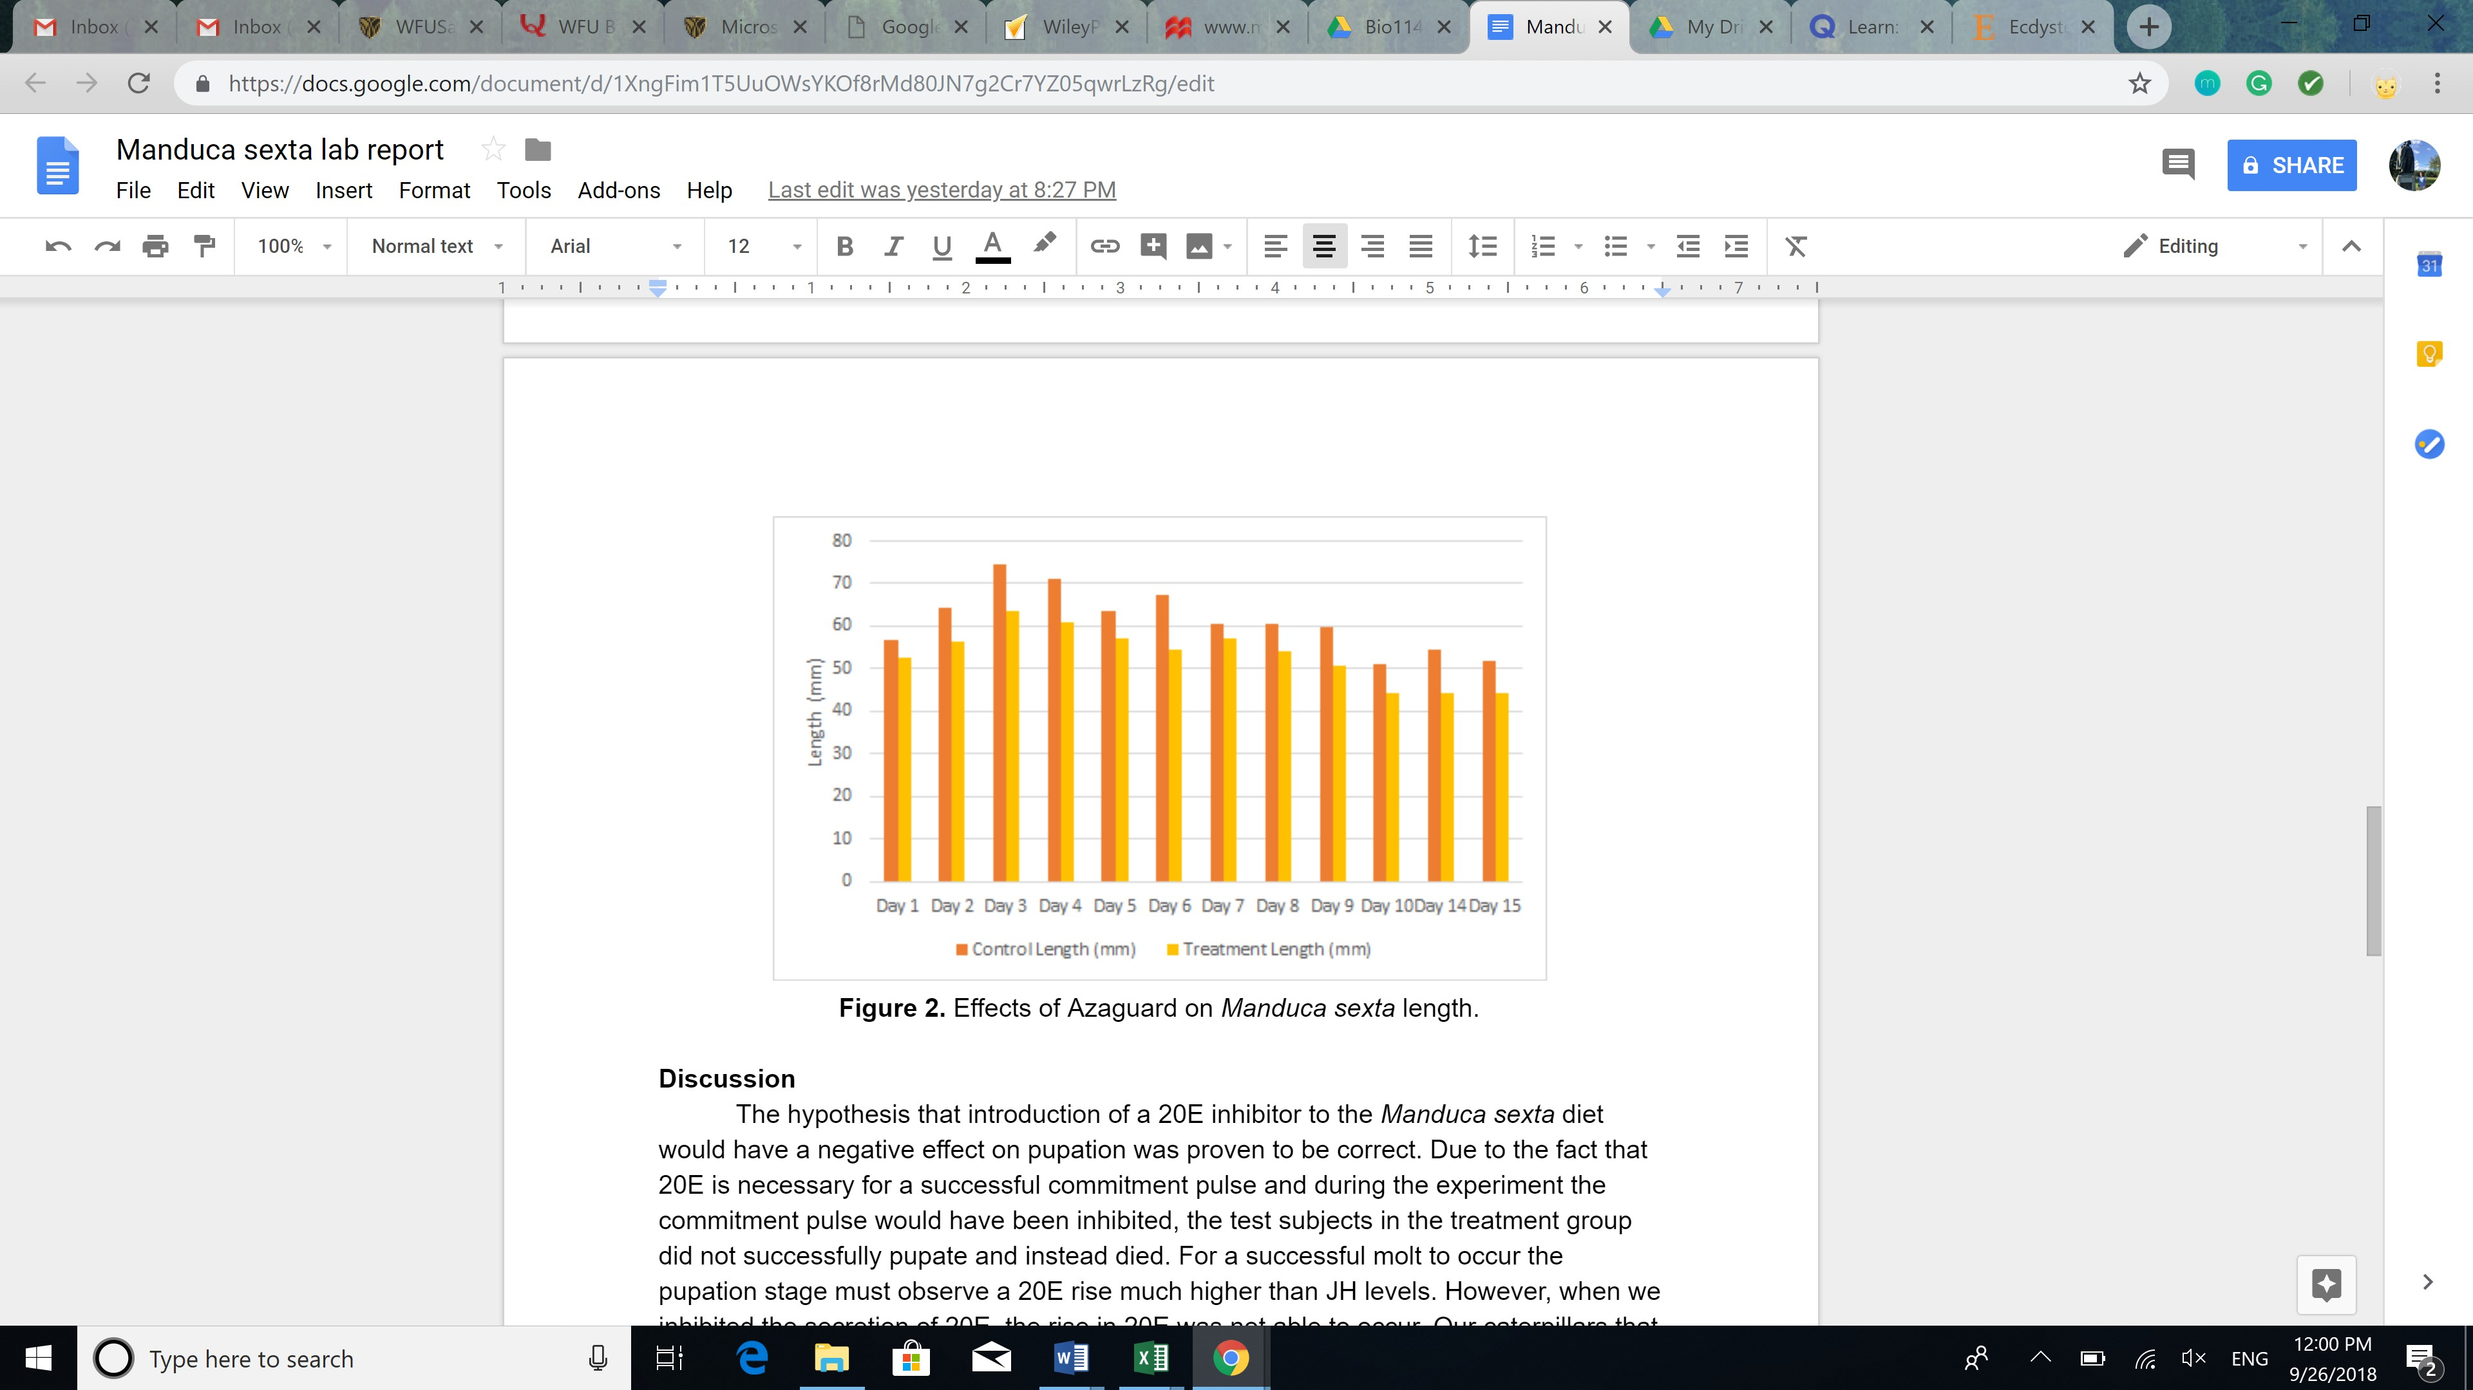

Figure Legends: Figure 1. Effects of Azaguard on Manduca sexta weight. Figure 2. Effects of Azaguard on Manduca sexta length.

**Appended Example of Feedback for This Report**

Normally this report would be flagged and rejected automatically by our pre-evaluation process because it lacks an Abstract (which was required at the time this report was submitted.) For demonstration purposes the Sections filter was turned off so SAWHET could generate a rules-based feedback report.

Students would receive a copy of their submitted report with this appended feedback by email within 5 minutes of posting a report online.

**\*\*\*\*\*\*\*\*\*\*\*\*\*\*\*\*\*\*\*\*\*\*\*\*\*\*\*\*\*\*\*\*\*\*\*\*\*\*\*\*\*\*\*\*\*\*\*\*\*\*\*\*\*\*\*\*\*\*\*\*\*\*\*\*\*\*\*\*\*\*\*\*\*\*\*\*\***

**Automated Feedback from SAWHET**

**Disclaimer:**

*This section contains feedback that was automatically created by SAWHET, the lab report submission software of the Biology Department.*

*SAWHET is trained to detect the most common problems found in lab reports, and give you useful feedback. Please read through the comments carefully, and think about the advice. Sometimes though, SAWHET makes mistakes and flags something as a problem when it is not. In that case, you can just ignore the comment.*

*Also, please remember that SAWHET is only programmed to give you advice about the most common errors found in lab reports. It catches mainly errors in organization and format. Other issues such as flaws in how you report data and scientific writing problems will be commented on by your TA. Think of SAWHET and your TA as a team dedicated to helping you write better.*

**Title**

SAWHET did not detect issues in this section.

**Abstract**

1. The abstract seems too short. The abstract is a summary of the paper and contains the most important information of EACH section. Make sure that you included a bit of Introduction, Materials and Methods, Results, and Discussion in your abstract.

**Introduction**

1. SAWHET detected some issues with your citation format. The correct citation format is: [LastnameFirstAuthor: Year], for example [Smith: 2002]. If you are citing more than two papers, it would be [LastnameFirstAuthor: Year; LastnameFirstAuthor: Year]. Please revise accordingly.

2. Make sure the Introduction doesn't contain too many details, especially for the Materials and Methods part. For example, information on how much mM will be used usually is too detailed and should only be mentioned in the Materials and Methods section.

**Materials and Methods**

1. SAWHET detected that your Materials and Methods section is a bit short. This could indicate that some necessary information is missing. The Materials and Methods section should contain a detailed description of what you did during the study, including chemicals, procedures, and analyses. The intent is to make the research reproducible and transparent. If you are not sure what is sufficient detail, look at primary literature articles for examples.

**Results**

1. It looks like this section is a bit long. You might have information in this section that belongs to either Materials and Methods or to Discussion. The Results section should only contain the outcomes of the study without any interpretation of the results or how the outcome was obtained. It could also be that your text is a bit repetitive. If so, please revise accordingly.

2. SAWHET did not find any reference to figures or tables in your Result section. If you do not have graphs or figures that display your results, please think carefully if there is a good reason why not. Usually, all scientific papers have outcomes graphically represented in graphs or figures. If you have figures and graphs, make sure you point to them in your Results section.

**Discussion**

1. SAWHET could not detect any citations. The Discussion section is where you compare your results with what others have found, so there need to be citations. You are required to cite at least one primary resource (and the lab manual is not a primary resource!), but more usually is better because it shows that you are evaluating your results from different angles.

2. It looks like you are using words like ‘correct’, ‘proven’ or ‘wrong’ to describe the outcome or outlook of your experiment. This is problematic because it implies that experiments can be either correct or wrong and that hypotheses can be proven. All we can do with experiments is to support or reject a hypothesis. Also, data that oppose a hypothesis are not wrong, they just do not support our thinking.

**Literature**

SAWHET did not detect issues in this section.

**\*\*\*\*\*\*\*\*\*\*\*\*\*\*\*\*\*\*\*\*\*\*\*\*\*\*\*\*\*\*\*\*\*\*\*\*\*\*\*\*\*\*\*\*\*\*\*\*\*\*\*\*\*\*\*\*\*\*\*\*\*\*\*\*\*\*\*\*\*\*\*\*\*\*\*\*\***

**Instructor Comments, Notes**

* This paper also would be flagged for review for minor plagiarism. A citation referenced in the Introduction is not included in the Literature Cited.