GTAs’ Report Grading Guide
(Note: this is an excerpt from a larger GTAs Handbook we provide as part of initial training.)

Before You Start Grading
Remind yourself what our lab program philosophy and learning goals are. Remember, these goals cannot be achieved in 1-2 semesters; 100-level labs emphasize mastery at an appropriate introductory level of foundational process, thinking, analysis, and communication skills.
- We want to help undergraduates:
  - Develop authentic, transferrable process and thinking skills they can use in many situations, not become experts in one field.
  - Learn to work as part of a productive, self-directed team.
- Technical skills that we want students to develop are:
  - Experimental design, hypothesis generation and basic statistical analysis
  - Data management, specifically:
    - Documenting work in notebooks
    - Summarizing and analyzing data using Excel and similar tools
  - Scientific communication
    - Reading and discussing primary literature with peers
    - Scientific writing
    - Peer review
- Mindset & thinking skills we want students to begin developing are:
  - Evidence-based thinking. At this level we want students to:
    - Make a habit of providing evidence to support claims or statements, either statistically or by referencing appropriate resources.
    - Start using data and prior evidence to inform experimental designs, rather than performing experiments then looking for supporting data.
    - In science, a null result is not failure.
  - Self-regulation. Students should learn to find their own answers and evaluate their own work. This begins with things as simple as expecting students to:
    - Refer to and follow guidelines we provide; and
    - Respond to feedback by self-correcting their work.
  - Resilience- and growth-oriented mindset.
    - Scientific process skills are not innate; they develop over time.
    - It is okay & even beneficial to fail if we learn from it and improve.

Remind yourself what should be in lab reports. This is described in detail in the BioCore Writing Resource Guide.
- General requirements and format are the same for all BioCore lab courses.
- We STRONGLY urge every TA to review the report grading guidelines regularly.
TAs should not change or modify the practice activities, format requirements, due dates, or other parts of lab reports without getting express permission from the Lab Coordinators first.

Grading Procedure

Criteria
These are the criteria we use to assign scores to lab reports. They can be divided into basic criteria, technical flaws, and writing quality flaws.

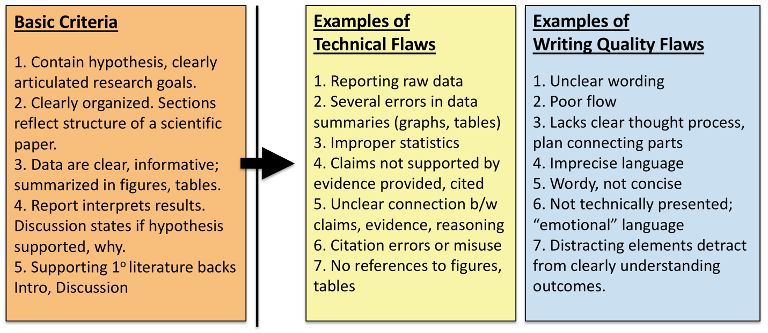

There are five pre-defined Basic Criteria; either a student’s report meets them, or it does not. Items listed under Technical Flaws or Writing Quality Flaws are examples of commonly encountered errors; there could be other flaws.

General Strategy
Most students in BioCore have not read scientific primary literature before, and very few have designed experiments or written reports in our format. Grading and comments should focus on guiding and helping students improve as writers (coaching). From WAC/WID literature we know students improve more and faster if we:
- Limit the number of comments. Students only process and respond to a limited number of feedback items. Given too many comments, students tend to correct the easiest issues first and leave larger issues uncorrected.
- Focus on the largest flaws and errors first. Work down to smaller errors later. This reinforces the previous item, and so they improve their writing faster.
- Refer students to resources. We provide extensive guidelines. It wastes your grading time rewriting what is available elsewhere. Students need to develop a habit of seeking out their own answers instead of looking to us for them.
- Do not copy-edit unless absolutely necessary. It is appropriate to point out where writing is vague or unclear, but students must learn to self-correct rather than expect someone will show them what to do every time.
- Ask questions that encourage reflection. “Reflective coaching” models the kinds of questions students should ask themselves. With practice, students will adopt these questions and begin to self-correct.

Workflow
This is one way to organize the grading process your first few times. As you gain experience, you likely will find other ways that work better. That is fine; applying our criteria consistently is more important than how you get there.
- Allocate 10-15 minutes per report. Use a timer; your phone works well. If you fall behind, decide whether you need a break, or are spending too long per report.
- Budget your time appropriately. Occasionally a report needs so much work that a face to face meeting with the student to discuss the problems will take less time than writing out comments. When this is the case, stop and schedule a meeting.

First Pass Sorting
Open each report in MS Word and SKIM it (1 minute or less), looking for the features in the table below. When you see one, highlight it and attach a comment box (you will refer back to these in the next step.) Sort reports into 3 temporary groups.
- Clearly unacceptable. One or more basic criteria are obviously missing.
- See some flaws.
- No obvious flaws.

Feature | Interpretation/Group
Are all required sections there? | “No” on ANY item means report goes into “Unacceptable” group
Do you see citations in Introduction AND Discussion? Look for [Name: Year]
Quickly read last 1-3 lines of Introduction. Is there a hypothesis near end of Introduction?
Is there a table or figure summarizing data?
Quickly skim first 1-3 lines of Discussion. Does author reference their hypothesis? | “No” should go into “Some flaws” group – could be elsewhere
Does the flow and wording sound reasonable for a technical audience | “No” should go into “Some Flaws” group
Do figures or data tables at end look right?  Do citations at the end look generally right? | Present, but you see errors means report goes in “Some flaws” group.
Nothing stands out in first brief skim through | Put in “No obvious flaws” group

Second Pass: Double-Check & Read Deeper
This time you read the full text of each report. Don’t grade one entire pile at once. Take a report from each group in turn.
- This helps you avoid getting frustrated when grading.
- You are more likely to subconsciously change your grading standards if you keep grading reports of similar quality.
- Your first pass was an initial sort only. As you re-read you may see that you sorted a report incorrectly, and should move it into a different group.

You have three goals this time.
- You already marked several items with comment boxes. This time you should confirm that they are actually present/ flawed/ absent.
- Identify the 2-3 highest impact corrections that the student needs to make. These are what you will point out in your reflective coaching comments. Put your coaching comments on the first page of the report, with the student’s overall score. Remember, these comments should directly reference the criteria.
- Identify and provide short comment on other errors. Limit these to 3-5 per page. Avoid simple copy-editing. Try to address these errors by:
  - Asking reflective coaching questions, or
  - Referring students to the Resource Guide or other reference sources.

Strategies for marking up a report from each group.
- Unacceptable Group:
  - If one of 5 basic criteria is indeed missing, keep the report in this group.
  - Correcting the Basic Criteria should be the student’s top priority. On the front page, list which required items are missing, and the score.
  - If you make comments about technical or writing flaws, put them in the short comments on individual pages. Do not spend an excessive amount of time though. A report that does not meet basic criteria should take LESS time to grade, not more.
- Some Flaws Group:
  - As you read, separate reports into 3 sub-groups:
    - Flaws in writing only
    - Flaws in technical execution of stats, figures, tables, etc.
    - Flaws in BOTH areas.
  - As you divide the reports, look for the larger/global errors the student should address first. What 2-3 corrections that the student could make that would make the report fundamentally better?
  - In the front page comment, summarize the most important corrections needed, and the score.
  - Add no more than 3-5 short comments per page. Use these comments to point out smaller corrections, not the global issues. Comments should be questions or refer to other sources if at all possible.
- No Obvious Flaws Group:
  - Double check that you did not overlook any writing or technical flaws.
  - Identify 2-3 points where you think the report could be improved.
  - In the front page comment, summarize the most important areas the student could improve, and the score.
  - Add no more than 3-5 short comments per page. Use these comments to point out smaller corrections, not the global issues. Comments should be questions or refer to other sources if at all possible.
  - As the grader, remember that even if a report earns the highest possible score, it can always be better.

Provide Feedback by Reflective Coaching, Not Copy Editing
Reflective coaching comments have both specific information or guidance/rationale, and foster thinking. Often they have open ended questions that help a student think about BOTH WHAT TO CHANGE AND WHY. This approach is harder for students at first, but with practice students learn to self-correct the indicated error, and apply similar thinking to other situations.

This example is a front-page summary comment for a lab report. The table below it breaks down the individual elements.
This is good work on your first submission. You met all 5 of our basic criteria. The most important area to work on next is your discussion. Really think about resource allocation and herbivory, and your explanation. Ask yourself, is there another possible explanation besides herbivory? Also think about your results and what they’re really saying. Is there a better way to display or summarize the data that makes your main points clearer? Your writing was very clear; good work! There were some other minor technical points that also need correcting that I’ve highlighted. Overall Assessment: Needs Minor Revisions.

Statements | Breakdown
The most important area to work on next is your discussion. Also think about your results and what they’re really saying. | These two statements identify the first 2 points where the student should concentrate effort.
Really think about resource allocation and herbivory, and your explanation. Ask yourself, is there another possible explanation besides herbivory? | Student is prompted to think more about their initial explanation, and whether it is the only option. Note that the comment does not actually give alternatives, only points to a possibility.
Is there a better way to display or summarize the data that makes your main points clearer? | The question should be self-evident; there likely is a better option. The student can either look for a solution themselves, or talk with the instructor.
Your writing was very clear; good work! | Student does not need to focus on improving writing at this time.
There were some other minor technical points that also need correcting that I’ve highlighted. | Technical errors (statistics, figures) are the third major area needing correction.
Overall Assessment: Needs Minor Revisions. | Score aligns with description; report needs work mainly on interpretation of data, other smaller technical aspects.

Provide Shorter Reflective Comments In Text
The excerpt below from a student report has two comments for the same block of text. The first version is a simple correction. The second version invites deeper thinking.

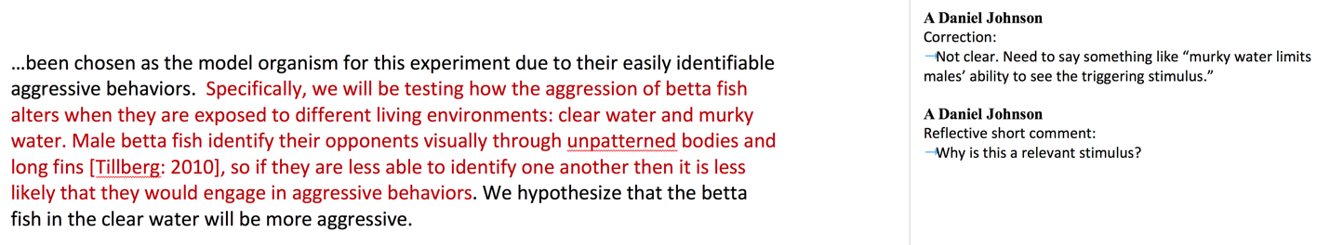

These are more examples of shorter reflective comments embedded in report pages. Read each comment. Try to identify the specific information or guidance/rationale, and how each comment encourages deeper thought.
- Did you mean for each leg before and after injection? Why is that important?
- What is the relevance of this observation in the moth life cycle?
- Are you sure it is the correct tense for this section? Check it in other primary lit.
- Did you find any primary literature articles that deal with interspecific interactions in betta fish? It would be very useful to cite and talk about those here, if there are.

Remember:
- Try to limit in-text comments to 3-5 per page
- Focus on basic criteria first, then the large global issues.
- Only focus on smaller details once basic criteria and global problems have been fixed.

Avoid Simple Copy-Editing Comments
Copy-editing comments explain how to correct a SPECIFIC location but give no rationale. They range from pointers (simple punctuation marks or single words indicating an error) to more specific instructions. They do not foster reflection or guide broader thinking, so any lessons learned do not transfer easily to other situations.

Below are examples of copy-editing comments, and how they could be modified to foster reflection. Several reflective versions (marked **) can be recycled with little or no revision.

Correction-Oriented Comment | More Reflective Alternative
?? (could be interpreted many ways) | What is the purpose of this statement?**
Correct this scientific name, i.e., italicize or underline. | Is this correct format?**
No direct quotes – paraphrase | Are quotes allowed? How can this be presented more succinctly?**
Capital “P” here | What is standard format for reporting stats?**
Refer to Figure 1/Table 1 here. | Where are your references in text to each figure or table?**
Add/revise/remove a word, phrase, image, etc. | Add/revise/remove a word, phrase, image, etc., because …
Ambiguous, awkward | I am not sure what this sentence means. Are you referring to X, or Y?
Methods should be past tense | Check articles we read previously for correct tense, format for this section.**
Raw data | Looks like raw data; where are these summarized?
Avoid recipe style (with no further explanation) | Check articles we read for correct tense, format for this section.
Need units | What is required for all numbers? Is this correct format?**
Organize this section more clearly. Put X, then Y, then Z. | I’m not following your logic. Do you mean…?**
Clarify this step in procedure or analysis | I am not sure what this step means. Are you referring to X, or Y? Could someone with prior knowledge of this lab repeat what you did?**
Be more specific about how salinity changes root transport. | Focus in here. How so? What biological processes are happening due to salinity?**
I’m having trouble following logic here. Make sure your hypothesis is consistent with the rest of your introduction | I’m having trouble following your logic here. How could you revise the early part of the Intro so it leads to your hypothesis?
State here why plants allocate resources to leaves versus roots. | Be more specific. Why would they allocate resources to either structure?
Revise “changes over time” to say “changes in root growth per unit time.” | What does phrase “changes over time” mean? Root growth? Shoot growth? Something else?
No. Carbon allocation explains this more than any other nutrient. | What about carbon? Is R:S ratio showing carbon allocation more than other nutrients?

Refer to the BioCore Writing Guide in Comments
Our Writing Guide is very thorough, but students are notoriously reluctant to use it. Reinforce that your students should be referring to the Writing Guide FIRST by referring to specific pages in the Guide (especially for basic formatting and technical errors) instead of writing out your own detailed explanation or feedback comment. This also cuts down grading time.

Correction-Oriented Comment | Alternative Using a  Resource Reference
Report the stats in your results using (t=, d.f. =, P= ) format | See p. 48 of Resource Guide for how to report your stats results
Add your alpha value
Report mean as x+s.d.
Improper citation format. Use [Name: Year] in text. | Follow p. 36 of Guide for in-text and end citation format.
This citation is not correct. We do not use URLs or DOIs only. You need to include authors, year, title, journal info.
You need y-axis labels for figure. Add a caption explaining measurements. Put caption in Figure Legends section. | See p. 41 of Resource Guide for format of axis labels, contents, location of caption.

Tips:
- If you find you are putting the same comment on different reports, create a master list of comments and copy/paste the appropriate ones rather than re-typing them.
- If you are an experienced TA, remember that the Resource Guide is updated regularly. Double-check that you are using the correct page numbers for the current version.

If You MUST Address Basic Writing Mechanics
Sometimes basic writing is the biggest weakness of a lab report. Here is an example; this Introduction is so poorly written that it is hard to understand the student’s thinking:
Organisms metabolism is fundamental in the ways that it is the sum of the chemical reactions that take place within each cell of a living organism that provide energy for vital processes and for synthesizing new organic material. The amount of energy expended by an animal over a specific period of time is referred to as a rate of heat energy released from an animal’s body (this procedure is known as calorimetry). However, measuring heat from an animal body with accurate precision requiring special equipment, which is often expensive. As a result, we use a process to measure metabolic rate that is controlled directly with heat production: rate of oxygen consumption.
In an article published in 2000, K.A. Sloman set to exploring environmental factors and specific metabolic rate. The researcher carried out a study where he observed the effects of aggression on metabolism through the use of the brown trout (salmo trutta). Sloman placed a pair of the species in small, confined aquarium where he allowed one trout to establish a social hierarchy by becoming the dominant fish. He found that, other fish (subordinates) experienced high levles of soceity stress as a result of the aggression exhibited by the dominering trout. This led the smaller fish to have an increase in specific metabolic rate, which was measured through oxygen consumption (Sloman AK, 2000. Annals Biol. 34:15-17). This experiment is similar to our own as we wish to test the effects of aggression on the specific metabolic rate. In order to do this, we will use crayfish (Orconectes sp.). We will carry out this experiment with the following hypothesis in mind: a crayfish is exposed to aggression/social stress should have a significant increase in specific metabolic rate.

It is hard to address so many errors using just reflective coaching and references to other resources. Adding to the challenge, the entire report likely needs corrections, not just 1-2 paragraphs.

We do not expect TAs to spend time copy editing entire reports. Instead, use one of these two strategies for responding to writing mechanics problems.

- Option 1: highlight one poorly written paragraph, and attach a new comment. List the specific errors that you see. Be sure to tell the student that you saw similar errors in other paragraphs, and that they are responsible for finding and correcting them. For example, the feedback comment for the flawed paragraph above might read:

You have a lot of basic writing flaws in your report that you need to correct or revise. For example, I found all of these basic errors in just these two paragraphs:
- Unclear flow of the logic in both paragraphs
- Errors in grammar (example: "Organisms metabolism is fundamental in the ways that it is the sum..."
- Awkward wording, run-on sentences (ex. "The amount of energy expended by an animal over a specific period of time is referred to as a rate of heat energy released from an animal’s body (this procedure is known as calorimetry)."
- Improper word usage (ex.: dominant, not domineering)
- Improper citation location and format (ex.: look at Sloman reference.)
- Format errors in scientific names
- Spelling errors (ex. levles of soceity)
You need to revise this report very carefully. I recommend that you contact the Writing Center in the library first. They can help you with basic writing issues. After meeting with their tutors, make an appointment with me to work on how you could better organize your logic and key points.

- Option 2: use minimal marking. Edit one paragraph thoroughly for grammatical errors. Then attach a comment in the margin telling the student they are responsible for fixing similar errors beyond this paragraph. Search on Google to learn more about minimal marking; there are many good guides available.

Other General Suggestions When Giving Feedback
- Provide some positive encouragement or praise when warranted, but do not over-state it, or give undeserved praise.
- If one particular item was done well, refer the student to it as an example of how to correct other parts of the report.
- Avoid “but.” Think about this comment: “I like how you wrote your Intro, but the Methods need…”. The “but” negates what the student did well. Try wording that invites continued effort: “I like how you organized your Introduction. Now for the revision, try using the same organizational strategy for your Methods section, which needs…”.
- Do not interject writing conventions and idioms of your sub-field. For example, students are not required to use different formats for in-text citations, depending on the number of authors on the source article. These details become important later as students specialize; at the introductory level we want to focus on foundational issues.

Recording Report Scores in the LMS
Be sure your students understand that these numbers represent categories, not grades.
- Acceptable. Enter a 4 in gradebook.
- Needs minor revisions. Enter a 3 in gradebook.
- Needs major revisions. Enter a 2 in gradebook.
- Submitted but Unacceptable. Enter a 1 in gradebook.
- No report submitted, or plagiarized. Enter a 0 in gradebook.

