First-Semester Reading Annotation Exercise

Overview for Instructors

Red text is supplemental information for instructors only, and instructions for when the survey is administered online.

In our courses, this exercise comes after students have read and discussed a published scientific article. Usually we choose an article from an undergraduate research journal, so it is not too difficult for students to read and analyze. We do not ask students to annotate that first article; they need the opportunity to understand the overall structure first. This is the first assignment where they must identify where features of articles go.

First-Semester Reading Annotation Exercise

Overview

This is a **low-stakes** **diagnostic exercise.** You are graded mainly on effort, not whether you give the right answers. You can do the in-class practice portion without any background reading. Read pp. xx-xx (Writing Lab Reports) of the Writing Guide before doing the homework part of this exercise.

**Why are we assigning a diagnostic exercise?**

It has three purposes.

1. It introduces you to the language we use when we talk about scientific writing and gives you an opportunity to practice using it.
2. Next week your GTA will be talking about our writing requirements for lab reports. They will use a summary of the responses from the entire class to decide what topics to talk about in depth, and what topics everyone understands already.
3. What you get wrong on this annotation exercise **predicts what you are more likely to do wrong** on a report. Students tend to make the same mistakes on this exercise and their lab reports. If you learn how to avoid your mistakes on this exercise, you will score higher on lab reports.

**Some Terms You Need to Know**

These are important features of scientific writing that many past students struggled with when they first started out. We pointing them out now to help you learn to avoid them. As you gain experience, you will develop you own sense of what is appropriate in scientific communication. Other terms like hypothesis, independent and dependent variable, controls, etc., are defined and discussed in detail in the *BioCore* *Resource Guide*.

***Scientific vs. Non-Scientific Language***

A **scientific term** is a word or phrase that has a precise or formal definition specific to science or biology specifically. Someone who has not studied college-level science is unlikely to know the meaning.

A **colloquial term** is a word or phrase that is informal or less precise. You also can think of it as an "unscientific term." You would be likely to use the word or term in casual conversation, or see it in poetry or a novel, but NOT in formal scientific writing.

There is no clear-cut rule that separates scientific versus colloquial terms. The best way to learn what is appropriate wording in scientific writing is to READ scientific literature.

***Scientific vs. Common Knowledge***

A **biological statement** is a sentence or phrase stating a previously established biological fact or an observation or experimental result. Usually these are not common knowledge, and so you will need to cite the source for the information.

A **common knowledge statement** is a sentence or phrase stating a well-known fact or piece of information in the scientific community. It may not be well-known by non-scientists, but someone who has some basic scientific knowledge probably does not need to know the specific source of that information.

Like scientific vs. colloquial terms, there are no clear-cut rules saying what statements are common knowledge versus biological statements. You will develop a better idea of what needs a citation as you read more literature. In general it is better to provide more citations than needed than to provide too few citations. There is no penalty for excess citations, but NOT citing some fact that should be is a form of plagiarism.

***Research Question vs. Hypothesis***

A **research question** is RELATED to a **hypothesis**, but they are not identical. Usually a **hypothesis** is formatted as an "If ... /Then ... statement." Each hypothesis tries to predict a single outcome (the "Then" part) based on specific starting conditions & assumptions (the "If" part of the statement.) Some primary literature may not have an obvious "if/then" hypothesis statement. The authors of these articles leave it to readers to work out their hypothesis. This is not a good practice generally, and we want you to always include a clear hypothesis statement in your reports for now.

A **research question** is a **broader** statement of an author's specific aim or purpose for performing a series of experiments, or the overall question they hope to answer by collecting a particular set of observations then analyzing them. Often the research question is near the end of the Introduction section. It is very rare for a primary article not to have a statement of the main research question(s) for that article. In your reports, the research question usually will be just before your hypothesis statement.

**In-Class Practice**

If you are doing this exercise online:

* Open the link to the exercise provided by your GTA.
* To highlight, **click and drag to highlight one or more words.** Then click one of the displayed labels to color and tag the highlighted text. To remove tag, highlight text again and click "Remove" from the label options shown.
* **Mark longer phrases or sentences first**. Then go back and mark shorter phrases or individual words. If you do not see an example of an item, simply leave that annotation tag unused.

If you are using a paper copy, you can either:

* **Circle your chosen text** then label it using an obvious abbreviation like “BioSt”, “SciTm”, or “ColTm”.
* **Mark the different parts directly** using different colored pens, pencils, or highlighters.

**Practice Sample Blocks**

**Practice Sample Block #1**

In the two paragraphs below:

1. Find and mark **3 biological statements** (statements about an established biological fact or result that need to be supported with evidence).
2. Mark all **scientific terms** that someone without college-level biology would not know.
3. Mark all **colloquial terms** you think are not appropriate for a scientific article.

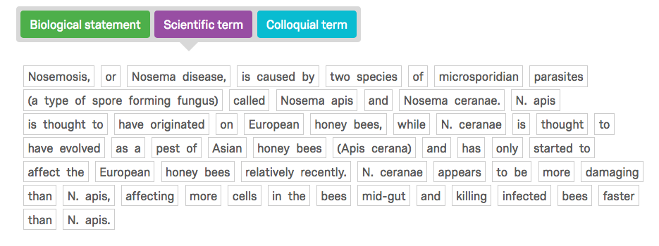

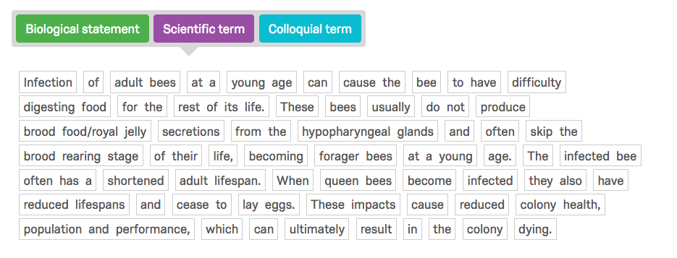

Based on the language of this example, for what audience was the text written?

* Scientific Community
* General (Lay) Public

Does this text read like it is part of a scientific paper?

* Yes
* No
* I don't know

**Practice Sample Block #2**

This time the annotation is a bit harder. Remember, mark larger blocks of text first, THEN go back and mark the individual items or terms.

1. First label 2 **biological statements** that need support of evidence.
2. Next, label any **common knowledge** statements.
3. Next, label all of the **scientific terms** you can find.
4. Next, mark all **colloquial terms** you think do not belong in a scientific paper.
5. Finally, label all **citations** you can find.

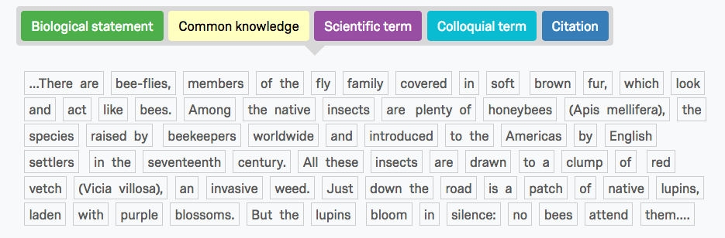

Based on the wording of this example, for what audience was the text written?

* Scientific Community
* General (Lay) Public

Does this text read like it is part of a scientific paper?

* Yes
* No
* I don't know

**Homework**

*The rest of this annotation exercise is your homework assignment. The assignment takes about 1 hour to complete. Remember, read pp. 41-52 of the* Resource Guide *first.*

*There are 7* ***blocks.*** *Each block focuses on a different part of a primary literature article. Your answers to questions in each block help us understand how well you understand what we expect you to write in your own lab reports, and what may be unclear.*

*You need to complete this at l****east 1 day before your next lab meeting****. Your GTA will get a report of how the class responded, and use it to guide a class discussion of confusing or unclear points.*

**Block 1**

*Annotate the text below by clicking on phrases or words and choosing from the given labels.* *Mark whole sentences first and then mark individual terms.The text is split up in* ***2 paragraphs****. Treat both paragraphs as one, and:*

1. *Find and label the* ***research goals*** *or* ***hypothesis****.*
2. *Label* ***2 citations****.*

Given the structure, where does this text belong in a scientific paper?

* Introduction
* Abstract
* Materials and Methods
* Results
* Discussion

*If response to previous question = Introduction, display this:*

Which of the following statements are true about the INTRODUCTION part of a scientific paper?

|  |  |  |  |
| --- | --- | --- | --- |
|  | No | I don’t know | Yes |
| Contains biological statements. | O | O | O |
| Has citations. | O | O | O |
| Shows reproducibility of the experiment. | O | O | O |
| Objectively states outcomes. | O | O | O |
| Is a summary of the paper. | O | O | O |
| Is written in past tense. | O | O | O |
| Contains hypothesis or research goals. | O | O | O |
| Explains why study is relevant. | O | O | O |
| Subjectively interprets the findings. | O | O | O |

Do you have any questions about writing this part of a report?

**Block 2**

*Annotate the text below by clicking on phrases or words and choosing from the given labels.* *Mark whole sentences first and then mark individual terms. The text is split up in 2 blocks. Treat both blocks as one, and:*

1. *Look and label all* ***statistical analyses or procedures****.*
2. *Identify the* ***control and independent variable*** *in the experiment.*

Given the structure, where does this text belong in a scientific paper?

* Introduction
* Abstract
* Materials and Methods
* Results
* Discussion

*If response to previous question = Materials and Methods, display this:*

Which of the following statements are true about the MATERIALS AND METHODS part of a scientific paper?

|  |  |  |  |
| --- | --- | --- | --- |
|  | No | I don’t know | Yes |
| Contains biological statements. | O | O | O |
| Has citations. | O | O | O |
| Shows reproducibility of the experiment. | O | O | O |
| Objectively states outcomes. | O | O | O |
| Is a summary of the paper. | O | O | O |
| Is written in past tense. | O | O | O |
| Contains hypothesis or research goals. | O | O | O |
| Explains why study is relevant. | O | O | O |
| Subjectively interprets the findings. | O | O | O |

Do you have any questions about writing this part of a report?

**Block 3**¶ *Annotate the text below by clicking on the words and choosing from the given labels.* *Mark whole sentences first and then mark individual terms.*

1. *Label* ***all statements relating to reporting statistical results*** *you can find.*

Given the structure, where does this text belong in a scientific paper?

* Introduction
* Abstract
* Materials and Methods
* Results
* Discussion

*If response to previous question = Results, display this:*

Which of the following statements are true about the RESULTS part of a scientific paper?

|  |  |  |  |
| --- | --- | --- | --- |
|  | No | I don’t know | Yes |
| Contains biological statements. | O | O | O |
| Has citations. | O | O | O |
| Shows reproducibility of the experiment. | O | O | O |
| Objectively states outcomes. | O | O | O |
| Is a summary of the paper. | O | O | O |
| Is written in past tense. | O | O | O |
| Contains hypothesis or research goals. | O | O | O |
| Explains why study is relevant. | O | O | O |
| Subjectively interprets the findings. | O | O | O |

Do you have any questions about writing this part of a report?

________________________________________________________________

**Block 4**

*Annotate the text below by clicking on the words and choosing from the given labels.* *Mark whole sentences first and then mark individual terms.The text is split up into* ***2 paragraphs****. Treat both paragraphs as one, and:*

1. *Label* ***ALL*** *sentences that contain* ***interpretations of evidence or data****.*

Given the structure, where does this text belong in a scientific paper?

* Introduction
* Abstract
* Materials and Methods
* Results
* Discussion

*If response to previous question = Discussion, display this:*

Which of the following statements are true about the DISCUSSION part of a scientific paper?

|  |  |  |  |
| --- | --- | --- | --- |
|  | No | I don’t know | Yes |
| Contains biological statements. | O | O | O |
| Has citations. | O | O | O |
| Shows reproducibility of the experiment. | O | O | O |
| Objectively states outcomes. | O | O | O |
| Is a summary of the paper. | O | O | O |
| Is written in past tense. | O | O | O |
| Contains hypothesis or research goals. | O | O | O |
| Explains why study is relevant. | O | O | O |
| Subjectively interprets the findings. | O | O | O |

Do you have any questions about writing this part of a report?

________________________________________________________________

**Block 5**

*Go through these selected citations from the Literature Cited section and annotate the text according to the labels.*

Citation formats vary from journal to journal, and course to course. In BioCore we use a modified version of Harvard's *Name-Year* format. It is described in detail in the *Resource Guide*.

Suppose you wanted to use the two references in the previous question in your lab report. Based on the format in the *Resource Guide*, which of the choices below is the correct one?

* ...[1]...[2]...
* ...[Klein et al., 2007]...[Biesmeijer et al., 2006]...
* ...[Klein: 2007]...[Biesmeier: 2006]...
* ...(Klein et al. 2007)...(Biesmeijer et al. 2006)...
* ...(Klein)...(Biesmeijer)...

Do you have any questions or comments about citations you want the TA to discuss or clarify?

________________________________________________________________

**Block 6**

*Annotate the text below by clicking on the words and choosing from the given labels. Hint: some of them may not be present.*  Mark whole sentences first and then mark individual terms.

1. *Label* ***2 biological statements****.*
2. *Label the main* ***research goals****.*
3. *Label* ***statistical tests or results****.*
4. *Label the* ***citations****.*

Given the structure, where does this text belong in a scientific paper?

* Introduction
* Abstract
* Materials and Methods
* Results
* Discussion

*If response to previous question = Abstract, display this:*

Which of the following statements are true about the ABSTRACT part of a scientific paper?

|  |  |  |  |
| --- | --- | --- | --- |
|  | No | I don’t know | Yes |
| Contains biological statements. | O | O | O |
| Has citations. | O | O | O |
| Shows reproducibility of the experiment. | O | O | O |
| Objectively states outcomes. | O | O | O |
| Is a summary of the paper. | O | O | O |
| Is written in past tense. | O | O | O |
| Contains hypothesis or research goals. | O | O | O |
| Explains why study is relevant. | O | O | O |
| Subjectively interprets the findings. | O | O | O |

Do you have any questions about writing this part of a report?

________________________________________________________________

**Block 7**

**Based on the abstract reprinted below, write a title for the paper.**

**HINT**: a title normally contains the name of the study organism and main outcome of the paper. The *Resource Guide* has additional information about what goes in good titles.

Abstract:

"Recent declines in honey bee populations and increasing demand for insect-pollinated crops raise concerns about pollinator shortages. Pesticide exposure and pathogens may interact to have strong negative effects on managed honey bee colonies. Such findings are of great concern given the large numbers and high levels of pesticides found in honey bee colonies. Thus it is crucial to determine how field-relevant combinations and loads of pesticides affect bee health. We collected pollen from bee hives in seven major crops to determine 1) what types of pesticides bees are exposed to when rented for pollination of various crops and 2) how field-relevant pesticide blends affect bees’ susceptibility to the gut parasite Nosema ceranae. Our samples represent pollen collected by foragers for use by the colony, and do not necessarily indicate foragers’ roles as pollinators. In blueberry, cranberry, cucumber, pumpkin and watermelon bees collected pollen almost exclusively from weeds and wildflowers during our sampling. Thus more attention must be paid to how honey bees are exposed to pesticides outside of the field in which they are placed. We detected 35 different pesticides in the sampled pollen, and found high fungicide loads. The insecticides esfenvalerate and phosmet were at a concentration higher than their median lethal dose in at least one pollen sample. While fungicides are typically seen as fairly safe for honey bees, we found an increased probability of Nosema infection in bees that consumed pollen with a higher fungicide load. Our results highlight a need for research on sub-lethal effects of fungicides and other chemicals that bees placed in an agricultural setting are exposed to."

Your Title:

________________________________________________________________

Do you have any questions or comments about titles you want the TA to discuss or clarify?

________________________________________________________________

**Congratulations! You've finished the assignment!**

Please re-enter your **email address** so your TA knows you completed the exercise.

________________________________________________________________

When you submit your answers, you will see a button or link that lets you download a PDF copy of your assignment.

**MAKE SURE you download a personal copy.**  You need it for your next lab meeting, and we cannot pull your individual responses out very easily if you forget.

Sources

Text in this exercise was taken from:

1. <http://beeaware.org.au/archive-pest/nosema>

2. <http://journals.plos.org/plosone/article?id=10.1371/journal.pone.0070182>