Name: KEY Section:

EXERCISE 12: Metabolism and Nutrition

Reference: Exercise 39 in Lab Book

OBJECTIVES: after this exercise, the student will be able to…
- Define enzyme terminology and discuss how it relates to metabolism.
- Discuss how large molecules get broken into smaller molecules during digestion, with a focus on specific enzymes and anatomical locations.
- Apply stethoscope skills to observing digestive sounds and associating them with movements of anatomical structures.
- Compare and contrast peristalsis and segmentation movements of the digestive system.
- Describe the levels at which gene expression is regulated and the role of transcription factors in this process.
- Discuss lactase persistence, its biochemical mechanism, the genetic basis of lactose intolerance, how this is inherited and the demographics of the lactase persistent phenotype.
- Interpret physiological data regarding lactose intolerance and explain the mechanisms behind pH, glucose, respiration and osmolarity changes.

A. Enzymatic action

- Define the following terms.

 | Definition
Enzyme | Large proteins that are catalysts
Catalyst | Increase the rate of a chemical reaction (are not consumed)
Hydrolases | Digestive enzymes  Add water to molecular bonds, cleaving to monomers
Substrates | Molecules enzymes act upon (organic food molecules)

B. Chemical breakdown of nutrients

- Fill in the following chart regarding chemical breakdown of nutrients.

Foodstuff | Multimer or dimer | Monomer | Enzymes | Site of action
Carbohydrates | Oligosaccharides (starch)  Disaccharides (lactose, maltose, sucrose) | Monosaccharides (galactose, glucose, fructose) | Salivary and pancreatic amylases  Brush border enzymes (lactase, sucrase, etc) | Mouth  Small intestine
Proteins | Proteins  Polypeptides | Amino acids | Pepsin  Pancreatic enzymes  Brush border enzymes | Stomach  Small intestine
Fats | Triglycerides | Monoglycerides  Fatty acids | Lingual lipase  Gastric lipase  Bile salts  Pancreatic lipases | Mouth  Stomach  Small intestine
Nucleic acids | Nucleic acids – DNA, RNA | Pentose sugars  Nitrogenous bases  Phosphate ions | Pancreatic ribo- and deoxyribo-nucleases  Brush border enzymes | Small intestine

C. Segmentation and Peristalsis

- Compare and contrast segmentation and peristalsis. What purpose do they serve?

Segmentation breaks up food, peristalsis pushes food through the digestive track. Both involve smooth muscle contraction.

D. Movements and sounds of the digestive system

- Take a base line blood glucose test.

  - Wash hands with soap and water. Dry.
  - Use an alcohol pad to clean the area to be lanced
  - Place test strip and fully insert into monitor / code monitor if needed
  - Use lancing device to lance area
  - Touch blood drop to test strip
  - Record glucose level
  - Dispose of lance and contaminated materials in biohazardous sharps container.*

*Blood contains pathogens. Only handle your own blood, lancet and test strip. If blood gets somewhere unintended, please spray with bleach and wipe it up.

- Complete Activity 5 (pg 602). This will be the beginning of our lactase test, so drink 1 L of whole milk as fast as possible while your partner observes.

  - What did your tongue do as you swallowed the milk? Up and back

  - What did you observe as you watched your partner swallow the milk?
Tracheal cartilage moves

  - What do these movements accomplish?

Moves liquid to back of through, close of nasal cavity, flap down epiglottis

  - Interval between arrival of the milk at the sphincter and the opening of the sphincter: less than 1 second

E. Record and display blood glucose levels (mg/dL). Be sure to record all groups’ data. You will be making a graph for homework.

Individual | 0 minutes | 15 minutes | 30 minutes | 45 minutes | 60 minutes

F. Interpret experimental data on lactase persistence.

1. Watch video on lactase persistence (http://www.hhmi.org/biointeractive/making-fittest-got-lactase-co-evolution-genes-and-culture) and read through background below.

A defining characteristic of mammals is that mothers produce milk for their infants through a process called lactation. “Mother’s milk” is packed with the proteins, fats, and carbohydrates that support the baby’s growth and development. The main carbohydrate in milk is the sugar lactose, which is a disaccharide.
Infant mammals produce the enzyme lactase in their small intestines, which breaks down lactose into glucose and galactose. The two simpler sugars, or monosaccharides, are easily absorbed through the small intestine and into the bloodstream. The blood delivers the sugars throughout the body to provide cells with a source of energy.
At around the time that children stop drinking their mother’s milk, most of them also stop producing lactase. If lactase is not produced and a person drinks milk, undigested lactose travels from the small intestine to the large intestine, where it is digested by bacteria. When this happens, a person could have abdominal pain, bloating, flatulence, and diarrhea. Individuals with these symptoms are lactose intolerant.
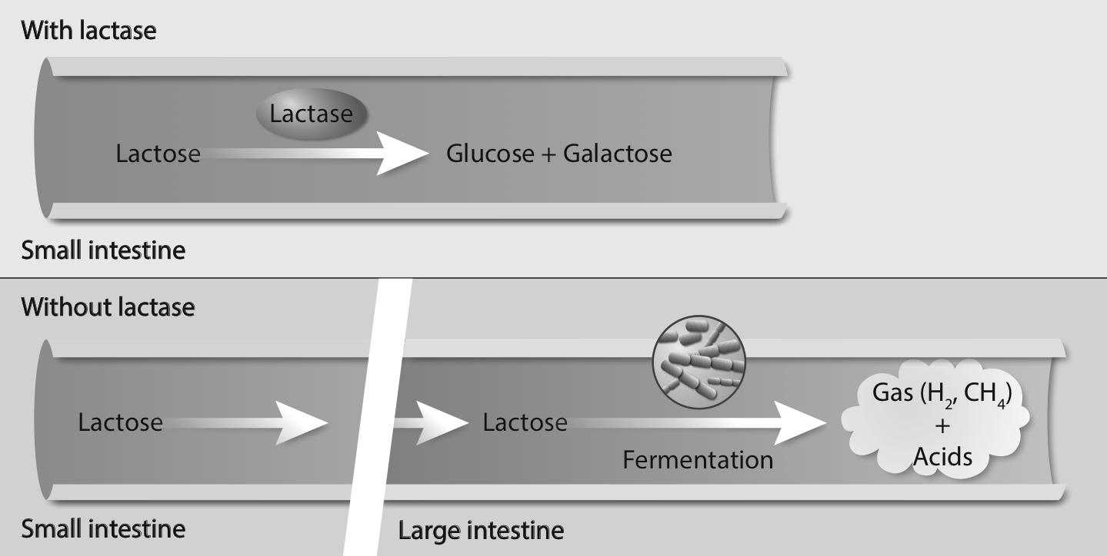
Figure 1. If lactase is produced, the lactose in milk is digested into glucose and galactose in the small intestine. If lactase is not produced, undigested lactose goes from the small intestine to the large intestine, where it is digested by bacteria through fermentation. That process results in the production of various gases and acids that can cause discomfort.
Only a minority of human adults—35% of the global human population—continues to produce lactase into adulthood. These individuals are lactase persistent, meaning that lactase production persists beyond childhood. (They are also usually lactose tolerant, meaning that they don’t have any problems when they drink milk.)
Genetic studies suggest that lactose tolerance arose among human populations in the last 7,000 to 9,000 years. This is also when humans began domesticating animals like cows, goats, and camels and started drinking their milk.
The film Got Lactase? The Co-evolution of Genes and Culture traces the evolution of lactose tolerance. It also describes how researchers analyzed the pedigrees of several Finnish families to identify the changes in the DNA, or mutations, responsible for this trait.
2. Inheritance and Genetics of Lactose Tolerance/Intolerance
a. Determining the Pattern of Inheritance
To determine how lactose tolerance/intolerance is inherited, researchers examined nine extended Finnish families for five generations.
Below is one of those pedigrees. Look at the pedigree and then answer the questions below.
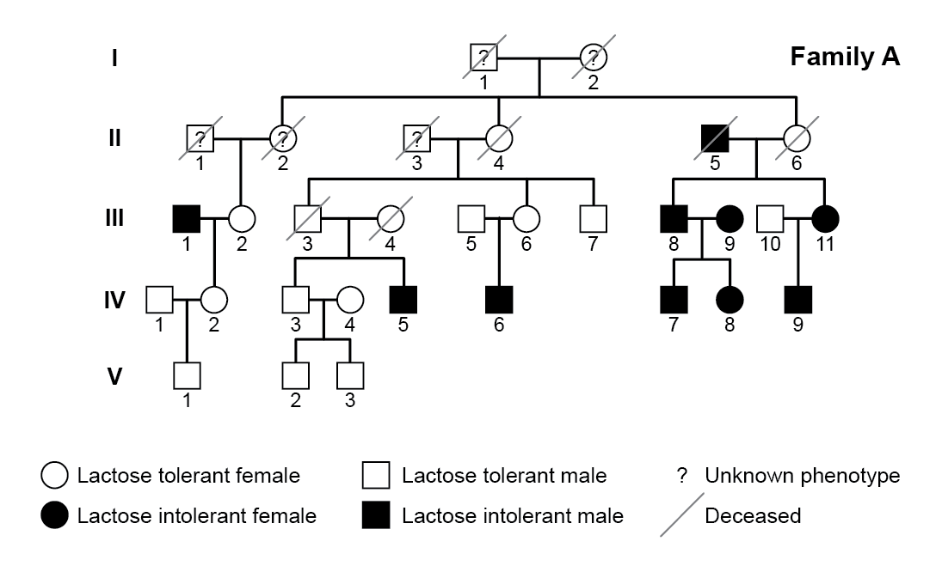
Figure 2. Pedigree of Family A. (Adapted from a figure in Enattah, N. S., et al. 2002 Nature Genetics 30: 233-237.)
Answer the following questions:
1. Based on the pedigree above, which of the following terms are appropriate for describing the inheritance of the lactose-intolerance trait (filled-in symbols)? Check all that apply.
__X__ Recessive ____ Dominant __X__ Inherited ____ X-linked
2. Which of the following terms are appropriate for describing the inheritance of the lactose-tolerance trait (empty symbols)? Check all that apply.
____ Recessive ___X_ Dominant __X__ Inherited ____ X-linked
3. Use the data in the pedigree and the terms listed in questions 1 and 2 to make a claim about how lactose intolerance is inherited. Provide at least two pieces of evidence in support of your claim.
The inheritance pattern of lactose tolerance is autosomal recessive. Evidence: (1) pedigree shows two parents who are lactose tolerant can have a child who is lactose intolerant, (2) occurs in males and females, so not X-linked
4. How comfortable are you with drawing a firm claim about the inheritance of lactose intolerance? What might you do next to increase your confidence in making this claim?
Uncomfortable – single pedigree
5. Study Individuals 5 and 6 of Generation III in Family A and their child. The two parents are lactose tolerant, yet their son is lactose intolerant. Are these data consistent or inconsistent with the claim you made in question 3? Explain your answer.
The two parents are lactose tolerant, meaning they can be homozygous or heterozygous for the dominant allele. The only way to explain how their son can be lactose intolerant is if both parents are heterozygous and have passed on the allele to their son.-evolution of Genes and Culture STUDENT HANDOUT
b. Finding the Responsible Mutation
In the film Got Lactase? The Co-evolution of Genes and Culture, you learned that researchers did not find any changes in DNA sequence, or mutations, in the coding region of the lactase gene that were associated with lactose tolerance/intolerance. This finding suggested that the genetic change responsible for whether someone is lactose tolerant or intolerant is not in the coding region of the gene.
Could the change be in the regulatory region of the gene?
Genes are regulated, or turned on or off, by genetic elements called switches. When the lactase switch turns the lactase gene on, the lactase enzyme is produced. In babies, the lactase gene is turned on. But when babies grow into adults, the switch turns the lactase gene off in most people. In a minority of adults, a mutation in the lactase switch prevents the lactase gene from turning off. These adults are lactose tolerant.
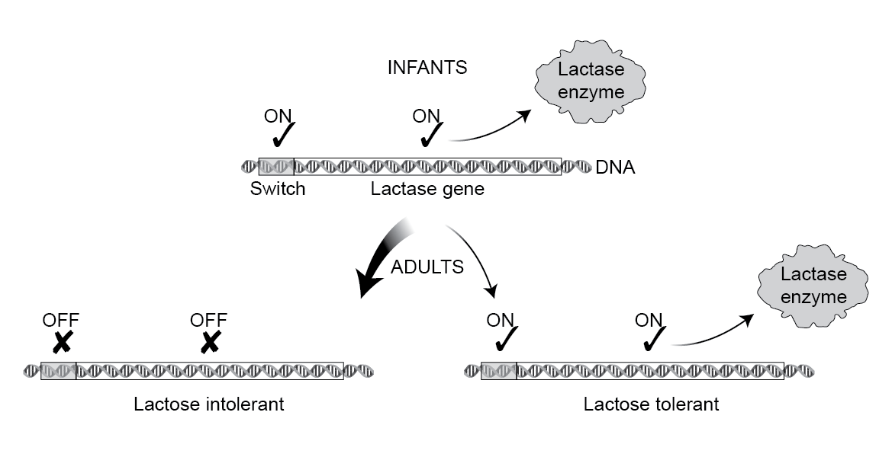
Figure 4. The genetic switch that regulates the expression of the lactase gene is active in babies but not in most human adults. Individuals who are lactose tolerant (or lactase persistent) have a mutation in the lactase switch that keeps the switch turned on into adulthood.

To find the mutation that keeps the lactase gene on, researchers analyzed the DNA sequence of the lactase switch in several individuals. They found many differences. For example, at one particular position in the sequence of DNA, some individuals might have an adenine (A) nucleotide and others a thymine (T) nucleotide.
Most of the differences in DNA sequence have no effect on lactase production. To detect changes in DNA that are associated with lactose tolerance, researchers looked for variations that are consistently found in people who are lactose tolerant but not in people who are lactose intolerant, and vice versa.
Watch the Click and learn: http://media.hhmi.org/biointeractive/click/Lactase_Regulation/14.html
Answer the following questions:

- What is the difference between lactose tolerance and lactose intolerance? Be specific.

Amounts of lactase enzyme

- Why is lactose tolerance also called lactase persistence?

People who continue to make lactase as adults are able to tolerate (metabolize) lactose

- What normally happens to the levels of lactase produced throughout a person’s lifetime?

Decrease

- At what level (i.e., transcription, translation, or protein processing) is the lactase gene (LCT) regulated?

Transcription

- Using your knowledge of activators and repressors, hypothesize two ways in which transcription of the LCT gene could be turned off.

Binds a repressor, does not bind an activator

- In what regions of the world is lactase persistence most prevalent? Interpret the data below showing the fraction of adults with the lactase persistence trait.

Northwest Africa and Europe
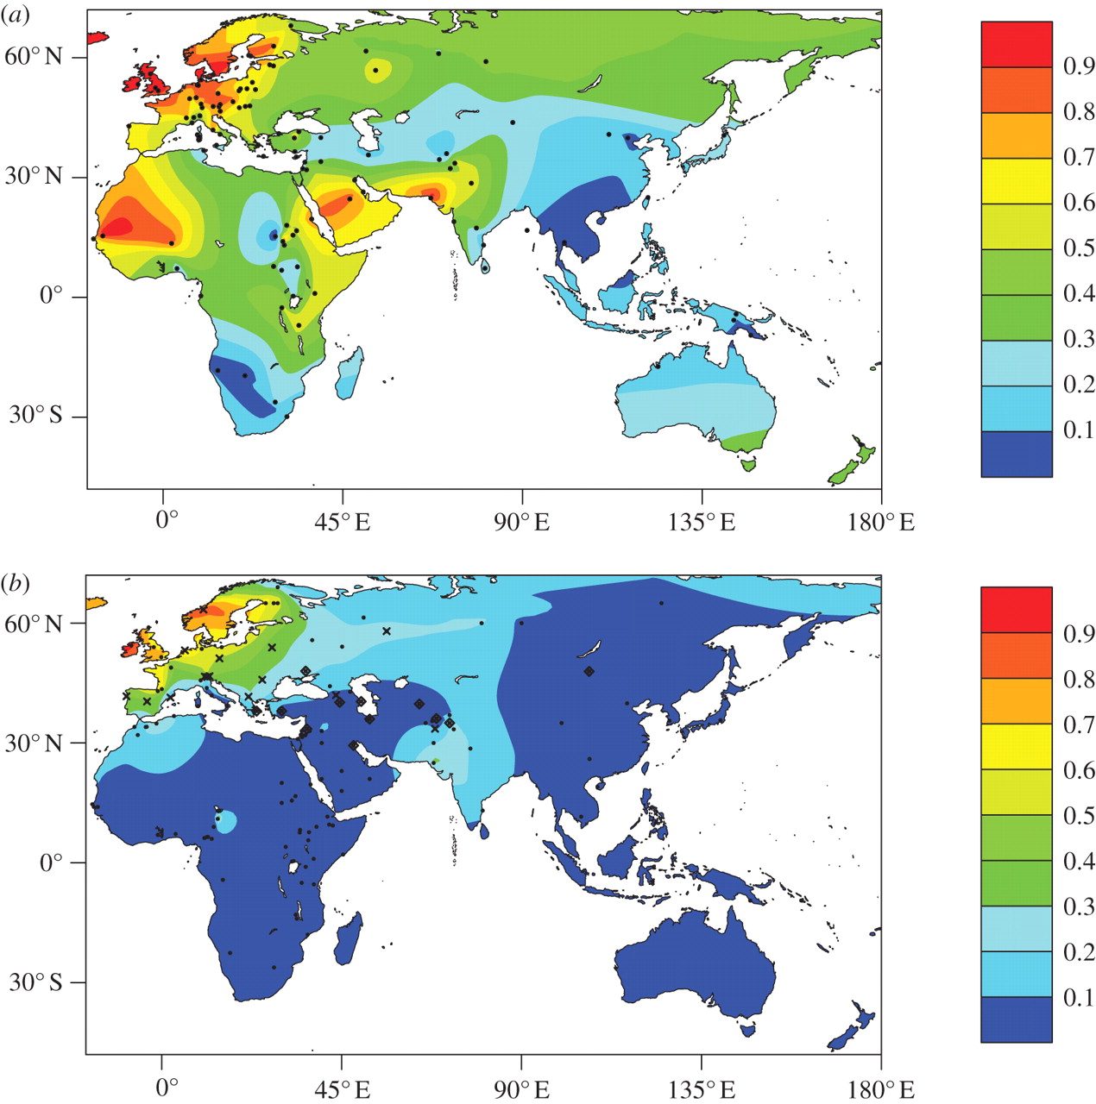
- How is lactase persistence an example of human evolution?

Environmental conditions (presence of nourishing milk), selected for those with lactase persistence. Longer animal domestication = more lactase persistence

- Explain the effect of the mutation that occurs among northern European people on LCT gene expression.

Increases expression of the LCT gene

- What are the similarities and differences between the lactase persistence mutations found in African populations and the one found in European populations? (Consider, for example, type of mutation, location, function.)

Different mutation, same end result

- Physiological affects of lactose intolerance.
Blood glucose level is just one of many ways to test for lactose intolerance. Another common method is the hydrogen breath test, in which the patient breathes into a balloon-type container before and after drinking milk. Normally, there is little or no hydrogen in a persons breath; the test is considered normal if the increase in hydrogen is less than 12 parts per million (ppm) greater than the fasting hydrogen level.
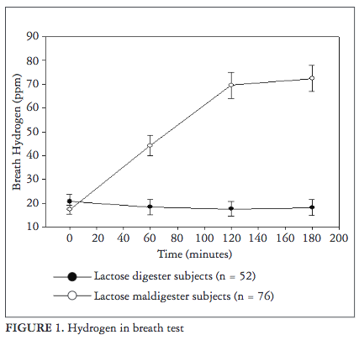
Answer the following questions based on the figure above.

- Which fluctuates more, breath hydrogen levels in lactose tolerant individuals or lactose intolerant individuals? Why?

Lactose intolerant: higher pH in blood

- What process produces hydrogen gas?

Fermentation of lactose

- Where is this hydrogen produced? Why?

Large intestine: that’s where the bacteria live

- How might hydrogen gas lead to the bloating symptoms typical of lactose intolerance?

Build up of hydrogen gas in the large intestine

- Describe the route the hydrogen would take to end up being exhaled.

Lactose-> hydrogen gas + acids, H+ buffered in blood: carbonic-acid bicarbonate buffer system – dissociates into H2O + CO2 – CO2 exhaled

- What might you expect to happen to respiratory rate as a result of lactose intolerance? Why?

Increase to expel excess CO2 and lower blood pH

Another test for lactose intolerance is the stool acidity test, in which an individual is given lactose to drink and then the pH of the stool is measured.

- What results would you expect from a stool acidity test performed on a lactose intolerant individual?

Acidic stool due to fermentation of lactose

- What other samples might the physician request in order to test acidity?

Blood, urine

If other tests are inconclusive, an intestinal biopsy for lactase levels can be performed.

1. Where (specifically) would the section of tissue be removed in order to perform this biopsy?

Jejunum – brush border enzymes

2. From your findings above, explain why lactose intolerance causes abdominal pain, bloating and flatulence. Why might lactose intolerance cause diarrhea (hint: there is a concentration gradient involved)?

Gas accumulation in large intestine from fermentation
Lactose (and byproduct) build up will draw fluid from the blood into the large intestine, causing watery stools (diarrhea)

- Glucose level results and interpretation.
- Plot the results from all the individuals we tested today (not just your partner) as a graph in Excel. Make sure to include a legend and axis labels for your graph. Attach the graph and hand in at the beginning of next week’s lab. Answer the following questions based on your graph.

- Why is measuring blood glucose levels an indicator of someone’s lactase activity?

Lactose -> glucose + galactose (by the lactase enzyme)

- The blood test is considered normal if your glucose level rises more than 30 mg/dL (1.6 mmol/L) within 2 hours of drinking the lactose solution. A rise of 20 to 30 mg/dL (1.1 to 1.6 mmol/L) is inconclusive. Does anyone fall into the inconclusive range or below? What follow-up test might you recommend?

Breath hydrogen levels, stool acidity, etc.

- If you performed the same blood glucose test on a group of people who are from the Maasai population in Kenya, predict whether their results would show lactose tolerance or intolerance. Explain your prediction. (Hint: Remember from the film that the Maasai people are pastoralists.)

Tolerance – pastoralists have domesticated animals

- A person taking a blood glucose test is usually told to fast prior to the test. Why do you think that might be necessary?

Not calculating activity of other enzymes that breakdown other nutrient sources

- Summarize the various tests for lactose intolerance below, what they measure and how this measurement is linked to lactose intolerance.
Test name | Substance assessed | Relation to lactose intolerance
Genetic sequencing | DNA | Screens for lactase persistent mutation
Glucose blood test | Blood glucose | Blood glucose will not rise after lactose is consumed if a person is lactose intolerant
Breath hydrogen test | Hydrogen in breath | Lactose intolerance leads to fermentation of lactose in the gut which increases blood acidity
Stool acidity test | Acidity of feces | Lactose intolerance leads to fermentation of lactose in the gut which increases stool acidity
Intestinal biopsy | Presence of lactase enzyme in jejunum | If lactase is not present, the patient is lactose intolerant
References:

- Activity Adapted from “Got Lactase” Activities from HHMI Biointeractive."Biointeractive Homepage | HHMI BioInteractive." Biointeractive Homepage | HHMI BioInteractive. N.p., n.d. Web. 03 Apr. 2017.
- "Lactose Tolerance Tests." MedlinePlus Medical Encyclopedia. N.p., n.d. Web. 03 Apr. 2017.
- Torres, Evelyn Mendoza, et al. "Diagnosis of Adult-type Hypolactasia/lactase Persistence: Genotyping of Single Nucleotide Polymorphism (SNP C/T-13910) Is Not Consistent with Breath Test in Colombian Caribbean Population." Arquivos De Gastroenterologia 49.1 (2012): 5-8. Web.

