**Help the sea turtles!**

**Module Overview**: students will explore the connection between sea turtle presence and light pollution, using virtual lab.

**Setting**:

High school biology major students, on-line virtual lab in a blended learning setting (the lab is led by the teacher). Typical class size: ~30 students, can be used by multiple teachers at the same time.

Learning Outcomes for the activity-

Students will practice research skills such as building graphs, analyzing data

Students will explore an example of human effect on nature.

How does data acumen align with this learning outcome? Place an “X” in the column next to the skills practiced in this activity

|  |  |  |  |  |  |
| --- | --- | --- | --- | --- | --- |
| **Quantitative Pillars** |  | **Data Life Cycle** |  | **Social/Pedagogical Concepts** |  |
| Mathematical | X | Data import |  | Communication |  |
| Computational |  | Management |  | Equity, Diversity, Inclusivity |  |
| Statistical thinking | X | Curation |  | Universal Design for Learning |  |
| Reproducibility | X | Analysis | X | Ethics |  |
|  |  | Sharing/ Reporting |  |  |  |

**Activity/Module**:

Describe the activity-

Start with the phenomenon: in the last 100 years less and less sea turtles arrive the shores of Israel.

Invite the students to **ask questions** regarding the problem

Have the students build a mind map of the phenomenon: offer entities, and propose relation between them.

Course type (e.g. Lecture, lab)-

Pedagogy (e.g. Case, research project, final report, lab activity)-

Describe the data and the tools used to interact with the data-

Heterogeneous class: Two types of data, according to students’ experience with modeling.

**Advanced students:** Raw data of observations done in the last 10 year on the shore of the medeatiranian

Tools: Codap?

**Beginners:** Simulated data on the relation between light pollution and sea turtles presence. The simulation includes 10% noise level, to mimic

Tools: moodle’s graph drawing, open and closed questions with immediate feedback

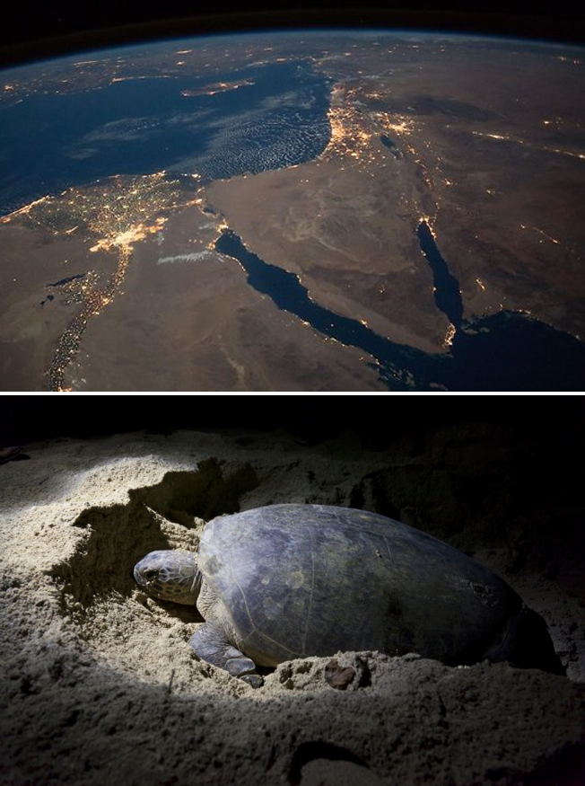

Both data sources are based on real data. Turtle nesting data collected by the Israel Nature and Parks Authority, light pollution data as seen from the ISS.

Describe where problem posing will be used and how you as the instructor will use problem posing to shape the activity-

The questions the students pose are the base for creating initial model.

* What is the Question Focus?
* How is the Question Focus introduced?

Describe the student products-

**Assessment**:

How will this learning outcome be assessed?

Closed questions regarding the data set - immediate feedback

Open questions will be assessed by the class’ teacher.

Will students practice this skill again? In what setting (same topic, new topic)?

Yes! More virtual labs to practice research skills.

**Extra information**:

What will students need to know before completing this activity?