REEBOPS
Modified from:  Patti Soderberg. Marshmallow meiosis. The Science Teacher 59(8):28-31, 1992. | 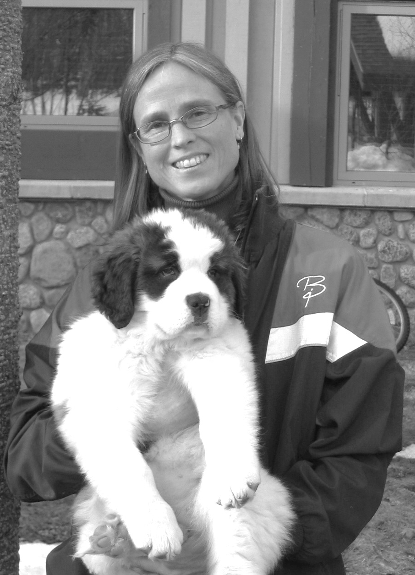
Your team of two should have: two envelopes containing parental chromosomes, the instruction sheet for the Reebop assembly, and access to materials for the construction of baby Reebops.
X^{D}X^{D}, X^{D}X^{d}, or X^{D}Y = 3 body segments  X^{d}X^{d}, or X^{d}Y = 2 body segments | Note: One pair of chromosomes, called X and Y, determines sex. All the alleles on X are not necessarily found on Y. In Reebops, alleles for the number of body segments are carried only on the X chromosome.

Note: Mom and Dad Reebops both have the following characteristics:
Antennae: 2
Nose: Orange
Eyes: 2
Body Segments: 3
Green Humps: 2
Tails: Curly
Legs: Blue
- Each person in the team takes one envelope. Open it and place the diploid chromosomes from your one Reebop parent face down and mix the chromosomes.
- Now sort the chromosomes into pairs by size. (This is like making a karyotype.) You should have either blue or pink chromosomes, not both right now.
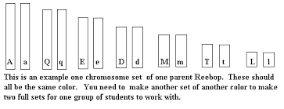
- Take one chromosome from each homologous pair to create haploid gametes. (This is like what happens in meiosis.)
- Turn over the chromosomes and record the alleles here.
Your gamete __ __ __ __ __ __ __
- Next, work with your partner who has an has a gamete with chromosomes of the other color. Record your partner’s gamete.
Partner’s gamete __ __ __ __ __ __ __
- Now combine the two gametes.(This is like fertilization.)
Record the resulting Reebop zygote genotype
__ __ __ __ __ __ __ __ __ __ __ __ __ __
- Use the zygote’s genotype above to construct your baby Reebop.
- Describe the phenotype of your new Reebop:
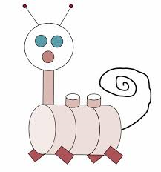
Antennae: Green Humps:
Nose: Tail:
Eyes: Legs:
Body Segments: Gender:

9. Take a picture of your baby. You will be posting this, so you need to name your baby Reebop.
10. Put the chromosomes for your baby Reebop into a new envelope. Label it with as F1 with baby’s name and sex.

Introduction to pedigrees
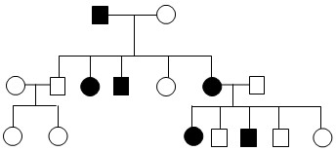
- Pedigree charts are used to trace inheritance of single traits or characteristics within a family (see sample pedigree chart above left.) Note that circles are females, squares are males. Filled in means the individual has the trait we are tracing. No fill means the individual lacks (does not have )the trait we are tracing. Horizontal lines represent matings. Vertical lines connect parents to their offspring.

Is the trait shown in the sample recessive or dominant? How do you know?

12. Create three pedigree charts for Mom, Dad and Baby Reebops for the inheritance of nose color, tail shape and number of body segments. Each trait gets its own pedigree.
Dad = 2 eyes Mom = 2 eyes Dad = curly tail Mom = curly tail Dad = 2 segments Mom = 3 segments

Part 2: Making the next generation(The F₂)
Time has passed. The baby Reebops are ready to mate. These are now F1 adults. When they mate, they are making the F2 generation.
- Look at the chromosomes belonging to your F1 adult. Are the chromosomes all the same color? ____________ Explain.

- Form gametes from the chromosomes of your F1 adult. This time you will make two gametes. Follow these instructions.
  - Turn the chromosomes face down and mix them up.
  - Arrange them in homologous pairs
  - While still face down, randomly choose one member of each homologous pair and set them aside. This is one gamete .
  - The remaining chromosomes are the other gamete.
- Record your two gametes here:
Gamete 1 __ __ __ __ __ __ __
Gamete 2 __ __ __ __ __ __ __

Join up with another group to find a Reebop of the opposite sex to mate with.
- FERTILIZATION! Choose Gamete 1 from each parent and combine them.
- Record the F2 baby Reebop’s genotype:
__ __ __ __ __ __ __ __ __ __ __ __ __ __
- Describe the phenotype of your F2 Reebop: What is its name? ___________________
Antennae:
Nose:
Eyes:
Body Segments:
Green Humps:
Tails:
Legs:
Gender:

OOOOOOOH it’s fraternal twins!
- Use the remaining gametes to make one more F2 Reebop!
Record the second F2 baby Reebop’s genotype:
__ __ __ __ __ __ __ __ __ __ __ __ __ __
- Describe the phenotype of your second F2 Reebop: What is its name? ___________________
Antennae:
Nose:
Eyes:
Body Segments:
Green Humps:
Tails:
Legs:
Gender:

- Now create 1 pedigree chart for the original Mom and Dad (the Parental Reebops), their children (F1 Reebops), and their grandchildren (F2 Reebops). Show the inheritance for nose color. For Reebops that have orange noses, fill in half the shape.
P

F1

F2

Remember that in the Parental Reebops (the original mating pairs) all Dads and Moms have orange noses.

20. What is the pattern of inheritance for nose color? Explain using evidence from your pedigree chart.

