Protocols for Assembling the RFP Gene

Oligo Mixes
Typically, 12-18 oligos are used to synthesize each building block (BB). These oligos are ordered individually and are delivered to us in 96 well plates. Each 96-well plate can contain oligos to make up to 4-5 complete building blocks.

For each building block that you are assigned, you will need to combine these 12-18 oligos together to create a templateless primer mix (TPM). This TPM will be used in a templateless PCR reaction (TPCR), which will anneal the oligos together and extend them to make longer DNA sequences, including only a small amount of the full-length building block sequence. Next week, you will use the outer primer mix (OPM) to amplify the full-length BB in a finish PCR reaction (FPCR) so that the predominant DNA following FPCR is your desired full-length BB.

Templateless primer mix (TPM)

The templateless primer mix (TPM) contains the 12-18 oligos that comprise the building block. All primers must be present at a concentration of 300nM in the TPM (a dilution of 1/20). These dilutions should be done in a 1.7ml microcentrifuge tube, and primer mixes should be stored at -20°C when not in use.

- Label your tube with: the BB name, the type of oligo mix (TPM), and the primer concentration (300 nM)
- To the tube, add 10 ul of each of the TPM oligos
- Add H2O to get a final volume of 200ul.
- Mix thoroughly and keep the tube on ice.

In some cases, there may be more than 20 oligos that comprise a building block. Mix 10 ul of each oligo and add no water. Even though the concentration will be slightly more dilute than 300 nM this does not seem to have any effect on reaction efficiency.

Outer primer mix (OPM)

For each building block, the outer primer mix (OPM) contains only the first and last oligos. The outer primers must be present at a concentration of 3uM in the OPM (the oligos must both be diluted by 1/2). Again, these dilutions should be done in a 1.7ml microcentrifuge tube, and primer mixes should be stored at -20ºC when not in use.

- Label your tube with: the BB name, the type of oligo mix (OPM), and the primer concentration (3 uM)
- To the tube, add 10 ul of each of the OPM oligos
- Mix thoroughly
- Put this primer mix into the box marked “OPM mixes” to be stored until next week

Templateless PCR

The goal of templateless PCR is to combine a mixture of short single-stranded DNA oligonucleotides (the TPM) and assemble them into a longer double-stranded DNA sequence, which we term a building block (BB). This building block DNA may have a sequence that is completely new and may not have ever previously existed in nature.

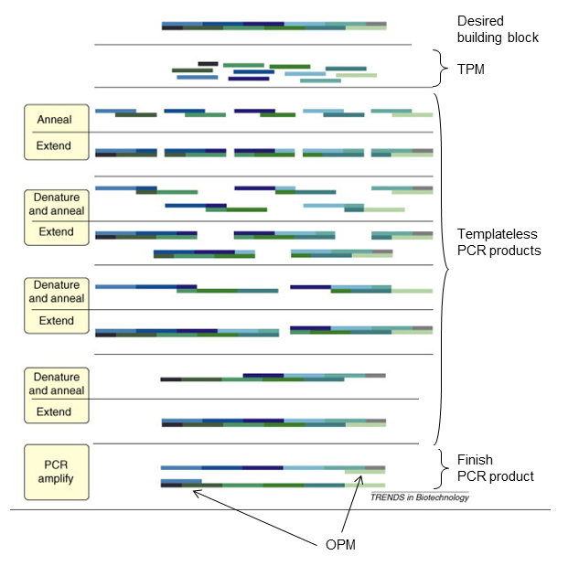
During the templateless PCR reaction, the oligos are denatured, annealed, and extended through multiple rounds of PCR until finally a small amount of the full-length BB (approximately 500-750 bp) is synthesized.

Reaction Setup
- Before you set up reactions, make sure you reserve a spot in the PCR machine. You will need to sign up for 3 spaces in the PCR machine-label each with your initials and either “BB”, “PC” or “NC”.
- Keep Phusion enzyme ON ICE AT ALL TIMES!

1. You will be performing 3 PCR reactions (1 building block (BB) plus one positive control reaction (PC) and one negative control reaction (NC).

2. Combine the reagents listed below into three different PCR tubes on ice (these are the very small tubes).

Reagent | Volume per 25ul reaction
2X Phusion Master Mix | 12.5ul
Water | 10 ul
Total | 22.5 ul

3. To the first tube, add 2.5 ul from the tube marked TPM.

4. To the second tube, add 2.5 ul from the tube marked PC. This will be your positive control reaction.

5. To the third tube, add 2.5 ul of water. This will be your negative control reaction.

6. Cap your tubes and make sure that they are sealed tightly so that the liquid will not evaporate. Flick the tubes gently to mix.

7. Place your tubes in the PCR machine in the positions for which you signed up. Make sure that you have recorded which sample (BB, PC, or NC) is in each position in the PCR machine.

Reaction Conditions:

1 cycle:
94ºC, 3 minutes
5 cycles:
94ºC, 30 seconds
69ºC, 30 seconds
72ºC, 1 minute
5 cycles:
94ºC, 30 seconds
65ºC, 30 seconds
72ºC, 1 minute
20 cycles:
94ºC, 30 seconds
61ºC, 30 seconds
72ºC, 1 minute
1 cycle:
72ºC, 3 minutes

Finish PCR

We just used templateless PCR to assemble a small amount of the full-length building block (BB) from oligonucleotides. However, templateless PCR produces very little of the full-length BB. Because templateless PCR is so inefficient at synthesizing the full-length BB, it also creates many smaller DNA fragments that are intermediates in building block synthesis. Therefore, the templateless PCR that we performed resulted in a mixture of DNA products: a small amount of the full-length BB is present among other DNA products of varying sizes.

The goal of finish PCR is to exponentially amplify the building block sequence so that most of the DNA present in the mixture following finish PCR will be the full-length BB. This is accomplished by using the outer primer mix (OPM), which contains two oligos to amplify only full-length DNA. The OPM primers bind to either end of the building block (which now serves as a template), enabling only BBs that are full-length (and therefore contain both ends of the BB sequence) to be amplified by PCR.

Reaction Setup

1. Obtain your templateless PCR reactions from the PCR machine.

2. You will no longer need your PC and NC reactions until we run the gel.

2. To your templateless PCR reaction that is labeled “RFP”, add 175 ul of water, cap the tube and invert to mix. We will use this diluted templateless PCR reaction in step 4 below.

You will be performing 3 PCR reactions (one RFP) plus one NEW positive control reaction (PC) and one NEW negative control reaction (NC).

3. Combine all reagents listed below into 3 different PCR tubes (the very small tubes).

Reagent | Vol/25ul reaction
2X HotStart Master Mix | 12.5 ul
OPM | 10.5 ul
Total | 23 ul

4. To the first tube, add 2 ul of the templateless PCR reaction from step 2 above. Once this is done, discard the tube containing the remainder of the templateless PCR reaction.

5. To the second tube (PC), add 2 ul from the tube labeled PC.

6. To the third tube (NC), add 2 ul of water.

7. Cap your tubes and make sure that they are sealed tightly so that the liquid will not evaporate. Place your tubes in the PCR machine in the position for which you signed up. Make sure that you have recorded which sample (BB, PC or NC) is in each position in the PCR machine.

Reaction Conditions:

1 cycle:
94ºC, 3 minutes

25 cycles:
94ºC, 30 seconds
55ºC, 30 seconds
72ºC, 1 minute

1 cycle:
72ºC, 3 minutes

Pouring a Gel:

1. Weigh out 0.5 g of agarose on a piece of weigh paper. Transfer to an Erlenmeyer flask. Add 50 ml of 1x TAE.

2. Heat in the microwave until the agarose is completely transparent and colorless. Using a rubber heat mitt, periodically swirl the flask to ensure that the agarose is melting evenly. If there is any cloudiness or particulates, then place the agarose back in the microwave for additional time until clear (check frequently).

3. Remove the flask of clear agarose and allow it to cool. This will take about 10 min. If you can hold your hand on the flask for 20 sec, then the agarose is cool enough to pour. (Warning: if poured while too hot, the agarose will leak and warp the plastic gel tray.)

4. While the agarose is cooling, place the gel tray into the gel box and add the black blockers and a comb.

5. When the agarose is cool, bring it to the hood to add 4 ul of Gel Red to the melted agarose (CAUTION: ethidium bromide is a mutagen. Wear gloves and a lab coat at all times when handling gels and gel equipment!).

6. Swirl the agarose to incorporate the Gel Red and pour the agarose into the gel tray –your gel should be about 1 cm thick.

7. Allow at least 20 minutes for the gel to solidify. Once solid, carefully remove the comb and the black blockers, and place the solidified gel (still on the tray) into the gel box so that the wells are oriented on the same side as the black electrode.

8. Add enough 1x TAE buffer to completely cover the gel by about 1 cm (~250 ml).

Preparing your samples:

- On a piece of parafilm, spot out 2 ul of 6x DNA loading dye with a P20 pipet. You should have 5 spots (one for each of your PCR products). Wait until your gel has started to solidify before beginning this step since the spots will dry out after ~10 minutes.

- Add 5 ul of water to each spot of dye.

- Add 5 ul of the PCR product.

Running a Gel:

1. Into the first lane of the gel load 5 ul of the 2-Log DNA ladder (mixed with water and dye).

2. Into lanes 2-5, load 10 ul of each of your PCR products (mixed with water and dye).

3. Place gel lid with electrodes on gel box. REMEMBER DNA RUNS FROM NEGATIVE (black) TO POSITIVE (red). CHECK YOUR LEADS: BLACK SHOULD BE AT THE TOP, RED SHOULD BE AT THE BOTTOM!

5. Set voltage to 100V. You should see bubbles coming up from the wire electrode.

6. After a few minutes, check to make sure everything is going smoothly. Run gel approximately 30 minutes or until the dye is 2/3 of the way down the gel.

7. Take a picture of your gel.

8. Use the DNA ladder (a picture is below) to approximate the size of each of your building blocks. Make sure you check that your building block is the correct size - do not assume that because you have a band, it is the correct product!

