Universal Design for Learning Chromosome Worksheet

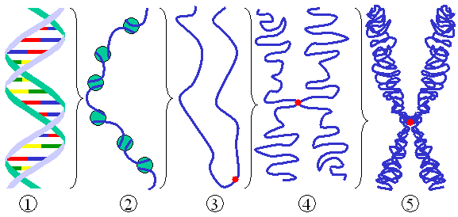
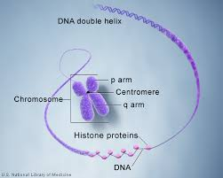
B
https://commons.wikimedia.org/wiki/File:Chromatin_chromosome.png CC3.0
A
https://ghr.nlm.nih.gov/primer/illustrations/chromosomestructure.jpg

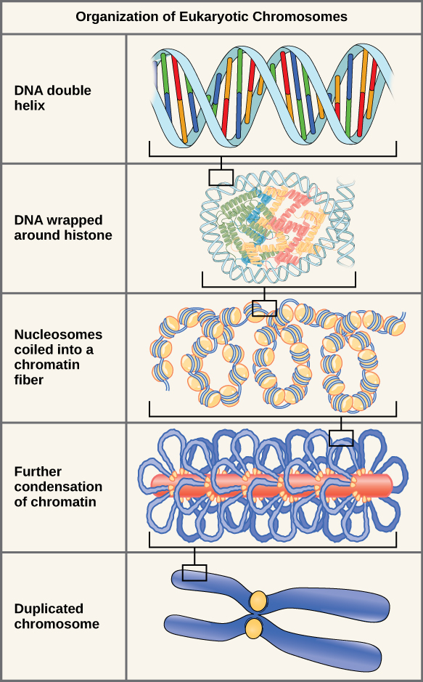
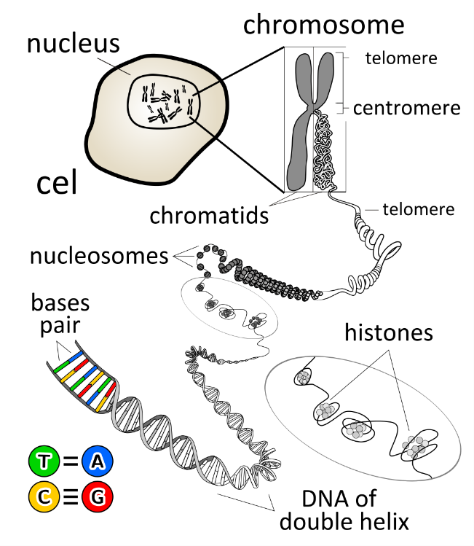
D
https://upload.wikimedia.org/wikipedia/commons/1/1a/Figure_10_01_03.jpg CC4.0
C
https://upload.wikimedia.org/wikipedia/commons/thumb/f/fd/Chromosome_en.svg/1045px-Chromosome_en.svg.png CC3.0

- Choose to work with A, B, C, or D. What information might students pull from this image?

- Where might students be misled with this image or struggle to understand the information?

- How might the relevant information in this image be made more explicit to students?

- Use what you found to develop ideas for an alternative-text description (brief, main point) and long description.

