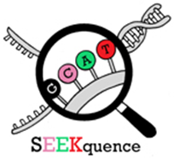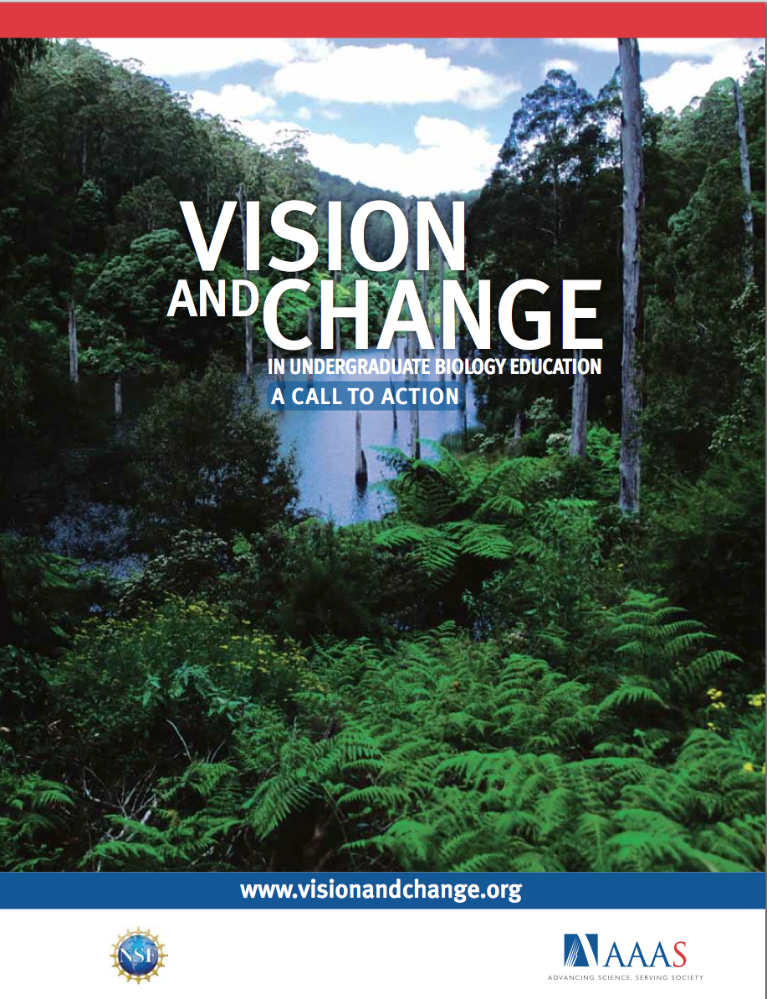

NSF Award # [DBI-1248096](http://www.nsf.gov/awardsearch/showAward.do?AwardNumber=1248096)

* Goal: **“focus on any topic likely to lead to improved participation, learning, or assessment in undergraduate biology curricula”** including but not limited to:
  + active and inquiry-based learning
  + engage faculty in professional development
  + incorporate new fields into the biology curriculum
  + introduce emerging technologies into the biology classroom and lab
  + improve assessment of student learning
  + improve transition from 2-year to 4 year institutions
  + incorporate authentic research experiences in courses
  + provide novel interdisciplinary training
* Developed by BIO and EHR (Division of Undergraduate Education – DUE)
* Supports projects to build communities of biology faculty and stakeholders
* Incubator awards ($50 K) to fund formation of new teams
* Full awards (up to $500K for up to five years) fund more mature projects

* Faculty can submit an incubator proposal first or submit a full proposal first
* We expect some incubator proposals will lead to full RCN-UBE proposals
* Other RCN-UBE ideas may evolve from different communities, professional societies, RCNs… and lead to new collaborations, projects, funding…
* NSF 15-527; Deadline January 6, 2016

RCN-UBE Program

Research Coordination Networks-Undergraduate

Biology Education Track