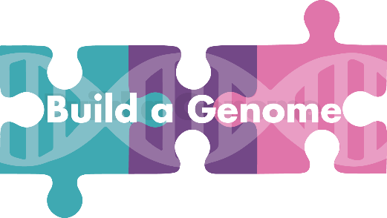

Join us for our Third National Workshop!
July 27-31, 2020
This is a virtual workshop, held online on Zoom at no cost to participants

Build-a-Genome:
- Features cutting-edge course content in synthetic biology
- Is a course-based research experience
- Provides both lab protocols and research workflows as well as teaching and ethics modules
- Works well at all types of institutions from research institutions to community colleges
- Is easily incorporated into current courses with modules ranging from 2 weeks to 1 semester
- Provides activities that can be completed through virtual teaching and learning for Fall 2020
- Is funded through the NSF Research Coordination Network for Undergraduate Biology Education
For more information, go to: https://qubeshub.org/community/groups/bag

Application
Application review will continue until the workshop is filled. Teams of participants (faculty pairs or faculty and an undergraduate student) are encouraged but not required.

Participant 1
Name:
Academic Rank/Title (if applicable):
Department (if applicable):
Institution:
Address:
Phone Number:
Email Address:

Participant 2
Name:
Academic Rank/Title (if applicable):
Department (if applicable):
Institution:
Address:
Phone Number:
Email Address:
- Please indicate your previous experience with each of these fields (prior experience not required for participation!):
 | No experience at all |  |  |  | A great deal of experience | Comments or explanations about your answer?
 | 1 | 2 | 3 | 4 | 5
Synthetic Biology (concepts and principles)
Synthetic Biology
(research and techniques)
Molecular biology
Yeast genetics
Microbiology
Virology (especially bacteriophages)

- Which of the three Build-a-Genome workflows are you interested in? If you select more than one, please rank them (1=most interested)! Not sure what we’re talking about here, check out the description of each workflow at: https://qubeshub.org/community/groups/bag

_______ Bacteriophage genomes
_______ Neochromosomes
_______ Yeast Scramble (genome rearrangement)
- How do you foresee incorporating Build-a-Genome into your teaching or research?

- Please explain why you would like to attend the workshop. How will it benefit your professional development?

If you teach undergraduate or graduate students, please complete questions 5-7; if not, please skip to question 8 and the Agreements.
- What courses (name and course level) do you currently teach?

- Briefly describe your experience mentoring undergraduate research.

- Do you have previous experience with a course-based research experience? (Which one?)

- Is there anything that we missed? Are there particular skills and experiences that you bring to the group?

- Would you be interested in special sessions on Covid-19 and genetics/genomics? ☐yes ☐no

- Would you be interested in special sessions on Covid-19 and synthetic biology? ☐yes ☐no

Agreements
- If I implement the course or use network resources, I agree to administer the BAG Network pre- and post-activity assessment with students and to complete the faculty post-utilization survey. ☐yes ☐no

- If I implement the course or use network resources, I agree to complete the BAG Network faculty post-course survey.
☐yes ☐no

- I have signed up for BAG network membership at https://qubeshub.org/community/groups/bag
☐yes ☐no

Please include a CV or resume for each participant. For undergraduates, a one paragraph description of career goals and prior preparation may be sent instead.

