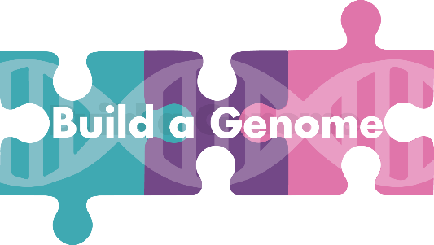
Join us for our Fifth National Workshop!
July 28-31, 2022
Hartwick College, Oneonta NY
There is no cost for this workshop.
Build-a-Genome:
- Is a course-based research experience for undergraduates
- Features cutting-edge course content in synthetic biology
- Provides both lab protocols and research workflows as well as teaching and ethics modules
- Works well at all types of institutions from research institutions to community colleges
- Is easily incorporated into your current courses with modules ranging from 2 weeks to 1 semester
- Is funded through the NSF Research Coordination Network for Undergraduate Biology Education
For more information, go to: https://qubeshub.org/community/groups/bag

Application
Application review will continue until the workshop is filled. Teams of faculty or of faulty and an undergraduate student are encouraged but not required.

Participant 1
Name:
Academic Rank/Title:
Department:
Institution:
Address:
Phone Number:
Email Address:
Participant 2
Name:
Academic Rank/Title:
Department:
Institution:
Address:
Phone Number:
Email Address:
- What courses (name and course level) do you currently teach?

- Please indicate your previous experience with each of these fields:
 | No experience at all |  |  |  | A great deal of experience | Comments or explanations about your answer?
 | 1 | 2 | 3 | 4 | 5
Synthetic Biology (concepts and principles)
Synthetic Biology
(research and techniques)
Molecular biology
Yeast genetics
Microbiology
Virology (especially bacteriophages)

- Which of the three Build-a-Genome workflows are you interested in? If you select more than one, please rank them (1=most interested)! Not sure what we’re talking about here, check out the description of each workflow at: https://qubeshub.org/community/groups/bag

_______ Bacteriophage genomes
_______ Neochromosomes
_______ Yeast Scramble (genome rearrangement)
- How do you foresee incorporating Build-a-Genome into your teaching?

- Briefly describe your experience mentoring undergraduate research.

- Do you have previous experience with a course-based research experience? (Which one?)

- Please explain why you would like to attend the workshop. How will it benefit your professional development?

- Is there anything that we missed? Are there particular skills and experiences that you bring to the group?

Agreements
- If I implement the course or use network resources, I agree to administer the BAG Network pre- and post-activity assessment with students. and to complete the faculty post-utilization survey ☐yes ☐no

- If I implement the course or use network resources, I agree to complete the BAG Network faculty post-course survey.
☐yes ☐no

- I have signed up for BAG network membership at https://qubeshub.org/community/groups/bag
☐yes ☐no

Please include a CV for each participant. For undergraduates, a one paragraph description of career goals and prior preparation may be sent instead.

Please submit this application to Lisa Scheifele at lzscheifele@loyola.edu Thanks!

