Algae-Brine Shrimp Ecosystem: Hypothesis, Predictions, and Experiment
Group members: ______________________________________________________________________
______________________________________________________________________The dynamics of an ecosystem are shaped by the size of the producer and consumer populations through either top-down or bottom-up effects that can have a number of effects on populations, communities, and the abiotic environment. Using the basic procedure described in “Food Chain Dynamics In A Simple Ecosystem” design an experiment to study trophic dynamics in this system. In two or three sentences explain the question you are going to investigate.

Our hypothesis is that if we manipulate:

then we should expect to observe:

because:

For our experiment, our control will be:

and our manipulation(s) will be:

We will collect the following data and analyze it by:

Standard Curve A standard curve is a tool used in science in which the relationship between two variables has been described by a line or curve. In this example, we are using a standard curve plotting the light absorbance at a particular wavelength against a known concentration of algal cells.
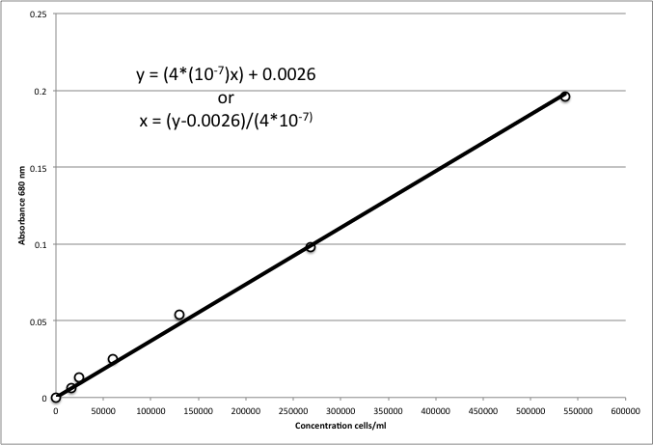
How To Do Calculations:
To achieve a particular concentration of algae, us the formula C₁V₁ = C₂V₂. Multiply the desired concentration by the desired final volume. Take the product of those two values and divide by the concentration in the algae stock solution. The value from this calculation will be the amount of the algae stock solution that you need to add to an amount of seawater to give your desired total volume, For example, if you have a stock solution of 230,000 cells/ml and you want 50 ml of a 5,000 cell/ml algae solution. The calculations would be:
((5,000 cells/ml)*(50 ml))/(230,000 cells/ml) = 1.09
50 ml – 1.09 ml = 48.91 ml
Therefore you need to add 1.09 ml of algae stock to 48.91 ml of seawater to obtain 50 ml of algae at 5,000 cells/ml.

Practice Calculations:
You are given 1L of algae and its concentration is 456,300 cells per milliliter (cell/ml) and you need a minimum concentration of 5,000 cells/ml to start with. How many milliliters of the stock would you need to add to achieve a final concentration of 10,000 cells/ml in a final volume of 50 ml of seawater? Show all work, and units.

Your lab partner takes a spectrophotometer reading at 678 nm, and records the absorbance as 0.23. Estimate the number of cells this would be equivalent to this absorbance using the standard curve from lab.

Group | Treatment | Jar | # Brine Shrimp  (Pre) | # Brine Shrimp  (Post) | pH  (Pre) | pH  (Post) | # Algae (cells/ml)  (Pre) | # Algae (cells/ml)  (Post)
 |  | 1
 |  | 2
 |  | 3
 |  | 4
 |  | 5
 |  | 6
 |  | 1
 |  | 2
 |  | 3
 |  | 4
 |  | 5
 |  | 6
 |  | 1
 |  | 2
 |  | 3
 |  | 4
 |  | 5
 |  | 6
 |  | 1
 |  | 2
 |  | 4
 |  | 5
 |  | 6

Indicate the amount of each component that will be added to each jar in the diagram below.

