Sexy Smells
Part I – Only a mother knows
Background: Historically, scientists thought that most bird species had fewer olfactory neurons, which means that their sense of smell is reduced. Therefore, it was assumed that chemical communication in birds, such as the use of pheromones for mate selection or species recognition, was essentially nonexistent. However, new research conducted by Dr. Danielle Whittaker (Whittaker, D. J., et al., 2013), pictured at left, indicate that birds do indeed have a sense of smell. Also, chemical compounds found in the preen oil of various passerine bird species, is used for assessing potential mates and has been linked to reproductive success.
Data Interpretation:
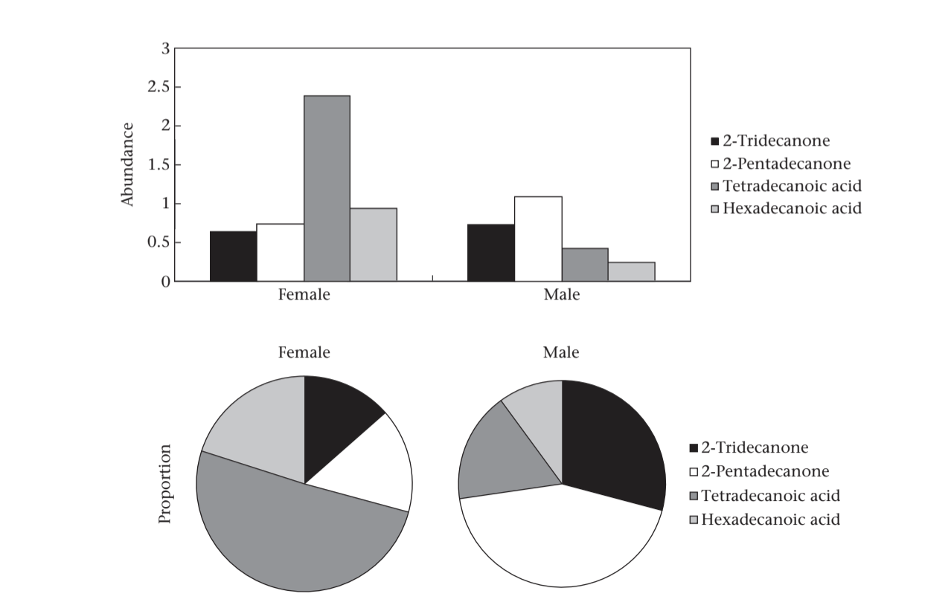
Above is an excerpt of Figure 1 from Dr. Whittaker’s study. This figure represents the abundance and proportion of several preen oil components using male and female junco average measurements.
Questions:
- What component is in the most abundant in female juncos? In male juncos?

- What component is in the highest proportion when looking at the preen oil composition in female juncos? In male juncos?

Part II: The Nose, Knows
Jane Boden, a human physiologist, was intrigued by Dr. Whittaker’s work. She decided to design a research team to determine if similar chemical components are found in humans. Recent research has shown that specific “pheromones” do play a role in human sexual attraction and selection of a mate. Dr. Boden decided she would review the structure of the human olfactory system, and then discuss potential research project with her graduate students.

Video Review Questions:
  - How many different smells can you distinguish as an adult?

  - What is the olfactory epithelium?

  - Using the structures identified in the video, explain the basic pathway for smell once the odor molecule enters the nose.

  - How many different olfactory receptor neurons does the average human have?

  - How often are olfactory neurons replaced? Is this rate of replacement common for neurons?

  - How is the processing of smell by the brain different from other senses such as sight?

  - What is anosmia?

Label the following diagram:
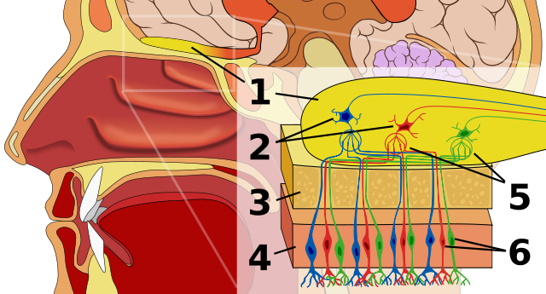

Part III: The Mysterious Human Pheremones
Dr. Boden thought this would be an excellent project for her two new graduate students, Priya Kapoor, who was studying human olfactory physiology, and Gina Menendez, who was studying the relationship between pheromones and animal behavior. There is a debate in the scientific community as to whether humans produce pheromones. She informed them of a couple of recent research students regarding pheromones in humans. Luckily, one of her colleagues had sent her video summaries of these projects to review.
Based on the information provided in the videos, answer the following questions:
- Describe what is meant by a pheromone.

- How do humans use pheromones? Provide an example of the chemical components that men detect in women and the components that women detect in men.

- Do humans have “breeding seasons”? What does this mean? Can you find evidence for this physiological phenomenon in humans?

- Is there evidence to show how humans assess/recognize breeding status (fertility, health, & quality)? Provide an example from the videos.

- In humans, what is meant by the terms primary and secondary sexual characteristics?

Part IV: Endocrine System
After review the video research summaries, Priya and Gina realized that they needed to review the hormones and feedback loops of the endocrine system. They decided to watch a few review videos to save time.
Answer the following questions:
- How do hormones find their target organ?

- At puberty in women:
- What 2 hormones are released by the anterior pituitary that have the ovaries as their target?

- Once the ovaries are stimulated, what hormone do they release that then target the uterus and create secondary sex characteristics?

- The first video mentions that males and females have the same hormones. If that is the case, at puberty, what hormones in males stimulates the release of testosterone by the testes and the creation of the secondary sex characteristics of males?

Study the following diagram, then explain what you think the effect of each hormone is on males and females at puberty. In the space provided, try drawing your own hormone cascade for the reproductive hormones.
T