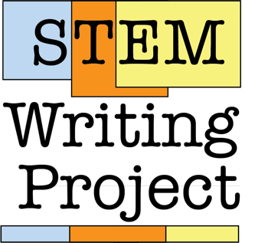

Synchronous Workshop

STEM Writing Project: Using Reflective Feedback on Scientific Writing to Increase Student Self-Efficacy

Background Reading For This Workshop

Why Should We Teach Scientific Writing?
Good communication skills are essential for 21st century STEM workers. They cut across STEM fields and are highly sought by employers independent of discipline or field of study. Job skills aside, good scientific communication skills help students rely less on intuition-based thinking and more on evidence-based thinking. They are better prepared to evaluate personal choices, societal issues, and larger policies that have deep connections to science and technology.

Why focus specifically on improving scientific writing skills?
- Writing often is a high-stakes assessment. Students who do not understand its conventions are more likely to perform poorly or leave STEM entirely.
- Writing helps students understand how to organize ideas so they tell a clear story, which makes it easier for them to communicate their ideas other forms.
- Scientific writing skills do not develop in a vacuum. Writing helps builds associated argumentation, critical thinking, & quantitative reasoning skills.
- The scientific community documents and shares knowledge mainly in written forms.

Why Is Teaching Scientific Writing So HARD?
Three reasons stand out.
- Class Sizes/Teacher Workload. Scientific writing is a skill that is best developed in small working groups where students discuss work in progress and teachers provide meaningful individualized feedback. This is simply not possible in BIO100 courses that enroll dozens or hundreds of students, and have other learning goals too.
- Limited Instructor Training/Knowledge. STEM faculty and teaching assistants are poorly equipped to guide novice writers. The Writing in the Disciplines, Write to Learn, and Writing Across the Curriculum (WID/WTL/WAC) community has defined core teaching principles that are based on >40 years of evidence and experience. Yet very few STEM teachers have any training in scientific writing pedagogy or know what those best practices are. How they approach it is more likely to reflect how they were taught. Their own prior writing experiences are not a reliable substitute; instructors are more likely to focus on writing features that are specific to their field rather than cross-cutting foundational skills.
- Instructor Resistance. STEM instructors can value scientific writing skills but still be unwilling to make it a priority. Possible reasons include:
  - “I don’t have time to develop something new.”
  - “I don’t have spare class time to spend teaching writing.”
  - “Students should learn how to write elsewhere.”
Resistance can be especially hard to overcome when instructors do not know HOW to make positive changes. Even faculty who innovate and adopt new methods can find it hard to sustain those changes, because there are few rewards for doing so.

Our Approach
We developed a Six Elements Model (SEM) for teaching scientific writing that brings together WAC/WID best practices and discipline-based education research methods. It has been our standard method for teaching scientific writing in BIO100-level courses for over 10 years.

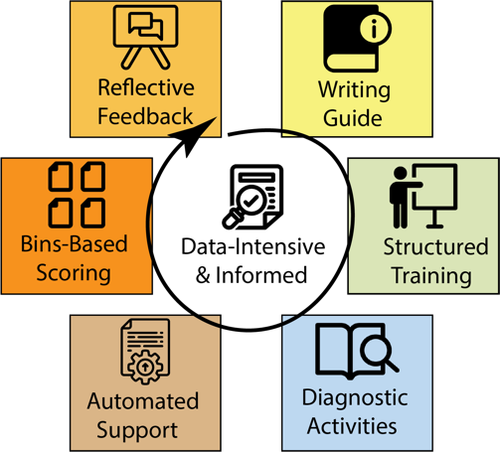

SEM combines:
- An open-source Biology Writing Guide
- Structured training activities for students and instructors
- Diagnostic activities that surface student misconceptions, so instructors can adjust the basic instructional strategy to local needs.
- Automation that both improves student outcomes, and streamlines routine data collection
- Bins-based scoring (a more authentic grading model that shifts the conversation away from "points-harvesting,") and
- Reflective, coaching-oriented feedback that avoids copy-editing and encourages self-correction.

Each Element contributes to creating a data-rich environment supporting assessment of student writers over time, and constant improvement of the model.

Why Does SEM Work?
- SEM stresses a growth-oriented mindset.
- Exercises produce actionable formative data about students' development as writers.
- Automation supports longitudinal tracking of both an individual’s progress, and cohorts of students over time.
- SEM is scalable. Multiple instructors (including GTAs and UTAs) can provide a consistent student learning experience, even in high-enrollment courses.
- SEM helps instructors set goals and adapt the components based on local data.

This workshop focuses specifically on reflective, coaching-oriented feedback. Go to either of the SWP home pages to learn more about the other five components of our writing training methods.
- Our home on the QUBES Hub
- Our home on GitHub

Graders’ Guide to Reflective Coaching-Oriented Feedback

Overview
Reflective coaching comments have both specific information or guidance/rationale, and foster thinking. Often they have open ended questions that help a student think about BOTH WHAT TO CHANGE AND WHY. This approach is harder for students at first, because most are accustomed to being told what to fix to earn a perfect score. With practice and consistent use though, students learn to self-correct the indicated error and apply similar thinking to other situations.
Watch the short overview video here

How Many Comments to Give
Over-commenting is a very common problem when grading student writing. We tell GTAs during training:
- Provide 1 summary comment on the front page of a student report. Use it to point out the 1-2 largest, most over-arching issues affecting the entire document.
- Do not provide more than 3-5 in-text comments per page
- Focus on helping students correct basic, essential requirements* and large global issues* first.
- Wait to address smaller details until AFTER basic criteria and global problems have been fixed.

(* You can learn more about SEM’s bins-based grading protocol here.)

How To Structure Reflective Comments
This is an example of a front-page summary comment for a lab report. The table below it breaks down the individual elements.
This is good work on your first submission. You met all 5 of our basic criteria. The most important area to work on next is your discussion. Really think about resource allocation and herbivory, and your explanation. Ask yourself, is there another possible explanation besides herbivory? Also think about your results and what they’re really saying. Is there a better way to display or summarize the data that makes your main points clearer? Your writing was very clear; good work! There were some other minor technical points that also need correcting that I’ve highlighted. Overall Assessment: Needs Minor Revisions.

Statements | Breakdown
The most important area to work on next is your discussion. Also think about your results and what they’re really saying. | These two statements identify the first 2 points where the student should concentrate effort.
Really think about resource allocation and herbivory, and your explanation. Ask yourself, is there another possible explanation besides herbivory? | Student is prompted to think more about their initial explanation, and whether it is the only option. Note that the comment does not actually give alternatives, only points to a possibility.
Is there a better way to display or summarize the data that makes your main points clearer? | The question should be self-evident; there likely is a better option. The student can either look for a solution themselves, or talk with the instructor.
Your writing was very clear; good work! | Student does not need to focus on improving writing at this time.
There were some other minor technical points that also need correcting that I’ve highlighted. | Technical errors (statistics, figures) are the third major area needing correction.
Overall Assessment: Needs Minor Revisions. | Score aligns with description; report needs work mainly on interpretation of data, other smaller technical aspects.

Provide Shorter Reflective Comments In Text
The excerpt below from a student report has two comments for the same block of text. The first comment is a simple copy-edit correction. The second version invites deeper thinking.

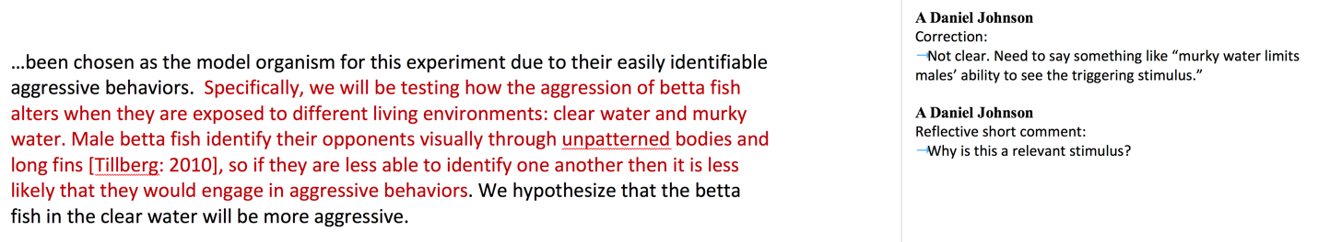

These are more examples of shorter reflective comments embedded in report pages. Read each comment. Try to identify the specific information or guidance/rationale, and how each comment encourages deeper thought.
- Did you mean for each leg before and after injection? Why is that important?
- What is the relevance of this observation in the moth life cycle?
- Are you sure it is the correct tense for this section? Check it in other primary lit.
- Did you find any primary literature articles that deal with interspecific interactions in betta fish? It would be very useful to cite and talk about those here, if there are.

Avoid Giving Simple Copy-Editing Comments
Copy editing comments explain how to correct a SPECIFIC location but give no rationale. They range from pointers (simple punctuation marks or single words indicating an error) to more specific instructions. They do not foster reflection or guide broader thinking, so any lessons learned do not transfer easily to other situations.

Below are examples of copy editing comments, and how they could be modified to foster reflection. Several reflective versions (marked **) can be recycled with little or no revision.

Correction-Oriented Comment | More Reflective Alternative
?? (could be interpreted many ways) | What is the purpose of this statement?**
Scientific name - italicize or underline. | Is this correct format?**
No direct quotes – paraphrase | Are quotes allowed? How can this be presented more succinctly?**
Capital “P” here | What is standard format for reporting stats?**
Refer to Figure 1/Table 1 here. | Where are your references in text to each figure or table?**
Add/revise/remove a word, phrase, image, etc. | Add/revise/remove a word, phrase, image, etc., because …
Ambiguous, awkward | I am not sure what this sentence means. Are you referring to X, or Y?
Methods should be past tense | Check articles we read previously for correct tense, format for this section.**
Raw data | Looks like raw data; where are these summarized?
Avoid recipe style (with no further explanation) | Check articles we read for correct tense, format for this section.
Need units | What is required for all numbers? Is this correct format?**
Organize this section more clearly. Put X, then Y, then Z. | I’m not following your logic. Do you mean…?**
Clarify this step in procedure or analysis | I am not sure what this step means. Are you referring to X, or Y? Could someone with prior knowledge of this lab repeat what you did?**
Be more specific about how salinity changes root transport. | Focus in here. How so? What biological processes are happening due to salinity?**
I’m having trouble following logic here. Make sure your hypothesis is consistent with the rest of your introduction | I’m having trouble following your logic here. How could you revise the early part of the Intro so it leads to your hypothesis?
State here why plants allocate resources to leaves versus roots. | Be more specific. Why would they allocate resources to either structure?
Revise “changes over time” to say “changes in root growth per unit time.” | What does phrase “changes over time” mean? Root growth? Shoot growth? Something else?
No. Carbon allocation explains this more than any other nutrient. | What about carbon? Is R:S ratio showing carbon allocation more than other nutrients?

Reference External Resources in Comments
We provide our students with a thorough, detailed Writing Resource Guide, and reinforce that students should be referring to the Resource Guide FIRST by referring to specific pages in the Guide (especially for basic formatting and technical errors) instead of writing out detailed explanation or feedback comment. This also cuts down grading time.

Correction-Oriented Comment | Alternative Using a Resource Reference
Report the stats in your results using (t=, d.f. =, P= ) format | See p. 48 of Resource Guide for how to report your stats results
Add your alpha value
Report mean as x+s.d.
Improper citation format. Use [Name: Year] in text. | Follow p. 36 of Guide for in-text and end citation format.
This citation is not correct. We do not use URLs or DOIs only. You need to include authors, year, title, journal info.
You need y-axis labels for figure. Add a caption explaining measurements. Put caption in Figure Legends section. | See p. 41 of Resource Guide for format of axis labels, contents, location of caption.

Tips:
- If you find you are putting the same comment on different reports, create a master list of comments and copy/paste the appropriate ones rather than re-typing them.
- If you are an experienced GTA, remember that the Resource Guide is updated regularly. Double-check that you are using the correct page numbers for the current version.
Note for BIOME 2022 Workshop: our Writing Resource Guide is available as an open-access multi-format book (see the demo here) that other instructors can revise to fit their specific program needs. Check out the QUBES Hub page or GitHub repository page to learn more.

If You MUST Address Basic Writing Mechanics
Sometimes basic writing is the biggest weakness of a lab report. Here is an example; this Introduction is so poorly written that it is hard to understand the student’s thinking:

Organisms metabolism is fundamental in the ways that it is the sum of the chemical reactions that take place within each cell of a living organism that provide energy for vital processes and for synthesizing new organic material. The amount of energy expended by an animal over a specific period of time is referred to as a rate of heat energy released from an animal’s body (this procedure is known as calorimetry). However, measuring heat from an animal body with accurate precision requiring special equipment, which is often expensive. As a result, we use a process to measure metabolic rate that is controlled directly with heat production: rate of oxygen consumption.
In an article published in 2000, K.A. Sloman set to exploring environmental factors and specific metabolic rate. The researcher carried out a study where he observed the effects of aggression on metabolism through the use of the brown trout (salmo trutta). Sloman placed a pair of the species in small, confined aquarium where he allowed one trout to establish a social hierarchy by becoming the dominant fish. He found that, other fish (subordinates) experienced high levles of soceity stress as a result of the aggression exhibited by the dominering trout. This led the smaller fish to have an increase in specific metabolic rate, which was measured through oxygen consumption (Sloman AK, 2000. Annals Biol. 34:15-17). This experiment is similar to our own as we wish to test the effects of aggression on the specific metabolic rate. In order to do this, we will use crayfish (Orconectes sp.). We will carry out this experiment with the following hypothesis in mind: a crayfish is exposed to aggression/social stress should have a significant increase in specific metabolic rate.

It is hard to address so many errors using just reflective coaching and resource references. Adding to the challenge, the entire report likely needs corrections, not just 1-2 paragraphs.

We do not recommend nor expect instructors to spend time copy editing entire reports. Instead, use one of these two strategies for responding to writing mechanics problems.

- Option 1: use minimal marking. Edit ONE paragraph thoroughly for grammatical errors. Then attach a comment in the margin telling the student they are responsible for fixing similar errors beyond this paragraph. Search on Google to learn more about minimal marking; there are many good guides available.

- Option 2: highlight one poorly written paragraph and attach a new comment. List the specific errors that you see. Be sure to tell the student that you saw similar errors in other paragraphs, and that they are responsible for finding and correcting them. For example, the feedback comment for the flawed paragraph above might read:

You have a lot of basic writing flaws in your report that you need to correct or revise. For example, I found all of these basic errors in just these two paragraphs:
- Unclear flow of the logic in both paragraphs
- Errors in grammar (example: "Organisms metabolism is fundamental in the ways that it is the sum..."
- Awkward wording, run-on sentences (ex. "The amount of energy expended by an animal over a specific period of time is referred to as a rate of heat energy released from an animal’s body (this procedure is known as calorimetry)."
- Improper word usage (ex.: dominant, not domineering)
- Improper citation location and format (ex.: look at Sloman reference.)
- Format errors in scientific names
- Spelling errors (ex. levles of soceity)
You need to revise this report very carefully. I recommend that you contact the Writing Center in the library first. They can help you with basic writing issues. After meeting with their tutors, make an appointment with me to work on how you could better organize your logic and key points.

Other General Suggestions For Giving Feedback
- Provide some positive encouragement or praise when warranted, but do not over-state it, or give undeserved praise.
- If one particular item was done well, refer the student to it as an example of how to correct other parts of the report.
- Avoid “but.” Think about this comment: “I like how you wrote your Intro, but the Methods need…”. The “but” negates what the student did well. Try wording that invites continued effort: “I like how you organized your Introduction. Now for the revision, try using the same organizational strategy for your Methods section, which needs…”.
- Do not interject writing conventions and idioms of your sub-field. For example, students are not required to use different formats for in-text citations, depending on the number of authors on the source article. These details become important later as students specialize; at the introductory level we want to focus on foundational issues.
- If you find you are putting the same comment on different reports, create a master list of comments and copy/paste the appropriate ones rather than re-typing them.

