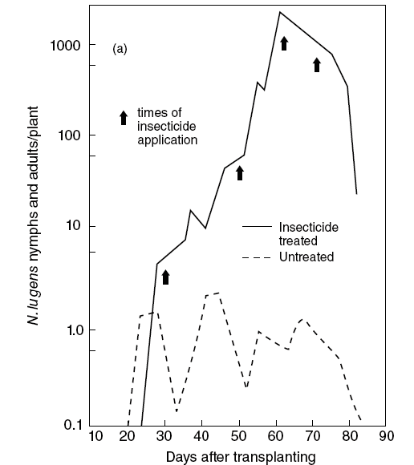
The Green Revolution of the late 1950s marked the advancement of agriculture technology and the development of high-yield crops became a priority in agriculture. In tropical Asia, the Green Revolution helped farmers to solve the problem of the brown planthopper (BPH), an insect pest that devastates rice crops. Prior to the Green Revolution the population density of the brown planthopper was naturally regulated by a variety of native predators, including spiders and insects. Although the development of rice cultivars and GMOS, synthetic fertilizers, and synthetic pesticides advertised increased production, farmers are facing larger problems than ever before. In fact, the end result was that an initial strategy to increase rice yields and avert crop failure has had the exact opposite effect.

The use of high-yield rice varieties, fertilizers, and pesticides has altered the natural balance of predator-herbivore-plant interactions that regulated the densities of the populations of BPH and its predators. When pesticides are sprayed, not only will the BHP be affected, but many pesticides are non-discriminatory and will kill a plethora of organisms, including those that naturally prey upon BPH. In the short term, pesticides will lower the magnitude of BPH but the lack of predators causes a resurgence of BPH that now lack pressure from the environment (Figure 1). Many research studies investigate the role of a pesticide in killing the target pest, but not the predators found in that area. However, Figure 2 highlights the research of one group of scientists who studied 11 different pesticides and how lethal they are to both BPH and one of their predators, the insect mirid.
Figure 1: BPH population density in pesticide sprayed and unsprayed rice fields. The days after transplanting are based on when BPH were first introduced into the fields.
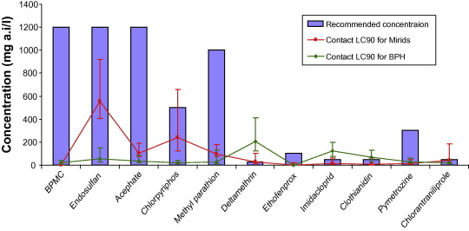
Figure 2: The LC90 (lethal concentration required to kill 90% of the population) of 11 different chemical pesticides on BPH and their predator mirids. The purple bars are the recommended concentration given by the manufacturers of the pesticides.

Before completing the exercises below complete the online click-and-learn activity on trophic cascades:

https://www.hhmi.org/biointeractive/exploring-trophic-cascades

Discussion Questions

Part 1

- Looking at Figure 1, what are the differences between the treated and untreated plants? What is the explanation for this trend?

- In Figure 2, which pesticide(s) and in what amount would you recommend to farmers? Why would you make this recommendation?

- The pesticide companies create the recommendations for how much farmers should use on their crops. Were there any recommendations that were higher than needed? How many? Why might a company do this?

- Identify any words, topics, acronyms, etc. that you did not know or understand from the introduction. In addition, use the space below to write one question that relates to the information presented.

Part 2
Table 1 from Sissgard et al., (2007) shows data on changes in population density for BPH alone and in the presence of two of its predators, Atypena formosana (Af) Pardosa pseudoanulata (Pp).

Table 1: Changes in population density of the BPH (N.lugens) in the presence and absence of spiders, Atypena formosana(Af) and Pardosa pseudoanulata(Pp) (from Sigsgaard, L. 2007, Bull.Ent.Res. 97:533-544).
Weeks | BPH | BPH+A.f. | BPH+P.s.
0 | 10 | 10 | 10
1 | 50 | 50 | 50
2 | 700 | 230 | 100
3 | 710 | 210 | 50
4 | 500 | 75 | 25
5 | 250 | 20 | 75

Graph the data from table 1 in the space draw an XY graph showing the changes in BPH population density changes with time in the three scenarios.

Based on the data shown in the graph what are the major conclusions of the study? Make sure you use the data from the graph to support your answers. Use the data when discussing the results.

Part 3

In nature changes in predator and prey density oscillate and are sustained through time. Using the Lotka and Volterra model for predator-prey interactions answer the following questions.

1. Play around with the model changing one of the parameters at a time and record below the effect on the amplitude of the oscillation, changes in density for predator and prey (do not change the initial population density of the predator and prey).

2. What coefficients in the model account for the predator density effects on prey density? Explain your answer.

3. Based on the data from figure showing the effect of various pesticides on the population density of BPH and its mirid predator, what coefficients in the model would be affected and how? Model the effect by changing these coefficients one at a time and explain the results. Be specific, e.g. the application of pesticide would increase the mortality rate d_{x} for the predator.

4. Under what conditions do predator and prey subsist at a stable equilibrium Under what conditions does the model crash, i.e. either the predator or the prey are extinguished. Explain your answers.

References
Gurr, G., Heong, K., Cheng, L., & Catindig, J. (2012) Ecological engineering strategies to manage insect pests in rice. In Biodiversity and Insect Pests: Key Issues for Sustainable Management, First Edition. Ed.: by Gurr, G., Wratten, S., Snyder, W., & Read, D. Pub.: John Wiley & Sons, Ltd.
Preetha, G., Stanley, J., Suresh, S., & Samiyappan, R. (2010). Risk assessment of insecticides used in rice on miridbug, Cyrtorhinus lividipennis Reuter, the important predator of brown planthopper, Nilaparvata lugens (Stal.). Chemosphere, 80(5), 498-503.
Sigsgaard, L. (2007). Early season natural control of the brown planthopper, Nilaparvata lugens: the contribution and interaction of two spider species and a predatory bug. Bulletin of Entomological Research, 97, 533–544.

