The Green Revolution of the late 1950s marked the advancement of agriculture technology and the development of high-yield crops became a priority in agriculture. In tropical Asia, the Green Revolution helped farmers to solve the problem of the brown planthopper (BPH), an insect pest that devastates rice crops. Prior to the Green Revolution the population density of the brown planthopper was naturally regulated by a variety of native predators, including spiders and insects. Although the development of rice cultivars and GMOS, synthetic fertilizers, and synthetic pesticides advertised increased production, farmers are facing larger problems than ever before. In fact, the end result was that an initial strategy to increase rice yields and avert crop failure has had the exact opposite effect.

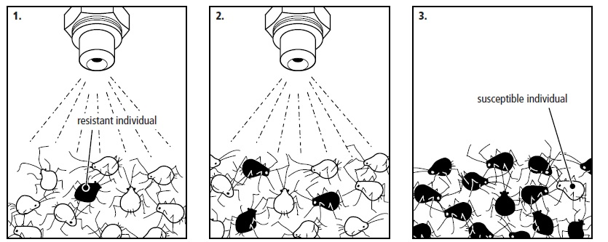
Pesticide resistance is one of the most important concerns when protecting crops from herbivorous insects such as the plant leafhopper. It estimated that 40% of crops in a field would be lost if pesticides become infective. Resistance to pesticides, or any type of chemical substance, is best defined as a change in the sensitivity of a population to a particular chemical. Note that resistance is not caused when an individual organism adapts to a particular chemical. Resistance occurs when certain individuals in a population are not significantly harmed by the chemical. These resistant individuals tend to reproductively outnumber the susceptible population. The ability to resist a particular chemical is due to mutations that impart some sort of protection from harm by the chemical. As shown in Figure 1, pesticide resistant individuals already exist in a population. Their prevalence is enhanced by applications of the pesticide.
Figure 1: The selection of pesticide resistant individuals from a breeding population of insects.

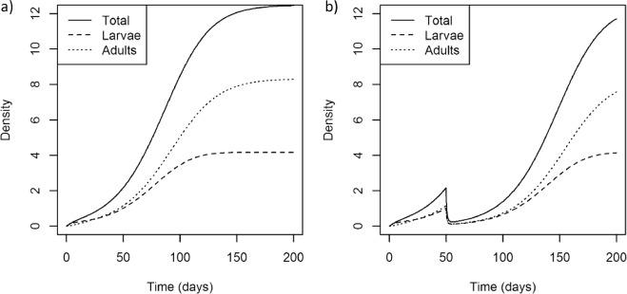
There are currently 29 insecticides that BPH populations are immune to in rice agriculture fields. Manufacturers are constantly in battle with BPH to create novel pesticides that will impact BPH before they build resistance to it. Figure 2 shows how this resistance builds over time.
Figure 2: The figures show the response of the total insect population, as well as the adults and larvae, when the population is (a) untreated, or (b) treated with a single insecticide application on day 50.

General Discussion Questions

PART 1

- Why is it important that agricultural researchers are able to measure the rate at which a population of insects becomes predominantly pesticide resistant?

- Explain the effect of the pesticide treatment during day 50 on the insect population in Figure 2, graph b. What evidence of pesticide resistance is shown in graph b in comparison to graph a?

- Predict what would expect to happen to the insect population density in Figure 2, graph b if the same pesticide was applied at 150 days.

- Identify any words, topics, acronyms, etc. that you did not know or understand from the introduction. In addition, use the space below to write one question that relates to the information presented.

PART 2
Notice the data in Table 1 showing the results of a pesticide treatment on three populations of adult plant leafhoppers. The plant leafhoppers have a population doubling time of approximately 10 days. Pesticides were administered on day 30 of the Treatment 1 and the Treatment 2 populations. A second treatment of the same pesticide was given to the Treatment 2 population at 70 days. Based the information provided above and the existing data in Table 1, hypothesis the data you would expect to see in Days 70 through 100 for Treatment 2. Place your hypothesized data in blank spaces under Treatment 2.
 | Number of Adult Individuals in Population
Day | Untreated | Treatment 1 | Treatment 2
0 | 12 | 12 | 12
10 | 24 | 23 | 25
20 | 49 | 46 | 49
30 | 101 | 3 | 4
40 | 203 | 7 | 8
50 | 398 | 15 | 16
60 | 789 | 30 | 31
70 | 1209 | 59
80 | 2200 | 118
90 | 3212 | 235
100 | 3842 | 471

5. Use the graph grid below to compare the population growth curves of each treatment population based on the data in Table 1.
6. Using your graphs as a reference, explain your rational for the population growth curve you hypothesized for Treatment Group 2.

Part 3
In nature changes in predator and prey density oscillate and are sustained through time. Using the Lotka and Volterra model for predator-prey interactions answer the following questions.
1. Play around with the model changing one of the parameters at a time and record below the effect on the amplitude of the oscillation, changes in density for predator and prey (do not change the initial population density of the predator and prey).

2. What coefficients in the model account for the effect of pesticide treatments on the predator and/or the prey? Explain your answer. Based on your answer model these effects by changing those coefficients in the model. Explain the outcomes.

3. Under what conditions do predator and prey subsist at a stable equilibrium Under what conditions does the model crash, i.e. either the predator or the prey are extinguished. Explain your answers.

References
Goodell, P. B, Godfrey, L. D, Grafton-Cardwell, E. E, Toscano, N., & Wright, S. D. (2001). Insecticide and Miticide Resistance Management in San Joaquin Valley Cotton for 2001.
Helps, J., Paveley, N., & van den Bosch, F. (2017). Identifying Circumstances under which High Insecticide Dose Increases or Decreases Resistance Selection. Journal of Theoretical Biology, 428(7), 153-167.
Roush, R. & Miller, G. (1986). Considerations for Design of Insecticide Resistance Monitoring Programs. Journal of Economic Entomology, 79(2), 293–298.
Win, S., Muhamad, R., Ahmad, Z., & Adam, N. (2011). Life Table and Population Parameters of Nilaparvata lugens Stal. (Homoptera: Delphacidae) on Rice. Tropical Life Sciences Research, 22(1), 25–35.
Wu, S., Zeng, B., Zheng, C., Mu, Z., Zhang, Y., Hu, J., Zhang, S., Gao, C., & Shen, J. (2018). The evolution of insecticide resistance in the brown planthopper (Nilaparvata lugens Stål) of China in the period 2012–2016. Scientific Reports, (8)4586.

