Cell Division in the Presence of a Growth Factor

Introduction
Under optimal conditions, growth of cells occurs as each cell completes the cell cycle and doubles producing two daughter cells which later themselves divide. Growth factors can provoke the growth of cells. For example, interleukins are made by white blood cells to stimulate the growth of other immune system cells. Erythropoietin is made by the kidney to promote growth of red blood cells.

Importance
We can use equations to determine how the growth factor affects the rate of cell growth.

Questions
How do growth factors affect the rate at which cell populations grow?

Variables
N_{t} | number of cells in the population
N₀ | number of cells initially
f | frequency of cell cycles per unit time (1/hour)
t | time (hour)
f_{max} | maximum cell cycle frequency (1/hour)
c | constant (hour x mg/mL)
[G] | concentration of growth factor (mg/mL)

Methods
The growth of cells is often described exponentially (one cell becomes two cells become four cells become eight cells...). This can be described mathematically by the following equation:
$$N_{t}=N_{0}×2^{tf}$$ | LaTeX Code: \[ N_t = N_0 \times 2^{tf} \]
where N_{t} is the number of cells at time t, N₀ is the number of cells initially, and f is the frequency of cell cycles per unit time. For example, if a cell completes the cell cycle two times an hour, then f=2 cell cycles per hour. Similarly, we can write the duration of the cell cycle as 1/f, or number of hours per cell cycle. If f=2, then the duration of the cell cycle is 1/2 hour.
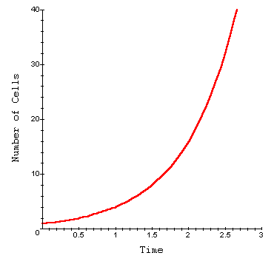
In the presence of a growth factor, the frequency of cell cycles may be increased. However, because growth factor receptors in the cell membrane may become saturated at high concentrations of growth factor, the cell growth rate cannot increase infinitely.
We can utilize Michaelis-Menten and Lineweaver-Burk equations to describe the duration of the cell cycle (1/f) as a function of the concentration of the growth medium [G] using the following equation:
$$\frac{1}{f}=\frac{1}{f_{max}}+\frac{c}{\left[G\right]}$$ | LaTeX Code: \[ \frac{1}{f} = \frac{1}{f_{max}} + \frac{c}{[G]} \]
where f_{max} is the maximum frequency of cell division when [G] is very large and c is a constant relating the intensity with which the growth factor increases cell division. We can plot 1/f as a function of [G] to examine how the growth factor concentration affects the duration of the cell cycle. Take c = 0.1 hours (mg/mL) and f_{max} = 5 cell cycles/hour.
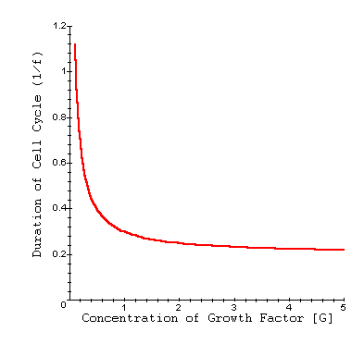

Interpretation
Even at relatively low concentrations of a growth factor, the duration of the cell cycle can rapidly decrease. This results in a higher frequency of cell divisions per unit time. As the concentration of growth factor increases however, the duration of the cell cycle eventually levels off, and the frequency of cell divisions cannot increase further.

Conclusion
The presence of a growth factor can greatly increase the rate at which a cell population grows. By quantifying this with simple equations, we can experimentally determine the maximum frequency of cell division for a population as well as the speed with which a growth factor helps the cells reach that maximum frequency.

Additional Questions
1. Look at the equation for 1/f. What is the cell duration as [G] goes to infinity?
2. Graph f as a function of [G]. How does the interpretation of this graph compare to that of the function 1/f? What other biological processes is this function similar to?
3. How does the exponential growth of the population (the function N_{t}) change as the growth factor concentration [G] increases? Graph N_{t} as a function of time for several values of f.

Source
Chen, C. and S. C. Chen. 1981. Cell growth factor activity: New quantitative method in cell culture assay. Experimental Cell Research 136:43-51

About this Resource
This material was originally distributed as part of “Alternative Routes to Quantitative Literacy for the Life Sciences” - National Science Foundation Award DUE-9752339 to the University of Tennessee, Knoxville for August 1, 1998 - July 31, 2000. Principal Investigator: Louis J. Gross. Co-Principal Investigators: Beth C. Mullin and Susan E. Riechert.
This material is now being revised as part of the “Resources for Improving Quantitative Skills in Community College Biology” project. As part of that project is also aligned with the OpenStax Biology Textbook.
It is published using the QUBES Open Education Resources publishing platform.

http://www.tiem.utk.edu/~gross/bioed/
https://qubeshub.org/community/groups/quantbioatcc/
https://openstax.org/details/books/biology-2e
https://qubeshub.org/qubesresources/publications/1031/

