Mechanisms of Cell Attachment

Introduction
Fibrous elements of the cytoskeleton, including microtubules and filaments, help maintain cell shape. Cell shape is determined by the interaction of these elements with the surface to which the cell is attached.

Importance
Because of the difficulty in visualizing the underside of cells, light reflection through a cell and glass slide can be used to describe the attachment of cells to surfaces. By measuring how the refractive index of a cell changes, we can determine how a cell's density and cytoskeleton changes when it attaches to a surface.

Questions
How do the density and cytoskeleton of a cell change when it attaches to a surface?

Methods
For a cell in a surrounding medium attached to a glass slide, light is reflected onto particular regions of the cell. If the cell is directly attached to the glass, then the intensity of light reflected at this interface can be measured. If, instead, the surrounding medium separates the cell from the glass, then the intensity of light reflected is determined by the glass/medium interface. The refractive index of the glass, cell, and medium determines how much light is reflected at each of these interfaces.
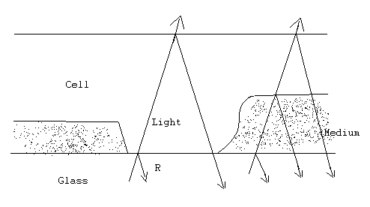
The relative intensity (R) of reflected light at the interface of the glass and cell is given by
$$R={\left(\frac{r_{g}-r_{c}}{r_{g}+r_{c}}\right)}^{2}$$ | LaTeX Code: \[ R = \Bigg( \frac{r_g - r_c}{r_g + r_c} \Bigg)^2 \]
where r_{g} and r_{c} are the refractive indices of the glass and cell respectively. The refractive index of the glass used here is approximately 1.515 and is generally greater than the refractive index of the cell. As cell density increases, the refractive index of the cell increases. Notice that as r_{c} increases, the denominator increases, but the numerator decreases. Therefore, this is a decreasing function, and the relative intensity of reflected light (R) decreases as the refractive index (r_{c}), or cell density, increases.
By rearranging this equation, the refractive index (r_{c}) of a particular region of the cell can be calculated by measuring the intensity of reflected light at that region:
$$r_{c}=r_{g}×\frac{1-\sqrt{R}}{1+\sqrt{R}}$$ | LaTeX Code: \[ r_c = r_g \times \frac{1 - \sqrt{R}}{1 + \sqrt{R}} \]
The refractive index can be calculated for different regions along a cell surface to compare the density of the cell at regions where it is focally, broadly, and not attached to a surface.
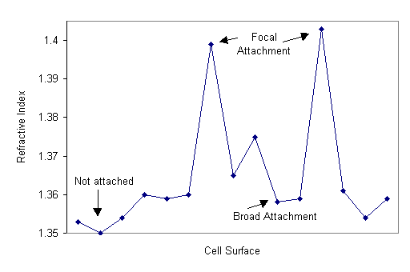

Interpretation
In regions where cells were attached to glass by a single focal point, refractive indices were higher than regions of the cell that were broadly attached to the glass or not attached to the glass at all. The higher refractive indicates regions of focal contact reflect an increase in the density of the cytoplasm at regions of attachment.

Conclusion
In regions of a cell attached to a substrate, the density of that local region of the cell increases. This results in a decrease in the amount of light reflected. The increased density at attachment sites results from microfilaments in the cytoskeleton contracting to support the cell.

Source
Bereiter-Hahn, J., C. H. Fox, and B. Thorell, 1979, Quantitative reflection contrast microscopy of living cells, J. Cell Biology 82:767-779
Izzard, C. S. and L. R. Lochner. 1976. Cell-to-substrate contacts in living fibroblasts: An interference reflexion study with an evaluation of the technique. Journal of Cell Science 21:129-159.

About this Resource
This material was originally distributed as part of “Alternative Routes to Quantitative Literacy for the Life Sciences” - National Science Foundation Award DUE-9752339 to the University of Tennessee, Knoxville for August 1, 1998 - July 31, 2000. Principal Investigator: Louis J. Gross. Co-Principal Investigators: Beth C. Mullin and Susan E. Riechert.
This material is now being revised as part of the “Resources for Improving Quantitative Skills in Community College Biology” project. As part of that project is also aligned with the OpenStax Biology Textbook.
It is published using the QUBES Open Education Resources publishing platform.

http://www.tiem.utk.edu/~gross/bioed/
https://qubeshub.org/community/groups/quantbioatcc/
https://openstax.org/details/books/biology-2e
https://qubeshub.org/qubesresources/publications/1033/

