Nucleoplasmic Index

Introduction
As cells pass through the cell cycle, their nuclear volume doubles in preparation for division into two daughter cells. When cells are in resting condition, however, the ratio of nuclear volume to cytoplasmic volume remains stable. This ratio is known as the nucleoplasmic index.

Importance
The nucleoplasmic index is considered to be closely related to the mitotic cellular cycle and to the functional phase of cells. It is also a good indicator of dynamic changes in cells. For example, after lizard tails are amputated, spinal nerves, which do not undergo division, might be expected to experience changes in volume to supply the regenerating tail.

Questions
How does the nucleoplasmic index change with the cell cycle? What can the nucleoplasmic index tell us about changes spinal nerves experience when lizard tails are regenerating?

Variables
NP | nucleoplasmic index
Vn | nuclear volume (micrometer³)
Vc | total cell volume (micrometer³)

Methods
The nucleoplasmic index (NP) is expressed mathematically as
$$NP=\frac{V_{n}}{V_{c}-V_{n}}$$ | LaTeX Code: \[ NP = \frac{V_n}{V_c - V_n} \]
where V_{n} is the nuclear volume and V_{c} is the total cell volume. When NP is plotted over time, we can see how the ratio of nuclear to cytoplasmic volume changes with the cell cycle.
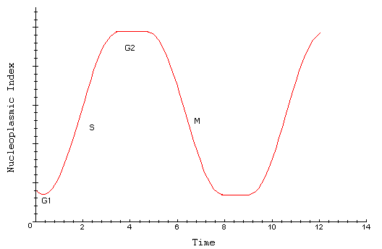

Interpretation
During the G1-phase, the cell is in a resting state, and the nucleoplasmic index is stable. During the S-phase of the cell cycle, DNA replicates. Consequently, one expects to see an increase in NP as the nuclear volume increases. During the G2 phase, the cell is again stable, although the nuclear volume is now doubled. After mitosis, when the cell divides, NP returns to normal as each daughter cell enters the resting stage, G1. The nucleoplasmic index increases and decreases again as the cell cycle continues.

Methods
To determine if lizard spinal nerves experience changes after lizard tails are amputated, the nucleoplasmic index can be calculated for spinal cells supplying the cervical, thoracic, lumbar, and caudal regions of the lizard.
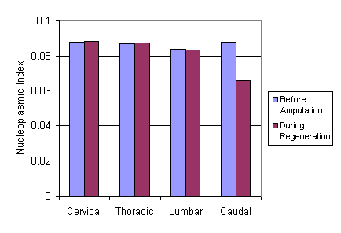

Interpretation
After amputation of a lizard's tail, the nucleoplasmic index for spinal nerves supplying the upper and middle regions of the lizard did not change significantly. However, spinal nerves supplying regenerating lizard tails (in the caudal region) experienced a decrease in the nucleoplasmic index. The lower nucleoplasmic index indicates regenerating tails are innervated by spinal nerves that increase in volume to compensate for the missing tail.

Conclusion
The nucleoplasmic index can indicate changes in nuclear volume over time in cells divide. Additionally, the index reveals dramatic changes in cell volume in response to a stimulus.

Source
Borrione, P., L. Fabiani, S. Geuna, M. G. Giacobini-Robecchi. 1997. Nucleo-plasmic index variability in dorsal root ganglion neurons of the lizard (Podarcis sicula) during neuronal hypertropy. Neuroscience Letters 233:1-4

About this Resource
This material was originally distributed as part of “Alternative Routes to Quantitative Literacy for the Life Sciences” - National Science Foundation Award DUE-9752339 to the University of Tennessee, Knoxville for August 1, 1998 - July 31, 2000. Principal Investigator: Louis J. Gross. Co-Principal Investigators: Beth C. Mullin and Susan E. Riechert.
This material is now being revised as part of the “Resources for Improving Quantitative Skills in Community College Biology” project. As part of that project is also aligned with the OpenStax Biology Textbook.
It is published using the QUBES Open Education Resources publishing platform.

http://www.tiem.utk.edu/~gross/bioed/
https://qubeshub.org/community/groups/quantbioatcc/
https://openstax.org/details/books/biology-2e
https://qubeshub.org/qubesresources/publications/1038/

