Sperm Motility

Introduction
Mammalian sperm cells consist of a head, midpiece, and flagellum. The midpiece is densely packed with mitochondria. These mitochondria provide energy in the form of ATP to the flagellum to propel the cell.

Importance
Movement of the flagellum depends on properties of the sperm and surrounding medium. We can quantify expected flagellum movement and compare it to actual data to see how efficient mammalian sperm are using ATP.

Questions
How can we quantify sperm movement? How efficient are mammalian sperm at converting ATP to flagellar movement?

Variables
f | beat frequency of flagellum (Hz)
E | production rate of energy from ATP per volume of mitochondria (ergs/(μm³ s)
M | mitochondrial volume (μm³)
v | viscosity of surrounding medium (poise)
L | length of flagellum (μm)
p | a constant

Methods
The beat frequency (f) of the flagellum is directly related to the production rate of energy from ATP per volume of mitochondria (E) and the mitochondrial volume (M). It is inversely related to the viscosity of the surrounding medium (v) and the length of the flagellum. This relationship was expressed by Caruzzo and Baltz as
$$f=\sqrt{\left(\frac{EM}{pvL^{3}}\right)}$$ | LaTeX Code: \[ f = \sqrt{\Bigg ( \frac{EM}{pvL^3} \Bigg )} \]
We can plot f as a function of the energy output of the mitochondria (EM) to determine how an increase in energy output affects beat frequency.
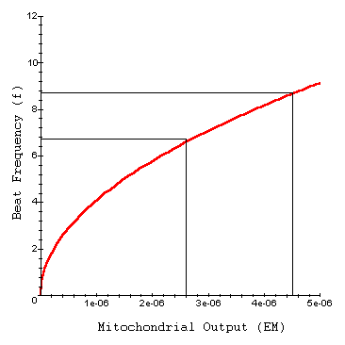

Interpretation
Beat frequency increases as mitochondrial output increases. However, the slope of this function becomes shallower as EM increases. In response to increased power, the beat frequency of sperm flagella also increased. However, due to the nature of this function, the resulting increase in movement is not very efficient. For example, if we increase EM by 70%, we have a new value of 1.7 x EM. We can substitute this into the function f to determine the corresponding increase in beat frequency.
$$f_{new}=\sqrt{\left(\frac{EM\left(1.7\right)}{pvL^{3}}\right)}=\sqrt{1.7}×f_{old}=1.3×f_{old}$$ | LaTeX Code: \[ f_{new} = \sqrt{\Bigg ( \frac{EM(1.7)}{pvL^3} \Bigg )} = \sqrt{1.7} \times f_{old} = 1.3 \times f_{old} \]
Therefore a 70% increase in power leads to only a 30% increase in beat frequency. Experimentally, in the presence of a metabolite, mitochondrial output increased approximately 72 % from 2.6x10⁻⁶ ergs/sec to 4.5x10⁻⁶ ergs/sec. The corresponding increase in beat frequency, however, was only about 19%.

Conclusion
Mammalian sperm movement is a function of mitochondrial output and sperm length. Experimental data and the equation of Cardullo and Baltz suggests mammalian sperm are inefficient at converting ATP to flagellar movement.

Source
Cardullo, R. A. and J. M. Baltz. 1991. Metabolic regulation in mammalian sperm: Mitochondrial volume determines sperm length and flagellar beat frequency. Cell Motility and the Cytoskeleton 19:180-188

About this Resource
This material was originally distributed as part of “Alternative Routes to Quantitative Literacy for the Life Sciences” - National Science Foundation Award DUE-9752339 to the University of Tennessee, Knoxville for August 1, 1998 - July 31, 2000. Principal Investigator: Louis J. Gross. Co-Principal Investigators: Beth C. Mullin and Susan E. Riechert.
This material is now being revised as part of the “Resources for Improving Quantitative Skills in Community College Biology” project. As part of that project is also aligned with the OpenStax Biology Textbook.
It is published using the QUBES Open Education Resources publishing platform.

http://www.tiem.utk.edu/~gross/bioed/
https://qubeshub.org/community/groups/quantbioatcc/
https://openstax.org/details/books/biology-2e
https://qubeshub.org/qubesresources/publications/1082/

