Tension in Blood Vessels: Laplace’s Equation

Introduction
The closed circulatory system of vertebrates is composed of arteries, veins, and capillaries. Arteries are thick walled and carry blood away from the heart. Veins carry blood to the heart. Capillaries are small tubes that connect arterioles (small arteries) and venules (small veins).

Importance
We can use an equation describing the tension in the wall of a hollow cylinder in order to gather information about the construction of blood vessels and understand why the types of blood vessels differ in thickness and size.

Questions
How does is the tension in the walls of blood vessels affected by their thickness and size? Does the size and thickness of blood vessels make sense considering their particular roles?

Variables
T | tension in the blood vessel wall (kg/s²)
r | radius of the blood vessel (mm)
p | pressure across the vessel wall (kPa)

Methods
Laplace’s equation assumes the tension (T) in the wall of a hollow cylinder is directly proportional to the cylinder’s radius (r) and the pressure (p) across the wall caused by the flow inside:
$$T=p×r$$ | LaTeX Code: \[ T = p \times r \]
We can assess properties concerning the thickness and size of veins and arteries by using Laplace’s equation. We will plot T as a linear function of r for different values of p.
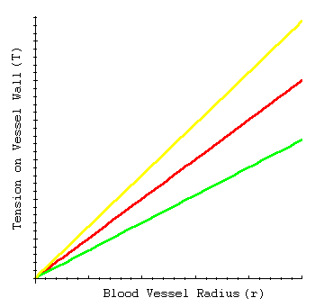

Interpretations
For a given blood pressure, increasing the radius of the cylinder leads to a linear increase in tension. This implies that large arteries must have thicker walls than small arteries in order to withstand the level of tension.
Notice that as we increase the pressure (p) we increase the slope of the line. For a given radius (r), cylinders carrying a higher pressure of flow also have higher tension. We can extend this idea to similar sized veins and arteries. Arteries must have thicker walls than veins because they carry much higher blood pressure.
Capillaries also carry high blood pressure, but unlike arteries, capillary walls are thin. This is because their small size leads to a reduced level of tension so that thick walls are not necessary.

Conclusions
A simple equation quantifying the tension in the walls of a cylinder can be related to blood vessels. Properties of this relationship helps us understand the variable thickness of arteries, veins, and capillaries.

Sources
Schmidt-Nielsen, K. 1990, Animal Physiology: Adaptation and environment, Cambridge University Press, Cambridge

About this Resource
This material was originally distributed as part of “Alternative Routes to Quantitative Literacy for the Life Sciences” - National Science Foundation Award DUE-9752339 to the University of Tennessee, Knoxville for August 1, 1998 - July 31, 2000. Principal Investigator: Louis J. Gross. Co-Principal Investigators: Beth C. Mullin and Susan E. Riechert.
This material is now being revised as part of the “Resources for Improving Quantitative Skills in Community College Biology” project. As part of that project is also aligned with the OpenStax Biology Textbook.
It is published using the QUBES Open Education Resources publishing platform.

http://www.tiem.utk.edu/~gross/bioed/
https://qubeshub.org/community/groups/quantbioatcc/
https://openstax.org/details/books/biology-2e
https://qubeshub.org/qubesresources/publications/1084/

