Environmental Workshop
Spring 2019
The Effect of Climate Change on Butterfly Phenology

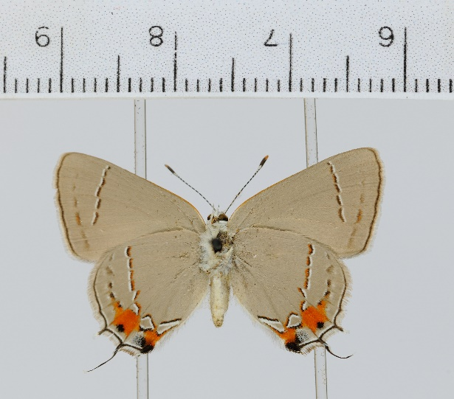
Strymon melinus (Media retrieved from: http://api.idigbio.org/v2/media/
c4ca533b9aff812438198337589626bf)

Ecological Question:

What are the effects of climate change on butterfly phenology and how do phenological changes of one species compare to that of an associated species?

Learning Objectives
- Identify trends in long-term climate data.
- Measure shifts in the timing of life history events using long-term, specimen-based organismal data.
- Compare trends in climate change and phenology shifts.
- Predict the effects of phenology shifts on interspecific interactions.
- Evaluate the advantages and limitations of specimen-based data in addressing specific biodiversity questions.

DATA SOURCES:
iDigBio portal of natural history collections records for butterfly specimen data (www.idigbio.org/portal/search)
Environment and Climate Change – Canada for surface air temperature data of British Columbia (https://www.ec.gc.ca/dccha-ahccd/default.asp?lang=en&n=1EEECD01-1)

Adapted from Dr. Debra Linton.

Introduction

Phenology is the study of the timing of cyclical events in an organism's life cycle, such as the flowering of plants, emergence of worker bees from the hive, or the migration of birds. The timing of critical life stages can be triggered by external environmental clues such as seasonal temperature change, photoperiod, or precipitation. As global weather patterns alter or fluctuate due to climate change, an organism's phenology may shift in response to a change in triggers. If species that interact closely respond to triggers that are no longer synced, the interaction may be disrupted. This is known as an ecological mismatch and can impact organisms across trophic levels (Winder and Schindler 2004, Both et al. 2006). For example, warmer spring temperatures often result in earlier emergence dates for temperature sensitive insects. If the plant nectar source is triggered by day length, the flowering time may not change in sync with the pollinator flight. If the emergence dates of their insect pollinators are not triggered by the same cue as the plant nectar source, the pollinator may not have food to fuel reproduction and the plants can lose a pollinator that is an important component of their reproductive success (e.g., Robbirt et al. 2014).

To address the impacts of climate change on phenology we need to examine long-term historical patterns and trends in both the environmental conditions and phenologies of the species of interest. We need current and historical data on when and where species occur, the timing of phenological events (e.g. emergence, flowering dates, peak flight), and key environmental variables that can initiate phenological transitions (e.g. temperature, precipitation). This means we need long-term data for both the organisms we study and the ecosystems they occupy. No problem! We are in the data rich era of science. Environmental data and data from natural history collections, professional scientists, and long-term weather stations provide the information that is necessary to investigate phenological changes.

Natural history collections data are based on a physical specimen that was collected by a scientist, carefully preserved, and stored in a museum, university, or research collection space, much like books in a library. These collections serve as warehouses for all kinds of biological data such as phenology, taxonomy, evolution, and ecology of the species (e.g., Robbirt et al. 2011, Jacquemyn et al. 2015). Each specimen has information beyond the physical object itself. A specimen contains valuable metadata (e.g., collection date, location, habitat, images) and is accessible for repeatable, iterative, and expanded observations when physical verification is needed, new questions arise, or new investigative techniques are developed. For example, recent technological advances allow researchers to use specimens to study past biological phenomena such as molecular variation, historical environmental conditions, presence of environmental toxins, and host parasite assemblages; topics or approaches that were generally not imagined when the original specimen was collected. Natural history collections provide a source of biodiversity data that is unequaled in temporal, geographic, and taxonomic complexity and unique in its ability to allow researchers to verify and expand the data by returning to the physical specimens on which they are based. Further, these data can be combined with other data sources to inform research questions. For example, climate data can provide information on historic temperature and precipitation, citizen science observations can provide contemporary species occurrence information, and genetic data can provide information about evolutionary history.

Here, we’ll be using the earliest collection date each year of butterfly specimens as a proxy for phenology. That is, the date that the adult butterfly was collected signifies a date that the butterfly was in flight. The relatively short lifespan of butterflies allows us to use their collection date to study how their phenology may have changed over time and relative to abiotic variables such as temperature. Today we’ll use data from an online natural history collections database, iDigBio. This database provides us the opportunity to peek into the past, in this case as far back as the 1930s, to see the species, dates, and localities of butterflies that were collected. Butterfly phenology research conducted by Kharouba and Veland (2015) using specimens collected in British Columbia, Canada, provide the inspiration for this activity.

So this week:
First, we’ll explore the iDigBio portal where the data came from as a class.
Then, you’ll work in teams to explore and analyze the provided data with both guided and open-ended questions.
You’ll also complete a model- and self/team- evaluation.

Turn in (by 2:29pm Tuesday April 2, using the folder on the course website):
- Answers to the questions (10), including figures/graphs created (team deliverable, everyone needs to turn in their own copy)
- Model- and self- evaluation (individual deliverable)

Using the data provided, complete the following activities and answer the related questions:

- Data from how many weather stations are compiled in the Temperature Data?

- How many butterfly species are in the Butterfly Data?

- Create a scatterplot of average annual temperature vs. year for British Columbia. Add a trend line. Based on the trend line, how has annual temperature changed over time in British Columbia?

- Natural history collections are rich repositories of biodiversity data. We can use information from specimen labels to compile data about phenology. Specifically, the date that a butterfly specimen was collected represents a day during which the butterfly was in flight. Create a scatterplot of butterfly flight date vs. year. Add a trend line. Based on your graph, how has the phenology of these butterflies shifted over time?

- Now compare your team’s findings to the provided published scientific papers. How does your estimate of phenological shift from Question 4 compare to the estimate from Kharouba et al 2015 that is provided in Table 1 of their article? Why is this?

- Create a scatterplot of butterfly flight date vs. mean spring temperature and add a trendline. Repeat with mean summer temperature instead of spring. Based on your graphs, how does the phenology of butterflies relate to temperatures in each season?

- Is the change in temperature the cause of the changes in phenology? Why or why not?

- Kharouba et al. 2015 found that plants are more sensitive to temperature than butterflies. Using the figure and values you derived in Question 6 as a reference, describe how a plot of the phenology of temperature-sensitive plants vs. temperature would compare to your butterfly plot.

- How would you recognize if an ecological mismatch was possible between butterflies and their host plants? Describe how this would look when plotted.

- During which periods of time were there the greatest numbers of collected specimens? When were there the least? How might this impact the analysis?

Literature Cited:

Both, C., S. Bouwhuis, C.M. Lessels, and M.E. Visser. 2006. Climate change and population declines in a long-distance migratory bird. Nature 441:81-83.
Jacquemyn, H. and M.J. Hutchings. 2015. Biological flora of the British Isles: Ophrys sphegodes. Journal of Ecology 103:1680-1696.
Kharouba, H.M. and M. Veland. 2015. Flowering time of butterfly nectar food plants is more sensitive to temperature than the timing of butterfly adult flight. Journal of Animal Ecology 88:1311-1321.
Robbirt, K.M., D.L. Roberts, M.J. Hutchings, and A.J. Davy. 2014. Potential disruption of pollination in a sexually deceptive orchid by climatic change. Current Biology 24:2485-2489.
Robbirt, K.M., A.J. Davy, M.J. Hutchings, and D.L. Roberts. 2011. Validation of biological collections as a source of phenological data for use in climate change studies: a case study with the orchid Ophrys sphegodes. Journal of Ecology 99:235-241.
Winder, M. and D.E. Schindler. 2004. Climate change uncouples trophic interactions in an aquatic ecosystem. Ecology 85:2100-2016.

