Ebola Exercise Solution
1. Multiple Sequence Alignment of the first 119 amino acids
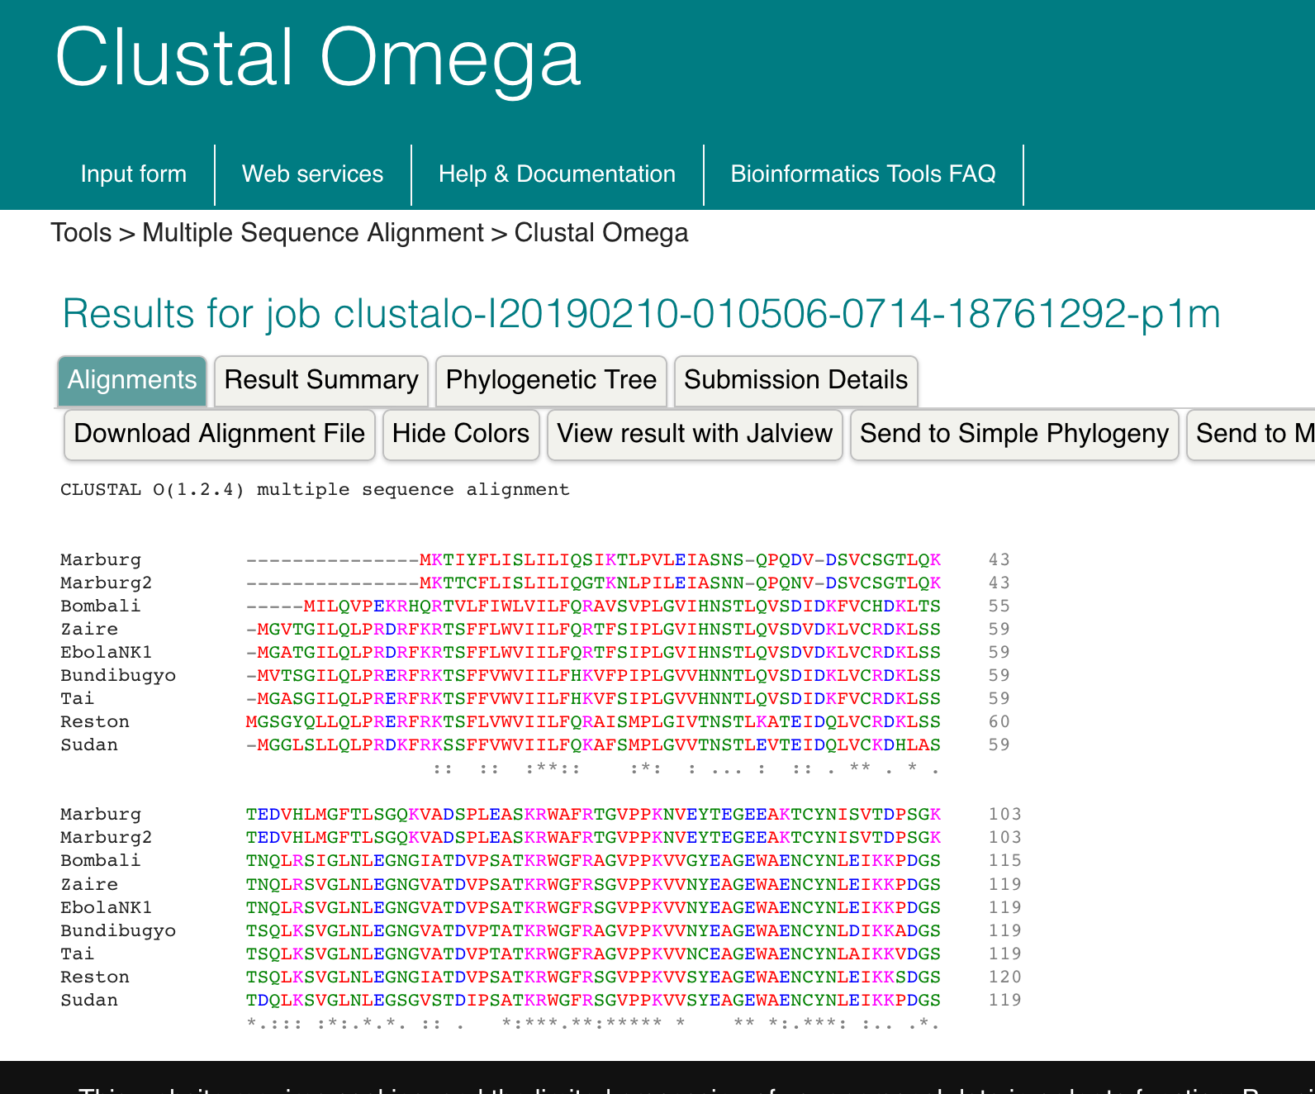
2. Phylogenetic Tree
Figure 1. Phylogenetic Tree of Ebola Reference Strains and North Kivu Strain 1

As shown in the tree above, the North Kivu sequence is very closely related to Ebola Zaire. It is not at all closely related to Marburg virus and is distantly related to the other strains of Ebola.

Another question: We used GP as a molecular clock for Ebola. Would the results be supported if a different protein was used?

