Experiment 13
Spectrophotometric Estimation of Nitrate
Objective
In this experiment, you will use a UV/VIS spectrophotometer to determine the nitrate concentration of an unknown water sample.
Introduction
In the Experiment 9, you learned to analyze the phosphate concentration in water samples. Phosphate estimation is performed in the visible region of the spectrum. Chemicals like nitrate absorb light in the ultraviolet region of the spectrum. The method is purely instrumental and does not involve the use of chemical reagents.
Materials: Water samples (please bring your own) UV/Visible Spectro.
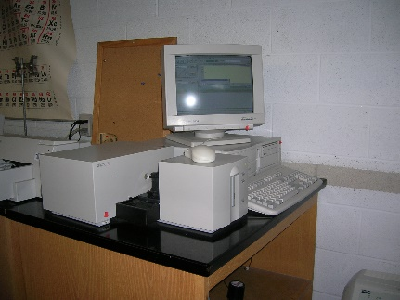
Procedure: Instructor will set up the instrument then the class will measure nitrate.
Data | Source | Concentration (ppm) | Absorbance
Standard |  | 7
Unknown #1
Unknown #2
Unknown #3
Unknown #4
Single Standard Method to determine the nitrate concentration of the unknowns.

Concentration_{unk} #1: __________ ppm. Concentration_{unk} #2: _________ ppm

Concentration_{unk} #3: __________ ppm. Concentration_{unk} #4: _________ ppm

