Explore a simple model of COVID-19
# Adaptation of an example that is part of the documentation for EpiDynamics
# Adapted by Carrie Diaz Eaton - Bates College

What does it mean to “flatten the curve?”
This gif (link), adapted from the CDC, shows that we should try to “flatten the curve” of the disease by enacting preventive measures. When we flatten the curve, we keep the curve from exceeding health care capacity limits (from testing to bed numbers to ventilators). To better understand why preventing transmission flattens the curve of a disease, we can simulate the disease using an SIR model.

What is an SIR model?
SIR models are a simple class of models which describe the rate of change of susceptible, infected, and recovered individuals in a mixing population with a disease.

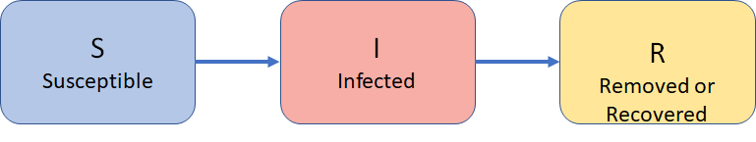
Figure 1. SIR model: Susceptible (S), Infected (I), and Recovered (R) or Removed boxes with arrows from S to I and from I to R

These boxes and arrows are pictorial representations of underlying differential equations which mathematically describe the rate of change.

Why is COVID-19 an SEIR model?
Due to the long time lag before the display of contagious symptoms, we add a class of individuals that is “exposed,” but not infected. The model presented here is a useful oversimplification. It makes several assumptions and the parameters might be in the ballpark for COVID-19, but should not be considered an accurate forecasting model.

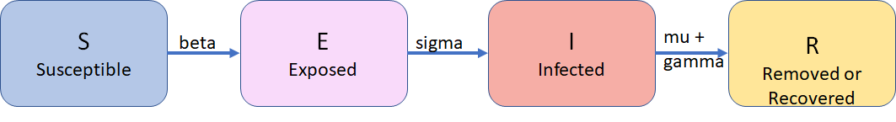

Figure 2. SEIR model: Susceptible (S), Exposed (E), Infected (I), and Recovered or Removed (R) boxes with arrows from S to E influenced by parameter beta for transmission rate, from E to I influenced by parameter sigma, from and from I to R influenced by parameter mu for death rate and parameter gamma for recovery rate.

Code for R exploration
- We can explore this SERI model using R. Copy and paste the following code into RStudio or another IDE for R. If you do not have one installed, try using https://qubeshub.org/tools/rstudio.

#SEIR model

# example from
# https://cran.r-project.org/web/packages/EpiDynamics/EpiDynamics.pdf
install.packages('EpiDynamics')
library(EpiDynamics)

# Initial conditions
initials <- c(S = 0.9, E = .01, I = .001, R = 1 - 0.9 - .01 - .001)

# parameters must be in the following order
# mu = the per capita death rate (and the population level birth rate),
# beta = transmission rate,
# sigma = the movement form exposed to infectious,
# gamma = the recovery rate
parameters <- c(mu = 1 / (70 * 365), beta = 500 / 365,
sigma = 1 / 14, gamma = 1 / 7)
# this example is meant to be read in days, for example the recovery rate at 1/7 means an individual is infectious, but recovers in 7 days.

# Solve and plot.
seir <- SEIR(pars = parameters, init = initials, time = 0:180)
PlotMods(seir)

- Run the code above.
  - When does the peak occur (if time is in days)?
  - What fraction of the population is exposed at that time?
  - What fraction of the population is infected at that time?

- Now put a # on install package. Change the code to have a beta value of 200/365 and re-run the simulation.
  - When does the peak occur (if time is in days)?
  - What fraction of the population is exposed at that time?
  - What fraction of the population is infected at that time?

- How does this relate to the gif in the introduction and the CDC recommendations?

- Play with beta and other parameters. Tell me about something you learned.

