Instructions for Accessing Data
from the iDigBio portal
for use in BLUE modules

Introduction

iDigBio (Integrated Digitized Biocollections) is a data aggregation project founded by the National Science Foundation as part of the Advancing Digitization of Biodiversity Collections (ADBC) initiative. The mission of iDigBio is to develop the infrastructure for a permanent digitized repository that provides free and open access to data and images of the biological specimens housed in Natural History Collections.

This user guide was developed to accompany BLUE (Biodiversity Literacy in Undergraduate Education) educational modules that utilize specimen-based occurrence data to investigate ecological and evolutionary principles in undergraduate Biology classes. Additional resources for using the iDigBio portal can be found at: https://www.idigbio.org/education.

Searching the iDigBio Portal

- Navigate to the iDigBio website @ https://www.idigbio.org  - Click on “Search the Portal”  - To search, you could use the “search all fields” search box, but we recommend using the filters tab.  The “add a field” drop-down menu includes over 50 options for filters, including various taxonomic levels, collection events, and locations options. | 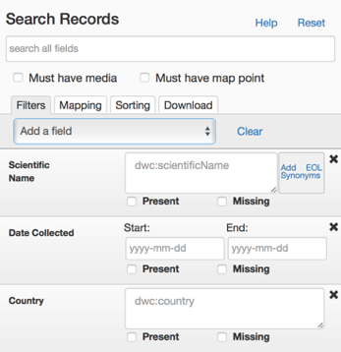

- Enter your search criteria.  You can specify multiple search criteria for each search. For example, all records of a species within certain dates or from specific locations/ranges (or both).  You can also search for multiple species at the same time. |  | 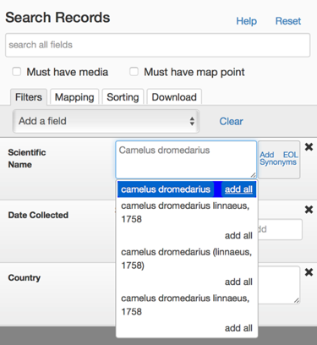
- A dot will appear on the map for each record that has a map point.  Typical map features (e.g. zoom and move) are available.  You can use the camera button to download the image, but the text is clearer in a screen shot. | 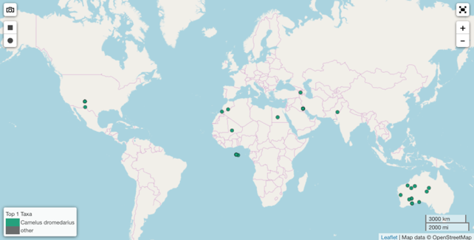
- Below the map, each record will be listed individually, and the total number of records located will be indicated.
- Click on “view” to review the details for individual records.
- You can change the columns displayed using the “columns” button.
- You can sort the records by column by clicking on the column header.

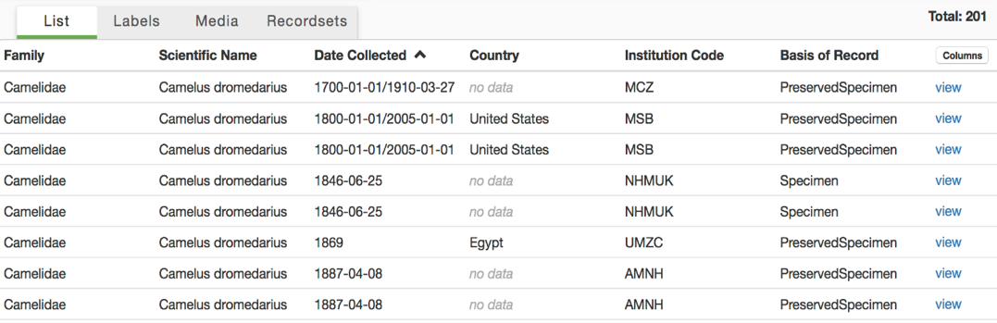

- To limit your search to records containing media (e.g. photographs) or with an associated map point, use the buttons to select these options. | 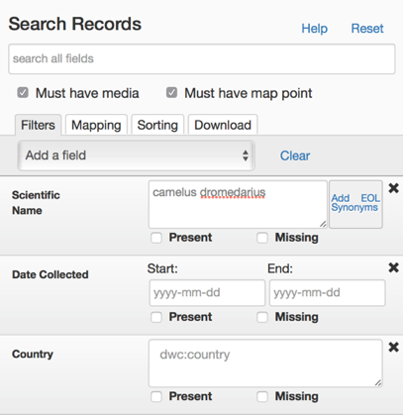

- To download all records, click on the “Download” tab. Enter your email address and hit the “down” arrow. | 