This file was downloaded from https://docs.google.com/document/d/1oJlbGDtyL6gl8_RbalxQvousS8O2QhOcIm_NlSraP8s/edit on 5/16/20

Introduction - Avida-ED and Digital Evolution

Avida-ED is the educational version of Avida, a software platform created by a group of computer scientists and software engineers interested in the experimental study of digital organisms in order to better understand how biological evolution works. Both Avida and Avida-ED provide an instance of evolution in a model environment. The evolution itself is real; the digital organisms are subject to the same processes as biological organisms, such as reproduction, mutation, and natural selection. Scientists use Avida to study how digital organisms evolve, and examine questions related to the evolution of complex features, sex, parasitism, cooperation, and foraging behavior. Avida has even been used to confirm the outcomes of ongoing biological experiments. This is possible because the process of evolution is “substrate neutral,” meaning that when a system possesses three key characteristics – variation, inheritance, and selection – evolution will inevitably result.

Using the powerful study system of Avida-ED, you will be able to design and perform your own experiments to test hypotheses about evolution in much the same way that researchers use Avida. An arrow ➜ indicates a question you should answer.

Questions to Think About as you Go Through the Introduction
- What is Avida-ED (and how does it work)?
- Can we study evolution by performing experiments? Explain.
- How is Avida a useful tool for biologists? What are the strengths and limitations of this model?
Tasks
- Begin by reading the article by Carl Zimmer “Testing Darwin” that appeared in Discover Magazine in 2005. The article can be found in the Lab Book or online here: http://discovermagazine.com/2005/feb/cover
- Start Avida-ED, available at URL below. The program runs in a web browser. Please note that the program may take a minute to load; be patient. Navigate to:
https://avida-ed.beacon-center.org/app/AvidaED.html
- Watch the Avida-ED video tutorial to help you explore the application’s controls. It can be found in the support section of the Avida-ED website or on YouTube: https://youtu.be/mJwtg0so4BA
- Familiarize yourself with the Avida-ED Quick Start User Manual, which can be found at the end of this Lab Book. Along with a Glossary, this is an invaluable resource on how the Avida-ED program works.
- Continue with the rest of this Introduction activity. It will demonstrate how the program can be used while introducing biological concepts to be further explored.
Avida-ED Workspace Areas

- The “Navigation” area allows you to switch among three viewer modes:
  - Population – the Virtual Petri Dish (Map), experimental setup, and statistics panels; allows evolution experiments to be conducted and data collected
  - Organism – the execution of an individual’s genomic instruction sequence; allows the confirmation of phenotypes and display of offspring’s mutations
  - Analysis – the collected data from a finished experiment; allows comparisons of population variables (e.g. average fitness) over time
- The “Freezer” area allows you to collect and use saved materials:
  - Configured Dishes – experimental setups to aid in treatment replication
  - Organisms – individual Avidians for use as ancestors in Population viewer experiments, or for examination with the Organism viewer
  - Populated Dishes – experimental populations for continuing experiments using the Population viewer, or for examination with the Analysis mode
- The “Lab Bench” area is where things happen; experiments are performed, Avidian individuals and population are observed, and data are collected.

When in the Population viewer, the Lab Bench consists of the Virtual Petri Dish (or Map), which is the digital environment in which the Avidians reproduce and the Avidian population evolves (Figure 1).

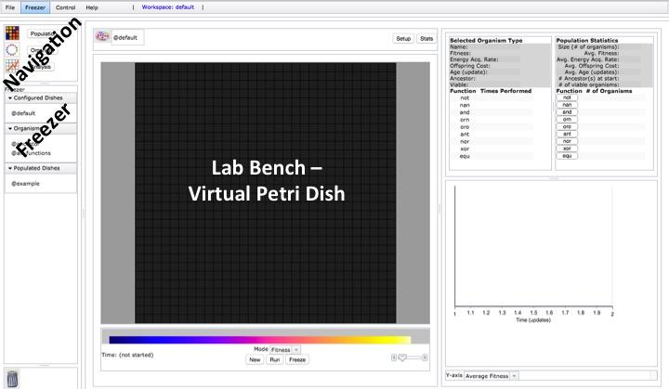
Figure 1. The Population viewer with its Lab Bench area set to Map mode, with labeled Navigation and Freezer areas on the left.

By selecting “Setup” above the Map you can access the experimental settings (Figure 2). Here you can change the Per Site Mutation Rate (default, 2.0%), the availability of resources associated with Avidian functions (default, all available), and other parameters.

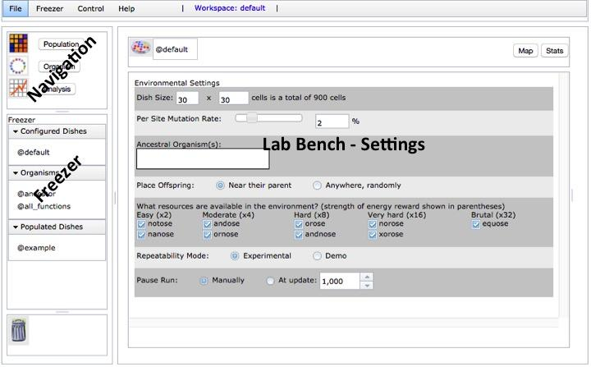
Figure 2. The Population viewer flipped to Setup.

To run an experiment, go to the Population viewer, flip to Setup, drag an organism from the Freezer to the Ancestral Organism box, flip to Map view, select “Run” below the Map.

To examine a single Avidian, navigate to the Organism viewer and drag an organism from the Freezer to the genetic code box next to the genetic symbol near the top of the Lab Bench. Then use the navigation buttons below the box to observe the Avidian’s life processes (Figure 3). The genome is circular and is composed of instructions, represented by single letters within colored circles. Each instruction is a simple programming command, which altogether create a computer program. Notice the genome of the “@ancestor” organism contains many tan-colored “c” instructions; these are “no operation” commands.
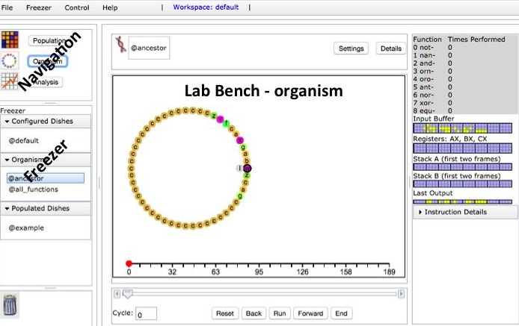
Figure 3. The Organism viewer with the “@ancestor” organism.

Part I – Examining an Avidian and observing reproduction

The digital organisms in Avida-ED, called Avidians, have a “genome” composed of a series of instructions, which are simple programing commands. In Avida-ED, an Avidian genome is always exactly 50 instructions in length, and the genome’s execution constitutes the organism’s life processes. An Avidian is able to reproduce only if it has a sequence of instructions that allows it to do so. The Avidian used to start many experiments in Avida-ED is “@ancestor” and it has the ability to reproduce itself.

Observe an Avidian undergoing reproduction:
- Navigate to the Organism viewer, and the lab bench will display a large rectangle with a set of navigation buttons at the bottom.
- Drag the “@ancestor” from the Freezer to the genetic code box near the top of the lab bench area. After a second or two, the genome will load (see Figure 3).
- Select “Run”, and observe the organism’s genome being executed. The curved lines or execution path within the genome represent the instructions being executed and their height (increasing towards the center of the genome) represents the number of times that instruction has been executed. Eventually the organism will begin reproducing – its offspring’s genome will take shape on the right.
- Use the slider and/or the “Back” and “Forward” buttons to observe the genome being executed at the position and pace you wish to explore.
- While paused or at the end of the reproduction process, you can display the genomic position (number) of any instruction by selecting it.

After exploring an Avidian reproducing, please respond to the following questions:
- Which position of the Avidian genome is the first to be executed?

- Which positions of the Avidian genome are responsible for reproduction? (Hint, what does the execution path, and its height, represent?)

Storing an Avidian in the Freezer and examining an offspring’s genome:
- Select “End” to skip to the very end of the reproduction process. A genetic code symbol will appear within the offspring’s genome.
- To freeze the offspring for later use, drag its genetic code symbol directly on top of an organism already listed in the Organisms section of the Freezer. Another method is to simply choose “Save Offspring Organism” in the Freezer menu.
- A prompt will appear to name the Avidian. You may use any name you like, but for future use we suggest a descriptive name of some sort. Items saved in the freezer may be renamed or deleted by right-clicking on the freezer item.
- You can now examine the offspring by placing it in the Organism viewer.

Practice freezing your offspring Avidian, placing it in the Organism viewer, and then deleting it from the Freezer. You will need to apply these skills in Part II and Part III.
Part II – Observing mutations that occur during Avidian reproduction

- While still in the Organism viewer, select Settings above the Lab Bench area.
- Set the Per Site Mutation Rate to 10% by entering “10” in the box next to the slider.
- Drag the “@ancestor” from the Freezer to the genetic code box.
- Select “Run” then “End” to skip the animation. The number line and slider track the current location within the entire set of commands being executed. Notice that the total number of instructions executed (far right number line value) is greater than the Avidian genome length of 50. Some instructions may be executed many times (very high curved execution paths) and others might not be executed at all (the execution path jumps those instructions). The number of executed instructions required to complete reproduction is termed Offspring Cost.
- Observe the mutations that occur in the offspring’s genome. A mutation is highlighted with a black outline around the instruction circle. In Avida-ED, mutations only occur during the reproduction process, and appear in the offspring of an ancestral Avidian.

After observing reproduction with a 10% mutation rate, respond to the following:
- In your own words, provide a description of how an Avidian reproduces.

- Given a 10% per site mutation rate, how many sites do you predict will have a mutation? Show your calculations or provide support for your response.

- How many mutated sites did you observe your Avidian’s offspring to actually have?

- Describe how the offspring’s genome compares to the parent’s genome.

- If a mutation occurred in the sequence of instructions responsible for reproduction what do you predict would happen to the mutated offspring’s ability to reproduce?

After recording this prediction, perform the experiment. If your current offspring does not have one or more mutations in the set of reproduction instruction positions, select “Reset” then “Run” and “End” to observe another reproduction replicate. Continue until there’s an appropriate offspring genome; freeze and examine using the Offspring viewer.
- Were your predictions upheld?

- What is happening to its ability to reproduce? (Hint, compare the Avida-ED terms “viability” and “death” in the Glossary of the Avida-ED Quick Start User Manual.)

Part III – Comparing Avidian genomes and phenotypes

- While still in the Organism viewer, drag the “@all_functions” organism from the Freezer to the genetic code box.
- Select “Run”, and observe the Avidian’s genome being executed.
- While it is executing, notice the numbers directly above the number line. At each of these points during its execution, the organism performs a logic function. Each number corresponds to a function listed in the Details window at the top right. Notice that the number of Times Performed indicated here should increase by one at each of the indicated points above the number line. The performance of a function is a phenotype of the Avidian, as is the ability to reproduce. The sequence of instructions in the genome is the genotype of the Avidian.
- The labeled arrays of yellow and blue squares describe in computer science terms how the organism’s genome (computer program) is working. Selecting “Instruction Details” will display a description of the instruction (simple programing command) just executed as well as the instruction about to be executed. All of these computer science details can be ignored unless the user is particularly curious.

After observing its ability to perform functions, compare the “@all_functions” organism to the “@ancestor” organism investigated in Parts I & II:
- How do the genotypes and phenotypes of the “@all_functions” and “@ancestor” organisms compare?

- The “@all_functions” organism is a descendant of the “@ancestor” organism.
How do you think it became so different?

- How does the execution path of the “@all_functions” and “@ancestor” organisms compare?

- What accounts for the Offspring Cost difference between the “@all_functions” and “@ancestor” organisms?

Considering Parts I, II, & III and your prior knowledge, respond to the following:
- How is an Avidian genome similar to a bacterial genome?

- How is Avidian genetics different from biological genetics?

Part IV – Evolving a Population of Avidians

Avidian populations grow in the Virtual Petri Dish (or Map), similar in many ways to how bacterial populations grow when plated on a medium in a Petri dish. The Map is divided into a grid in which each cell contains one Avidian. When an Avidian reproduces, the offspring is placed in a cell adjacent to its parent (the default setting) or randomly on the Map. As we saw in Part II, if there is mutation, the resulting offspring Avidian will not be identical to its parent.

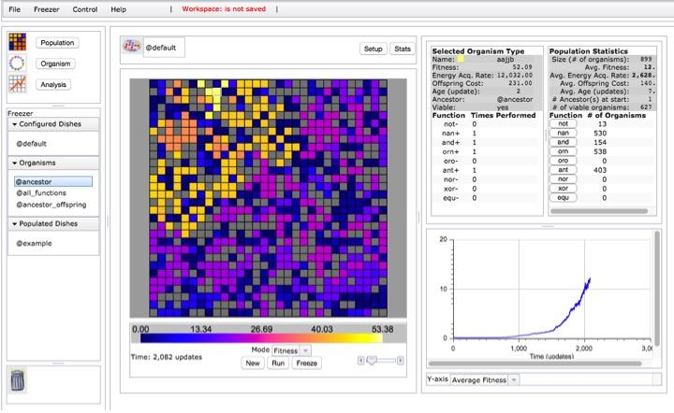
Figure 4. The Population viewer with a paused experiment, displaying Selected Organism and Population Statistics panels, as well as a real-time graph showing Average Fitness in the population, among other options.

Evolving a population from a single ancestor; identifying an Avidian with high fitness:
- Navigate to the Population viewer and flip to “Setup” (Figure 2).
- Drag “@ancestor” from the Freezer to the Ancestral Organism(s) box.
- Set the following parameters: Dish Size 30x30; 2% Per Site Mutation Rate; Place Offspring Near their parent; Uncheck all resources; Repeatability Mode Experimental; Pause Run Manually. [Note: each resource available in the environment provides increased energy, which alters the Energy Acquisition Rate of Avidians performing the corresponding function. Since Fitness equals Energy Acquisition Rate divided by Offspring Cost, relative fitness also changes.
- Select “Map” to return to Map view. Below the Map, confirm that the viewing Mode is set to “Fitness”; Avidians on the Map will be colored according to the continually adjusting Fitness color scale. The slider on the left will increase the Map view size.
- Select “Run” below the Map and watch as the ancestor organism and its descendants multiply. Notice changes within the Population Statistics panel at the top right and the graph below.
- Select “Pause” to halt population growth when there are no empty (black) cells.
- View an organism’s details by selecting its Map cell, outlining it in white. Information for the Avidian in this cell will be displayed in the Selected Organism Type panel (Figure 4). Select a few other Avidians and notice how their details differ.
- Continue the experiment by selecting “Run”. Notice the Y-axis options for the graph on the lower right and view each in turn while the experiment is in progress.
- Pause the experiment when there have been about 500 updates, as indicated below the Map on the left. (An update is a unit of time in Avida-ED.)
- Identify an individual organism with a relatively high fitness for the population. To do so, select organisms in turn and check the Selected Organism Type panel. If there is enough variation in the population, the Fitness color scale may also be helpful.
- Practice saving an Avidian to the Freezer. With your identified high fitness organism selected, select “Freeze” beneath the Map. Choose “Organism” from the displayed options, and enter a name. For future experimental use we suggest a descriptive name that is meaningful to you, for example “org_fitness0.55”.
- Practice saving a populated dish to the Freezer. Select “Freeze” beneath the Map and choose “Population”. Again, use a descriptive name. We suggest using a labeling system that denotes important experimental variables, for example “2%mut_30x30_no-res_@anc” for this experimental setup. [Note: the Freezer menu can also be used to store items in the freezer.]

Considering this entire activity and associated readings, respond to the following:
- What distinguishes the Avidian in a grey cell from an Avidian in any other (non-black) colored Map cell? How does an organism become like this?

- Describe how fitness is measured and how it can change (Hint – Quick Start User Manual.)

- Choose two viable Avidians in your population with different fitness values and explain how differences in these Avidians contribute to differences in their fitness.

- Why do some scientists find Avida (the academic research version) and Avida-ED (the educational version) to be good model systems? What can they study with these model systems?

- What are the limitations of these systems, that is, what can’t you study using them?
Reflection and Metacognition
Think-Pair-Share: Work with your lab team to answer the following questions.

- What did you learn from this exercise?

- What are you still wondering about?

- What would you change in this exercise?

