Independent Research - Experimental Evolution Project

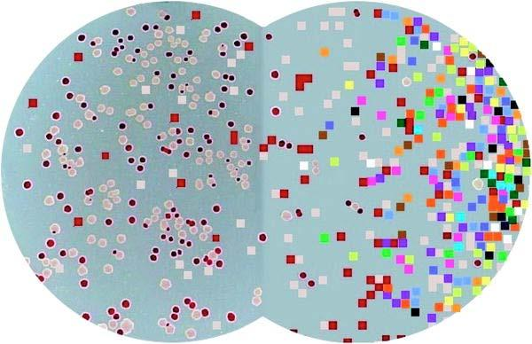
Two model evolutionary biology study systems:
E. coli bacteria (biological organisms) are on the left, and Avidians (digital organisms) are on the right.

Background
Some evolutionary biologists, such as Richard Lenski at Michigan State University, conduct experiments using microorganisms like E. coli to answer fundamental questions about evolutionary processes. Bacteria are useful model organisms because they reproduce quickly and their small size means that they don’t take up much space in the laboratory. Lenski and his colleagues’ work with E. coli has helped shed light on some important aspects of evolution and, having spanned over 25 years and 65,000 bacterial generations (and counting!), it is the longest-running investigation of its kind.

As far as biological organisms go, E. coli reproduce—and evolve—at an incredibly fast rate. Even so, E. coli grow too slowly to be of practical use in addressing many questions about evolution that require long periods of study. Further, while scientists have invented many tools and techniques to manipulate such microorganisms, some research questions require even greater genetic or environmental control of the study system. To pursue questions that require greater time, effort, or tractability, scientists can use digital organisms that model biological systems. Avida is such a model system, and is used by researchers to study evolutionary processes applicable to biological life and even to find solutions to engineering problems. The educational version, Avida-ED, maintains these features while being user friendly.

Your research team will perform experiments using digital organisms in Avida-ED to explore a research question. The question is up to you; your team will propose a hypothesis and then design an experiment that you will conduct to address your question. The final product of your work will be a research poster that your team will present to your peers and instructors.

Research Team Tasks

Brainstorm research questions: Individually and then within your team, brainstorm research questions that are of interest to you and apply to a general biological phenomenon. The questions should not apply to any particular study system, but could be applied to any, for example bacteria, ants, elephants, Avidians, etc.

Form a hypothesis: Propose a hypothesis to one of your research questions that can be tested with Avidians as the model study system using Avida-ED.

Design an experiment: Develop an experimental protocol that your team will follow to test your hypothesis. Consider how you will design your experimental treatments, including which variables you will control by leaving consistent and which you will experimentally alter. Consider what data to collect and how you will use replication so that statistical analyses can be used to draw conclusions about your data.

Predict the results: Indicate what experimental outcomes you would expect to find if indeed your hypothesis is supported by the data you collect, as well as what outcomes would indicate that your hypothesis is not supported. Decide how it would be best to represent your data, and create appropriate figures and/or tables using example data so that your predictions can be graphically examined.

Write your Research Proposal: Prepare a summary of your proposed research project. This should be short, only as long as is necessary to discuss all items indicated above, other than any irrelevant research questions discarded after brainstorming.

Present your Proposal: Prepare a presentation that you present to your peers and instructors. Each team member briefly presents at least one slide. Practice a concise talk that addresses everything discussed in the Research Proposal.

Conduct your experiment: Carry out your proposed research and record the appropriate data in an organized manner.

Analyze your data: Summarize your data and perform appropriate statistical tests. Reevaluate your predictions and determine whether or not your hypothesis is supported by your data. Represent your data using appropriate figures and/or tables.

Report your findings: Construct a research poster as a final presentation of your work. The poster content should fully address your research project by including an introduction, methods, results, and discussion section, while maintaining a pleasing appearance. Your well-practiced presentation will be given to peers, instructors, and passersby.

Guidelines and Expectations for Research Teams 150 total points

Pre-proposal Discussion – 15 points
After considering project ideas individually and then together, your group meets with the instructor(s) to discuss your preliminary project design. Be prepared with more than one proposed project if your primary design is deemed not suitable during the conversation.

Research Proposal – 40 points
Teams should follow the directions on the previous page, from brainstorming through writing this proposal, which should only be as long as is necessary to discuss all items. Alongside the requirements below are group member role designations for the Proposal Presentation; your group may choose to follow these in writing the Research Proposal too.
Ten points are based on the structure and writing of the proposal (neat, clear, logical, etc.). Five points are awarded for descriptions of each of the following requirements:
- Research question generally applicable in biology; why it is interesting α X i
- Hypothesis placing the research question as testable in the Avida-ED context α X i
- Experimental treatments with control and experimental variables; data collected α Y ii
- Replication, how it's employed; proposed statistical analyses β Y iii
- Predictions if hypothesis supported, with figures/tables of example data β Z iv
- Predictions if hypothesis not supported, with figures/tables of example data β Z iv
Presentation roles for groups of size: 2 3 4

Proposal Presentation – 20 points
Teams should create a set of approximately seven slides, a title slide introducing the team and its members followed by one slide per each bulleted requirement listed for the Research Proposal. Each team member presents one or more slides based on their chosen contribution role, as indicated above using Greek letters for teams of two members, Latin letters for teams of three, and Roman numerals for teams of four. Three points are awarded for each bulleted requirement above (totaling 18 points); the final two points are awarded to each individual member based on the presentation of their slides.

Poster Presentation – 75 points
Teams should construct their research poster using any templates and/or formatting suggested by the instructors. Professional dressed pairs present in a confident and well-practiced manner, using the poster as a resource while focusing on the audience. Pairs switch during the session. Teams of two will only present for half of the poster presentation session. Points are as indicated for each of the following requirements:
- Informative title and team members’ names and degree/college affiliations 5
- Introduction including background information, research question, and hypothesis 10
- Methods including experimental design, emphasizing the most important factors 10
- Results showing figures and/or tables with statistical analyses 20
- Discussion emphasizing hypothesis as supported or not supported, and remarks on
how the research is applicable to biological systems and knowledge generally. 10
- Logically organized poster, written clearly, and nicely balancing text and graphics 10
- Knowledgeable presentation, addressing audience questions (awarded individually) 10

