Landscape Indicators: Nutrients
Adapted from Nuding and Hampton 2012 TIEE

Introduction
Small streams are vital to the United States' major rivers because they deliver water and provide pathways for the movement of fish and other aquatic organisms. Humans rely on both large and small waterways for drinking, irrigation, industrial uses and transportation. Thus, if the water quality of any particular stream is impacted, it affects not only local fish, aquatic organisms and plants, but also non-local organisms, in other parts of the state or country, and ultimately the livelihood of humans. While the term “environmental health” is a scientifically controversial term (Simberloff 1998), we may find it useful to think about stream “health” as describing the conditions that humans find desirable such as water with low levels of pollutants and pathogens, high levels of oxygen, and providing otherwise good habitat for fish and wildlife (Meyer 1997; Gordon et al. 2004). A variety of factors affect which aquatic organisms are present, such as the stream's size and morphology, geographic location, stream flow (volume and speed of water), available light, temperature, and water quality (Vannote et al. 1980; Poff 1997).

In this exercise we will examine two water quality parameters of great importance in streams: nitrogen and phosphorus. These two nutrients are among the most common pollutants in streams, lakes and coastal waters, resulting in degraded water quality (EPA 2007). Nitrogen and phosphorus generally come from fertilizer applied to farm lands (and from lawns, to a lesser extent), as well as sewage, and they are carried by ground water, rain water, or irrigation water from the land into streams (Vitousek et al. 1997; Smith 2003; Dodds 2006; EPA 2007). In addition, these nutrients may be deposited on land or water through the air after the combustion of fossil fuels or other industrial operations (Driscoll et al. 2006; Pepper et al. 2006). Specifically in this activity you will be looking at values of “total nitrogen” and “total phosphorus,” two very commonly measured water quality parameters. Total nitrogen includes all organic and inorganic nitrogen-containing compounds in the water. Inorganic forms are nitrate (NO₃⁻), nitrite (NO₂⁻), ammonia (NH₃), and ammonium (NH₄⁺). Organic forms include proteins, peptides, nucleic acids, urea and synthetic organic materials (Pepper et al. 2006). Total phosphorus, similarly, includes all phosphorus-containing compounds in the water, which includes orthophosphate (PO₄) and organically bound phosphate.

When these nutrients become very high, algae (photosynthetic organisms) can grow extremely quickly and the waters can become cloudy, reducing the light availability in the stream. Importantly, when these algal blooms die, this large amount of dead algae fuels bacterial growth in the water. The bacteria decompose the algae and in doing so they consume much of the oxygen available in the water (Mallin et al. 2006). In many cases the waters become uninhabitable by aquatic organisms because of the lack of dissolved oxygen in the water. An extreme example of this is the “dead zone” in the Gulf of Mexico, which is an area of the ocean about as large as Connecticut, in which few aquatic organisms can survive, primarily due to the input of nutrients from the Mississippi River (USGS 2010).

Data Set Description
In 2002, the US Environmental Protection Agency (EPA) set out to characterize the health of all the waterways throughout the continental US. The EPA is required by law as set forth in the Clean Water Act to report to Congress on the health of the nation’s waters. This survey of “wadeable” streams – streams shallow enough to sample without a boat – is the EPA’s largest effort to make a scientifically and statistically defensible claim about how healthy, or unhealthy, the nation’s waters are (EPA 2007).

A statistically sound sampling design was necessary for the EPA to be able to detect major trends in stream quality across the nation. Ideally the EPA would take samples from every waterway in the US, but that is totally infeasible; it would be a huge, expensive, and very time-consuming endeavor. Therefore, the EPA devised a sampling regime of wadeable streams. Wadeable streams provide a strong link between land use and water quality, and they contribute to larger rivers systems, so they are a good indicator of the health of waters throughout the entire US (EPA 2007). Even though wadeable streams are relatively small and shallow, they comprise about 90% of the length of all perennial waterways.

A total of 1,392 sites were sampled in the 48 states. The type of sampling design selected for any ecological study or experiment is key to making more general assertions about the status of waterways throughout the nation. The sampling was designed to ensure that the site selection was representative and random. More information about the sampling design can be found in Chapter 1 in the section of the WSA Report entitled “How Were Sampling Sites Chosen?” (pgs. 15 – 17, WSA Report).

Literature Cited
Dodds, W.K. 2006. Eutrophication and trophic state in rivers and streams. Limnology and Oceanography 51:671-680.

Driscoll, C., D. Whitall, J. Aber, E. Boyer, M. Castro, C. Cronan, C. Goodale, et al. 2003. Nitrogen pollution in the northeastern United States: sources, effects, and management options. BioScience 53:357-374.

Gordon, D.N., T.A. McMahon, B.L. Finlayson, C.J. Gippel, R.J. Nathan. 2004. Stream hydrology: an introduction for ecologists. Wiley, New York, New York, USA.

Mallin, M., V. Johnson, S. Ensign, and T. MacPherson. 2006. Factors contributing to hypoxia in rivers, lakes, and streams. Limnology and Oceanography 51:690-701.

Meyer, J.L. 1997. Stream health: Incorporating the human dimension to advance stream ecology. Journal of the North American Benthological Society 16:439-447.

Pepper, I.A., C.P. Gerba, M.L. Brusseau. 2006. Environmental and Pollution Science. Second edition. Academic Press, Elsevier, Burlington, MA, USA.

Poff, N. 1997. Landscape filters and species traits: Towards mechanistic understanding and prediction in stream ecology. Journal of the North American Benthological Society 16:391-409.

Simberloff, D. 1998. Flagships, umbrellas, and keystones: is single-species management passé in the landscape era? Biological Conservation 83: 247-257.

Smith, V.H. 2003. Eutrophication of freshwater and coastal marine ecosystems a global problem. Environ Science and Pollution Research 10:126-139.

U.S. Environmental Protection Agency. 2006. Wadeable Streams Assessment: a collaborative survey of the nation's streams. (http://www.epa.gov/owow/streamsurvey/) Accessed August 17, 2010.

U.S. Geological Survey 2010. The Gulf of Mexico hypoxic zone. (http://toxics.usgs.gov/hypoxia/hypoxic_zone.html). Accessed August 17, 2010.

Vannote, R.L., G.W. Minshall, K.W. Cummins, J.R. Sedell, C.E. Cushing. 1980. The river continuum concept. Canadian Journal of Fisheries and Aquatic Sciences 11:130–137.

Wallace, J. and J. Webster. 1996. The role of macroinvertebrates in stream ecosystem function. Annual Review of Entomology 41:115-139.

Exploring Data Sets

Land Cover

Many agencies and other organizations that have a lot of ecological data, like the U.S. Geological Survey, provide those data online with some tools to explore the data. Look at the map of NLCD land cover (Supplement 1). You may find it helpful to view it on your screen at a larger size (e.g., 200%) to see more detail.

- What are the dominant types of land cover in your region? Based on your knowledge of sources of nutrients, which EPA Region(s) do you predict will have the highest and lowest nutrient values? EPA regions are outlined in black on the NLCD land cover map. Region numbers are in white. Also see Supplement 2 for a map of the EPA Regions and the sampling locations.

- Now look at the table of mean (average) values of total nitrogen (NTL) and total phosphorus (PTL) in each EPA region, located in Supplement 3. Which regions have the lowest and highest mean nutrients, and how does this compare with your prediction? Are the mean values useful at characterizing streams in a region? Why or why not? Offer some suggestions about what additional information would be useful to more fully characterize nutrient levels within an EPA region.

Nutrients

A common first step in analyzing the distribution of data points is through the use of box plots. Box plots show you where the median of your data is – the point at which half (50%) of the data points are below that value, and half of them are above. The lower quartile, Q1, is the point below which 25% of the data is contained. The second quartile (Q2) is the same as your median. The upper quartile, Q3, is the point below which 75% of the data is contained. To find Q1, you take the median of the data points that lie between your lowest value and Q2. To find Q3, you take the median of the data points that lie between your highest value and Q2. The upper extreme is the largest value that is less than Q3+ 1.5*(Q3-Q1). The lower extreme is the smallest value that is greater than Q1- 1.5*(Q3-Q1). “Outliers” are points far outside the range of the majority of the data - specifically, if their value is larger than the upper extreme, Q3+ 1.5*(Q3-Q1), or less than the lower extreme, Q1- 1.5*(Q3-Q1).

- Open the Stream Nutrient Data file shared in the instructions in this week’s module. After opening the file find the median, quartile, extreme and outlier values of total nitrogen for Regions 7 and 10 separately and enter into Table 1 below. It will probably easiest to sort the spreadsheet and then copy the Region 7 data into a new sheet and Region 10 into another sheet. The median and quartiles can be found using the following Excel functions.

The parentheses should contain the column or row of data you wish to analyze. Here we use cells E1:E70, just as an example.
To calculate the median, type (without the quotation marks) “=MEDIAN(E1:E70)”
To calculate the Q1, type “=QUARTILE(E1:E70,1)”
To calculate Q3, type “=QUARTILE(E1:E70,3)”

The remainder of the data points can be obtained from the equations provided, and from inspection of the data.

Table 1. Levels of total nitrogen (NTL) for EPA Regions 7 and 10

 | Median  (µg/L) | Q1  (µg/L) | Q3  (µg/L) | Upper  Extreme  (µg/L) | Lower  Extreme  (µg/L) | # outliers  above Q3  (upper  extreme) | # outliers  below Q1  (lower  extreme)
EPA
Region 7
EPA
Region
10

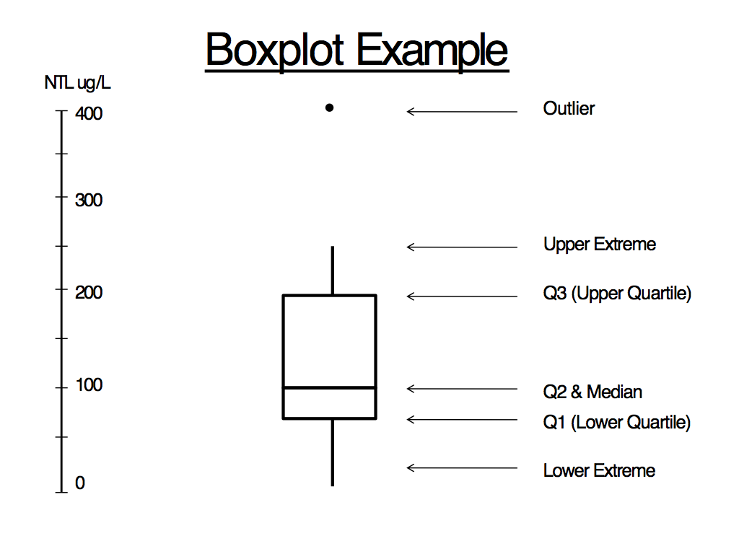

Figure 1. An example of a box plot table for total nitrogen (NTL).

- Using the data in Table 1, generate box plots. If you have not created box plots before, follow these Excel instructions. What percent of the data lies within the box? Describe the distribution of the data outside the box, e.g. are the points relatively close or spread widely, where are outliers, etc. Given what you have learned so far, would you expect an “outlier below Q1” to have more or less algae than other streams?

In a separate nutrient study by the EPA (EPA 2001), the lower quartile (Q1) value from water samples was recommended as the level below which nutrients in streams should be maintained in each ecoregion - note this is not the same as an EPA Region, as you can see in the map provided in Supplement 4. Below are the recommended total nitrogen values for the ecoregions within EPA Regions 7 and 10. The full data set and a map of the ecoregions are available in Supplement 4.

EPA REGION 7:
Ecoregion IV (Great Plains Grass and Shrublands) – 560 ug/L
Ecoregion V (South Central Cultivated Great Plains) – 880 ug/L
Ecoregion VI (Corn Belt and Northern Great Plains) – 2180 ug/L

EPA REGION 10:
Ecoregion II (Western Forested Mountain) – 120 ug/L
Ecoregion III (Xeric West) – 380 ug/L

Compare the information you generated in Table 1 with the EPA recommended nutrient criteria.

- How do the values you calculated for Region 7 and Region 10 compare to EPA’s recommendations for various ecosystem types, or ecoregions, within these two regions?

- Based on the data and maps you’ve looked at, can you assert whether the waters in EPA Regions 7 and 10 are “clean” or “polluted”? Explain your answer using data from parts I and II. If you feel more information is needed to make an assertion, state what information you would need to have. Note: there is not one “right” answer here, so what is important is how well you explain your answer.

- How does the region in which you live compare to other regions? List the region you are using and then briefly hypothesize factors that may influence nutrient levels in your region.

