Group Names:

Adaptations to High Altitude Living

Part I: High Altitude Adaptations

What adaptations of the respiratory or circulatory systems might you see in populations adapted to high altitude living where the low partial pressure of O₂ reduces the diffusion of O₂?

Group Names:

Part II: Comparison of Tibetan vs Andeans Adaptations to High Altitude Living

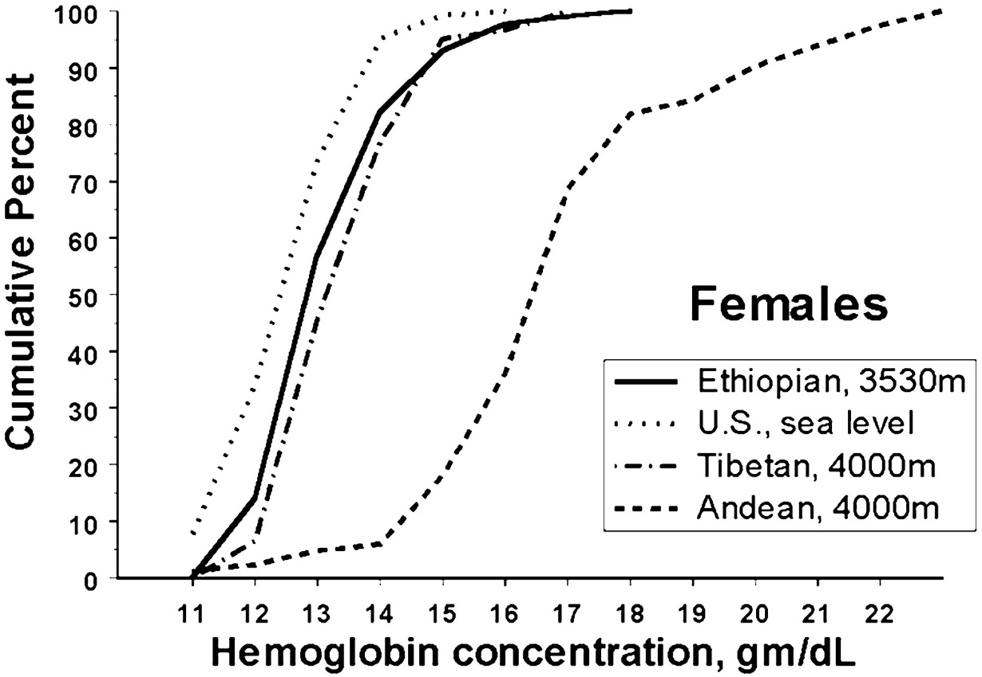
With respect to the adjacent figure, what adaptation for high altitude living is shown above? Explain why it might be adaptive at high altitude. How do Tibetans and Andeans compare?

Figure 1: Hemoglobin concentration distributions
of U.S. sea level and Ethiopian and Tibetan and
Andean high-altitude females.

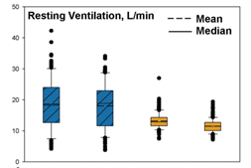
Examine Figure 2. What adaptation for high altitude living is shown? Explain why it may be adaptive at high altitude. How do Tibetans and Andeans compare?

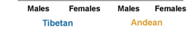
Figure 2: Boxplots comparing Tibetan and
Andean (at ≈4,000-m) resting ventilation.

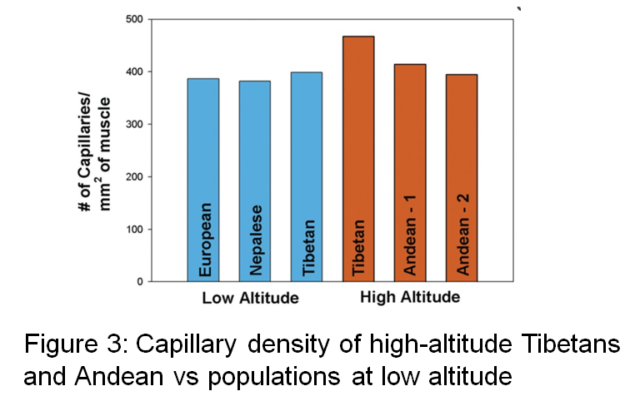
Examine Figure 3. What adaptation for high altitude living is shown? Explain why it may be adaptive at high altitude. How do Tibetans and Andeans compare?

How would the O₂ dissociation curve shift if there was an adaptive change for high altitude living in the O₂-binding affinity of hemoglobin? Explain your reasoning

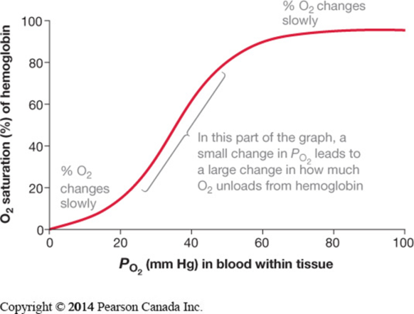

Examine the Figure below. Do the results match your prediction of how the O₂-dissociation curve might differ for populations adapted to high altitude living? Explain.

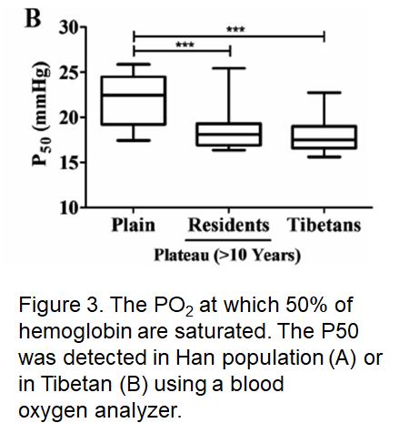

Examine the Table below. Do the results match your prediction of how the O₂-dissociation curve might differ for populations adapted to high altitude living? Explain. How do the P50s and Hill coefficients compare between the ethnic Tibetans and non-Tibetans?

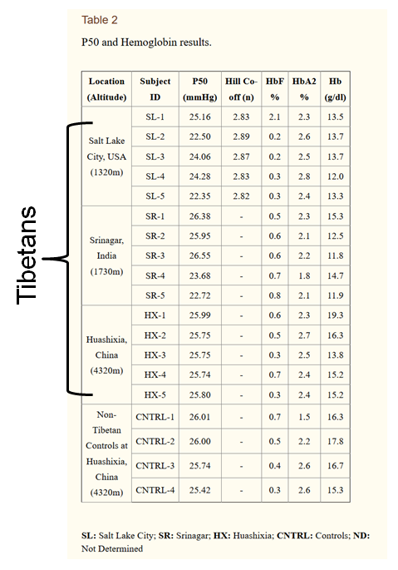
Group Names:

Part IV: Putting It All Together
Consider all the figures and tables provided, what do you conclude about the adaptations for high altitude living in Andeans and Tibetans? How do the adaptations compare to your predictions?
Group Names:

Part V: Natural Selection for High Altitude Living

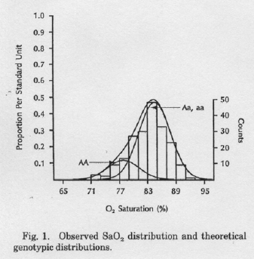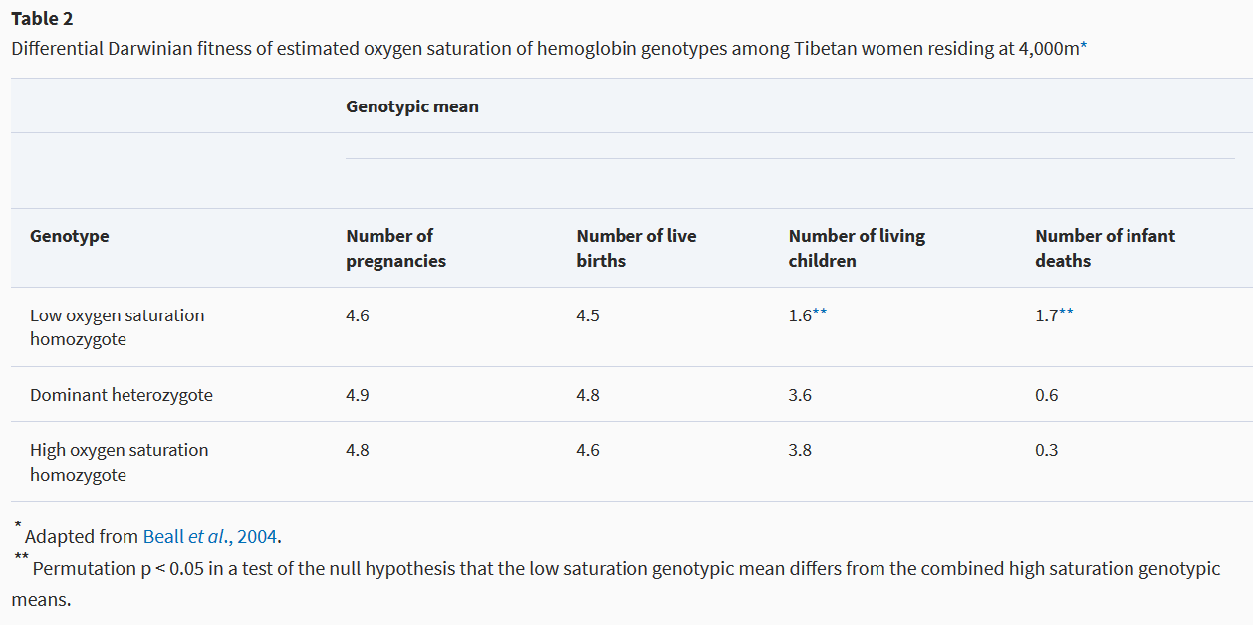

How does the the ‘a’ gene affect fitness at high altitudes?

What would you predict with respect to the frequency of the ‘a’ gene in the Tibetan versus Han Chinese (closely related population living at lower elevations)?

