Why does Blood Flow Change?
Investigating the Math of Blood Flow Dynamics
Graphing Ticket-to-Enter
Graphing (Openstax Elementary Algebra section 4.1)
https://cnx.org/contents/CImQfPDv@8.49:S6EErGb5@19/4-1-Use-the-Rectangular-Coordinate-System
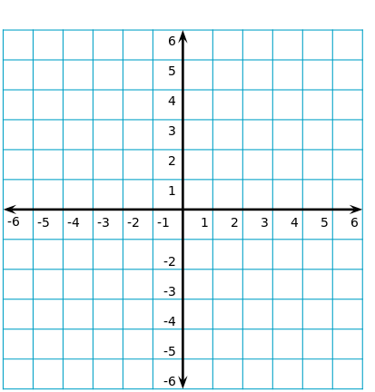

1) Review the coordinate plane: Label the following items on the image above.
- Label the x and y axis.
- Label the 4 quadrants
- Label the origin
- Plot and label the point (1, 3)
- Complete Example 4.1 parts a - e.

2) Complete Example 4.3: A __________________, B____________________, C___________________

D__________________, E ___________________, F ___________________

3) Watch the Variation video.
(https://www.youtube.com/watch?v=Nz5xl0GR1y4)

- Which variable is considered independent? _________________ Explain why or how to recognize it.

- Which variable is considered dependent? _______________ Explain why or how to recognize it.

- The shape of a graph tells you about the relationship between the variables. What key trait should you see in the graph of variables that vary directly?

- What key trait should you see in the graph of variables that vary inversely?

Why does Blood Flow Change?
Investigating the Math of Blood Flow Dynamics
Graphing In-Class Activity
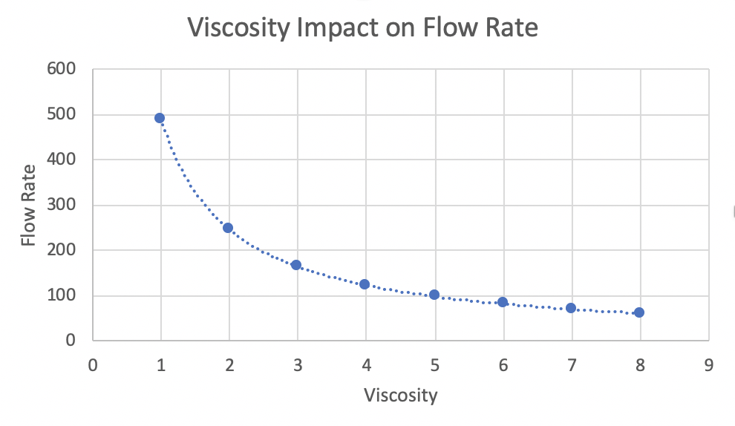
- Which variable is considered independent?

- Which variable is dependent?

- If clotting mechanisms are stimulated in the blood, platelet aggregation and interactions with plasma proteins occur. This leads to entrapment of red cells and clot formation, which dramatically increases blood viscosity. How much would the blood flow change if the viscosity changed from 4 to 8? Write the ordered pairs that you used and your work in answering the question.

- Some patients with anemia have low hematocrits, and therefore reduced blood viscosities. How much would the blood flow change if viscosity changed from 4 to 2? Write the ordered pairs that you used and your work in answering the question.

- Looking at the graph, what would this person’s blood flow be if the viscosity was 5?

- Based on the shape of the graph, what type of variation do you think exists between blood flow rate and viscosity?
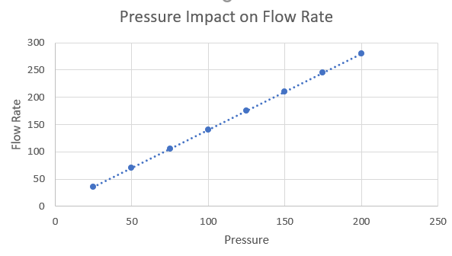
- Which variable is considered independent?

- Which variable is dependent?

- A patient’s blood pressure has increased from 100 mm Hg to 125 mm Hg since the introduction of IV medications to regulate blood pressure in the ICU. Use the graph to estimate the change in blood flow. Write the ordered pairs that you used and your work in answering the question.

- Due to trauma, a patient’s blood pressure has dropped to 75 mm Hg. The patient’s normal blood pressure was 120 mm Hg. Use the graph to estimate the change in blood flow. Write the ordered pairs that you used and your work in answering the question.

- If a patient’s blood pressure were to decrease by half (drop from 200 to 100 mm Hg), would the patient’s blood flow also decrease to half as much? Explain using estimated values from the graph.

- Based on the shape of the graph, what type of variation do you think exists between flow rate and blood pressure?
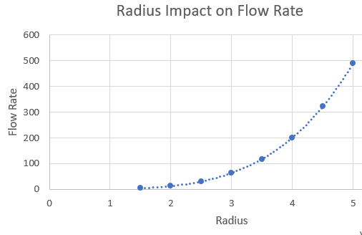
- When a part of the body is well oxygenated, the smooth muscles in the artery walls will constrict (called vasoconstriction) to decrease the radius of the blood vessel. What is the impact on blood flow?

- Vasoconstriction decreases the vessel radius from 4 mm to 2 mm. Calculate a numerical estimate of the change in blood flow. Write the ordered pairs that you used and your work in answering the question.

- Vasoconstriction decreases vessel radius from 5 mm to 2.5 mm or to half the original size. Does this change also decrease blood flow to half of the original amount? Explain using estimated values from the graph. If blood flow is not half of the original amount, calculate what percentage of blood flow remains.

Why does Blood Flow Change?
Investigating the Math of Blood Flow Dynamics
Graphing Assessment
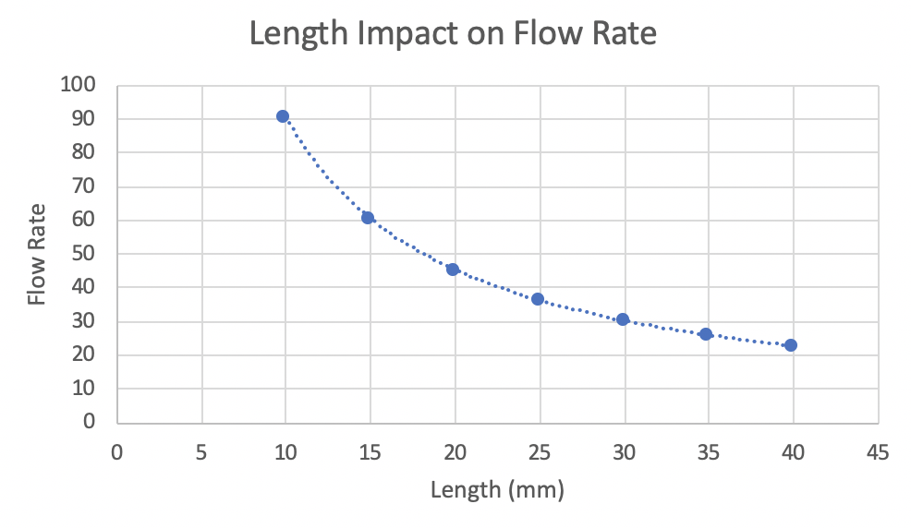
- The length of our blood vessels increases throughout childhood as we grow. How much would the blood flow change if the length increased from 15 mm to 20 mm? Write the ordered pairs that you used and your work in answering the question.

- Losing weight can decrease the length of blood vessels. How much would the blood flow change if the length decreased from 30 mm to 25 mm? Write the ordered pairs that you used and your work in answering the question.

- Looking at the graph, what would the flow rate be if this person’s blood vessel length is 10 mm?

