Why does Blood Flow Change?
Investigating the Math of Blood Flow Dynamics
A&P Lab Ticket-to-Enter

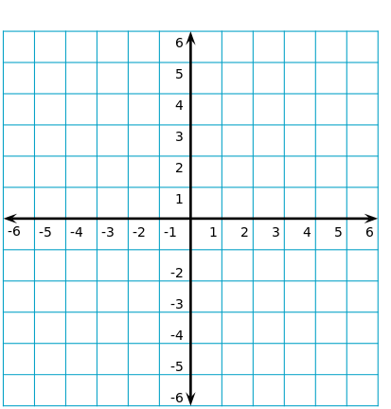
Use the information on graphing from Openstax Elementary Algebra section 4.1 to answer question 1.

1) Review the coordinate plane: Label the following items on the image above.
a. Label the x and y axis.
b. Plot and label the point (1, 3)

2) Watch the Variation video.

- Which variable is considered independent? _____________ Explain why or how to recognize it.

- Which variable is considered dependent? _______________ Explain why or how to recognize it.

- The shape of a graph tells you about the relationship between the variables. What key trait should you see in the graph of variables that vary directly?

- What key trait should you see in the graph of variables that vary inversely?

- In Direct Variation: When one item increases, the other item _________________. When one item decreases, the other item___________________. Give a real-life example of items that vary directly.

- In Inverse Variation: When one item increases, the other item_____________________. Give a real-life example of items that vary inversely.

Why does Blood Flow Change?
Investigating the Math of Blood Flow Dynamics
A&P Lab Activity
During this activity, we will discuss critical variables that contribute to blood flow. Blood flow refers to the movement of blood through a vessel, tissue, or organ, and is usually expressed in volume of blood per unit of time. Contraction of the ventricles of the heart start the flow. Ventricular contraction ejects blood into the major arteries and blood flows from regions of higher pressure to regions of lower pressure, as blood encounters smaller arteries and arterioles, then capillaries, then the venules and veins. During this activity, we will discuss critical variables that contribute to blood flow. The French scientist Jean Louis Marie Poiseuille developed the formula that relates the factors that impact blood flow:
Blood flow = $\frac{πPr^{4}}{8vL}$
π/8 represents a constant of approximately 0.393
P represents blood pressure
r represents the blood vessel radius
v represents the blood viscosity
L represents the blood vessel length
This equation shows that four variables affect flow: viscosity, vessel length, pressure, and radius, since π/8 is constant. The blood pressure variable (P) has a directly proportional impact on blood flow. The remaining three factors affect resistance to blood flow. Resistance refers to factors that slow or impede blood flow. The variables viscosity (v) and vessel length (L) change slowly in the body. Only the radius (r), can change rapidly by vasoconstriction and vasodilation. This change dramatically impacts resistance and flow. Further, small changes in the radius (r) greatly affect flow, since it is raised to the fourth power in the equation. (Copied and adapted from Anatomy & Physiology by OpenStax)

We will be using the following app to complete the tables below: https://bmorgante.shinyapps.io/BloodFlow/
Instructions on how to use the app: The four variables for flow rate are seen on the left. As you slide the circles for each variable, the flow rate is calculated at the top of the page. Below the flow rate, you will see the graph for pressure. Click on the tabs for the other variables to see their graphs. Be sure to notice how the y-axis will change as you slide the circles for each variable.
For the first table: Set the radius to 3 mm, set the viscosity to 3.5, and set the length to 50 mm. Keep these three variables constant.
1. Explore Blood Pressure – change the blood pressure to the settings below and record the change in flow rate.
Blood Pressure (mmHg) | Flow Rate (mL/min) | - While exercising, a person’s blood pressure will rise. What is the impact on blood flow?
20
60
100
140
180
Use the Pressure Impact on Flow Rate Graph to answer questions b-f.
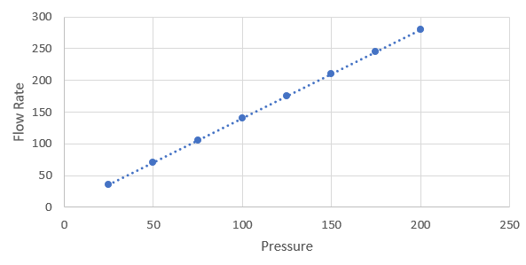
- Which variable is considered independent?

- Which variable is dependent?

- A patient’s systolic blood pressure has increased from 100 mm Hg to 125 mm Hg since the introduction of IV medications to regulate blood pressure in the ICU. Use the graph to estimate the change in blood flow.

- Due to trauma, a patient’s systolic blood pressure has dropped to 75 mm Hg. The patient’s normal systolic blood pressure was 120 mm Hg. Use the graph to estimate the change in blood flow.

- Based on the shape of the graph, what type of variation do you think exists between flow rate and blood pressure?

2. Set the pressure to 100 mm Hg, set the viscosity to 3.5, and set the length to 50 mm. Keep these three variables constant.
Explore Blood Vessel Radius – change the radius to the settings below and record the change in flow rate.
Vessel Radius (mm) | Flow Rate (mL/min) | - As a person ages, he/she will often experience arteriosclerosis, which is a thickening and hardening of the walls of the arteries. Arteriosclerosis decreases the radius of the vessels. How will arteriosclerosis impact blood flow?
1
2
3
4
5

Use the Radius Impact on Flow Rate Graph to answer questions b-d.
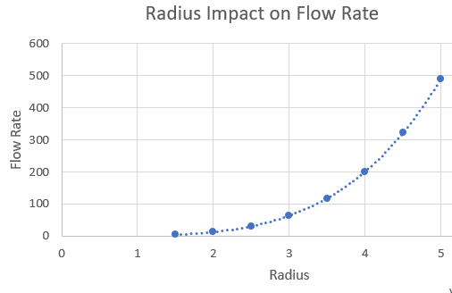
- Vasodilation increases the vessel radius from 2 mm to 4 mm. Calculate a numerical estimate of the change in blood flow.

- Vasoconstriction decreases vessel radius from 5 mm to 2.5 mm or to half the original size. Does this change also decrease blood flow to half of the original amount? Explain using estimated values from the graph.

- Based on the shape of the graph, what type of variation do you think exists between flow rate and blood pressure?

3. Set the pressure to 100 mm Hg, set the radius to 3 mm, and set the length to 50 mm. Keep these three variables constant.
Explore Blood Viscosity – change the viscosity to the settings below and record the change in flow rate.
Viscosity | Flow Rate (mL/min) | - Blood doping is the practice of injecting oxygenated blood into a person to enhance athletic performance. The addition of these red blood cells increases the viscosity of the athlete’s blood. What is the impact on flow?
1.5
3.5
5.5
7.5
8.5

Use the Viscosity Impact on Flow Rate Graph to answer b-e
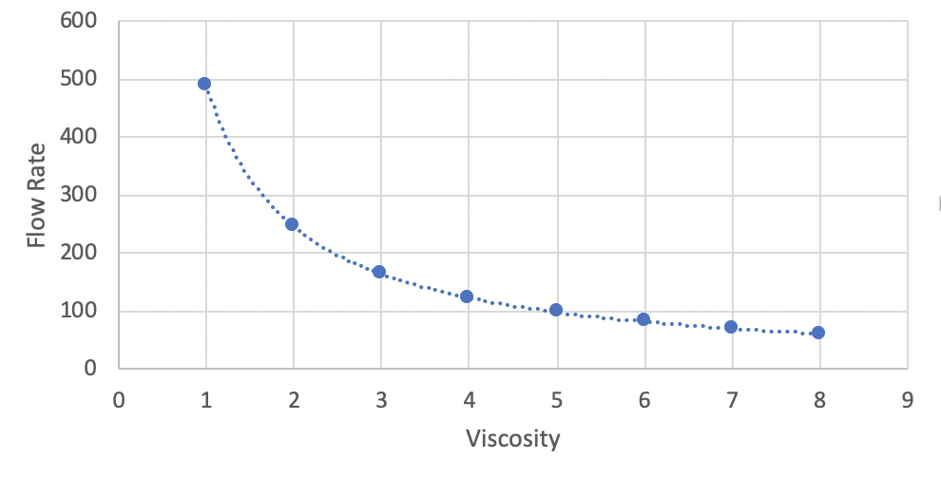
- Which variable is considered independent?

- Which variable is dependent?

- If clotting mechanisms are stimulated in the blood, platelet aggregation and interactions with plasma proteins occur. This leads to entrapment of red cells and clot formation, which dramatically increases blood viscosity. How much would the blood flow change if the viscosity changed from 4 to 8?

- Some patients with anemia have low hematocrits, and therefore reduced blood viscosities. How much would the blood flow change if viscosity changed from 4 to 2?

- Based on the shape of the graph, what type of variation do you think exists between blood flow rate and viscosity?

4. Set the pressure to 100 mm Hg, set the radius to 3 mm, and set the viscosity to 3.5. Keep these three variables constant.
Explore Blood Vessel Length – change the length to the settings below and record the change in flow rate.
Length  (mm) | Flow Rate (mL/min) | - The length of blood vessels changes over the lifespan. Infants have shorter blood vessels than adults. How does an increase in length impact blood flow?
10
20
30
40
50

Use the Length Impact on Flow Rate Graph to answer b-d.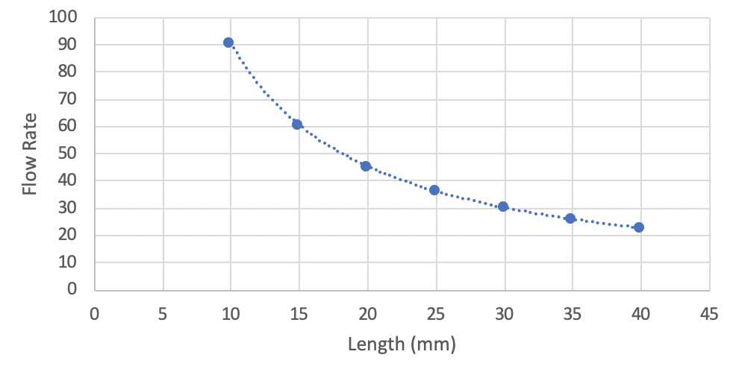
- The length of our blood vessels increases throughout childhood as we grow. How much would the blood flow change if the length increased from 15 mm to 20 mm.

- Blood vessel length decreases 50 mm to 25 mm or to half the original size. Does this change also decrease blood flow to half of the original amount? Explain using estimated values from the graph.

- Based on the shape of the graph, what type of variation do you think exists between blood flow rate and viscosity?

Summary Question
Which factor (radius, viscosity, length or pressure) requires the smallest change to make a big impact on blood flow?

Why does Blood Flow Change?
Investigating the Math of Blood Flow Dynamics
A&P Lab Assessment
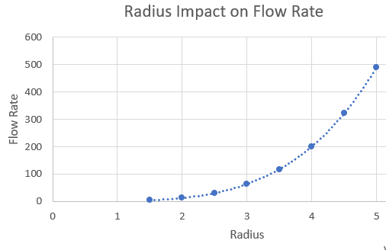

            - What is the independent variable in the graph above?

            - When a part of the body is well oxygenated, the smooth muscles in the artery walls will constrict (called vasoconstriction) to decrease the radius of the blood vessel. What is the impact on blood flow?
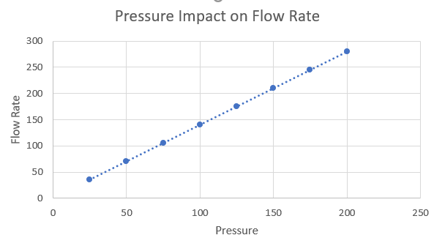

            - What type of variation exists between flow rate and pressure?
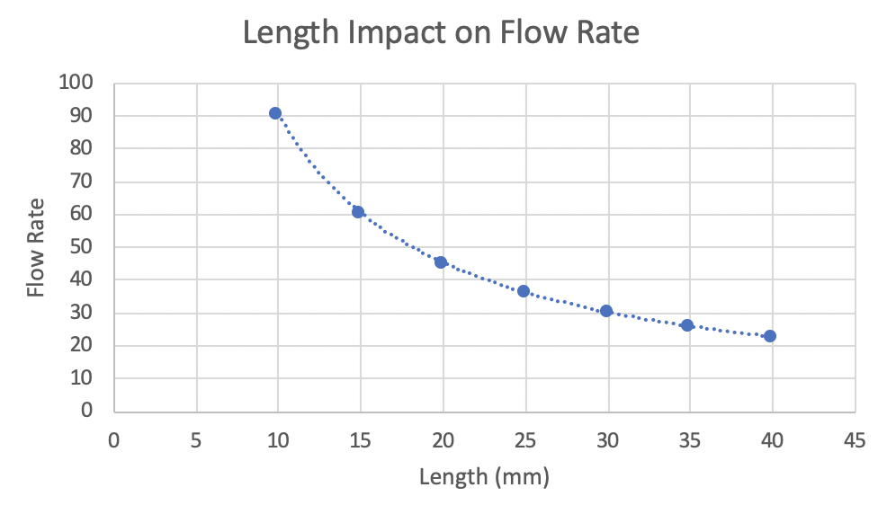
            - What is the dependent variable in the graph above?

            - Gaining a pound of muscle can add approximately 400 miles of to the total length of blood vessels in your body. If all other factors were constant, how would this affect blood flow?
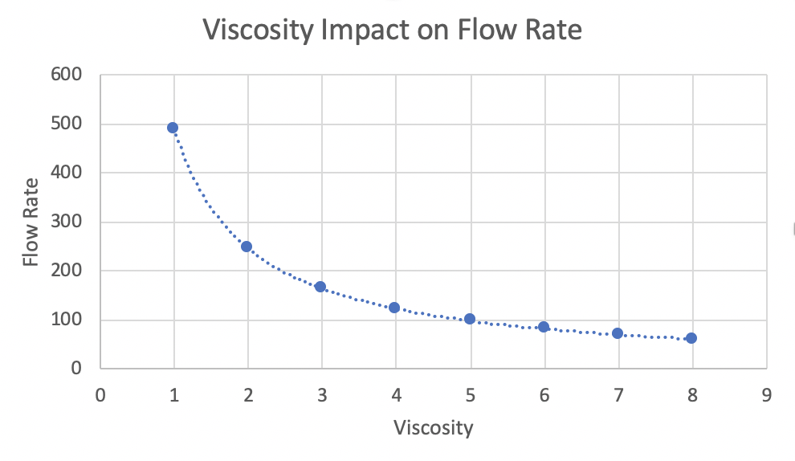

            - If a patient with anemia had a low hematocrit, what would their blood flow be if they had a viscosity of 2?

            - Which of the variables (length, pressure, radius, viscosity) would allow for quick changes in resistance when the body requires increased blood flow to a particular area?

