Geog 250: Tidy Management
Due on Blackboard, Monday, Jan 20, 10 am.

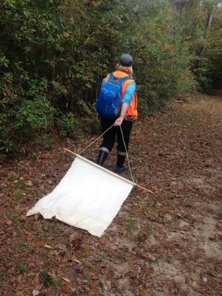
You were just handed field notes on research on density of ticks on the Blandy Experimental Farm in Northern Virginia (Figure 1). Your advisor said that the field researcher went out to sample and perform tick counts over different land-covers, in pasture and in deciduous forest cover. She went out every three weeks where ticks had been previously detected, and six weeks everywhere else. She also told you that she sampled for abundance using drag cloths – i.e. dragging a cloth behind her while walking in predetermined areas, and then counting the ticks that became attached to it (Figure 2). This work may seem tedious, but determining where and when ticks are most prevalent are essential for understanding the transmission of debilitating diseases like Lyme disease, particularly as Lyme and other tick-borne diseases doubled between 2004 and 2016, from 22,000 to 48,000 (Bai et al. 2016) and ticks that transmit Lyme disease are now found in over 48% of counties in the United States (Eisten et al. 2016).
Figure 1. Green square represents site of Blandy Experimental Farm in Northern Virginia, part of the National Ecological Observatory Network.

Your advisor has given you a few tasks for these data.
- Take these handwritten field notes and create an Excel workbook with the data using best data management practices.
- Create a hypothesis having to do with tick prevalence and any other variable that you either already have information on, or think you can easily get information on.
Figure 2. Using a drag cloth to collect ticks. Photo credit: Mackenzie Tietjen

Your submission should include:
- Spreadsheet created from field data using best practices.
- A statement of your hypothesis

Works Cited
Bai, N. (2016, May). Lyme Disease Is On The Rise – An Expert Explains Why. University of California San Francisco. Retrieved
January 7, 2018. https://www.ucsf.edu/news/2018/05/410401/lyme-disease-rise-expert-explains-why
Eisen, R.J., Eisen, L., Beard, C.B. (2016). County-Scale Distribution of Ixodes scapularis and Ixodes pacificus (Acari: Ixodidae) in the
Continental United States. Journal of Medical Entomology, 2(1), 349-386. Doi:10.1093/jme/tjv237

