Worksheet 1 - The COVID-19 pandemic

Learning Objective: This worksheet introduces students to the COVID-19 pandemic and its cause.

The Pandemic

In December 2019, the COVID-19 pandemic (caused by the virus SARS-CoV-2) was first observed in patients in Wuhan, China. The viral disease causes respiratory illness which in some cases may be mild while in others may lead to death. In the span of four short months, the pandemic spread around the world, leading to extreme responses, such as social isolation, business closures in cities, states and entire countries, as well as travel bans among countries. The virus infects cells and takes over the host cell machinery.

Introduction to the Central Dogma

The Central Dogma of Molecular Biology provides an overview of the flow of information within cells (Figure 1) The concept illustrates the how all cells replicate the genetic information, transcribe the information into RNA molecules (including mRNA) and translate the mRNA molecules into polypeptides. The polypeptides, when folded properly in their 3-dimensional shape, become proteins.

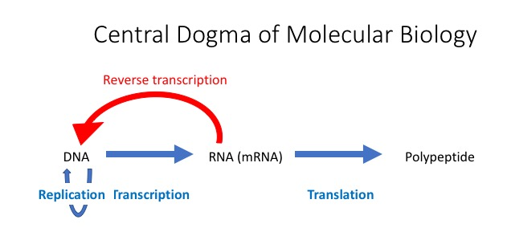
Figure 1. Central Dogma of Molecular Biology. The original concept of the Central Dogma as proposed by Francis Crick (1959) is shown in blue. With the identification of retroviruses that have an RNA genome and a reverse transcriptase, the model was updated in 1970 (Crick, 1970).

Box 1: Some molecular biology background

DNA (deoxyribonucleic acid) is the molecule that holds genetic information that is passed between cells and influences cellular and higher level development in organisms.
RNA (ribonucleic acid) is the nucleic acid that is made from DNA (transcribed) and may serve as a the template for making polypeptides. Some RNA molecules serve other functions within cells.
mRNA (messenger RNA) is the RNA molecule that is translated into the polypeptide.
Polypeptide is the linear, assembled chain of amino acids that can fold into 3-dimensional structures to become a protein.
Replication is the cellular process of making copies of the DNA.
Transcription is the cellular process of making RNA from regions of the DNA.
Translation is the cellular process of assembling amino acids into a polypeptide based on the sequence of an mRNA.
Reverse transcription is the process (uses an enzyme reverse transcriptase) of making a DNA copy from an RNA template. This is the means in which a retrovirus makes a DNA copy to perform the remainder of the Central Dogma.

Developing a Vaccine

Currently there is no therapy for this disease and no means for prevention. Clearly, in addition to developing treatments for those infected, there is an urgent need to develop vaccines that can protect individuals who are not infected. There are many researchers from all over the world who are working on some novel approaches.

Vaccines are compounds (weakened or attenuated virus, dead virus or proteins from a virus) that are given to individuals to stimulate their immune system to mount a long-term response to the compound. The first vaccination study being conducted in the US during this pandemic is the introduction of an mRNA encoding the SARS CoV-2 S glycoprotein into human volunteers. Listen to a brief podcast of the vaccination trial that started on March 16, 2020.

The Virus

Viruses are not considered to be living as they do not have their own machinery to replicate and/or produce any biological macromolecules (e.g., nucleic acids or proteins). They are truly parasitic since they infect other cells and hijack their cellular machinery (use the Central Dogma of the cell - Figure 1). Viruses infect a cell by first attaching to a surface protein on host cells (called attachment). The surface protein interaction is specified by the sequences of the viral surface protein and the host cellular protein. View the video “How does a virus attach to a cell” for an overview. Some viruses mutate more easily and this can lead to the attachment to other cell types or even different species.

After viral attachment to the host cell, the virus enters the cell either through endocytosis (in some cases receptor-mediated endocytosis) or through a fusion of the viral membrane with the host cell plasma membrane. The virus hijacks the host cell machinery to produce copies of the viral genome, synthesize proteins and assemble new virions (virus particles) (Figure 2). Please view the following video of “How does a virus replicate in a cell” for a brief review.

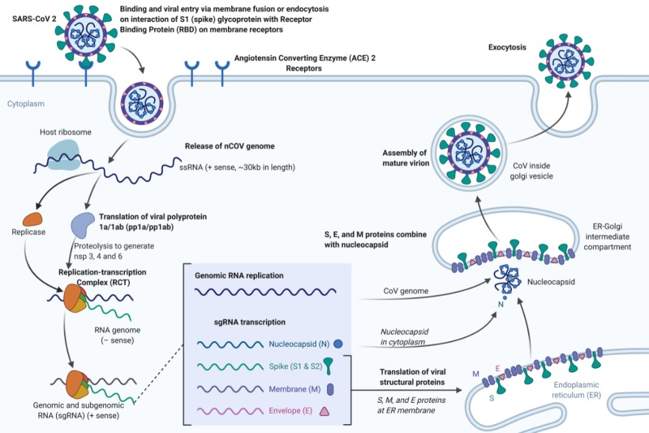

Figure 2. SARS-CoV-2 infection cycle (image is reproduced from Features, Evaluation and Treatment Coronavirus (COVID-19) by Cascella et al. (2020) – Creative Commons License) (https://www.ncbi.nlm.nih.gov/books/NBK554776/figure/article-52171.image.f1/).

SARS-CoV-2 is one of seven coronaviruses that are known to infect humans. The name coronavirus comes from the crown or corona of “Spike” proteins that surround the virus (Figure 3).

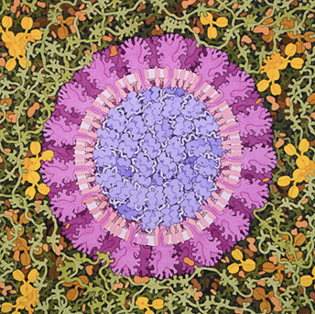
Figure 3. Painting depicting coronavirus. (Acknowledgement: Illustration by David S. Goodsell, RCSB Protein Data Bank; doi: 10.2210/rcsb_pdb/goodsell-gallery-019.)

Several coronaviruses cause mild, flu-like symptoms. Previous severe outbreaks of human coronavirus infections came in 2003-2004 (SARS) and starting in 2012 (MERS).

SARS-CoV-2 has a large, positive-strand RNA genome which encodes proteins that become part of the viral membrane, envelope and capsid (Figure 3). A positive-strand RNA genome can be directly translated like a normal cellular mRNA. One of the encoded proteins in the genome is a spike (S) glycoprotein that will be synthesized by the host cell and eventually be found on the surface of the virus particle. This S glycoprotein will be involved in the attachment of the virion to the host cell (Figure 4).

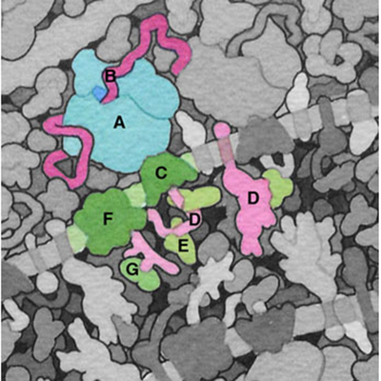

Figure 4. Painting depicting some of the coronavirus and cellular proteins and structures. A) Cellular ribosome; B) Viral coding RNA; C) Translocation channel; D) Spike protein; E) chaperonin BiP; F) Oligosaccharide transferase and G) glucosidases. (Acknowledgement: Illustration by David S. Goodsell, RCSB Protein Data Bank; http://pdb101.rcsb.org/sci-art/goodsell-gallery/coronavirus-life-cycle.)

Box 2: Virus terminology

Attenuation - weakened virus through culture in different host cells
Attachment - viral protein-host cell protein interaction that leads to viral uptake
Spike protein - viral transmembrane protein that is involved in attachment to the host cell
Glycoprotein - protein that has been modified through the addition of carbohydrates to specific amino acids. The carbohydrate groups are found on the outside of the cell membrane (extracellular)

Questions
- Viruses are considered to be non-living, yet they replicate. Do they follow the Central Dogma? Explain your answer with reference to the viral life cycle and the Central Dogma.
- The SARS CoV-2 virus infects human cells, but appears to have originally come from bats and possibly one or more intermediate species? Predict what protein changes might lead to a virus changing its host species or ability to infect other species? Is it more likely that the changes would occur in the virus or in the potential host species?
- How do you think that mRNA introduced into volunteers in the Moderna vaccination trial will produce an immune response? (Hint: Consider the Central Dogma.)

