Jigsaw Activity for Understanding Phage Immunity Systems:
Scientific Reading and Communication

Facilitator Guide

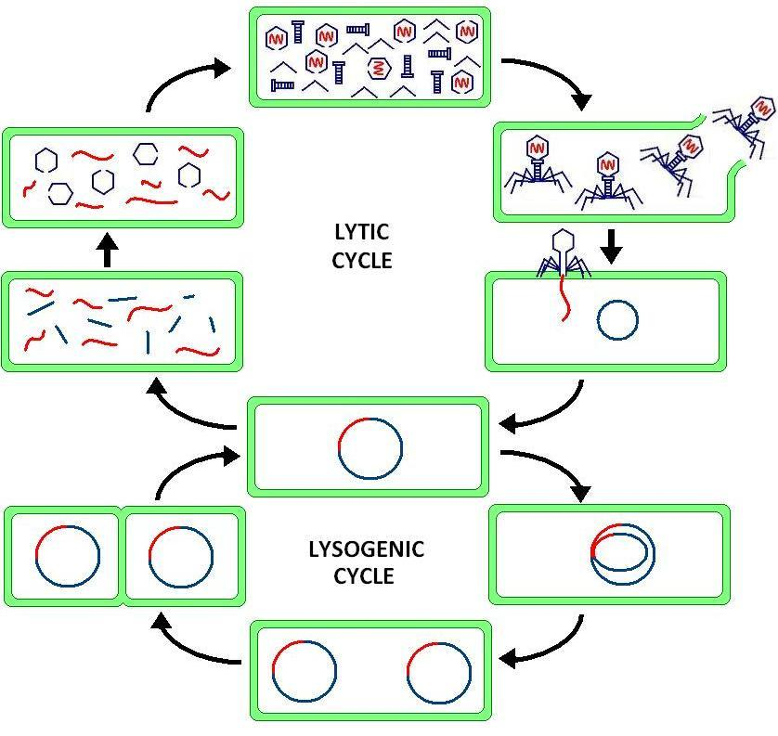
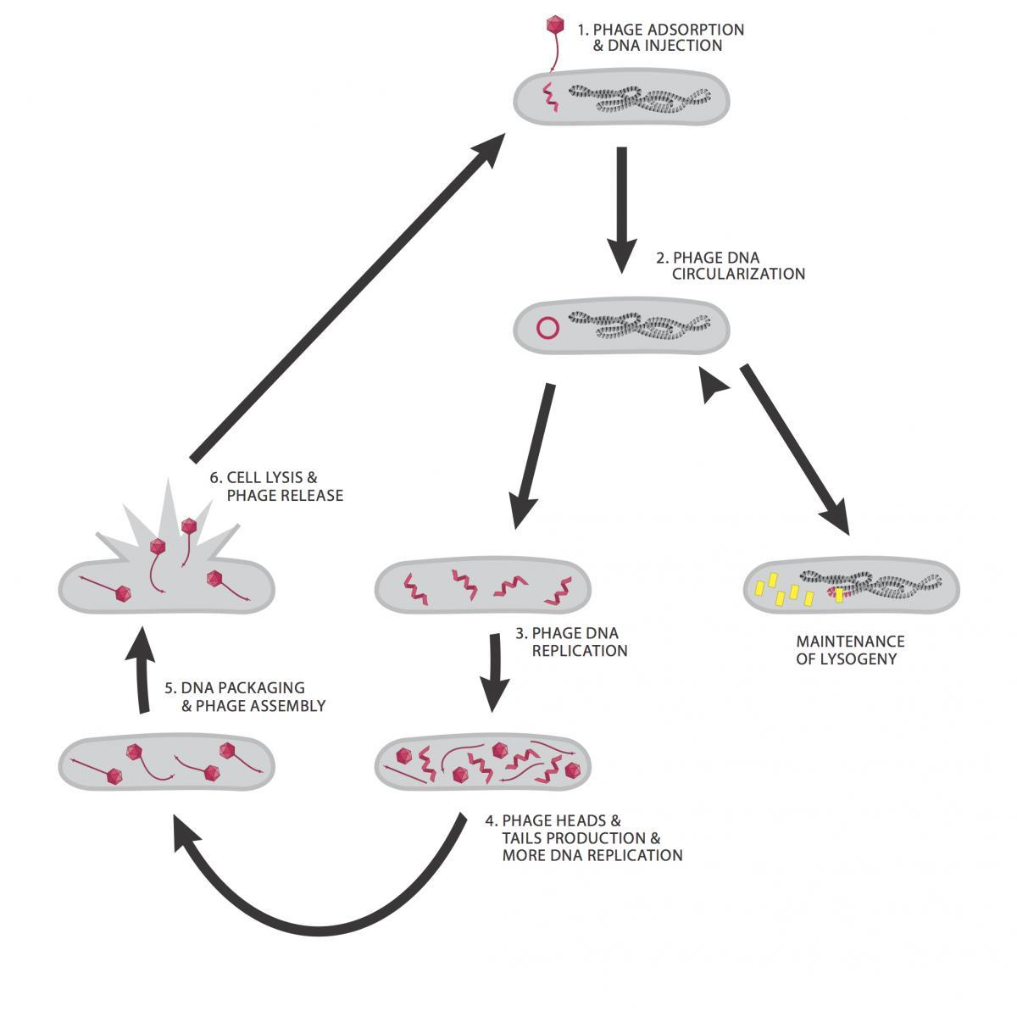
Introduction to Phage Immunity Systems
Bacteriophages have two replicative mechanisms: the lytic and lysogenic pathway. The lytic cycle is generally more common, and after phage adsorption to the host bacterial cell,
it leads to a relatively rapid production of new virions. These new phage particles lead to lysis of the host cell and release of the virions into the environment to infect new hosts. These phages are termed virulent phages. Some phages have the ability to stably incorporate into the host genome as
a prophage, thereby entering the lysogenic cycle. These phages are termed temperate phages.

The genes required for the lytic cycle are repressed in the lysogenic cycle, allowing the phage genome to be stably maintained
in the host bacterium in the form of a prophage. The prophage can be copied during prokaryotic binary fission and inherited by daughter cells. Most temperate phages integrate into the genome of the host to ensure stability through homologous recombination. This occurs with the help of a phage integrase and chromosomal attachment (att) sites on the prophage and bacterial chromosomes. The cells that carry a prophage are termed a lysogen. Prophages that are maintained as large extrachromosomal plasmids encode partitioning proteins (parABS) that ensure each daughter cell receives a copy of the prophage.

When a lysogen resists infection by a second phage this is known as superinfection immunity. There are three processes that mediate a lysogen’s ability to resist subsequent infection: Constitutive expression of the immunity repressor protein from the prophage, binding of the repressor to the DNA of the prophage, and the repression of lytic gene transcription. The immunity repressor can repress the expression of lytic genes from other injected phage DNA, granting the lysogen “immunity”. The expression of some prophage genes can alter host cell surface proteins, modifying them in such a way that other phages cannot adsorb and inject DNA. This is known as superinfection exclusion.

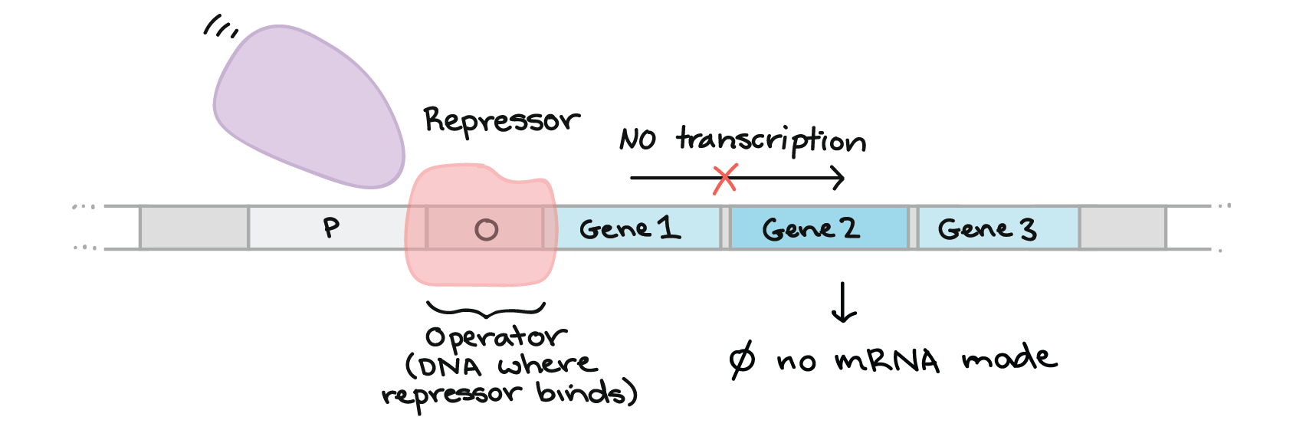
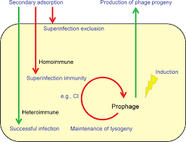
Bacterial insensitivity can occur via repressor-mediated immunity or exclusion. The immunity repressor can bind to sites called operators in order to block transcription initiation. As previously mentioned, this can happen through repressor binding onto related operators or stoperators on newly injected DNA. Immunity repressors are highly specific for conserved sequences in an operator. Therefore, if an immunity repressor stops infection by a second phage the two phages share some DNA similarity. This inability of closely related bacteriophages to infect each other’s lysogens is called homoimmunity. If phages are able to infect each other's lysogens, then this is heteroimmunity. Both types of immunity require the use of repressors. Exclusion on the other hand does not require related phages. Exclusion proteins change carbohydrates on the surface of the phage that interact with tail fibers. When the carbohydrates and tail fibers do not interact the new phage cannot attach and inject its DNA.

In summary, bacteriophages have a variety of mechanisms to ensure that superinfection does not occur. Whether through repressor-mediated immunity within the bacterial cytoplasm or by phage exclusion on the bacterial surface, the prophage can inhibit superinfection and exogenous expression from the prophage.

- Introduction to Jigsaw Collaborative Learning

A jigsaw project is a cooperative learning assignment that harnesses the power of peer-to-peer learning. A jigsaw project allows individual students to become experts on a topic and then teach this information to their peers. This is useful for studying phage immunity systems because of the difficulty of the material. One benefit for an introductory or freshman level course is that it assists students in learning how to read and understand a scientific paper. Another benefit of a jigsaw project is that it can promote higher levels of student engagement. It fosters student-student discussions and allows for “learning at your pace” within a prescribed instructional window. Students have multiple opportunities to combine their efforts for the betterment of the individual and the class as a whole.

Facilitator Instructions

Make it yours: Jigsaw Activity 1-Fundamental Concepts, Jigsaw Activity 2-Scientific Reading and Communication, and Phage Immunity Journal Club can be offered in sequence to create a comprehensive course on phage immunity systems.

Timing: This activity can be completed in 3-4 hours, and can be extended over 4 class periods to allow students to complete their assessments.

Part 1: Facilitator-Led Introduction
  - Course coordinators or facilitators should select a paper on phage immunity systems. A list of potential papers is provided in the “Resource” section to help you get started. There are several papers dedicated to Actinobacteriophages that are well-suited to SEA-PHAGES.
  - The facilitator explains the topic of phage immunity systems, providing context for why this topic is important and how it connects to the Phage Discovery or Phage Genomics portion of the class. Please review the phage immunity background above and the articles provided in the “Facilitator Resources” below.
  - The facilitator also provides a primer for reading scientific papers and the importance of effective communication in science. “Anatomy of a Research Article” from the American Society for Plant Biology is one option. Other options include “How to Read Scientific Papers” from Towards Data Science and “How to (seriously) read a scientific paper” from the American Association for the Advancement of Science (AAAS) .
  - Out-of-class Assignment: Students individually read the Introduction of the paper before the initial discussion.
  - Sample Assessment: Students answer questions on the introductory information presented by the instructor. A quiz would be appropriate for this type of course material to evaluate the level of student understanding.

Part 2: Figure Focus Groups (All members of the group discusses the same figure)

Out of class: Students should explore the figure or table in advance of group discussion, and attempt to understand the legend (also called a caption).

In-class:
  - Divide students into manageable groups based on the number of figures and tables within the journal article. The facilitator should establish a master list of the groups (focus groups and peer learning groups) and their assigned figure or table in advance, and share assignments early to give groups the maximum amount of time to work on their project. Advance planning should also include whether names are pre-assigned or if students are allowed to select the figure or table they would like to investigate.
  - Assign one figure or table to each group (now called a focus group). Keep groups small, up to 4 students. If the class is fairly large, the facilitator can choose to expand the group size to 5-6 or have more than one group work on difficult figures within the paper.
  - Assign student learning objectives for each group.
  - Begin by having each group read the Introduction/Background and Significance section of the paper. This gives them the opportunity to learn from each other. As a group, they work to identify the key background concepts and the prior work that this paper is building on. What are the main goals of the paper? Are they addressing specific hypotheses? Alternatively, the students could be assigned the Introduction to read outside of class, prior to the start of class.
  - Students in a focus group should dissect a figure or table by determining what it is about, how the data was obtained, and what experiments were conducted to yield the results. Have students begin by reading the legend/caption to understand the details of the figure or table, but they should not assume that it provides all the answers. For that, they should also read the section of the Methods and Discussion associated with their figure or table.
    - Figures (Photographs): For multi-paneled images, determine what is represented in each panel. Is this image a micrograph? What type of microscope was used to generate the image? What is the difference between TEM and SEM? Is this image from a fluorescent microscope? What were the fluorescent dyes used? Why were they selected?
    - Figures (Graphs/charts): What type of graph is it? What is this type of chart best designed to show? Know what is represented on the X-axis versus the Y-axis. What do the error bars represent? Is the data significant? What do the geometric shapes and color depict in the key?
    - Figures (Illustrations): Does this image depict an operon? What do the genes do? What do arrows represent? Is it an overview for a concept? What is the concept? How does it link back to the class?
    - Tables: Are the results in this table significant? What kinds of statistical tests were performed? Were they robust; appropriate? How can the data be summarized?
  - The focus group then discusses what they’ve learned until they reach a consensus about the specific details of the figure or table. They are encouraged to ask questions and each person in turn explains their understanding to the other members. The facilitator should work with each group to ensure the accuracy of information being explained.
  - The instructor should provide feedback to students to support learning and verify information before re-organizing the groups to form peer-learning groups.
  - Sample Assessment: An extended legend of the figure or table based on the group’s deeper exploration, to provide more detail and explanation.

Part 3: Peer-Learning Groups (Each member of the group represents a different figure)
  - Students are re-organized so that each group has someone representing a unique figure or table from the assigned paper. This new group is now called a peer-learning group.
  - Each person, in turn, leads the group through their area of expertise.
  - Sample Assessment: The peer-learning group writes a shared document summarizing the Introduction, each figure, and Conclusions/Discussion.

Part 4: Facilitator-led Class Discussion
  - The whole class meets together to discuss what they learned. The facilitator leads this class-based discussion to help refine understanding and underscore learning.
  - The facilitator determines the structure and length of the discussion.
    - Oral presentations, posters, or videos can be showcased here.
    - Ask students to share their experiences with collaborative learning and peer instruction.
  - Students should be able to demonstrate an understanding of phage immunity systems, as well as an ability to read scientific articles on phage immunity and to communicate the relevance of phage immunity to overarching topics of phage biology and the scientific community at large.
  - Determine the final product you want each group to generate for assessment.
  - Sample Assessment 1: These options focus on visual communication, and include oral presentations, posters, or videos.
  - Sample Assessment 2: These options emphasize written communication. This may include a summary of their assigned figure, a detailed synopsis of the entire paper, or a letter to the editor. For the latter, Each student writes a letter to the authors explaining what they learned, how they have matured as a young scientist by reading the article, and providing a critique of the paper from the perspective of someone new to the field.

- Facilitator Resources
This section provides the instructor with resources for working with groups and for strengthening fundamental knowledge on phage biology and phage immunity systems.

Working With Student Groups
Here is a sampling of resources that can be used to learn more about jigsaw activities and deciding the group size most effective for collaborative learning.

The Jigsaw Classroom (n.d.) https://www.jigsaw.org/

Kooloos JG, Klaassen T, Vereijken M, Van Kuppeveld S, Bolhuis S, Vorstenbosch M. Collaborative group work: effects of group size and assignment structure on learning gain, student satisfaction and perceived participation. Med Teach. 2011;33(12):983-988. doi:10.3109/0142159X.2011.588733

Reading Scientific Papers
Here are articles with effective strategies for improving scientific literacy.

- How to read scientific papers: https://towardsdatascience.com/how-to-read-scientific-papers-df3afd454179

- The Anatomy of a Research Article: http://aspb.org/wp-content/uploads/2016/04/HowtoReadScientificPaper.pdf

- How to (seriously) read a scientific paper
https://www.sciencemag.org/careers/2016/03/how-seriously-read-scientific-paper

Phage Biology Resources
Here are websites that can be used to help students concretize their knowledge of phage biology, physiology and ecology.

- Ask students to review “Chapter 3: Phage Basics” from the online Phage Discovery Guide for a brief introduction to phage biology. (https://seaphagesphagediscoveryguide.helpdocsonline.com/3-0-overview).
- Facilitator and students alike should read “Life in our Phage World” which is available as a free PDF download: https://seaphages.org/blog/2014/12/12/life-our-phage-world/

Phage Integration Resources
Here is a list of articles on phage immunity systems. Each subheading highlights the area of phage immunity the paper covers, and each entry provides an overview of the paper.

  - Phage Integration Systems, integrase (int), chromosomal attachment sites (att)
Kim et al. 2003. Mycobacteriophage Bxb1 integrates into the Mycobacterium smegmatis groEL1 gene. Mol. Micro. 50(2), 463–473.
Overview: Discovery of the attB and attP sites in cluster A phages, and the recognition sites for the serine integrases. Illustrates using PCR to identify phage integration

  - Repressors
Jain and Hatfull. 2000. Transcriptional regulation and immunity in mycobacteriophage Bxb1
Mol. Micro. 38(5), 971-985.
Overview: This paper is helpful for understanding the function of repressors. It describes the repressor proteins of Bxb1 (A1) and L5 (A2). It compares the sequences of these proteins and also the binding sites (stoperators). It also provides wet lab support for the size of the repressor protein (170 aa for Bxb1), which is helpful for annotation.

  - Operators
Mediavilla et al. 2000. Genome organization and characterization of mycobacteriophage Bxb1
38(5), 955-970
Overview: This paper provides background information about the mechanisms of immunity and how it is investigated in the lab. It shows the genome locations of stoperator (repressor binding) sequences in Bxb1 (A1) and L5 (A2). It also describes immunity testing with A1 and A2 phages.

  - Phage Partitioning systems (parABS)
Dedrick et al. 2016 Function, expression, specificity, diversity, and incompatibility of actinobacteriophage parABS systems. Mol Microbiol. August; 101(4): 625–644.
Overview: Describes the function of the parABS proteins in maintaining plasmid-like copies of the phage DNA in a lysogen.

  - Exclusion proteins
Gentile et al. 2019. More Evidence of Collusion: a New Prophage-Mediated Viral Defense System Encoded by Mycobacteriophage Sbash. mBio 10:e00196-19.
Overview: Cluster I phage Sbash encodes a novel exclusion protein

Montgomery et al. 2019. Yet More Evidence of Collusion: a New Viral Defense System
Encoded by Gordonia Phage CarolAnn. mBio 10:e02417-18.
Overview: Abortive infection defense system in Gordonia phages

Phage Immunity Resources

- Review of Phage Immunity
Bondy-Denomy J, Davidson AR. When a virus is not a parasite: the beneficial effects of prophages on bacterial fitness. J Microbiol. 2014;52(3):235-242. doi:10.1007/s12275-014-4083-3

van Houte S, Buckling A, Westra ER. Evolutionary Ecology of Prokaryotic Immune Mechanisms. Microbiol Mol Biol Rev. 2016;80(3):745-763. Published 2016 Jul 13. doi:10.1128/MMBR.00011-16

- Homoimmunity
Pope et al. 2011. Expanding the Diversity of Mycobacteriophages: Insights into Genome
Architecture and Evolution. PLoS ONE 6(1): e16329.
Overview: Demonstrated subcluster-specific homoimmunity in cluster A phages, and correlation with repressor protein sequences and stoperator sequences (Table 6 and Figure 6)

Mavrich and Hatfull. 2019. Evolution of superinfection immunity in Cluster A mycobacteriophages. mBio 10:e00971-19.
Overview: Describes the evolution of mesotypic (genetically related but distinct) immunity interactions, in addition to homotypic and heterotypic.

- Heteroimmunity
Dedrick et al. 2017. Prophage-mediated defence against viral attack and viral counter-defence. Nature Microbiology 2, 16251
Overview: Cluster N phages exhibit a heterotypic exclusion system and a predicted (p)ppGpp synthetase that confers resistance to superinfection by specific phages

Gentile et al. 2019. More Evidence of Collusion: a New Prophage-Mediated Viral Defense System Encoded by Mycobacteriophage Sbash. mBio 10:e00196-19.
Overview: Cluster I phage Sbash encodes a novel exclusion protein

Montgomery et al. 2019. Yet More Evidence of Collusion: a New Viral Defense System
Encoded by Gordonia Phage CarolAnn. mBio 10:e02417-18.
Overview: Abortive infection defense system in Gordonia phages

- Superinfection exclusion
Bondy-Denomy J, Davidson AR. When a virus is not a parasite: the beneficial effects of prophages on bacterial fitness. J Microbiol. 2014;52(3):235-242. doi:10.1007/s12275-014-4083-3
Overview: In addition to explaining superinfection exclusion, which is phage-mediated cell surface changes that prevent new phage DNA from entering a bacterial cell, this paper explores how prophages are beneficial to their bacterial host by providing defense from superinfection and increased pathogenicity.

van Houte S, Buckling A, Westra ER. Evolutionary Ecology of Prokaryotic Immune Mechanisms. Microbiol Mol Biol Rev. 2016;80(3):745-763. Published 2016 Jul 13. doi:10.1128/MMBR.00011-16
Overview: In addition to explaining superinfection exclusion, this paper reviews the mechanisms of innate and adaptive immunity in bacteria.

- Development of Scientific Skills
This instructional module provides students with an opportunity to engage with scientific literature in a collaborative manner and addresses 9 of the 10 student learning outcomes outlined in a “Model for Becoming a Scientist” (Hanauer, unpublished). Students work together to become “experts” on one of the figures or tables on phage immunity systems and then disseminate this information to peers. Group discussion on journal articles facilitate scientific literacy, cooperation, engagement and enthusiasm, and communication skills that promote critical evaluation, negotiation, and problem-solving. Peer-instruction, which is central to this activity, allows students to reflect on what they learned about how scientists analyze and share information.

