In order to use the Starterator Linux program, you will need to have the correct version of the SEA Virtual Machine installed on your computer. Complete instructions on how to perform this task are found on https://seaphages.org/software/virtualmachine/. Running Starterator on the SEA Virtual Machine requires that you complete the full installation process, including setting up Guest Additions on the virtual machine. Installing Guest Additions will allow you to set up a shared folder between your computer and the virtual machine. We recommend that you consider setting up your DNA Master Archive folder as the shared folder between your computer and the SEA Virtual Machine since you will need files generated by DNA Master to complete additional QC tasks on the virtual machine. Instructions on how to set up a shared folder can be found here.

In order to run a whole genome Starterator report for an unphamerated phage (the annotation your students submit to you for assessment), you will need to generate two files, a fasta file for your genome and a genome profile for the student annotated phage. The genome fasta file can be found on the phage page at www.phagesdb.org. Save this file in your DNA Master Archive.

To generate a genome profile for the student annotated phage, review the video Creating a Genome Profile in DNA Master or follow these instructions:
- Open the student annotation in DNA Master.
- Create a new minimal file from this annotation and save it as PhageName_QC. This step is critical because Starterator will crash if there are any genes with unusual names.
- Generate the Genome Profile by clicking on Genome → Profile. You will see a screen similar to the one shown below:
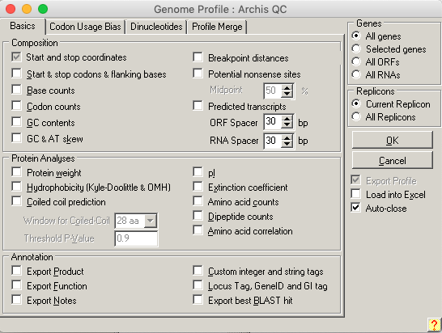
The only features you will need to generate the profile used for Starterator are the start and stop coordinates. You can generate additional Genome Profiles containing additional information to help you with the QC process. Be sure to deselect the “Load into Excel” option. If you are running DNA Master on a computer that does not have Microsoft Excel, leaving this box checked may result in DNA Master crashing.
- Save your Genome Profile in .csv format as PhageName_QC_Profile.
- You will need to transfer this file to your SEA Virtual Machine. If you set up a shared folder on your SEA Virtual Machine, you will be able to access this file through the SEA Virtual Machine file navigation system.

Generating a Whole Genome Starterator Report
- Start the SEA Virtual Machine.
- Click on the Phamerator icon as shown below to start Phamerator. This will ensure that the most recent database from Phamerator has been loaded, which is especially critical if you are using the SEA Virtual Machine for the first time or it has been more than a few weeks since the last time you used it. Wait for this task to complete (can take up to 30 minutes) and then quit Phamerator.
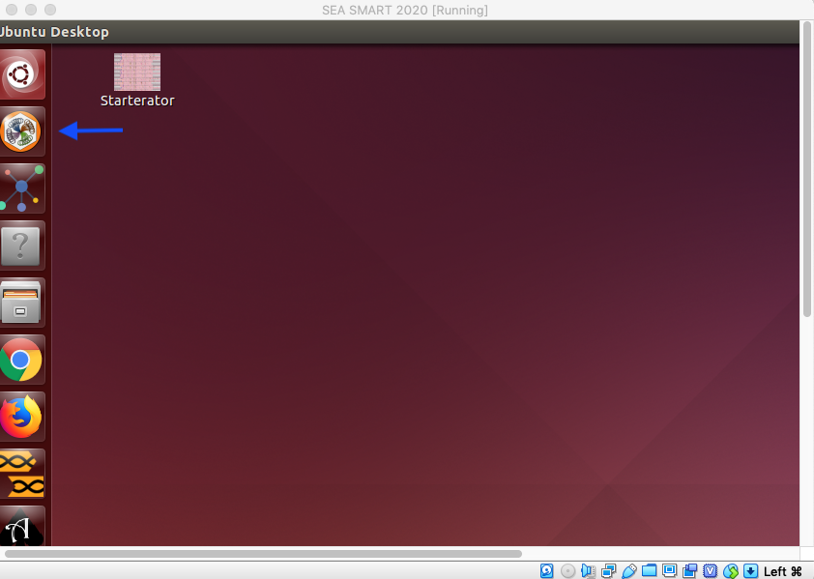
- Click on the “Starterator” icon to open the Starterator program.
- Select “Whole Unphamerated Phage” and upload information in the following fields:
  - Name: PhageName_Student (recommended so that you can differentiate the student annotation from other whole genome Starterator reports)
  - Genome fasta file: navigate to your shared folder and select the fasta file
  - Profile file: navigate to your shared folder and select the genome profile you created for the student annotation
- Click OK to begin the program. Depending on the power of your virtual machine and number of phages in the cluster, this may take up to 1 hour to complete.
- When Starterator is finished, a popup window will appear. Select “Link to Report” to view the PDF Starterator output. It is recommended that you save this PDF into your shared folder so that you can access it outside of the SEA Virtual Machine.

