Data Explorer Information: Obesity - An Epidemic with Unexpected Causes, Consequences, and Complexity

Title
Obesity - An Epidemic with Unexpected Causes, Consequences, and Complexity

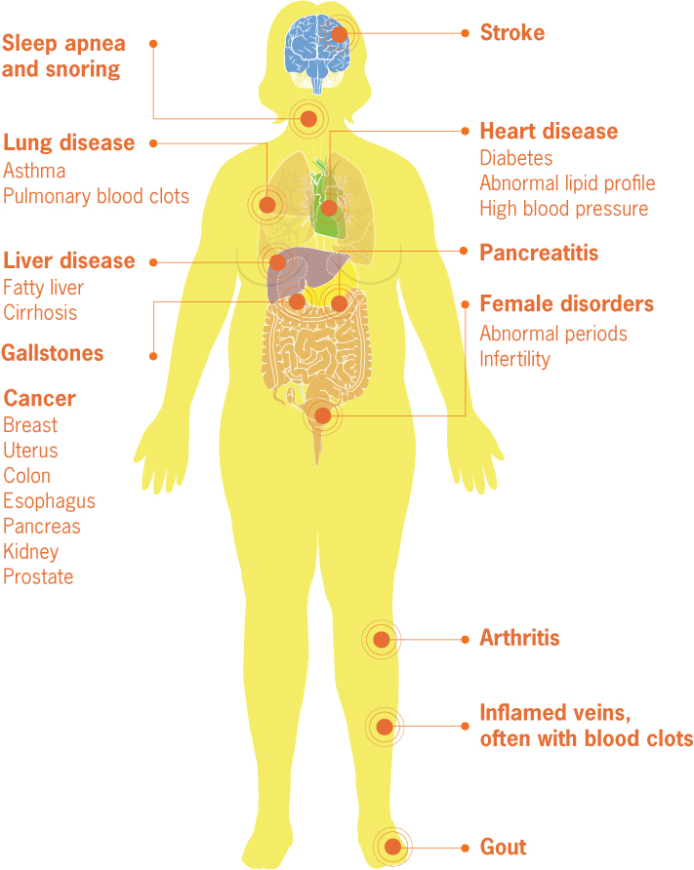
Summary - This dataset was collected from interviews conducted by the Centers for Disease Control and Prevention. State by state data are provided to explore the interactions of education, income, and race/ethnicity with obesity.

Introduction
Obesity is a challenge to one's health. Not only can it make day to day activities more challenging but obesity also places individuals at a greater risk of disease and death associated with non-communicable diseases. Specifically, obesity leads to conditions such as cardiovascular diseases, cancer, respiratory diseases, and type II diabetes mellitus (“Non Communicable Diseases” 2018), as seen in the figure to the right that displays the medical complications of obesity (“Adult Obesity Infographics” 2010). These comorbidities add to annual employer costs through direct medical costs and indirect costs associated with increased worker absenteeism and reduced overall productivity (“Workplace Health Promotion” 2016). Ultimately, extreme obesity and its related comorbidities may reduce one’s lifespan by as much as 20 years (Kitahara et al. 2014). In addition to the concerns associated with the health consequences of obesity and its comorbidites in adults, childhood obesity rates are rising and many believe that obese children are likely to become obese adults (“Childhood Obesity Facts” 2019).

With the aforementioned consequences and challenges associated with obesity you might expect that we have easy, replicable measures to determine obesity and a strong handle on its causes. Unfortunately, neither of these is currently true. Body Mass Index (BMI) is often used to indicate whether an individual has a healthy, overweight, or obese weight status. However, BMI is less than an ideal measure of obesity because it does not differentiate between muscle and fat mass. Additionally, BMI was developed from studies of white male populations and therefore the utility of BMI as a measure of female or non-white male health is currently only marginally accurate (Moharram et al., and Appropriate Body-Mass Index for Asian Populations and Its Implications for Policy and Intervention Strategies 2004).

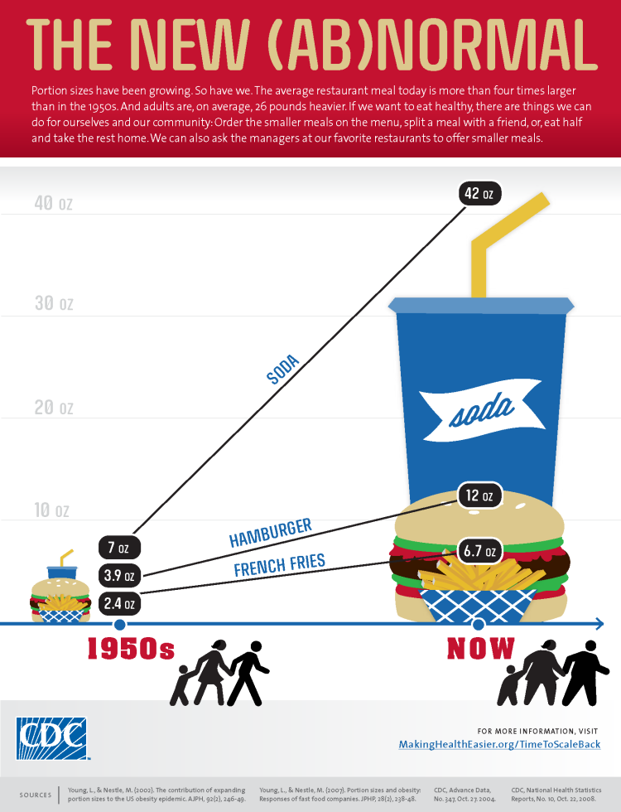
What do we know about the causes of obesity? A primary contributor to the development of obesity is excess caloric consumption in the presence of a sedentary lifestyle. The rise of processed food has reduced the cost and quality of foods and there is evidence that this processed food is a major contributor to the obesity epidemic (“Poor Nutrition,” 2020). As demonstrated in the infographic, The New(AB)normal, portion sizes have increased substantially in the past 50 years (“Infographics-The New (Ab)Normal” 2017 ).
Finally, few individuals get the recommended amount of physical activity per week (strength training 2X/week and moderate aerobic activity for 150 minutes OR vigorous aerobic activity for 75 minutes) and most get considerably less (“Physical Activity Guidelines for Americans” 2017). However, obesity is more complex than this simple energy budget would suggest and other factors, especially food environment and socioeconomic status, must be considered (“Adult Obesity 2020) .
Low-income neighborhoods that lack access to fresh produce and other high quality foods, based on a low abundance of grocery stores or farmer’s markets, often have disproportionately high obesity rates. These areas have been dubbed ‘food deserts.’ However, recent studies have demonstrated that food deserts may not drive obesity and that the lack of demand for fresh produce and healthy, high quality foods leads to the lack of supply (Allcott et al. 2019). ‘Food swamps’ complicate the food environment issue. Food swamps are also used to describe the food environment surrounding low-income neighborhoods. These areas have modest access to healthy food options but are overwhelmingly dense with fast- and junk-food options (Cooksey-Stowers et al. 2017).

These high calorie, low nutrient food options are less expensive and become the mainstay of residents in these areas. The socioeconomic status (SES) of residents of low-income neighborhoods impacts, and is impacted by, numerous facets of life including education and income levels. Each of these factors influence the food that is available for purchase and the food choices that one makes. All of these factors therefore influence one’s likelihood of becoming obese and developing comorbidites associated with obesity.

Learning Outcomes: Students will be able to
- Define comorbidities and locate datasets that evaluate the relationship between obesity and various comorbidities.
- Define, and note the shortcomings associated with, terms used in the study of obesity: BMI, food desert, food swamp.
- Choose a state and graph obesity rates over the time periods provided.
- Evaluate and report on trends when comparing states from the major regions of the United States.
- Work with the dataset and graphs to evaluate the relationships between obesity and factors associated with socioeconomic status.

About the data - The dataset is from the Centers for Disease Control and Prevention. The specific dataset in its entirety can be found at: https://chronicdata.cdc.gov/Nutrition-Physical-Activity-and-Obesity/Nutrition-Physical-Activity-and-Obesity-Behavioral/hn4x-zwk7.
Note that the dataset is based on data collected from telephone interviews. The questions asked during the interview generate the type of data found below; the dataset under consideration here is focused on question 36.

Question | Data point associated with question at left
Q018 | Percent of adults who report consuming fruit less than one time daily
Q019 | Percent of adults who report consuming vegetables less than one time daily
Q036 | Percent of adults aged 18 years and older who have obesity
Q037 | Percent of adults aged 18 years and older who have an overweight classification
Q043 | Percent of adults who achieve at least 150 minutes a week of moderate-intensity aerobic physical activity or 75 minutes a week of vigorous-intensity aerobic activity (or an equivalent combination)
Q044 | Percent of adults who achieve at least 150 minutes a week of moderate-intensity aerobic physical activity or 75 minutes a week of vigorous-intensity aerobic physical activity and engage in muscle-strengthening activities on 2 or more days a week
Q045 | Percent of adults who achieve at least 300 minutes a week of moderate-intensity aerobic physical activity or 150 minutes a week of vigorous-intensity aerobic activity (or an equivalent combination)
Q046 | Percent of adults who engage in muscle-strengthening activities on 2 or more days a week
Q047 | Percent of adults who engage in no leisure-time physical activity

The curated data set* contains the following columns:
Column 1 name - Year | Description - Year of data collection (either 2011 or 2018).
Column 2 name - State | Description - U.S. state
Column 3 name - % of adults 18 years and older that are obese | Description - % of adults 18 years and older that are classified as obese based on responses to questions asked by the CDC
Column 4 name - Lower Confidence Interval | Description - value at the lower end of a confidence interval
Column 5 name - Higher Confidence Interval | Description - value at the upper end of a confidence interval
Column 6 name - Sample Size | Description - Number of respondents to questions asked by the CDC.
Column 7 name - Age in Years | Description - The age of individual respondents; age brackets were (18-24, 25-34, 35-44, 45-54, 55-64, 65 or older)
Column 8 name - Education Level | Description - The level of education attained by respondents: categories included: less than high school, high school graduate, some college or technical, college graduate
Column 9 name - Gender | Description - The gender of the respondents; male or female
Column 10 name - Income Level | Description - The income levels for respondents; income brackets were: less than $15,000, $15,000 - $24,999, $25,000 - $34,999, $35,000 - $49,999, $50,000 - $74,999, $75,000 or greater
Column 11 name - Race/Ethnicity | Description - The race or ethnicity of respondents; possible categories included: two or more races, American Indian/Alaska Native, Asian, Hispanic, Hawaiian/Pacific Islander, Non-Hispanic White, Non-Hispanic Black, Other

*NOTE that in the curated dataset each state’s data have been sorted to provide the 2011 data followed by the 2018 data. All data from the intervening years has been removed to make the dataset more manageable.

Related activity
This data can be used to explore the complexity of obesity in the activity “Obesity - An Epidemic with Unexpected Causes, Consequences, and Complexity.” The activity focuses on the complexity of obesity as a disease (causes and consequences) through a comparison of data from states representing different regions of the country. In addition, the activity considers the impact of socioeconomic status on the obesity epidemic.

References
“Adult Obesity Infographics,” CDC-Vital Signs, Centers for Disease Control and Prevention, August 3, 2010. https://www.cdc.gov/vitalsigns/AdultObesity/Risk-large.html.

Allcott, Hunt, Jean-Pierre Dube, and Molly Schnell. “Eliminating Food Deserts Won’t Help Poorer Americans Eat Healthier.” The Conversation , December 1, 2019. https://theconversation.com/eliminating-food-deserts-wont-help-poorer-americans-eat-healthier-127295.

“Appropriate Body-Mass Index for Asian Populations and Its Implications for Policy and Intervention Strategies.” The Lancet 363, no. 9403 (January 10, 2004): 157–63. https://doi.org/10.1016/S0140-6736(03)15268-3.

“Childhood Obesity Facts,” Overweight and Obesity, Centers for Disease Control and Prevention, Last modified June 24, 2019. https://www.cdc.gov/obesity/data/childhood.html.

Cooksey-Stowers, Kristen, Marlene Schwartz, and Kelly Brownell. “Food Swamps Predict Obesity Rates Better Than Food Deserts in the United States.” International Journal of Environmental Research and Public Health 14, no. 1366 (November 14, 2017): 1–20. https://doi.org/ doi:10.3390/ijerph14111366.

“Food Swamps Predict Obesity Rates Better Than Food Deserts,” UConn Today, November 14, 2017. https://today.uconn.edu/2017/11/food-swamps-predict-obesity-rates-better-food-deserts/.

“Infographics-The New (Ab)Normal,” Division of Nutrition, Physical Activity, and Obesity, Centers for Disease Control and Prevention, November 21, 2017. https://www.cdc.gov/nccdphp/dnpao/multimedia/infographics/newabnormal.html.

Kitahara, Cari M., Alan J. Flint, Amy Berrington de Gonzalez, Leslie Bernstein, Michelle Brotzman, Robert J. MacInnis, Steven C. Moore, et al. “Association between Class III Obesity (BMI of 40–59 Kg/M2) and Mortality: A Pooled Analysis of 20 Prospective Studies.” PLOS Medicine 11, no. 7 (July 8, 2014): e1001673.
https://doi.org/10.1371/journal.pmed.1001673.

Moharram, Mohammed A. , Hamish M. Aitken-BuckAitken-Buck, Robin Reijers, Isabelle van Hout, Michael Ja Williams, Peter P Jones, Gillian A Whalley, Regis R Lamberts, and Sean Coffey. “Correlation between Epicardial Adipose Tissue and Body Mass Index in New Zealand Ethnic Populations.” Europe PMC 133, no. 1516 (June 11, 2020): 22–32.

“Non Communicable Diseases,” World Health Organization, Last modified June 1, 2018, https://www.who.int/news-room/fact-sheets/detail/noncommunicable-diseases.

“Poor Nutrition,” National Center for Chronic Disease Prevention and Health Promotion, Centers for Disease Control and Prevention, April 14, 2020. https://www.cdc.gov/chronicdisease/resources/publications/factsheets/nutrition.html.

“Physical Activity Guidelines for Americans.” President’s Council on Sports, Fitness, and Nutrition, U.S. Department of Health and Human Services, Last updated February 1, 2019. https://www.hhs.gov/fitness/be-active/physical-activity-guidelines-for-americans/index.html.

“Worker Productivity Measures,” Workplace Health Promotion, Centers for Disease Control and Prevention, Last modified April 1, 2016. https://www.cdc.gov/workplacehealthpromotion/model/evaluation/productivity.html.

Credits
Data curated by Edward Freeman PhD, St. John Fisher College, New York
Written by Edward Freeman PhD, St. John Fisher College, New York

